**Boulder County Hazardous Materials Team**

Decontamination

|  |  |
| --- | --- |
| Guideline Number | 3003 |
| Approved By | Advisory Committee |
| Date | 4-20-18 |
|  |  |

**Scope:** This guideline applies to all members of the Boulder County Hazardous Materials Team (BCHMT)

**Purpose:** The purpose of this guideline is to establish standard procedures for Decontamination for Emergency, Technical and Mass Decon for an incident involving Hazardous Materials.

**Guideline:**

* **Emergency Decontamination.**
* The Emergency Decon corridor will be supervised by the Decon Supervisor or the next most qualified individual.
* In the event a person enters a toxic atmosphere, and due to a physical or equipment problem, must leave the contaminated area immediately, an Emergency Decon line must be established prior to any entry. The Emergency Decon line will be a minimum of a 1 ¾” hose line connected to either a fire apparatus or a hydrant with sufficient pressure. Doff the clothes of the contaminated person then proceed to a full head to toe rinse. If possible, provide for privacy.
* If and when feasible, capture the Decon runoff.
* **Technical Decontamination**

* Technical Decon will be supervised by the Decon Supervisor
* Technical Decon will be performed whenever a team member enters a hazardous environment.
* Either Dry or Wet Decon will be performed. The Decon Supervisor will coordinate with the Research Officer to determine the type of Decon to be used. The number of pools used and the wash solution will be determined at this time. This process may vary depending on the specifics of the incident.
* The Decon corridor will be set up in a similar fashion to Figure 1.1
* Capture all Decon runoff.
* Job positions within Technical Decon may include:
* 1-4 people washing
* 1-4 people rinsing
* 1-2 people performing air monitoring, Ph testing, etc.
* A runner handling samples meant for research
* A LE officer maintaining control of any weapons or the chain of custody of samples



Figure 1.1 Decon Corridor

* **Mass Decontamination**
* There may be situations where there is a need to decontaminate large numbers of contaminated people.
* The technique used will depend on the severity of the exposure and the number of people requiring decontamination.
* When the BCHMT Hazardous Materials Mass Decon Truck is unavailable or not appropriate. (For use of the BCHMT Mass Decon Truck, please refer to the NCR Mass Decon FOG located in 2155.), setting up two engine companies with opposing fixed streams may be appropriate (Figure 1.2). Other options such as using a fog nozzle from a pre-connected hose or spraying water down from the tip of a ladder truck are also acceptable.
* Considerations must be given to the following when setting up any type of Decon operation:

* Management of ingress and egress points.
* Runoff containment.
* Individual privacy. Consider separate lines/areas for men, women, and children.
* Clothing and personal belonging collection and tracking.
* Don-it/Doff-it kits for post-Decon wear.

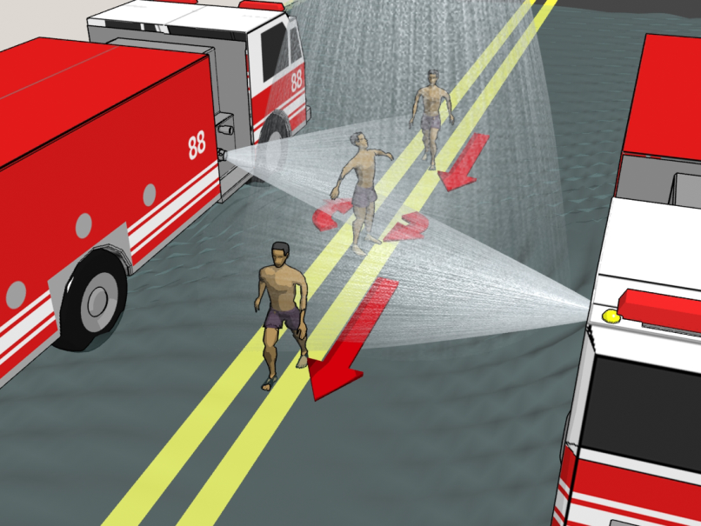

Figure 1.2