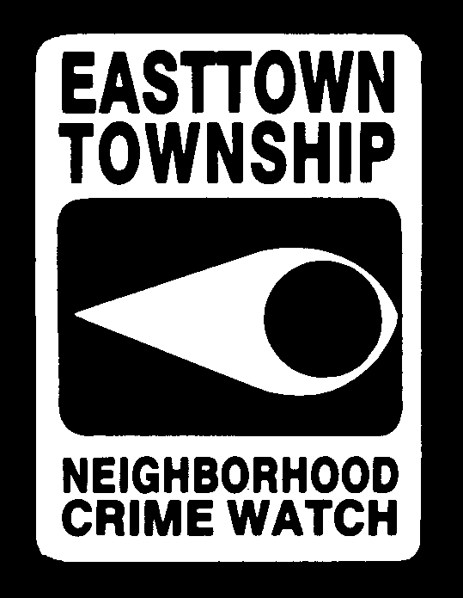

The Alert
A publication of Easttown Township Neighborhood Watch
Winter 2018

Sound familiar?????
Have you ever received a telephone call, email or letter promising a deal that’s “too good to be true”? You know, they promise guaranteed success, promise you’ll earn high income from a work at home job (sometimes requiring an upfront investment), or someone wants to overpay you for an item you’re selling and have you send them back the difference? These are all classic signs of a con game. Learn to play it safe: check the reputation of a business with your local Better Business Bureau before you do business with them. Don’t wire money to people you don’t know. Don’t fall for the “phone call from a relative whose car broke down or who got arrested and needs bail money” scam – call a family member first to check whether or not the “victim” is actually in the country they claim to be in or actually needs bail money. Don’t fall for the work at home job offers that involve reshipping items or financial instruments from your home – they aren’t legitimate. And you’re never going to win the Irish Sweepstakes (or any other foreign lottery) since they are illegal in the United States, so gamble at your local casino instead (the odds of winning are much better!)

It’s never too early either to talk to your kids about “too good to be true” offers. Teach them to be skeptical. Take an active interest in the financial affairs of your aging parents. Share information about scams with family and friends – and don’t forget to share on your social networking sites!

How does neighborhood watch work?

Neighborhood Watch is a program involving the joint efforts of the police department and the community. It is designed to enhance neighborhood security, heighten the

community’s power of observation and encourage mutual assistance and concern among neighbors. It’s one of the most effective and least costly ways to prevent crime.

Over the years, old well established neighborhoods have evolved into highly transient ones where people seek more and more privacy. This lifestyle tends to promote unfamiliarity with neighbors and a corresponding lack of concern. Unfortunately, this also enhances opportunities for the criminal element and increases the community’s vulnerability to crime. Neighborhood Watch can forge bonds among area residents, can help reduce burglaries and robberies, and make the local police department more
effective in its fight against crime through the individual’s involvement and participation. How do you participate? Unlike a Town Watch organization where you have scheduled patrols with a police officer, Neighborhood Watch requires a minimal commitment; there’s no riding on patrol with our police. You just need to be alert, get to know your neighbors and watch out for them from the comfort of your own home. Talk about your concerns with your neighbors. Act as the eyes and ears of the police department and report any suspicious activity to 9-1-1. Stay alert wherever you are, whether it’s in a mall, during your commute to work or just out on the town. Suspicious activity can include things like hearing screams for help; seeing someone looking into your neighbor’s windows or car; property being removed from a house where you know no one is at home or from a business after hours; or someone being forced into a vehicle or a stranger sitting in a car or stopping to talk to a child. Remember, the police would rather investigate situations that are harmless than be called too late. Your call could save a life, prevent an injury or stop a crime. That’s what Neighborhood Watch is about -- neighbor helping neighbor in the never ending fight against crime in our community. The bombings at the Boston Marathon are a great example of neighborhood watch at work; the resident in a house in the cordoned off area saw something suspicious in his yard. Rather than putting himself at risk (as did George Zimmerman in Florida by confronting someone who thought was suspicious) our Boston individual contacted 911 and reported it. The Boston Bomber was apprehended by local police and the individual who reported the incident remained safe inside his house.

If you’d like to organize your block into a Neighborhood Watch block, please contact the Officer Frank Keenan at 610-341-9780. He can provide information on hosting a Block Meeting. If you have questions or concerns about Neighborhood Watch please email us at etnw1982@gmail.com.

Pennsylvania Yellow Dot program
If you or a loved one are in an automobile accident, you want the EMS personnel to know your vital information as quickly as possible. Now, Pennsylvania has created a program to provide just that.

The Pennsylvania Yellow Dot Program was created to assist older Pennsylvania’s in the “golden hour” of emergency care after a traffic incident where they may not be able to communicate their needs. A yellow
dot sticker is placed in the rear window of your car to alert first responders that vital information (such as any prescription medications, medical conditions and the identity of the driver) is located in the glove compartment of the vehicle. A yellow dot folder should be completed for each vehicle you own.

The Pennsylvania Yellow Dot Program is a cooperative effort between the Pennsylvania Department of Transportation, Health and Aging; the Pennsylvania State Police; the Pennsylvania Turnpike Commission; and First Responders and local law enforcement.

The packet includes a medical information sheet to be completed and placed in your glove compartment. It also has a space to attach your photo and the yellow dot sticker to place inside the rear window of your vehicle. For additional information about the Yellow Dot Program, or to request a kit, call 1-877-724-3258 or visit www.YellowDot.pa.gov. Note: Only 1 folder is needed per vehicle. You can print a medical form out for each individual associated with the same vehicle, and put them in the one folder.

____________________________________________________________________

Fight back against identity theft

Identity theft is an ongoing issue – and the deteriorating economic situation doesn’t help. It’s a serious crime and one what you can take precautions against. Safeguard your personal information and that of your family members by shredding financial documents and paperwork containing personal information. Don’t carry your Social Security card in your wallet or write it on a check. Never click on links sent in unsolicited emails – visit OnGuardOnline.gov for computer safety information. Don’t use obvious passwords for your accounts (like your birth date, your mother’s maiden name or the last 4 digits in your Social Security number. Keep your personal information in a secure place (especially if you have roommates, employ outside help or are using contractors/workmen around your house).

Be vigilant about your bank accounts and credit card statements. Check them frequently for unauthorized charges or withdrawals. Immediate action should be taken if you are
denied credit for no apparent reason, start receiving unexpected credit card statements or get calls or letters about purchases you didn’t make.

You are entitled to a free credit report once per year from each of the three major credit reporting companies. Take advantage of this by visiting www.AnnualCreditReport.com or call 1-877-322-8228 to order your free annual credit report. If you find anything that is not accurate, contact the credit reporting company and the information provider. More information on fixing credit report errors can be found at ftc.gov/idtheft.

If, despite your best efforts, you become a victim of identity theft, place a “fraud alert” on your credit reports. Toll free numbers are available for each of the three nationwide consumer reporting agencies so you can place a 90-day fraud alert on your account. Posting an alert entitles you to free copies of your credit reports. Once you’ve done this, contact the security or fraud department of each company where an account was opened without your ok; you can find an ID Theft Affidavit at ftc.gov/idtheft to support your written statement(s). File a police report and report the theft to the Federal Trade Commission (1-877-438-4338.

Remember, criminals can get your personal information from dumpster diving (including your own trash can), skimming (using special storage devices when processing your credit card), phishing (pretending to be a financial institution, company or govt. agency), hacking into your personal computer or a company’s computer to gather information or just plain old stealing like purse snatching.

Drug Awareness

The news media has documented a growing tend in gruesome and violent “zombie-like” attacks by individuals using a new breed of synthetic drugs. There are now new challenges posed by designer drugs such as “bath salts” and synthetic marijuana, aka “fake pot”. Law enforcement officials noted that this extremely violent behavior is common by those individuals high on “bath salts”.

These drugs are readily available and freely marketed online as household items like incense, plant food and bath salts. In some cases they are sold in local neighborhoods in your corner markets and gas stations. And although they typically have the disclaimer “not for human consumption”, they are produced with the specific intention of being smoked or injected by people looking for a quick high.

A major concern is that the ease with which these drugs can be purchased on the internet has sparked a surge in use among teenagers. Many teens believe the products are safe, “legal” highs that will not be detected in a routine drug test and will not arouse parental suspicion. Others appear to believe they are safer alternatives to marijuana and amphetamines such as cocaine, which they are designed to mimic. In reality they appear to be far more dangerous.

Bath Salts are known to cause agitation, paranoia, hallucinations, chest pain, suicidal tendencies – and a form of animalistic behavior shown by violent attacks. Synthetic marijuana poses its own risks because of the way it alters the brain’s chemistry and has been linked to numerous deaths.

Given their misleading marketing, heightened availability and adaptive “legality”, it is not surprising that last year Poison Control Centers received over 13,000 human exposure calls regarding synthetic cannabinoids and bath salts, according to the US Drug Enforcement Administration

Teenagers, as well as parents, need to be informed about what these substances look like, how they are packaged and marketed and the negative long and short term effects of the substances which, at best, alter brain chemistry and, at worst, induce violent behavior.

These synthetic drugs do not just pose a danger to abusers. They also endanger innocent bystanders, law enforcement personnel and anyone else an individual high on these substances encounters.

Snowbirds – Don’t Be a victim while you’re away!

If you are lucky enough to get away from Mother Nature’s ice and snow during the winter, you need to take some precautions before you leave to prevent becoming a crime victim at home. Contact your local police department and let them know how long you’ll be away and who has a key to your residence. Put a hold on your mail (or have it forwarded) with the Post Office. Put a hold on newspaper delivery while you are away. Have your home phone (if you have a land line) call forwarded to your cell phone. Ask a neighbor to shovel snow from your walkways and drive while you’re away. Make sure a trusted family member or neighbor has a key to access your home in case of an emergency while you’re gone too.

ETNW Goes Digital
ETNW enters the digital age! We have a website (etnw.net) and are on Facebook (Easttown Township Neighborhood Watch). Like us on Facebook and keep posted on crime tips and public service information.

If you would like to receive the Alert via email, please send your contact information to etnw1982@gmail.com to be added to our distribution list. We will not sell your contact info. Thank you!

