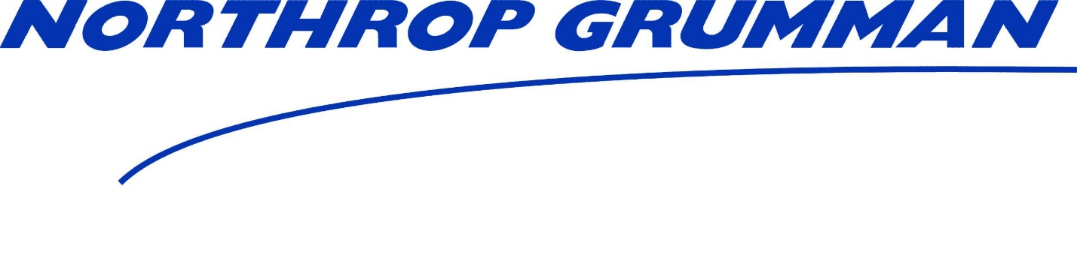

SpecTech USA, INC
Supplier Number: 90066719
6203 S 39th West Ave.
Tulsa, OK 74132

SpecTech USA, INC is an approved supplier of
Northrop Grumman.

01/01/2020

