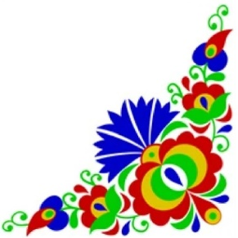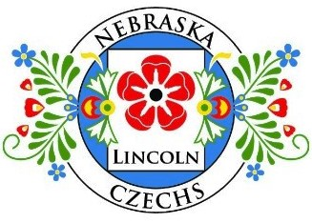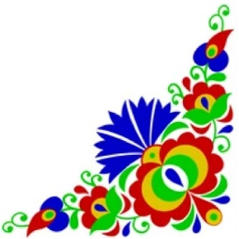

Nebraska Czechs of Lincoln
“Celebrating 56 years of Czech heritage in the Capitol City”

Czech Festival
Sunday, May 3, 2026
10:00 a.m. - 4:00 p.m.
Pla Mor Ballroom
6600 West “O” Street - Lincoln, Nebraska

~ Free admission – Open to the Public ~

10:00 a.m. Vendors & Bake Sales begin
10:45 a.m. Opening Ceremony and Anthems
11:00 a.m. Accordion Jam – (Bring your accordions in the keys of FBEA and join in the fun)
12:00 p.m. Lunch – Traditional Czech Food
1:00 p.m. Introduction and Crowning of Lincoln Czech-Slovak Royalty
Introduction of visiting Czech-Slovak Royalty
1:30 p.m. Young Talent
2:00 p.m. “Sauerkraut with Sinda” Demonstration (Northeast corner of booths)
2:00 p.m. Accordion Jam – (Bring your accordions in the keys of FBEA and join in the fun)
3:15 p.m. Introduction of Dr. Mila Saskova-Pierce (Honorary Czech Consul of Nebraska)
Czech Language Foundation Presentation
Better Life Bike Drawing & Presentation
3:30 p.m. Continue Accordion Jam
4:00 p.m. End of program – Closing Ceremonies

~ Vendors & Exhibitors ~

* Baked goods and traditional Koláče * Crystal from Czech/Slovak Republics *
* Garnet jewelry * Czech Music CD’s * Accordion Lessons * Czech Crafts & Goods *
* Czech Heritage Displays * Silent Auction * Czech Genealogical Society International *

For more information, please contact: Connie Jean at 402-464-5184 or Deb at 402-570-7300

Your valuable support enables us to continue funding our projects to the Czech Language
Foundation Scholarships at University of Nebraska at Lincoln (UNL) and the Czech-Slovak Royalty. 