275 NEBRASKA CZECH license plates sold through early December.
​
Nebraska Czechs of Lincoln, Inc. were instrumental in getting a Czech Heritage license plate approved, which went into effect January 1, 2025. The Czech license plate application is now available through the DMV, https://dmv.nebraska.gov/services, or your county clerk.​​​
A plate cycle is every six years. If the total number of registered vehicles that have Czech plates is less than 500 per year within any prior consecutive two-year period DMV shall cease their issuance. The cycle that we are in started in 2023. So the next new plate cycle will begin in 2029.
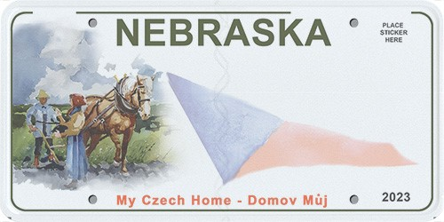
Get your Czech Heritage License plate!
1. Apply online at Nebraska DMV - https://edmv.nebraska.gov/
2. Select the Czech Heritage plate.
3. Choose a personalized message or a county number.
4. Explain your 5 character personalized message.
5. Select your county and where to receive you plate.
6. Pay by debit/credit card or electronic check.
7. The annual fee for a personalized message is $40, for a county number only $5.
8. You will be notified when the plate is available.
9. The new license will be issued at your annual license renewal. At any other time, an exchange fee of $13.75 is payable to your county treasurer.
​​​​​​​ 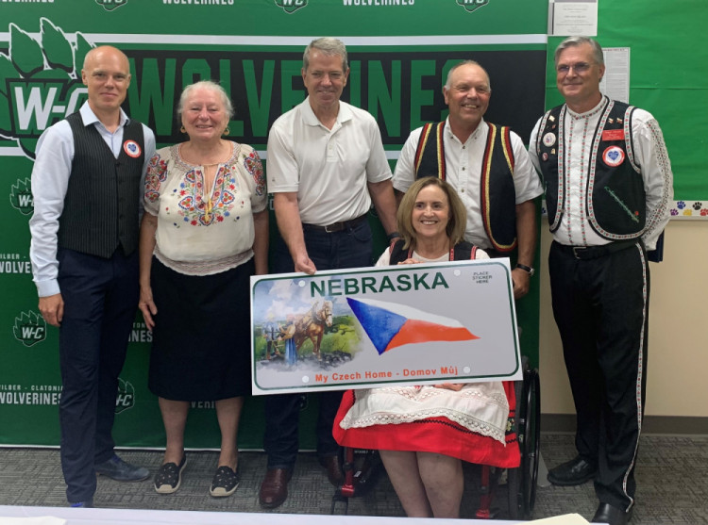
​​* It’s here! At long last the Nebraska Czech Heritage License Plate Legislative Bill 140 was signed into law by Governor Jim Pillen at the Wilber-Clatonia High School on Sunday, August 4 during the Annual Czech Festival in Wilber. Among those participating in the signing ceremony from the left are Ondrej Pometlo, Deputy Consul General of the Czech Republic in Chicago; Dr. Mila Saskova-Pierce, Honorary Consul of the Czech Republic in Lincoln; Governor Jim Pillen; Debbie Spanyers, Saline County Treasurer; District 32 Senator Tom Brandt; and Wilber Mayor Roger Chrans. The nationally renowned artist, Jim Cantrell, who grew up in Wilber, designed the License Plate featuring homesteaders with the Czech flag and words at the bottom saying, My Czech Home-Domov Muj demonstrating people leaving their homeland but not abandoning their culture to create new lives in Nebraska.​​​​​​

