Koláče baking on Saturday, April 25, 2026
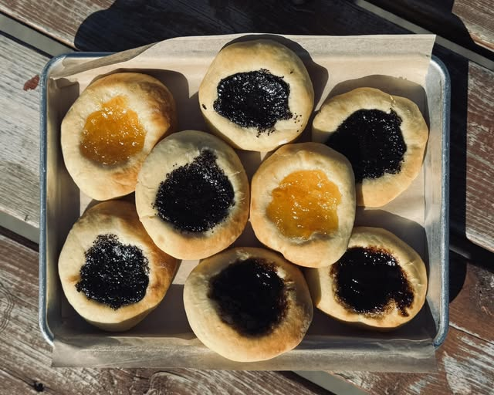
The Nebraska Czechs of Lincoln, Inc. will be baking koláče on Saturday, April 25, 2026 at the Hickman Presbyterian Church, 303 East 3rd Street, Hickman NE. The church’s kitchen has been reserved from 8:00 a.m. to 8:00 p.m. and the kitchen has 4 ovens!! Volunteers will be needed throughout the day. The first dough hopefully will be ready around 10:30 to put in the oven so early birds have to prepare the dough, letting it raise, weighing and rolling the dough, filling the koláče with many different delicious fillings and putting on the crumb mixture. The process will happen over and over until many dozen koláče are baked. Additional help will be needed as soon as the first batch is taken out of the oven and cooled. A sit-down job is to put one koláče in a plastic zip bag with a label of the flavor on the bag and place them in our flats. There will be a sign-up sheet at the March 13 and April 10, 2026 meetings to find out when you will be willing to help with the baking of koláče.
If you have friends who aren’t members and would like to learn how to make koláče, this would be a great time to invite them to join us. If you already know you can help with baking on April 25, 2026, please email or call Connie Jean Hulinsky so that you can be added to the volunteer list.
We will need 2 ½ quart glass bowls for mixing the dough and Airbake pans for baking the koláče. Please let us know if you have these items available to bring to the baking day.
Old Czech proverb, Bez prace nejsou koláč. “Without work, there are no kolaches.”
Connie Jean Hulinsky Festival Co-Chair Luconnie@windstream.net 402-464-5184 (land line with recorder after four rings)
And Deb Vocasek Festival Co-Chair

