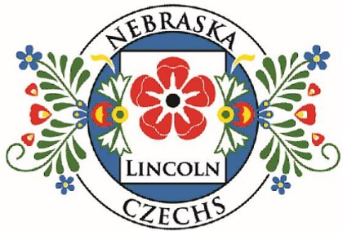
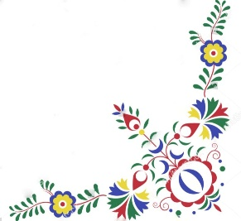
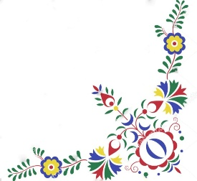

Save the Date!

Nebraska Czechs of Lincoln Festival
Sunday, May 3, 2026
10:00 AM – 4:00 PM
Pla-Mor Ballroom - 6600 West O St Lincoln NE

Open to the public – Free Admission!

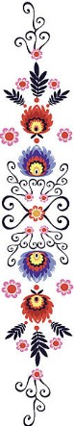
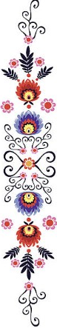
Join us for a day filled with Czech heritage, food, beverages,
baked goods, music, dance and fun!

Live Entertainment | Cultural Performances
Vendors & Crafts & Silent Auction

We will be serving Traditional Czech Food and Good Czech Beer!

Don’t miss this Celebration of Czech culture and tradition!
More details to come on our website. Stay tuned!
