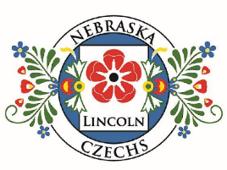
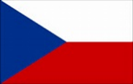

FEBRUARY 2026 (ύnor) NEBRASKA CZECHS OF LINCOLN, INC.
President: Rachel Taylor
Vice President: Evie Kantor
Secretary: Sinda Dux
Treasurer: Linda Taborek
Festival Chairs: Deb Vocasek
and Connie Jean Hulinsky
Board Members
Diane Vesely-Robb (12/31/2026)
Deb Vocasek (12/31/2027)
Susan Nagle (12/31/2028)

2026 Delegates to Nebraska Czechs, Inc.
Deb Vocasek
Mila Saskova-Pierce
Linda Taborek (alternate)

WEBSITE
lincolnczechs.org

FACEBOOK
https://www.facebook.com/LNKCzechs/

NEWSLETTER
Contact duxs2001@yahoo.com
402.800.0686

2026 MEMBERSHIP MEETINGS
Friday, February 13
Friday, March 13
Friday, April 10
Friday, May 8
MEETING LOCATION
HyVee 84 & Holdrege Sts.
5:30 Social Hour 6:00 Dinner
EVENTS
3rd Tuesday: Conversation Club (Zoom)
Last Tuesday: Reading Circle (Zoom)

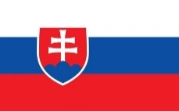

MEMBERSHIP MEETING
FRIDAY, February 13
Reservations due by Wednesday, February 11, to Diane Vesely-Robb 402.560.4847 dveselyrobb@yahoo.com
Menu: Fried Chicken and Baked Chicken, mashed potatoes, chicken gravy, green beans, rolls and butter
If you make a reservation but don’t attend, we will bill you since we are charged for your meal.
Please let us know if you have special dietary needs when you make your reservations.

LOCATION: HyVee 2nd Floor Party Room
1601 N 84 St, Lincoln, NE 68505
SOCIAL TIIME: 5:30 p.m.– 6:00 p.m.
WELCOME & DINNER: 6:00 p.m.-6: 30 p.m. (Cost $15.00)

PROGRAM (NAPROGRAMOVAT)
Robitschek Scholar Tomas Karasek (and maybe several others) will tell of his early schooling, learning about the scholarship, steps in obtaining the scholarships and experiences at UNL.
Firm Deadline for newsletter articles is the
20th of each month.
Two Important items for Members:
FEBRUARY
Month at a Glance
MEMBERSHIP MEETING
FEBRUARY 13
CZECH CONVERSATION CLUB
FEBRUARY 17
READING CIRCLE
FEBRUARY 24

- Pay Dues by Jan. 31 or lose membership.
- March Member Meeting will include Bylaws Revision votes. Members will receive the proposed revisions in an email before the March meeting.


Lincolnczechs.org
Check our website for dates, lists of Board members and commit-tees, news, newsletters, and our Bylaws. Robin McClanahan does a fine job of keeping our website up-to-date.

.

EDITOR’S NOTE – Dobry den. I’m Sinda Dux, the newsletter editor. CORRECTION from the January issue: In the paragraph about the Czech Ambassador’s reception at the Governor’s Mansion, “Nebraska Czechs, Inc.” should have been the Czech Language Foundation; that organization gave gifts to the Ambassador and provided kolaché.

PRESIDENT’S MESSAGE (Prezidentovo Poselství)
THE COURTESY COMMITTEE
Let us know if you are aware of someone who is celebrating something very special or is in need of our support.
Susan Nagle 402.440.2835
susan.nagle317@gmail.com

As we move into February, I’m reminded of how deeply history, culture, and resilience are woven into our shared Czech heritage. Our club exists to honor that legacy—by studying the language, celebrating Czech art, traditional foods, and keeping our history alive. February holds several powerful moments in Czech history that reflect both challenge and perseverance of our ancestors. On February 14, 1945, Prague was tragically bombed during World War II—an event that left scars on the city but did not break its spirit. Just a few years later, in February 1948, Czechoslovakia faced the Communist coup, marking a turning point that profoundly shaped the lives of Czech families at home and abroad. Many of our own ancestors carried their culture, values, and traditions with them through times of uncertainty, ensuring that Czech identity endured no matter the circumstances.
As we reflect on these moments, let us also celebrate the joy and richness of Czech culture—whether through music, language, storytelling, or shared meals. February is often the season of Masopust, a time of celebration before Lent, reminding us that Czech history is not only about hardship but also about community, humor, and joy. Thank you for being part of this club and for helping keep our Czech heritage alive, active, and proudly shared here in Nebraska.
Šťastný nový rok vám i vašim rodinám! Rachel

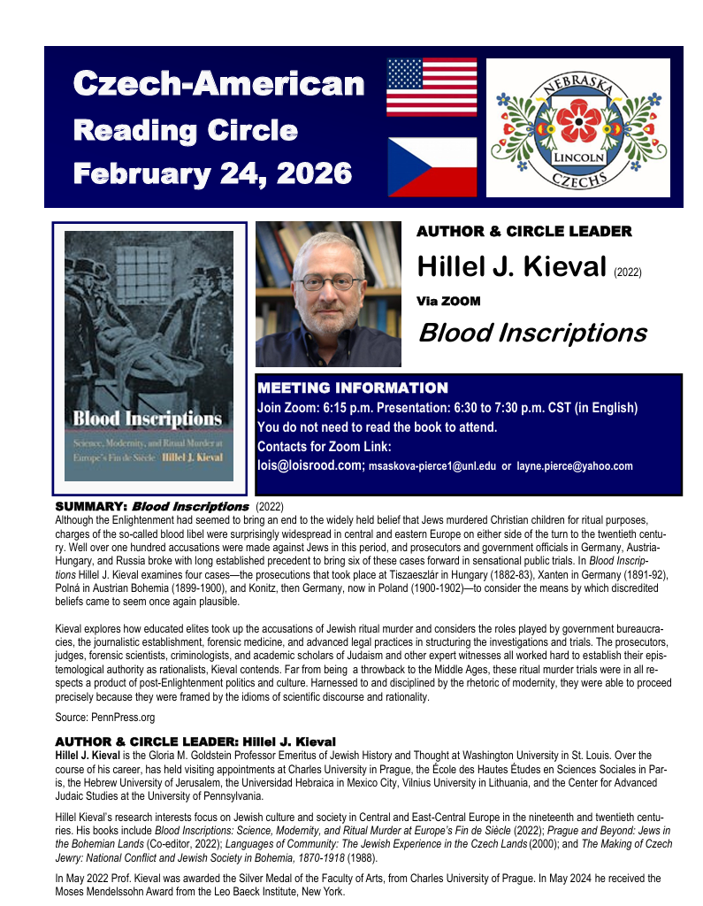

275 NEBRASKA CZECH license plates sold through early December. 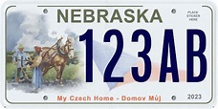
A plate cycle is every six years. If the total number of registered vehicles that have Czech plates is less than 500 per year within any prior consecutive two-year period DMV shall cease their issuance. The cycle that we are in started in 2023. So the next new plate cycle will begin in 2029.
********************************
The January Members Meeting involved many pictures of children enjoying themselves and that made everyone feel warm and friendly. The program was given by Susan Senft about the annual Czech Culture Day Camp in Wilber where children learn of Czech culture, music, language, and art.
*****************************
Interested in joining Czech on-line conversation?
The Czech Conversation Club is a group of heritage speakers and present or former students of the Czech language. We meet on the third Tuesday of the month at 7:00 PM Central Time on ZOOM and talk about a chosen theme prepared by one of Conversation Club members. We prepare vocabulary ahead of time and share it with the group before the meeting. If interested, please, let me know at msaskova-pierce1@unl.edu.
******* Every month on the Third Tuesday, 07:00 PM Central Time (US and Canada)*******
February 13-únor: Marie – Česká architektura – Czech architecture

Here's some information from the various Czech groups I am involved in. Debra Polacek
TJ Sokol Wilber, Wilber, NE, will hold the 4th annual Czech Cultural Day Camp July 7-10, 2026. Registration opens March 20th. Follow the facebook page TJ Sokol - Wilber Czech Cultural Day Camp. Campers must be 6 to 13 years old. Because of reading activities, younger children must have completed kindergarten grade and be six years old.
The Czech Culture and Education Foundation of Nebraska will host the brass band, Babouci, from Southern Bohemia in several venues in Nebraska: TJ Sokol, Wilber, NE, on April 17 from 7:00 - 10:00 p.m. Donation at the door. Food will be available.
Babouci will also be at the Clarkson Opera House, Clarkson, NE, on April 18 from 7:00 - 10:00 p.m. Donation at the door. Food available.
Omaha Czech-Slovak Culture Club Festival, Beardmore Event Center, Bellevue, NE, on April 19 from 3:00 - 5:00 p.m. Donation at the door. Food available.
The Czech Culture and Education Foundations is sponsoring a bus tour to the National Polka Festival, Ennis, Texas. The trip is 5 days and 4 nights from May 21 - 25. For more information email Steve Steager at ccefnebraska@gmail.com or call 402-740-3739.
Important News -- UNL will host the 26th Annual Czech and Slovak Studies Workshop in 2026. Among the sponsors is the Czech Language Foundation. Activities will include a visit to Wilber, screening of the documentary “The Art of Dissent,” discussions, and a keynote speaker who will explore Jewish-Czech Relations. More details will be forthcoming.

d


Czech Athletes in the 2026 Olympics in Milan/Cortina Italy February 6-22: 91 total including 48 men, 43 women in 8 sports: Men’s ice hockey, women’s ice hockey, figure skating, curling, snowboarding, biathlon, skiing, speed skating.
The men’s hockey team last won Gold in 1998 in Nagano Japan. The hockey team has 11 players from the American professional National Hockey League.

