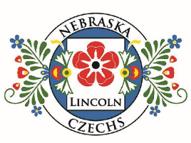
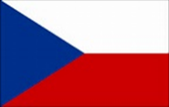
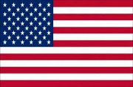
JANUARY 2026 (Leden) NEBRASKA CZECHS OF LINCOLN, INC.
President: Rachel Taylor
Vice President: Evie Kantor
Secretary: Sinda Dux
Treasurer: Linda Taborek
Festival Chair: Deb Vocasek
and Connie Jean Hulinsky
Board Members
Diane Vesely-Robb (12/31/2026)
Deb Vocasek (12/31/2027)
Susan Nagle (12/31/2028)

2026 Delegates to Nebraska Czechs, Inc.
Deb Vocasek
Mila Saskova-Pierce
Linda Taborek (alternate)

WEBSITE
lincolnczechs.org

FACEBOOK
https://www.facebook.com/LNKCzechs/

NEWSLETTER
Contact duxs2001@yahoo.com
402.800.0686
2026 Membership Meetings
Friday, January 9
Friday, February 13
Friday, March 13
Friday, April 10
Friday, May 8
MEETING LOCATION
HyVee 84 & Holdrege Sts.
5:30 Social Hour 6:00 Dinner
EVENTS
3rd Tuesday: Conversation Club (Zoom)
Last Tuesday: Reading Circle (Zoom)

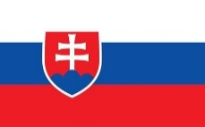

MEMBERSHIP MEETING
FRIDAY, January 9
Reservations due by Wednesday, January 7, to Diane Vesely-Robb 402.560.4847 dveselyrobb@yahoo.com
Menu: Roast beef, potatoes and gravy, vegetable, dinner rolls
If you make a reservation but don’t attend, we will bill you since we are charged for your meal.
Please let us know if you have special dietary needs when you make your reservations.

LOCATION: HyVee 2nd Floor Party Room
1601 N 84 St, Lincoln, NE 68505
SOCIAL TIIME: 5:30 p.m.– 6:00 p.m.
WELCOME & DINNER: 6:00 p.m.-6: 30 p.m. (Cost $15.00)

PROGRAM (NAPROGRAMOVAT)

Susan Senft of Lincoln, formerly of Wilber, will discuss the Czech Camp for Kids held at the Sokol Hall in Wilber during the day, one summer week. The children learn Czech traditions, music, dances, foods, and historical notable figures.

Firm Deadline for newsletter articles is the 20th of each month -- Editor
JANUARY
Month at a Glance
MEMBERSHIP MEETING
JANUARY 9
CZECH CONVERSATION CLUB
JANUARY 20
READING CIRCLE
JANUARY 27

BE SURE to pay your $10 2026 dues by January 31. Or you will be dropped as a member.
Linda Taborek 524 S. 53 St.
Lincoln NE 68510-2022
or bring dues to January 9 meeting

EDITOR’S NOTE –
Dobry den. I’m Sinda Dux, the new newsletter editor. If items are not laid out just perfectly, it’s because this is my first issue and I’m still learning. I’ve composed newsletters before but it’s been a long time. Lately I’ve been proofreading newsletters.
I’m Czech on my father’s side and German on my mother’s with one French ancestor and one Dutch.
My Czech great-grandparents are Wenzel Henry Schelbitzki and Maria Krutova, Wenzel from Grosmerigthal, Zwickau, Bohemia, and Maria from Biskaupkah, Okresu Zberov, Bohemia. Wenzel spoke German and Maria spoke Bohemian but they communicated somehow and had 13 children. Wenzel immigrated to the US in 1870 at age 27 and homesteaded in Fillmore and Saline Counties. Little is known about Maria before she married Wenzel. Wenzel became a naturalized American citizen in 1876 and that made his wife Maria and their children US citizens, also. It makes me proud that my great-grandfather chose to become an American citizen.

PRESIDENT’S MESSAGE (Prezidentovo Poselství)
THE COURTESY COMMITTEE
Let us know if you are aware of someone who is celebrating something very special or is in need of our support.
Susan Nagle 402.440.2835
susan.nagle317@gmail.com

As we come to the close of another year, I want to take a moment to thank each of you for the energy, enthusiasm, and heart you bring to the Nebraska Czechs of Lincoln club. It has been a year filled with good conversation, shared meals, laughter, and a deep appreciation for the language, history, and traditions that connect us. Being part of a community that values both heritage and community is something truly special, and I’m grateful for the chance to help guide us forward.
One of the brightest highlights of the year was undoubtedly our annual Czech Festival here in Lincoln. Thanks to the dedication of our volunteers, bakers, organizers, performers, and supporters, the festival was an outstanding success. Whether you were greeting guests, demonstrating traditions, or making dough at dawn, every contribution mattered. And of course, who could forget the koláče? Together we baked over 1,000 of them — a true testament to what we can accomplish when we come together. 😊
As we look ahead, I’m excited for the opportunities the new year will bring. We’ll continue to build on the great programs around Czech language learning, exploring cultural arts, celebrating Czech and Slovak history, and creating welcoming spaces for members old and new. I hope we can continue to expand our reach and share Czech culture more widely in Lincoln, and in the greater Nebraska area.
Thank you for being part of this wonderful community. I look forward to all the stories, traditions, and good company that await us in the coming year. Until then, I wish you and your families a peaceful and joyful holiday season.
Nazdraví — to a great year behind us and an even better one ahead!
Šťastný nový rok vám i vašim rodinám! Rachel
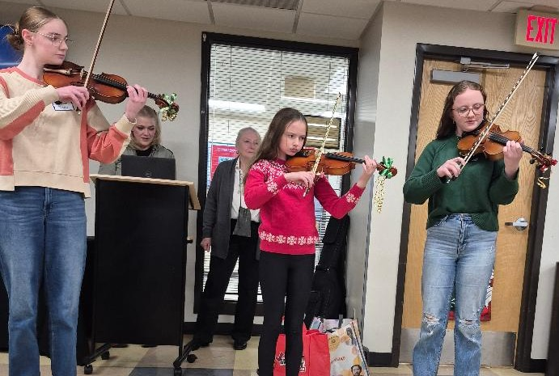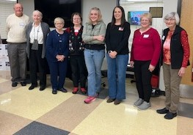
Picture by Sinda Dux Picture by Lois Rood
The December Members Meeting was an exciting one with a program of Czech Christmas customs presented by Mila Saskova-Pierce and Installation of 2026 Officers, Board Members, and Nebraska Czechs, Inc. delegates.
Pictured above are Josephine, Caroline, and Sydney Davis, who played Christmas music as part of Mila’s program. Layne Pierce on guitar accompanied carols sung in Czech, which went surprisingly well!! Fortune-telling with apples and walnuts caused much laughter.
Tom Zumpfe did a fine job installing Nebraska Czechs Inc. delegate Mila Saskova-Pierce, Vice President Evie Kantor, Secretary Sinda Dux, President Rachel Taylor, Board Members Diane Vesely Robb and Susan Nagle, and Lincoln Czech Festival Co-Chair Connie Jean Hulinsky.
Nebraska Czechs, Inc, Alternate Delegate Linda Taborek and Lincoln Czech Festival Co-
Chair Deb Vocasek were unable to attend.
RECEPTION FOR CZECH AMBASSADOR ATTENDED BY LINCOLN CZECH CLUB MEMBERS
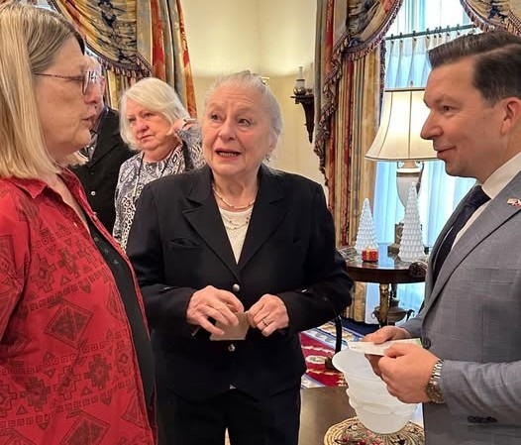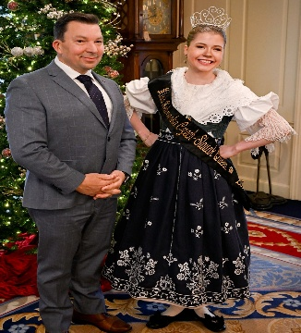
December 8 at the beautifully-decorated Governor’s Mansion, Ambassador Miloslav Stašek was honored by the Governor with the Legion of Merit medal and plaque. Amb. Stašek also received a Nebraska Czech license plate. Honorary Consul Mila Sašková-Pierce presented gifts from Nebraska Czechs, Inc. club which also donated delicious kolaches.
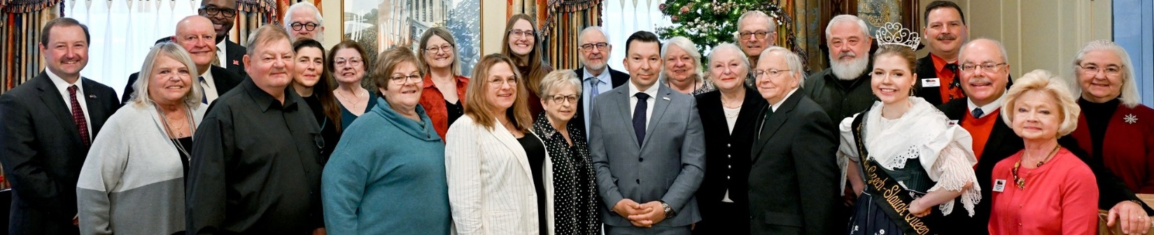
First picture: Nebraska Czechs of Lincoln, Inc. members Linda Táborek, Patti Fortik, and Mila Sašková-Pierce with the Ambassador; Second picture: Ambassador Stašek and Miss Nebraska Czech-Slovak Queen Lina Dvorak; Third picture: Attendees at the Reception. Many Nebraska Czechs of Lincoln, Inc. were in attendance. Pictures courtesy of the Nebraska National Guard.

Restoration of the Czech Independence Day
January 1 2026 This holiday commemorates the split of Czechoslovakia into two independent states: the Czech Republic and Slovakia, which occurred in 1993. It marks a significant moment in the country's history, symbolizing the establishment of a sovereign Czech state after years of political changes and struggles for independence.
Interested in joining Czech on-line conversation?
The Czech Conversation Club is a group of heritage speakers and present or former students of the Czech language. We meet on the third Tuesday of the month at 7:00 PM Central Time on ZOOM and talk about a chosen theme prepared by one of Conversation Club members. We prepare vocabulary ahead of time and share it with the group before the meeting. If interested, please, let me know at msaskova-pierce1@unl.edu.
******* Every month on the Third Tuesday, 07:00 PM Central Time (US and Canada)*******
January-leden: Layne - Knihovnictví: librarianship

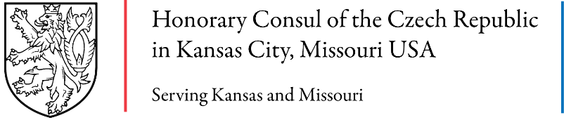

Friends and colleagues: you are invited to a special event on January 21, 2026 at the Truman Library, Independence Missouri
Freedom, Democracy and Human Rights: Bringing Václav Havel’s Wisdom to Today’s World
Enjoy an evening of dialogue, readings and song featuring Anne Marie Kenny and Martin Palouš.
Wednesday January 21, 2026
Reception: 5:30 p.m. CT
Program: 6:00 p.m. CT
Harry S. Truman Presidential Library & Museum
500 W US Hwy 24
Independence, MO 64050
Our speakers will share their insights into the role art can play in political change, and the relevance today of Václav Havel’s message of hope, personal responsibility in civic society, values-based leadership and creating a society that is, in his words, “humane, moral, intellectual, spiritual and cultural.”

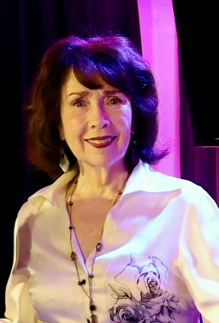
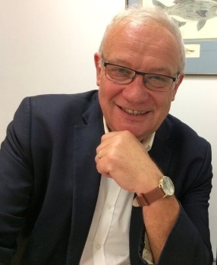
Anne Marie Kenny
Anne Marie Kenny, an Omaha native, lived her early adult years in France as a professional singer, performing at the Paris Ritz and on television, radio, and film. When the Iron Curtain fell in 1989, she wrote a poem and sent it to newly elected President Václav Havel, who invited her to sing at the Reduta Club. Soon after, she moved to Prague and started a staffing and training company that would be ranked #2 in the Czech market. She lived and worked alongside Czechs discovering their place in a new democratic society, while coming to terms with their past under totalitarian rule. Her book A Song for Bohemia is a tribute to the spirit of the Czech and Slovak people, and the story of a personal and collective journey to freedom.
Martin Palouš
Martin Palouš is a sought-after international speaker and commentator in the field of freedom, democracy and human rights. He was one of the original signatories of Charter 77 and served as its spokesperson in 1986. In November 1989, he was among the founders of the Civic Forum. After the Velvet Revolution, he became a member of Parliament, Deputy Minister for Foreign Affairs, and Ambassador of the Czech Republic to the U.S. and U.N. Today, he is on the board of supervisors of Václav Havel Library in Prague, director of International Cooperation of the Remembrance Society, member of the Council of the Institute for the Study of Totalitarian Regimes, and former board president of the Václav Havel Center in New York.

How to Register:
Go to the IRC website link to register. There is no charge to attend the event, however, please also consider pre-purchasing the soft or hard cover version of Ms. Kenny's book, A Song for Bohemia. Due to Truman Library's policy the book may not be available for purchase at the event.

Important News -- UNL will host the 26th Annual Czech and Slovak Studies Workshop in 2026. Among the sponsors is the Czech Language Foundation. Activities will include a visit to Wilber, screening of the documentary “The Art of Dissent,” discussions, and a keynote speaker who will explore Jewish-Czech Relations. More details will be forthcoming.
