SUPERNATURAL KINGDOM MINISTRIES

“FACILITY FUNDRAISING PROPOSAL”

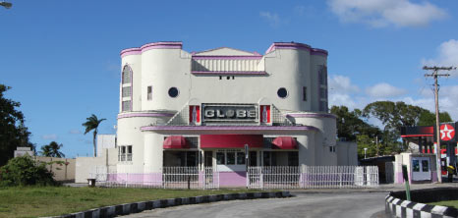
< A photo showing the outside view of the property we are going to acquire>

SKM’s Address:
Upper Roebuck Street,
Bridgetown, St. Michael., Barbados
Telephone: +1-246-2408111
Email: holyspiritministrieint@gmail.com
Website: http://www.supernaturalkingdomministries.org

Contact Person: Prophet - Adrian Ddungu

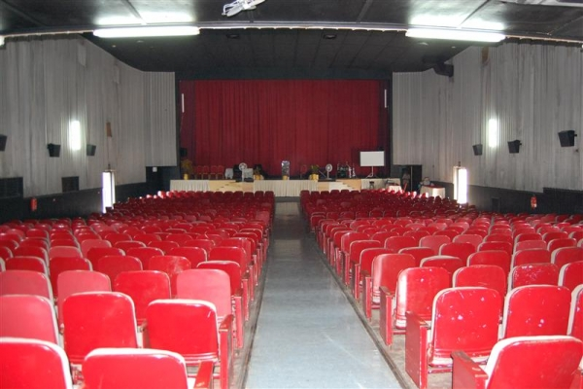
< A photo showing the inside view of the property we are going to acquire>

This Proposal is to be made available for your review under the Permission of Prophet Adrian Ddungu, God’s Servant and founder of Supernatural Kingdom Ministries.

You are welcome to review this proposal; your full or partial support is greatly appreciated.

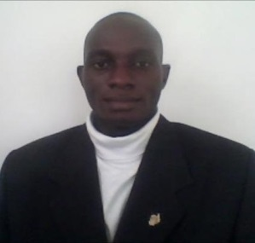
A Support Call from Prophet Adrian Ddungu

January 4, 2015
“²⁸ And we know that ^{[a]} God causes all things to work together for good to those who love God, to those who are called according to His purpose.” Romans 8:28 (NASB)
Dear Friend of God,
On behalf of Supernatural kingdom Ministries, I greet you in the Mighty Name of our Lord and savior Jesus Christ and pray that this letter finds you, your family and organization doing well. I humbly thank you in advance for your support towards the work of God in this season.
I however want to share with you briefly in this proposal a challenging ministry opportunity that God has presented to us as you will read in the executive summary.
I would love for you to support this divine cause. First, you can help support our vision God has entrusted us (to supernaturally change nations & touch lives as we minister the Kingdom of God) in prayer as we prepare to work with Him in the glorious ministry ahead.
Another way you could be involved is to help provide financial support. We need to obtain 1.4 Million USD to purchase this church facility for which this proposal is intended. Kindly view the link:-
http://www.karpreal.com/property_listing.php?property_id=1303&page=1
We greatly believe that it is in God’s perfect will that we acquire the property for His Kingdom Work. Hence, our ministry in this proposal is requesting you to support in any way you can to fulfil this noble work of God. Your contribution is appreciated and will never go in vain. I hope we can count on you.
You may check out to our website to view our mandate:
http://www.supernaturalkingdomministries.org.
You can send a check to this ministry or directly contact us on the above address.
I look forward to your participation in this “Kingdom” work.
May God bless you richly for your generous giving,
Prophet – Adrian Ddungu

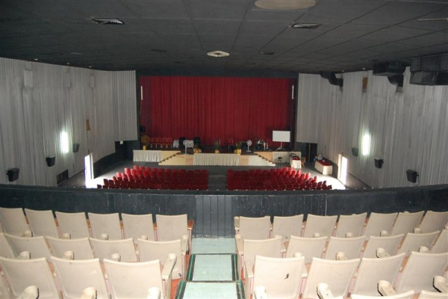
< A photo showing the inside view of the property we are going to acquire>

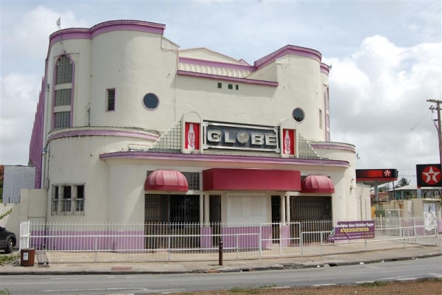

< A photo showing the outside view of the property we are going to acquire>

Executive Summary:

Supernatural Kingdom Ministries is a prophetic Deliverance ministry given the mandate, authority and power to make known among nations the person/role of the Holy Spirit and the manifestation of His anointing in bringing release to populaces and God's church as a whole. We have been called to minister the Kingdom of God message.
This ministry visionary Operates under the covering of the Holy Spirit in the areas of radical uncompromising Prophetic ream word, Evangelistic and Healing/Deliverance ministry. This ministry is characterized with FIRE & GLORY as declared by the Holy Spirit. The revelation of God is continuously unfolding day by day, second by Second devoting us to do greater works, miracles, Signs and wonders from God.
In ushering and enforcing God’s Kingdom and Will on Earth as it is in Heaven, this work of God is a movement committed to the authority of Holy Scripture and through the revelation and inspiration of the Holy Spirit. God has called and chosen us to exercise our spiritual senses by reason of use to change the atmosphere and create a very profound impact among nations for His Honor and Glory.
We are inspired by the prophetic mandate in this Scripture “See, today I appoint you over nations and kingdoms to uproot and tear down, to destroy and overthrow, to build and to plant. “Jeremiah 1:10 (NIV)
On the 12th Day of July 2012, Prophet Adrian Ddungu received a vision from God revealing that he had been called into the prophetic ministry/Office. He also received many dreams from God and Prophetic confirmations from other servants of God on the same issue. Prophet Adrian Ddungu was born in Uganda - East Africa, currently living in Barbados. His ministry is typically under the Prophetic mantle although he was nurtured under the Pentecostal and Apostolic backgrounds. He is a highly anointed/Spirit filled young man with a bosom relationship with the Holy Spirit. He is highly motivated by a prayer life and greatly favored by the Lord.

Our Objectives:

1) A movement/ body that is directed, guided and depends entirely on the Holy Spirit (supernatural Ministry);
2) Focused on Prophetic Deliverance; Evangelism and Kingdom Living;
3) A movement Committed to the authority of the Holy Scriptures;
4) A fellowship whose worship brings God's Power into the life of the Church and extends that power through the lives of believers;
5) A people who hunger for God;
6) A church that loves all people;
7) A movement that evidences a church that is Christ - Centered, People Oriented, and needs sensitive;
8) A movement that promotes policies and ministries which reflect an effort to remain relevant to each generation; and
9) A movement that Promotes, encourages, anoints, empowers and releases people to do the work of Ministry

10) A movement that purifies itself (consecration/Holiness) and steps out in power of resurrection to demonstrate/work/perform miracles, signs and wonders in the earth for the freedom of God’s people.

Our Mission:
The Mission of the Church is to minister the Kingdom of God and communicate the full Gospel of Jesus Christ (Matthew 28;19, 20), in the power of the Holy Spirit (Acts 2:1-4, 6, 13-18)

Property Descriptions:
This large building that God has blessed us with has been used as a cinema for many years and offers seating downstairs for 703 persons and upstairs for 258 persons. It also includes an office, lobby area, washroom facilities, raised stage area, a projector room, is air conditioned throughout and is equipped with a standby generator. The roof was replaced approximately 5 years ago.
This property offers good potential to be used as a meeting hall, church purposes and other related activities. Situated on the outskirts of Bridgetown, it is within minutes’ drive of the thriving Bridgetown City Center, other shopping facilities, dining and entertainment establishments, commercial activity centers and many other amenities found in the surrounding areas.

We are believing God and stepping out in faith to possess what He has given us. That is why with your financial support this will happen.

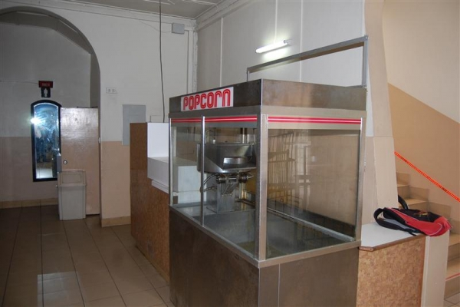
< A photo showing the lobby view of the property we are going to acquire>

PROPERTY DETAILS - Quotation
- Reference Number: | COTH0835
- Property Type: | Other
- Listing Type : | For Sale
- Price : | $ 1,400,000.00 USD
- Status: | Price Reduced
- Address : | Globe Cinema, Upper Roebuck Street, St. Michael
- Location: | Upper Roebuck Street
- Parish : | St. Michael
- Bathrooms : | 7.0
- Net Land Area (SQ.FT.) : | 22,950
Floor Area (SQ.FT.) : | 10,800
- Zoning : | Commercial
- Construction : | 1948

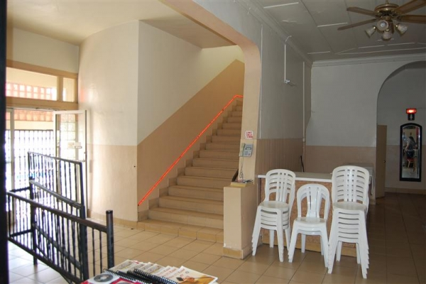

< A photo showing the part of the inside view of the property we are going to acquire>

Our Ministry Aim:

The Aim of this ministry is:
1) To Glorify God;
2) To Edify Itself;
3) To Purify itself;
4) To Educate its constituency;
5) To evangelize the World;
6) To act as a restraining and enlightenment force in the world;
7) Promote all that is good.

Start-up Summary:

Table: Start-up

Start-up

Requirements

Start-up Expenses

Legal | $0
Stationery etc. | $0
Brochures | $0
Consultants | $0
Insurance | $0
Rent | $0
Total Start-up Expenses | $0
Start-up Assets
Cash Required | $1,400,000
Other Current Assets | $0
Long-term Assets | $0
Total Assets | $1,400,000
Total Requirements | $1,400,000

Supernatural Kingdom Ministries once again thank you for your generosity in giving to the work of God. This facility that God has given us will only be used for activities that give glory and honour to God. We are a supernaturally thinking young energetic ministry that believes that all things are possible with God. We profoundly believe in miracles, signs and wonders and that Jesus is greatly at work in the earth through the Holy Spirit. We are at the same time immersed in the present day revelation of God that unfolds Himself on those He has chosen and consecrated to work with Him in ministry. Therefore with your help this work will be completed soon in Jesus Mighty Name.

Thanksgiving and Prayer
3I thank my God every time I remember you. 4In all my prayers for all of you, I always pray with joy 5because of your partnership in the gospel from the first day until now, 6being confident of this, that he who began a good work in you will carry it on to completion until the day of Christ Jesus. (Philippians 1:3-6)

May God richly Bless you.

