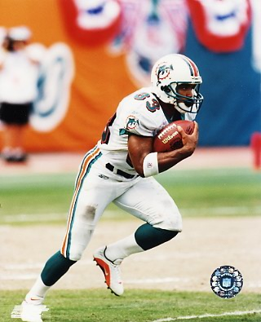
Albert Johnson - Wide Receiver
Hometown: Houston, Texas
College: Southern Methodist University
Experience: 4 seasons in the NFL

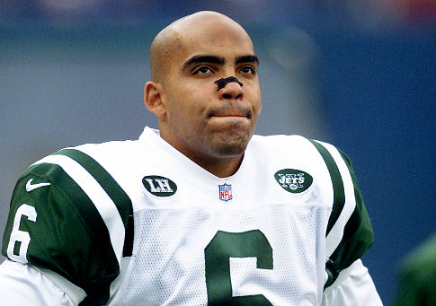
Ray Lucas – Quarterback/Wide Receiver
Hometown: Harrison, NJ (Harrison HS)
College: Rutgers University
Experience: 8 seasons in the NFL

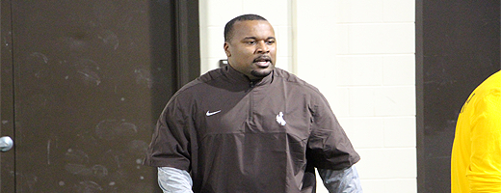
Jamar Cain - Defensive Line Coach
Hometown: Sacramento, California
College: New Mexico State University
Experience: 10 seasons coaching the
defensive line

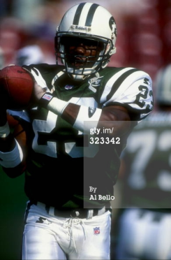
Kevin Williams – Defensive Back
Hometown: Pine Bluff, AR
College: Oklahoma State University
Experience: 5 seasons in the NFL

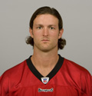
Chas Gessner – Wide Receiver
Hometown: Washington, D.C. (Our Lady of Good Counsel HS)
College: Brown University
Experience: 5 seasons in the NFL
1 season in NFL Europe
2 seasons in Arena Football League
2 seasons in United Football League

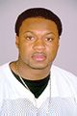
Ty Talton – Defensive Back
Hometown: Beloit, WI (F.J. Turner HS)
College: Northern Iowa
Experience: 2 seasons in the NFL
1 season in XFL

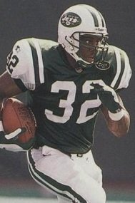
Leon Johnson – Running Back
Hometown: Morganton, NC (Freedom HS)
College: University of North Carolina Chapel Hill
Experience: 8 seasons in the NFL

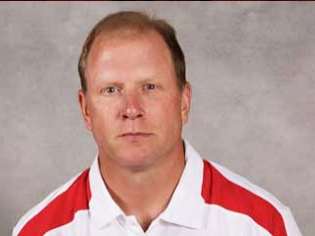
Pat Perles – Linebacker / Assistant Coach
Hometown: Detroit, MI (Upper St Clair (PA) HS)
College: Michigan State University
Experience: 4 seasons in the NFL
6 seasons in the CFL
11 seasons in College

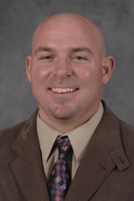
Andrew Follett – Coach
Hometown: Nebraska
College: Wayne State
Experience: 13 seasons coaching Wide Receivers, Running Backs and Quarterbacks

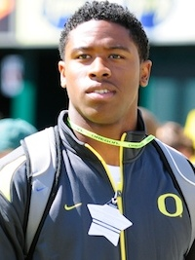
Christian French – Defensive End
Hometown: Cedar Rapids, Iowa
College: Oregon
Experience: 2 seasons with Oregon

