The ABCs of Screen-Free Time at Home
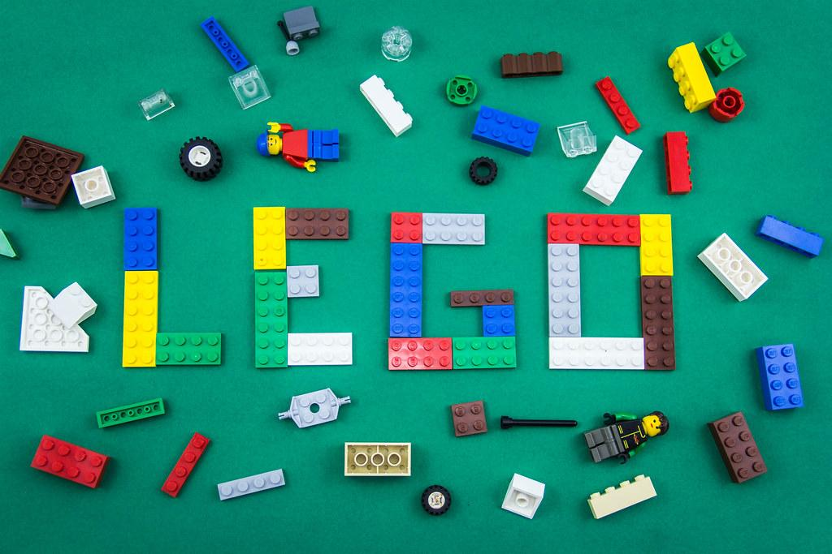
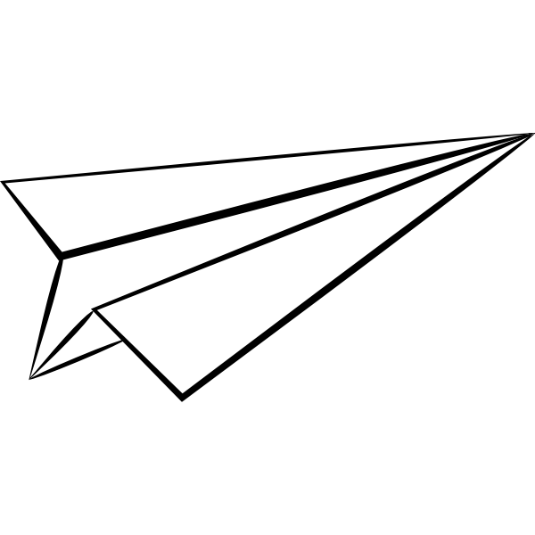
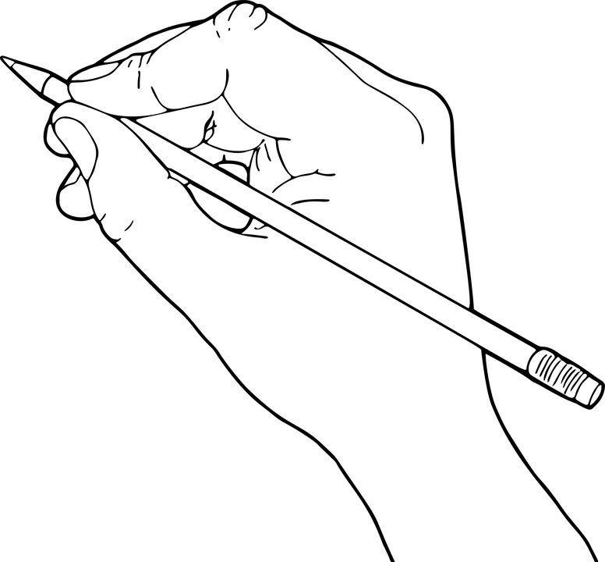
Airplane fun! Using the same type of paper, build three different paper airplanes. Test them to see how far they fly. | Build with Legos, Magna-Tiles, or Marble Maze. | Call a relative and interview him/her. | Draw your favorite book, toy, or stuffed animal.
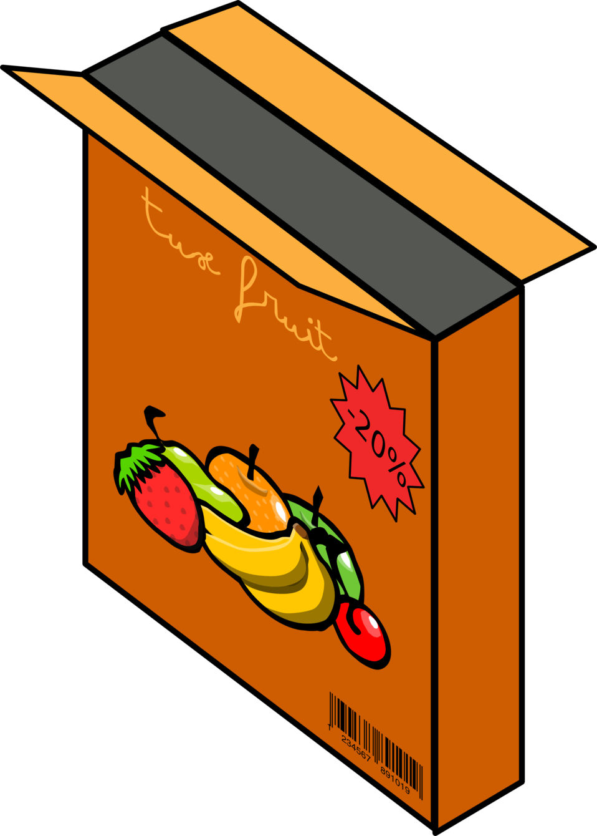  Explore the kitchen pantry. Pick 10 items (cereal, soup, pasta), and write down the states in which they were manufactured. | 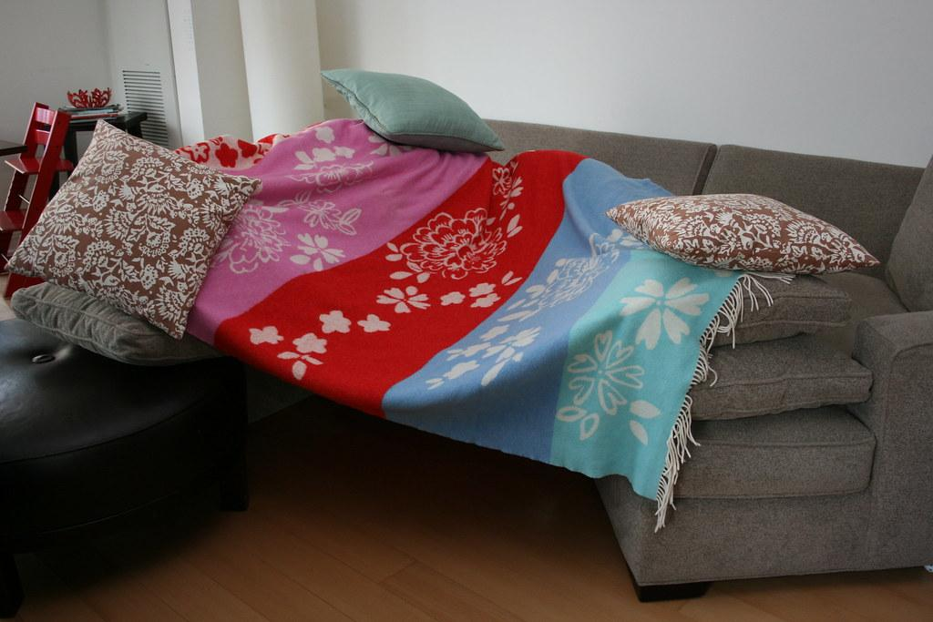  Fort building! Build a fort using blankets or sheets. Grab a flashlight, and read in your fort for fifteen minutes. | 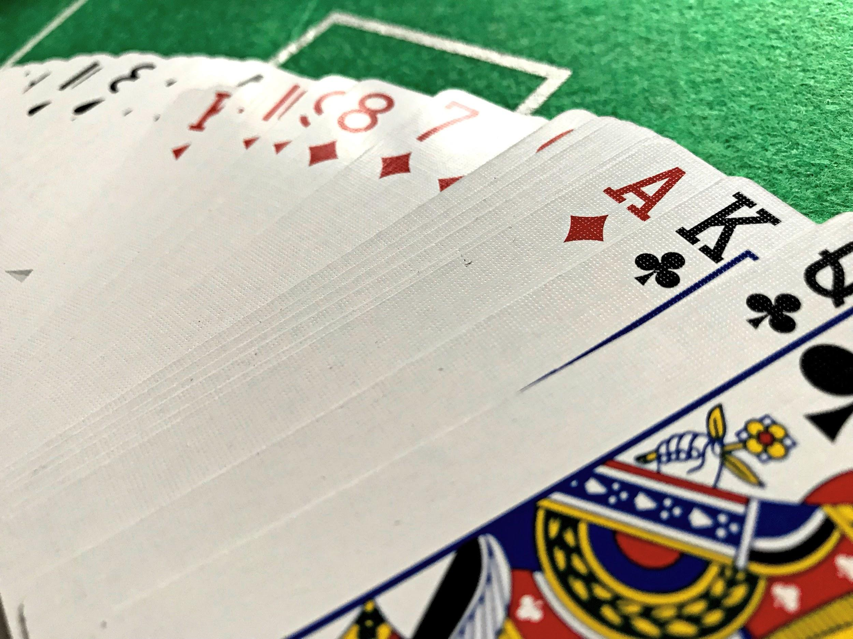  Go play a board game or a card game. | Help put a smile on someone’s face! Write, address, stamp, and mail a real letter to a relative, a friend, a teacher, etc.
Imagine, create, and fly a flag that tells the world about you. | 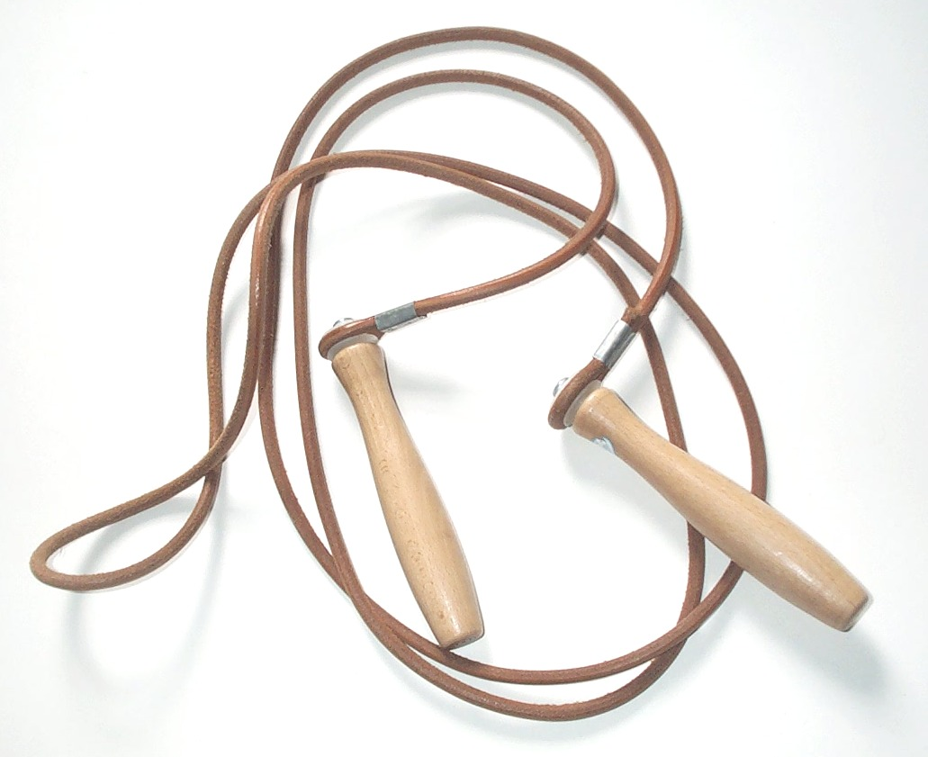  Jump rope for 10 minutes. Challenge yourself to create a jump rope routine to your favorite song. | Kinetic sand, Play-doh, and slime time! | Listen in silence for 10 minutes, and write down every sound you hear.
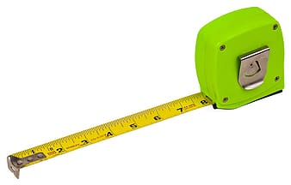  Measure the perimeter of three rooms in your home. | Need a laugh? Learn and perform three jokes. | Obstacle course challenge! Design a course throughout your home (going up/down stairs, crawling under tables, etc.). | Put together a puzzle.
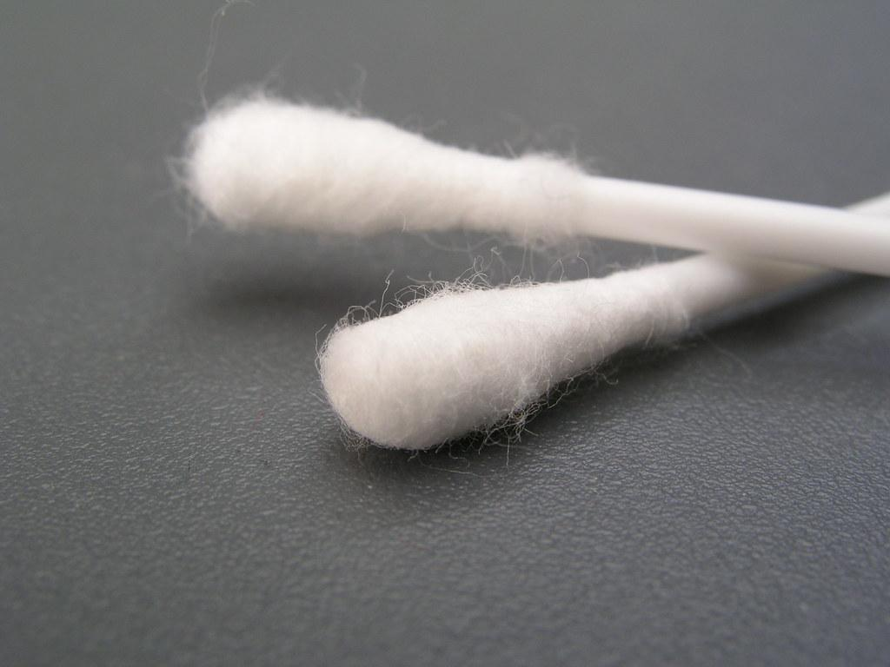  Q-Tip paint! Use Q-Tips to paint a picture. Recreate the picture using paint brushes. Compare your two paintings. | Research and perform three magic tricks. | Sticker art! Use stickers to create a picture. | 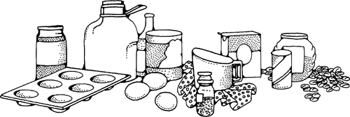  Try your hand at baking (with an adult)!
Use household materials to make and play an instrument. | Vacation time! In your journal, describe the next vacation our family should take. | Write with chalk. | 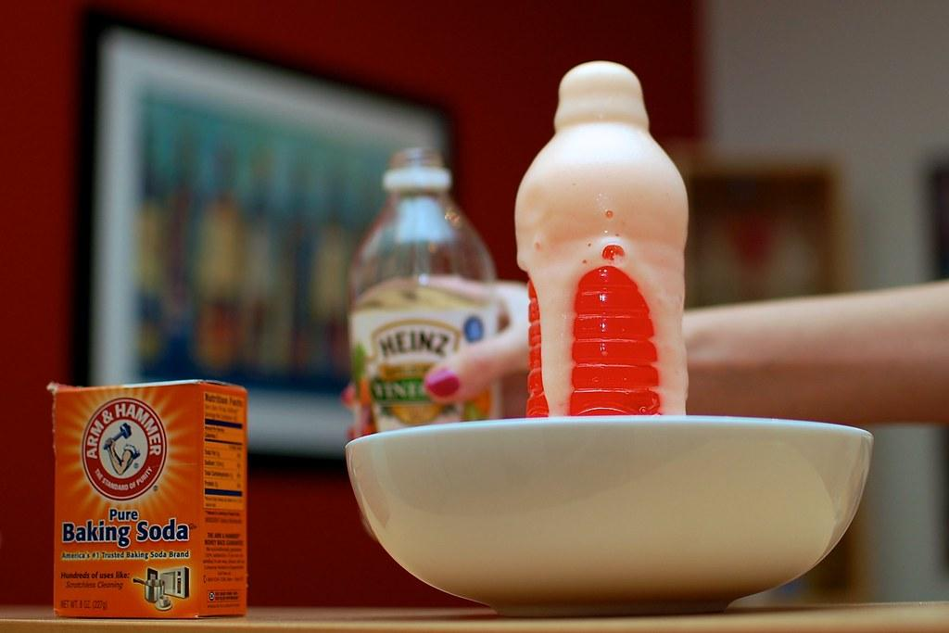  eXperiment with baking soda and vinegar. Pretend to make a volcano erupt!
Your challenge is to make a parachute for a small character. You can only use a coffee filter, a paper/plastic cup, string, tape, and a small character. |  | 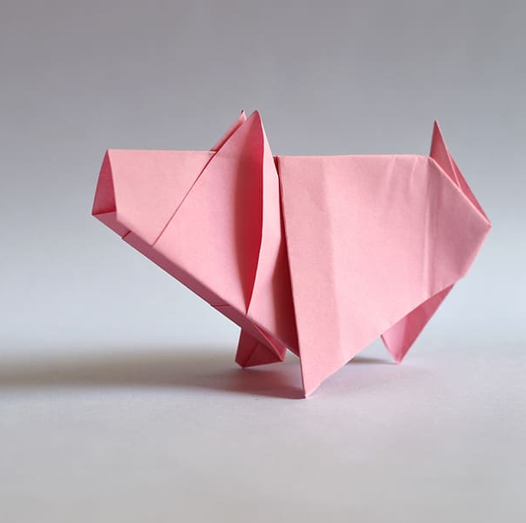  Zany zoo animals! Using one piece of paper, fold each corner in, and then fold the paper in half. It will stand up. Cut an oval or circle shape out of the paper on the edges of the “feet.” Use paper, foam felt, yarn, glitter, and anything else you can find to create eyes, a head, tails, fins, horns, a beard, etc. Give your animal a name.

