New Zealand Pygmyweed

Crassula helmsii
Origin: Tasmania / New Zealand
Route of introduction: Introduced through the aquatic plant trade, sold as an oxygenating plant for ponds and aquaria even though it ends up doing the opposite.
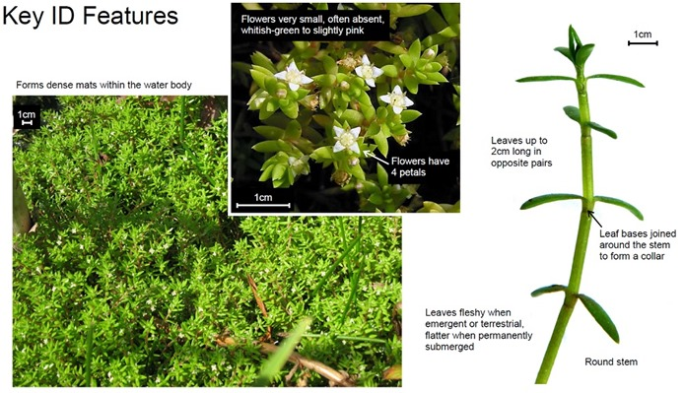
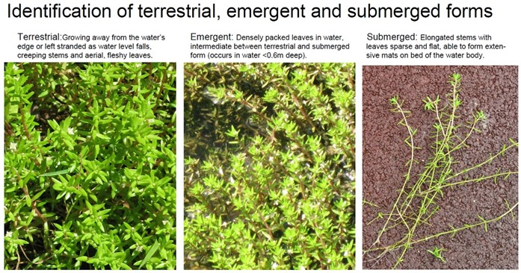
Small perennial which forms dense mats on the waters surface or on damp adjacent ground. Grows in still or slow-moving water up to 3m deep as well as on the surrounding damp ground. Can tolerate a wide range of climatic conditions surviving long periods or drying and frost. Grows year round with no dormant period.
Stems: up to 30cm long with roots frequently along them. Stems can emerge onto the surface, remain submerged in deeper water or creep on damp ground
Leaves: arranged in opposite pairs along the stem, light green in colour and small usually 4-15mm long.
(linear or only slightly widened, pointed, fleshy, stalk-less, and fused together at the base where each pair joins the stem into a 1mm ‘collar’ around the stem.)
Flowers: small white flowers with four petals on single stalks up to 8mm long.
Seeds: n/a spreads vegetatively from tiny fragments which can break off easily.
Not to be confused with:
Native water-starworts Callitriche spp. Distinguished by the notched or spanner-shaped leaf tips. Blinks Montia Fontana which has fatter leaves which are elliptical or paddle shaped. Waterworts Elatine spp. Which also have elliptical or paddle shaped leaves. Native pygmyweed, Crassula aquatic, stems are only up to 5cm long and leaves only up to 5mm long and flowers are stalk-less.
Impacts
Biodiversity: forms dense mats which cause shading and outcompete all other aquatic vegetation where it occurs, grows rapidly and may cover 100% of surface area of the infested water body. Severe oxygen depletion occurs in infested water bodies causing native plants and animals to be eliminated. It has been shown to reduce the breeding success of protected great crested newts.
Amenity: dense mats cause blockages of drainage systems and can impede flow increasing flood risk. The floating mats are dangerous as people and animals may mistake them for solid ground. The recreational value of water bodies infested with Crassula are often reduced due to the dense coverage impeding free movement.
Control
Chemical: control using glyphosate herbicides are the only option. It is applied to the emergent material on the bank or in the water as long as it is dry. Treatment is carried out from April to the end of Nov when the majority of the plant is emergent.
Manual: shading out using jute matting. As it is quite shade tolerant the shading material must be in place for at least 8 weeks and up to 6 months.

