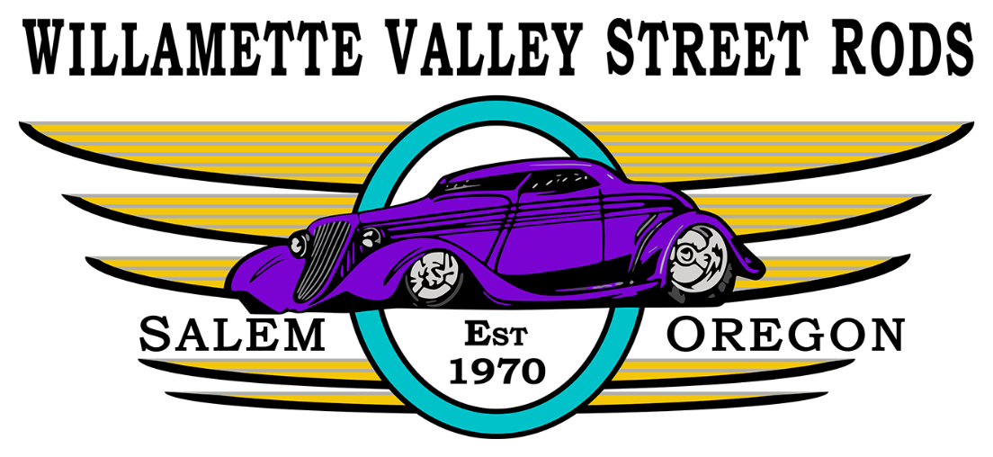
WVSR Carousel Cruise Sponsor Form
August 29, 2026

$150 – CARBURATED LEVEL - YOU WILL RECEIVE: Business name on event flyers & posters, in WVSR monthly newsletter (12 months), link on WVSR website (12 months), and Company name, service or product mentioned by the DJ multiple times during the event.

$300 – FUEL INJECTED LEVEL - YOU WILL RECEIVE all of the above, plus 1 Trophy awarded with your business name on it and a 10x10 booth space (w/o table)

$500 – TURBOCHARGED - YOU WILL RECEIVE all of the above, plus one more trophy with your business name on it, and a 10x20 vendor booth space (w/o table)

$1,500 – NITROUS LEVEL - YOU WILL RECEIVE all of the above plus one more trophy and headline all event flyers, posters, and apparel. (Only 1 Nitrous level sponsorship available)

___ Add or increase vendor space by 10x10 $50.00 or 10x20 $75.00
___ I have a banner to display (On Front St. fence up to 7 days prior to the show.) Pick up date? __/__/___

Contact: Angela Myers 503-884-9679 Sponsor Chair or Janet Darcy 541-990-6962 Show Chair
Proceeds from this event benefit:
Family Building Blocks, Honoring Heroes, NWCMM Speedster Program, Salem Carousel

YOUR BUSINESS NAME: __________________________________________________________

Contact Name & Number: __________________________________________________________

Mailing Address: _________________________________________________________________

Please make check payable to “WVSR” and mail to P.O. Box 4091, Salem, OR 97302 or reach out to Angela Myers, Sponsor Chair at 503-884-9679 or Janet Darcy, Cruise Coordinator at 541-990-6962
- - - - - - - - - - - - - - - - - - - - - - - - - - - - - - - - - - - - - - - - - - - - - - - - - - - - - - - - - - - - - - - - - - - - - - - - - -

Willamette Valley Street Rods is a 501(c)(7) non-profit organization and can be contacted at:
wvsrhq@gmail.com
Tax ID #93-1224654
THANK YOU FOR YOUR GENEROUS SUPPORT!

