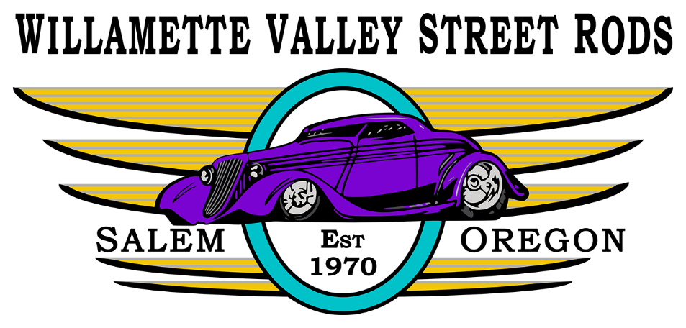
VENDOR FORM
WVSR Carousel Cruise August 29, 2026 at Riverfront Park, Salem OR
Name of Business:________________________________________________________________
Services or item(s) to offered:
________________________________________________________________________________
Contact person: __________________________________________________________________
Address:_________________________________________________________________________
Phone:_________________________Email:____________________________________________
Choose Space Size:
___10x10 = $60
___10x20 = $80
Mail payment to: WVSR, PO Box 4091 Salem, OR 97302 Amount enclosed $_________
For more information Contact Janet Darcy at 541-990-6962
By signing this release form, I agree to the following terms:
- Setup time is Saturday 6-7am. Tear down, clean up, and exit from the park will not be before the show ends at 3 pm unless pre-approved.
- Event is held rain or shine and fees are not refundable. Fees from no shows go to WVSR charities.
- Payments must be received by July 1st, 2026 to secure space.
- Generators will be placed behind and as far away as possible from the space.
- I discharge Willamette Valley Street Rods and anyone connected with the management of this Event, from any and all damages, losses, judgments, or claims sustained by them and/or their vehicles or personal property.

X_______________________________________________________________________________

