
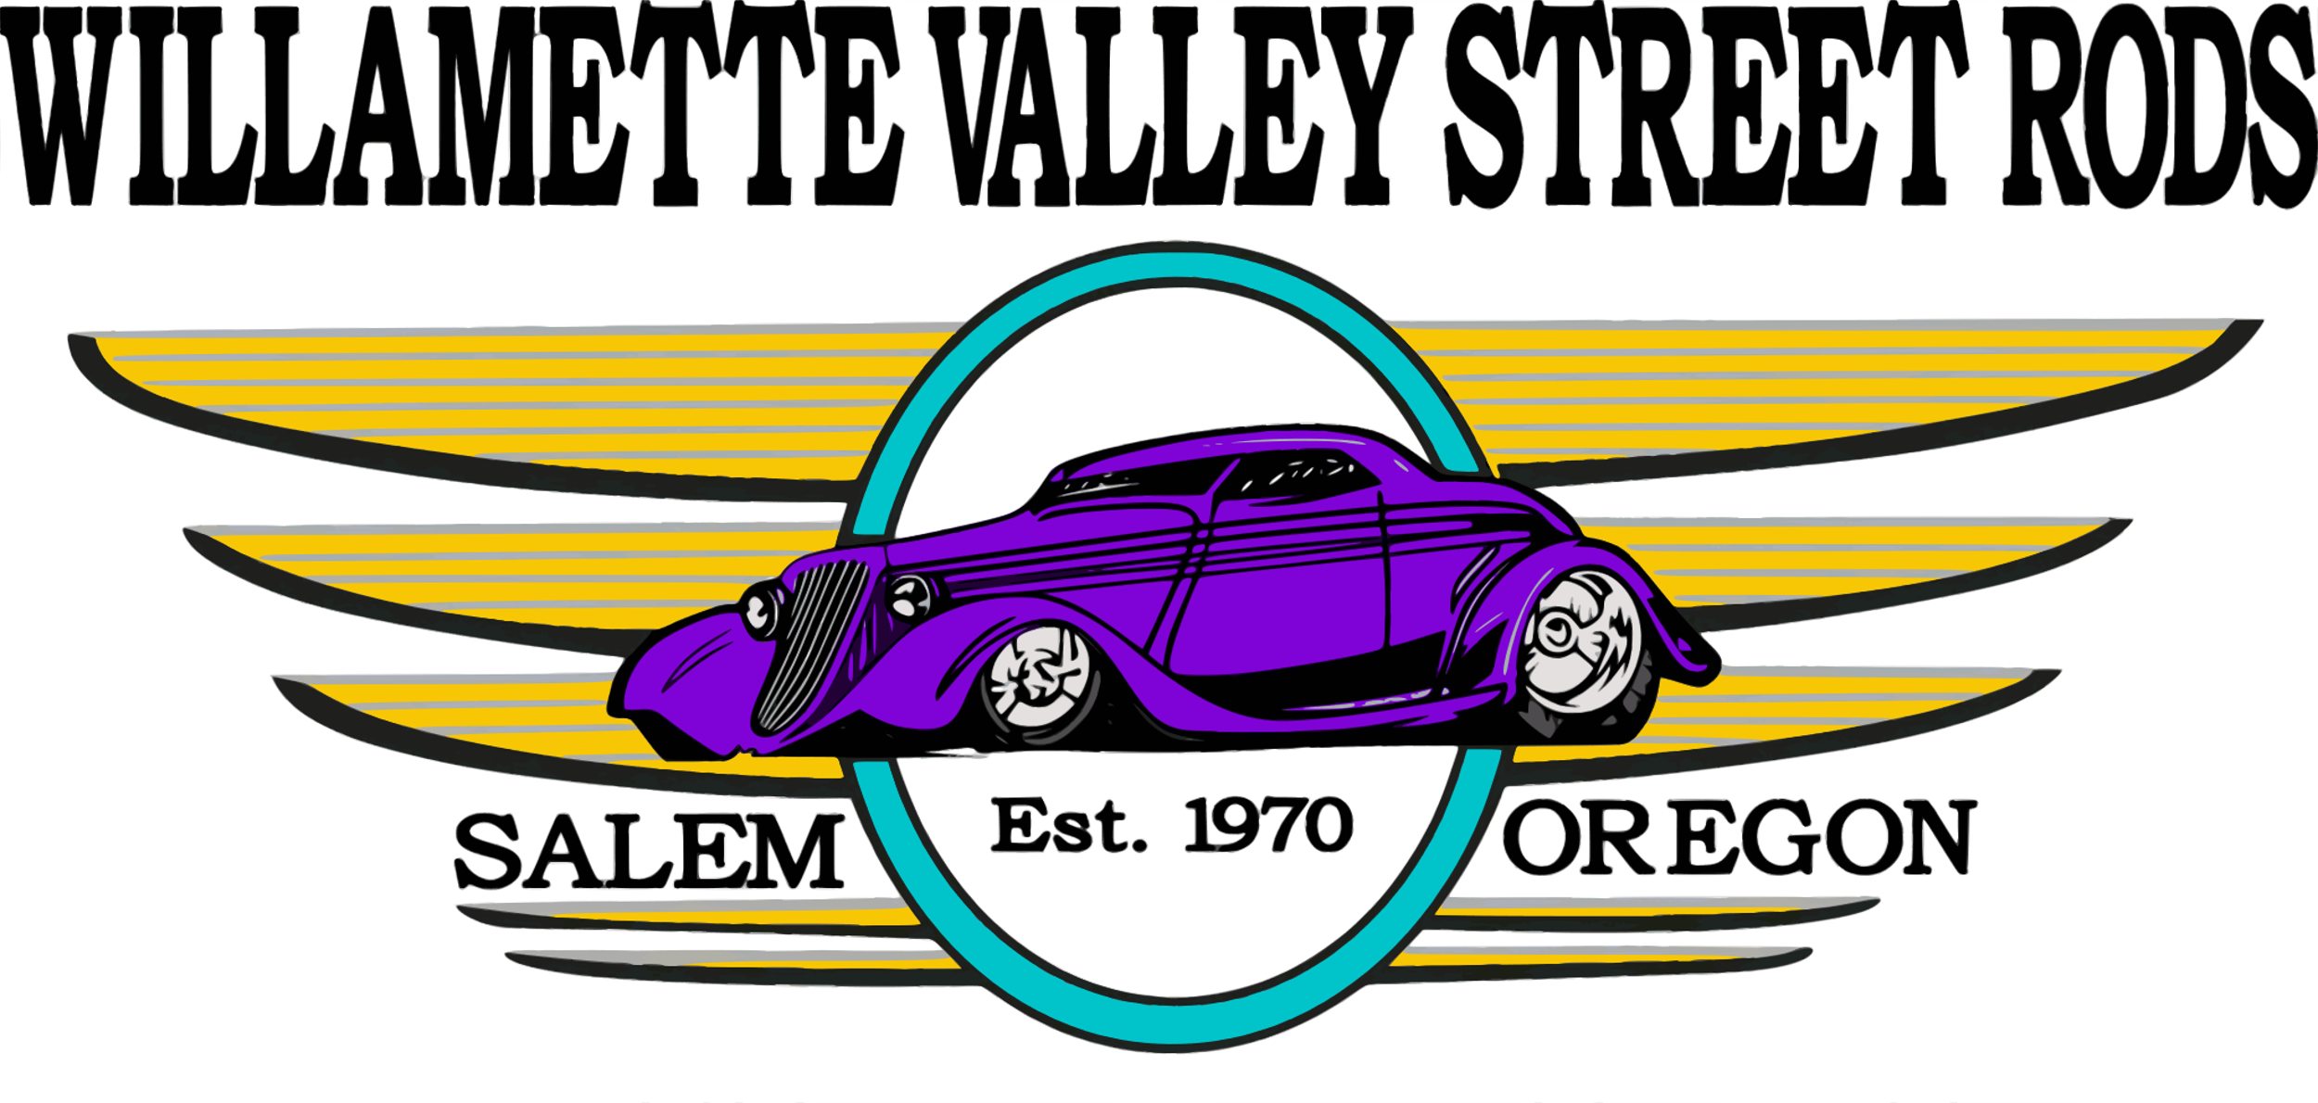
CRUZ’N NEWS JULY | 2025

MEETINGS

Club Meeting – 7/1
7:00 PM – All Welcome
Pietro’s Pizza in Salem
6:00 PM Food & Conversation

Officer Meeting 7/29
6:00 PM – Members Only
All Good Things - Aumsville

A 4th of July Tribute to Hot Rodding

This Independence Day, as we celebrate the liberties we cherish, we also salute the gearheads who keep the rebel spirit alive with every rev of an engine. Because in America, freedom isn’t just an idea—it’s a way of life.

Hot rodding has always been more than just a hobby—it’s a declaration of independence on four wheels. It’s about taking the ordinary and making it extraordinary, defying factory limits, and building something that’s yours alone. Like the Founding Fathers who refused to accept the status quo, hot rodders push boundaries, forge their own paths, and create rolling works of art that roar with personality.

Each custom build is a reflection of personal freedom: freedom to design, to innovate, and to express. Whether it’s a chopped '32 Ford, a blown muscle car, or a slammed truck, hot rods embody the same values America was built on—freedom, individuality, and the pursuit of something greater.



JULY COOKIE SUPPLIERS

Gloria Blair, Pat Coffey, Joel Memmott, Casey Boehmer

Please consider signing up to bring 2 dozen cookies to the monthly meeting.

﻿It was a great day for the Boone Ridge Car Show! The temperature was perfect which brought out more than 80 cars, many of them being WVSR members! It’s always nice to see so many smiling faces on the residents as they walk through the show. I had a number of residents stop to talk about childhood cars they remember in their lives. What a great way for our club to help with those memories. – Bob Repine

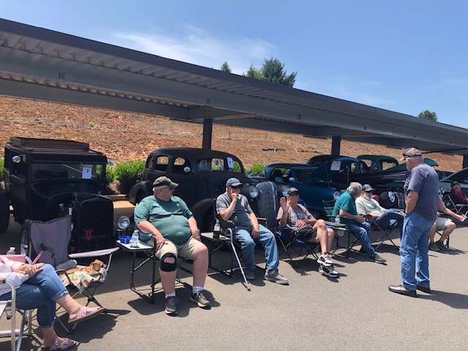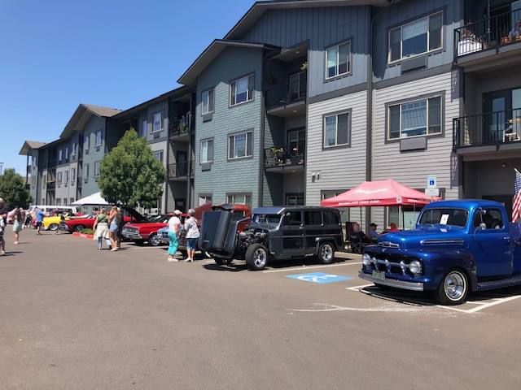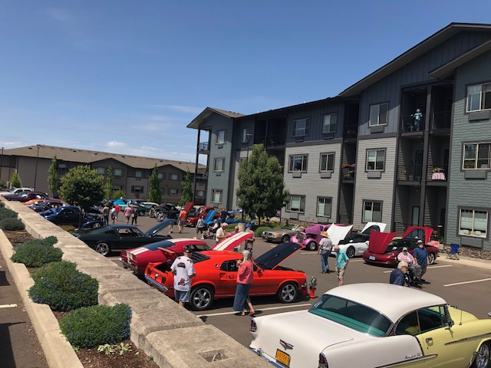


4 Penny Erickson, Bettye Hunt
6 Jay Lawshe
9 Yvonne Sanders
11 Jeff Fawcett, Tom Gates, Ken Marshall
17 Dwayne Haines
18 Jay Miller
19 Gloria Blair
20 Sam Pietzold
24 Pat Coffey
26 Jesse Greene
30 Aaron Reed

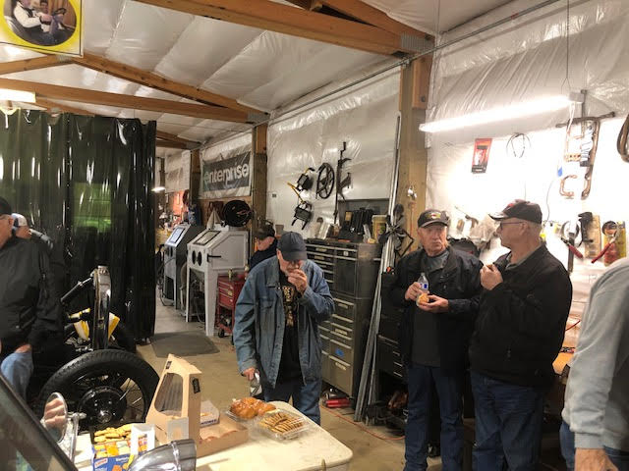
WVSR SPEEDSTER PROGRAM VISIT

While the weather was a little challenging, we had a nice turn out of WVSR members for our, now annual, visit to the Speedster Program out at the NW Auto and Motorcycle Museum at Powerland Heritage Park. Club members had the opportunity to see the rolling racks that were purchased this year by the Club. Gary Dennis, lead mentor, for the program, shared updates with WVSR members on this year’s activities with the students. Plenty of treats were brought by members to share and I think everyone enjoyed the visit!

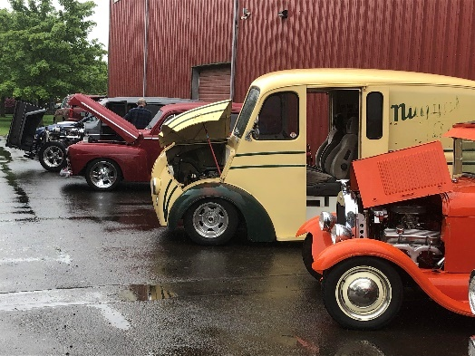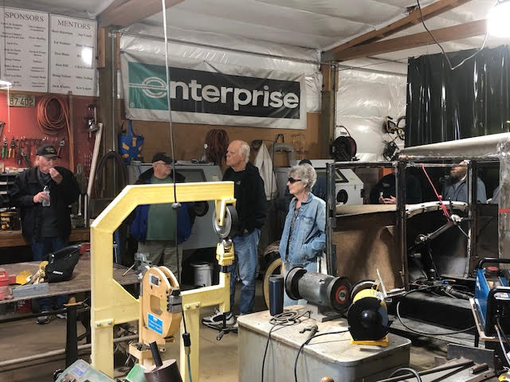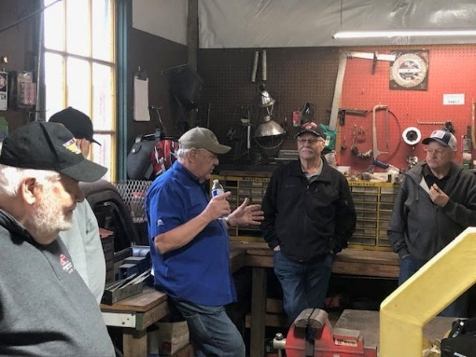

Bob Repine, Grant Program Chair

Please keep the following members in your prayers and thoughts as they become bionic!
Laurie Winslow – Hip surgery
Don Flamming – Knee surgery



Cascade High School Car Show

WVSR GEAR STORE OPENING SOON!

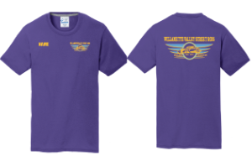
Look for another gear store to open starting July 3rd, a link will be provided when it opens. This time around we’ll have several choices of shirts and hoodies with the WVSR logo front and rear plus an option for your name. The minimum number of orders was raised to 36 articles in an attempt to keep prices a tad bit lower. Don’t forget we wear purple club shirts at the Carousel Cruise to make our club members easily identifiable to participants. Items purchased will be available at the August club meeting, if you can’t make it then send a message to wvsrhq@gmail.com need to make other arrangements to receive your gear.
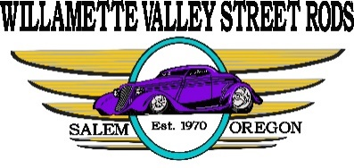
By-Laws Update: With the current political climate we want to ensure the information provided to our club members is accurate and relatable, now and into the future. With that in mind we’ve added to our by-laws some basic standards before discussing anything ‘political’ at general club meetings.

Section 1.04 Non-Profit Status and Political Activities

- WVSR currently has a 501(c)(7) tax exempt status as a social or recreational club under the IRS code that allows participation in political events, such as rallies, debates, and fundraising events, as long as it does not directly support or oppose a specific candidate.

- While individual members are free to engage in political activities, they cannot do so as representatives of the club.

To ensure the club's and its members' best interests, any information or activities deemed "political" must follow these guidelines:

- Officer Review Required: Before sharing any political topics or issues at a general club membership meeting, the matter must first be presented at the earliest Officers meeting.

- Written Proposal: Individuals wishing to raise a political topic or issue must submit a written statement to the Officers. This statement should clearly describe the issue or topic and explain its relevance or importance to the WVSR membership.

- Officer Decision and Communication: After reviewing the political topic or issue, the Club Officers will determine the next steps or actions for the presenter regarding the club's general membership. These next steps will be provided to the presenter in writing within 30 days of the Officers' decision.

- Methods of Sharing: Approved next steps or actions may include, but are not limited to, future presentations at a Club General Meeting, dissemination via official club communications, or other methods the Club Officers deem necessary.

- Presenter Responsibility: The individual(s) presenting a political issue will be responsible for keeping Club Officers updated on the issue or topic until its conclusion or final action.
W

Once again the Salem Auto Club Council was contacted to provide volunteers to work at the two-day MotorSport Auction Group auction at the Oregon State Fairgrounds the first part of June. We reached out to all of the SACC car clubs for workers and a few well known car guys who don’t belong to a club and almost everyone that worked at the 2023 auction
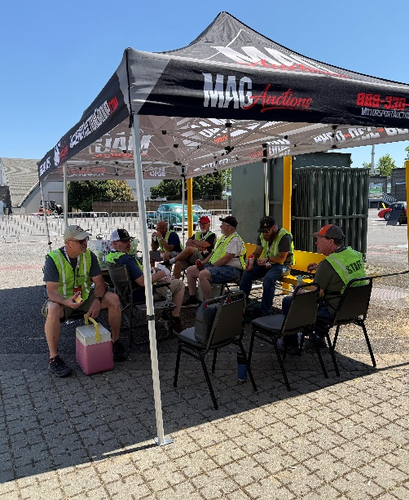
jumped at the chance to do it again. On auction days our volunteers drove all of the vehicles across the auction block making it a great opportunity for everyone to drive a vehicle they’ve always wanted to.
We did have some excitement when someone was dropping off their beautiful
classic Buick with 72,000 original miles on it. While it was outside waiting to be checked in the owner of an older pick-up sitting in front of the car got out and left it running. The pick-up started rolling backwards at a pretty good pace towards the Buick. A lot of our drivers were around but Jim Billings saw it firest and took off running and, just in the nick of time, jumped in and stopped it before it hit the Buick. We were all in awe at Jim’s quick reflexes and ability to avert what could have been a real tragedy so the next day at the daily driver’s meeting we had a little ceremony awarding Jim with a “Super Hero” cape and mask that was so well deserved. The weather was perfect this year and the auction was a success so they will
probably be back again.
– Article and Photos provided by Vicki Champ
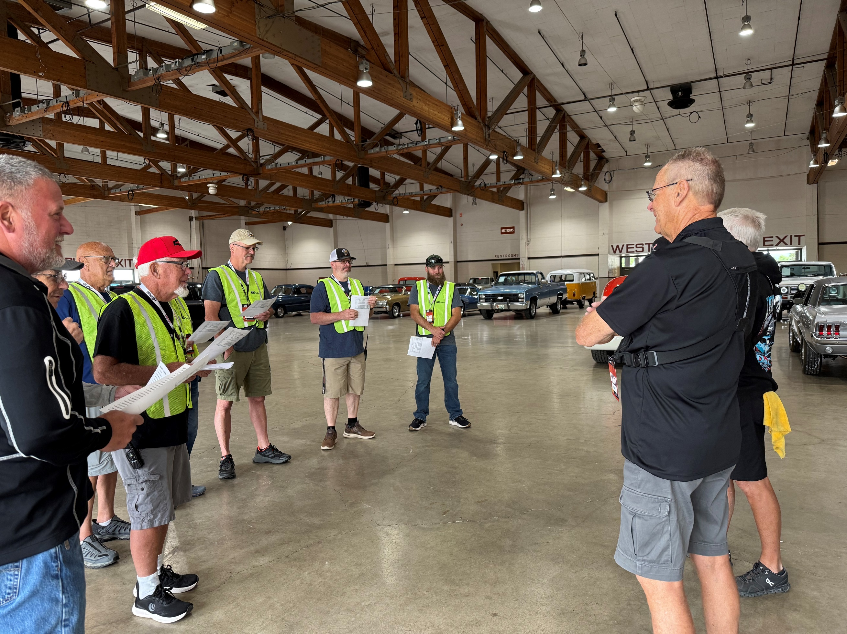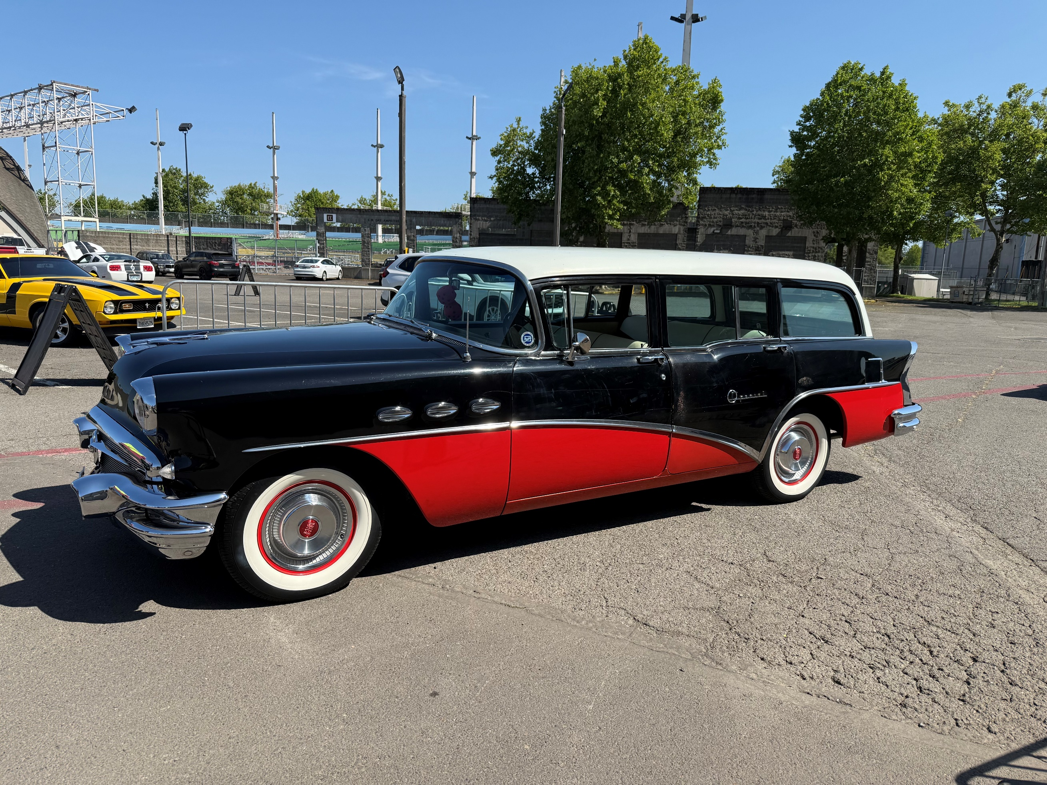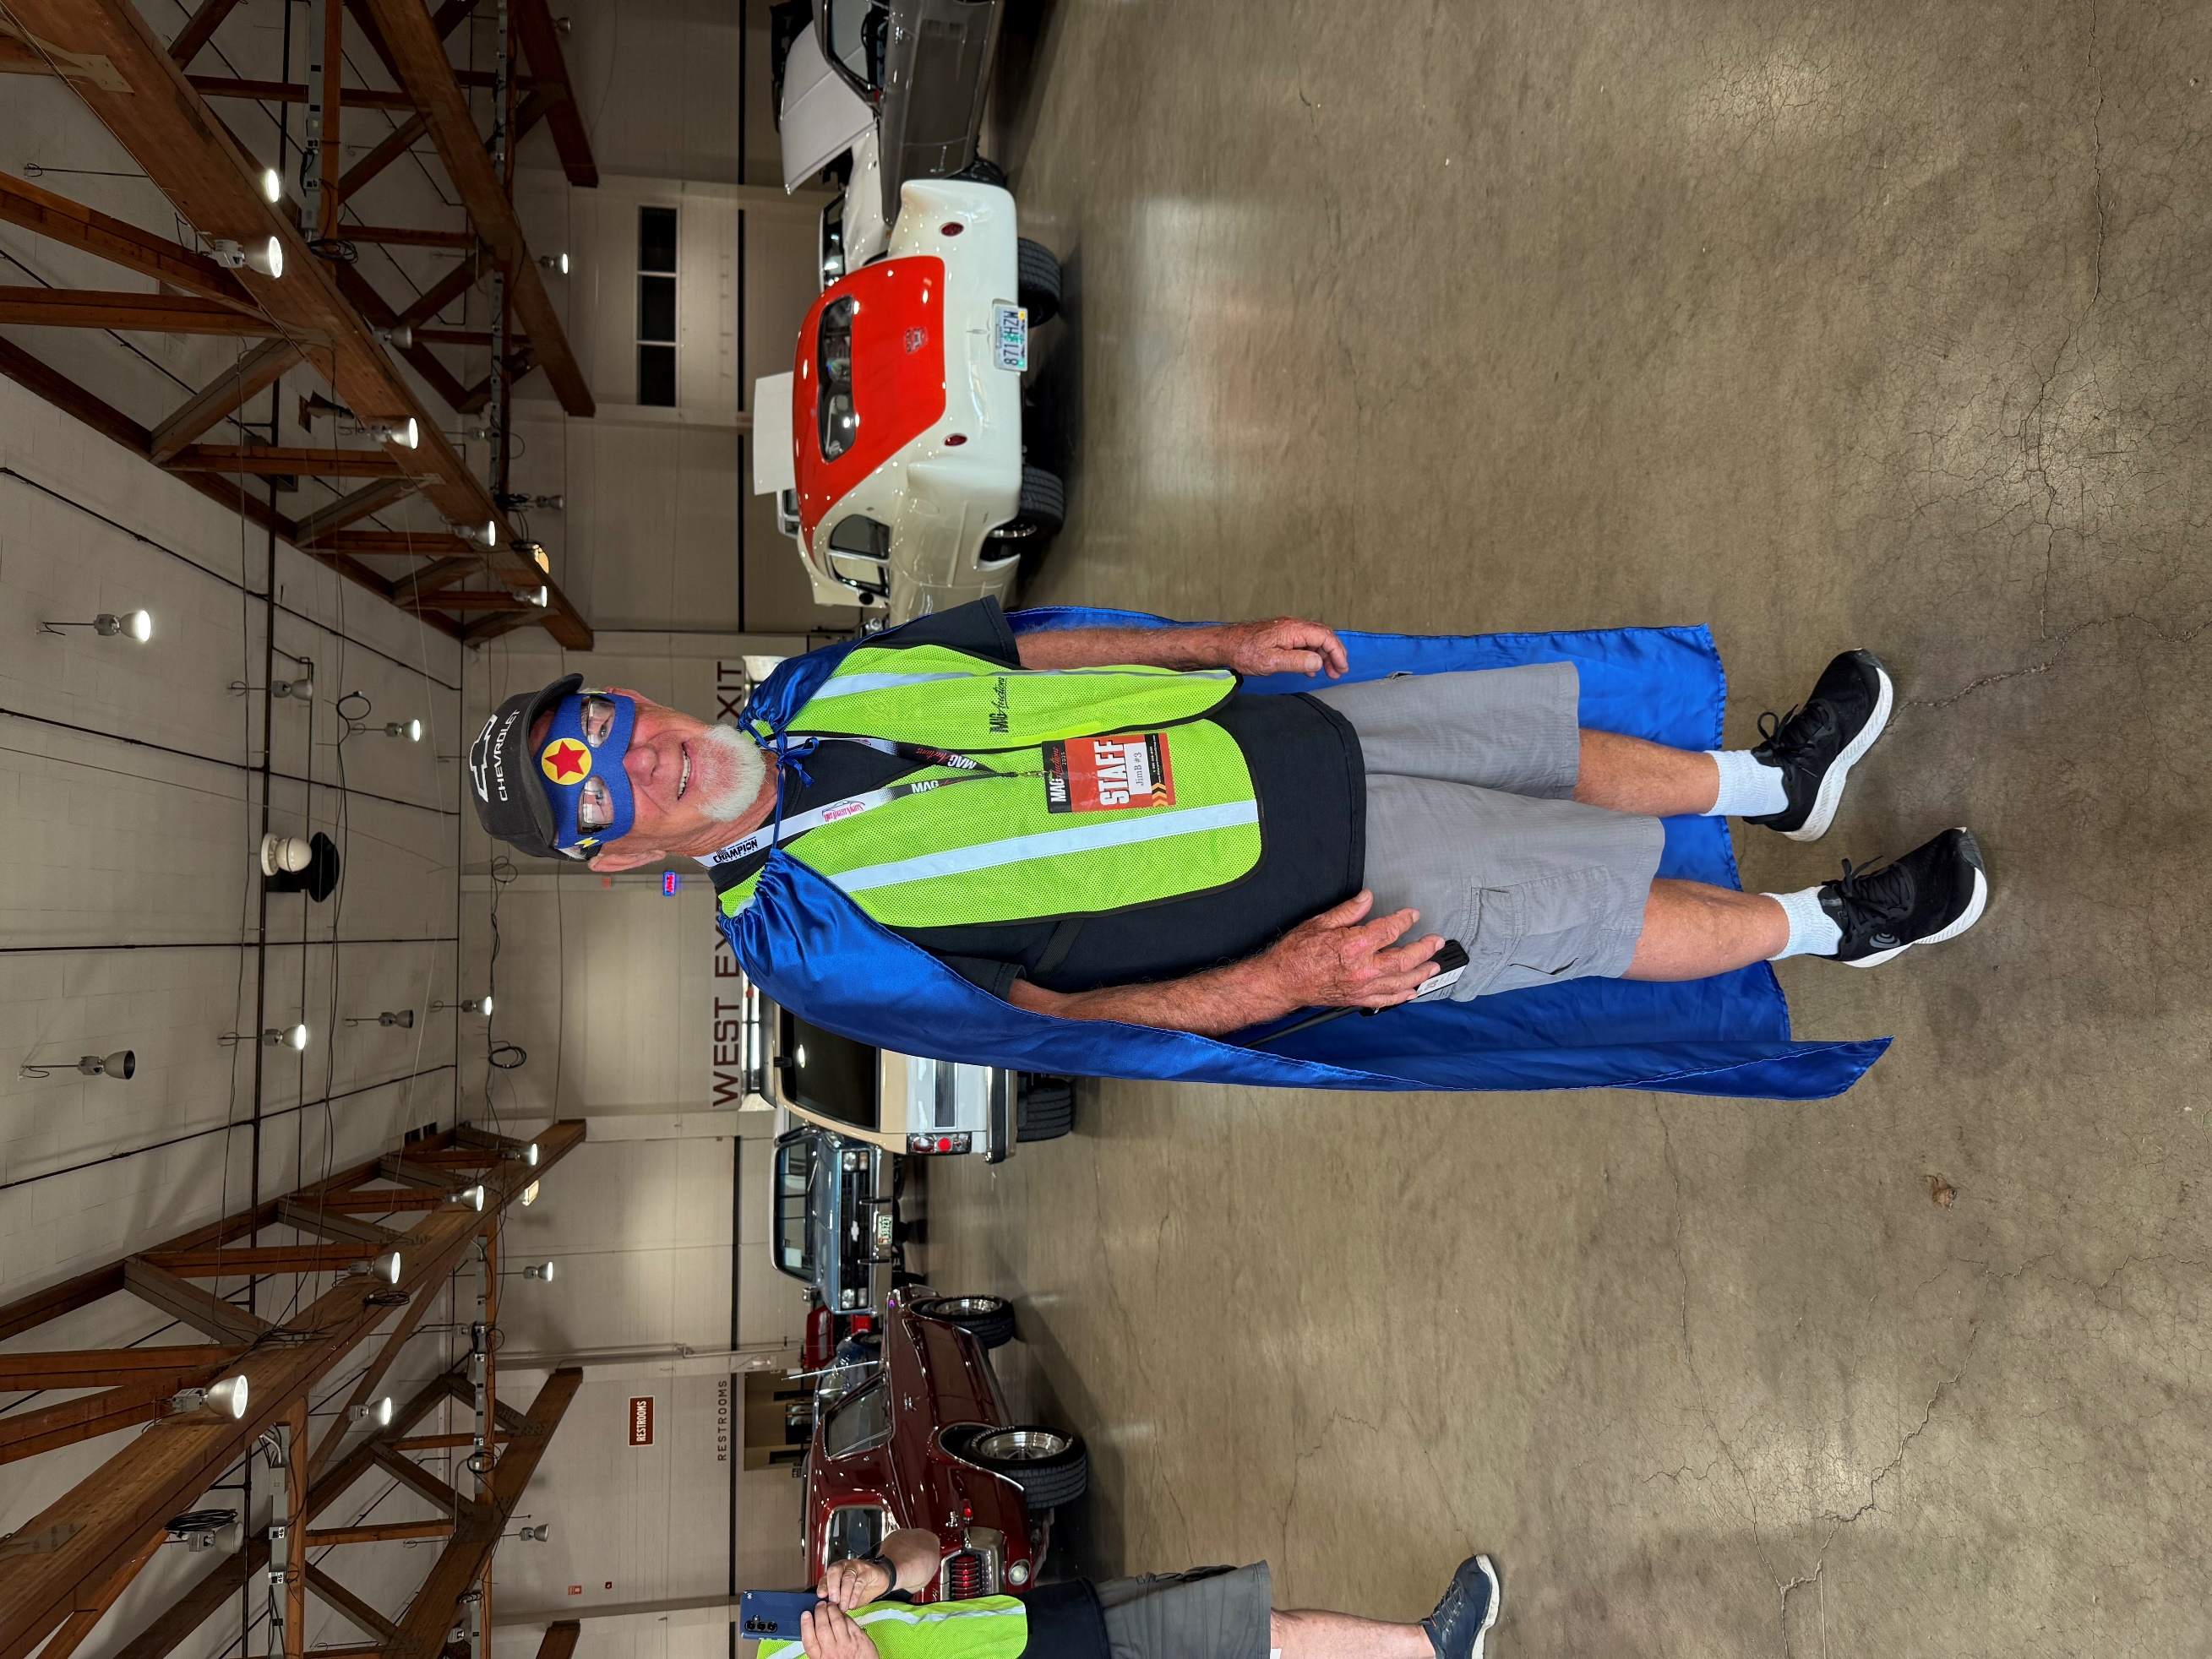

Kruise to Klamath

Russ was busy DJ’ing so Pat Coffey sent in some photos of the goings on in Klamath Falls.

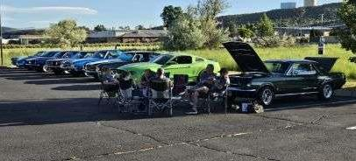
The first evening while Russ had to DJ the sock hop part of the group hung out in the hotel parking lot enjoying the weather and the company.

Friday was a series of mini events. Here are a few shots from the 4 shows at Fred Meyer, Winema Electric, Red Zone Sports Bar, & Mia’s and Pia’s Pizza.

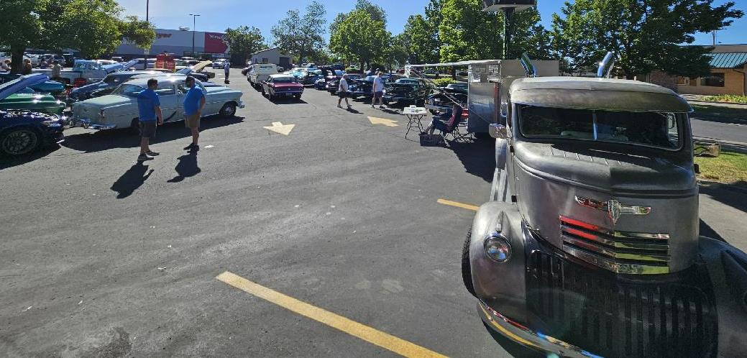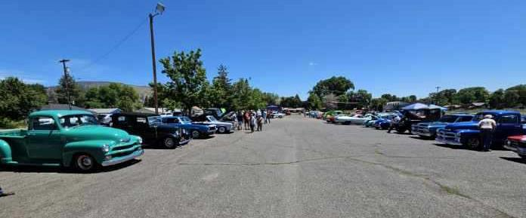
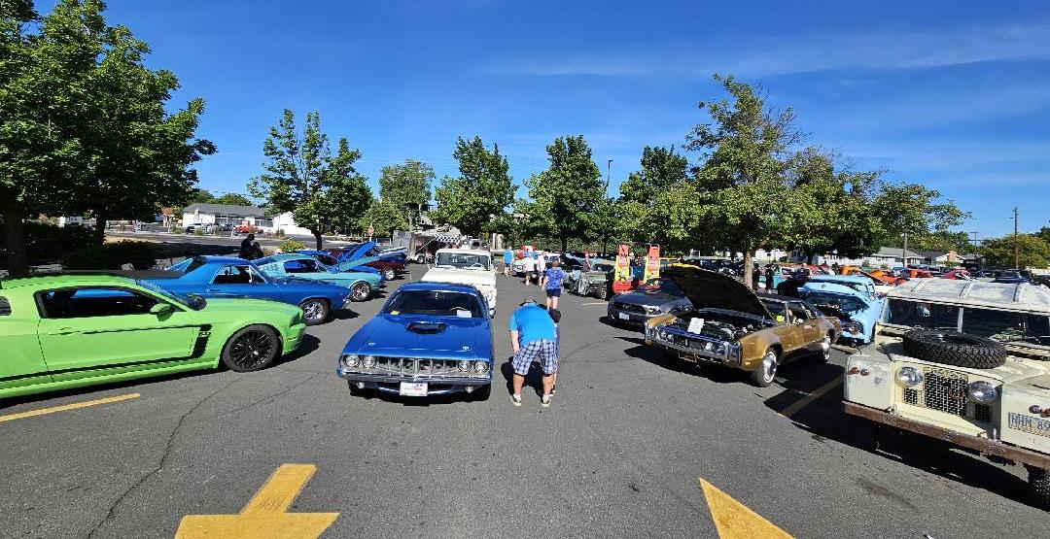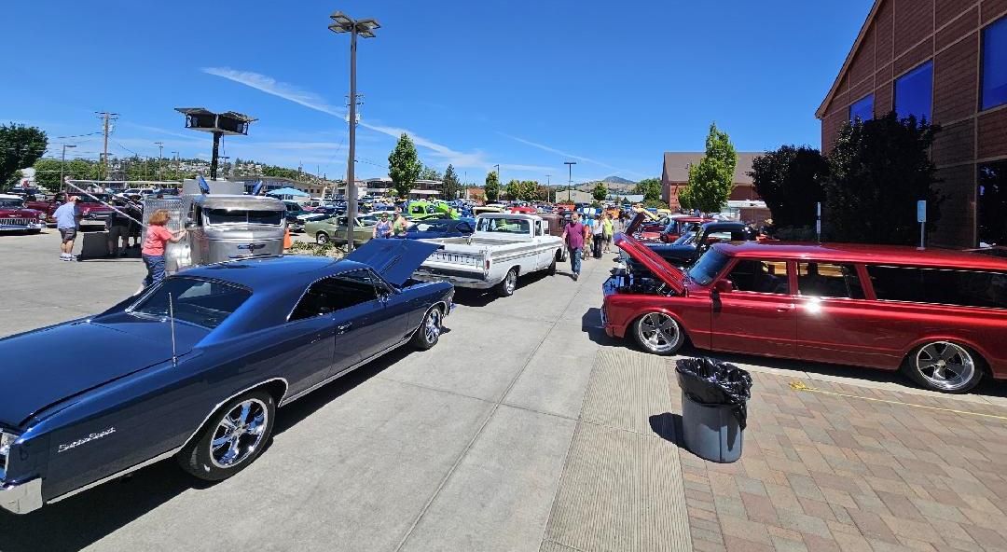

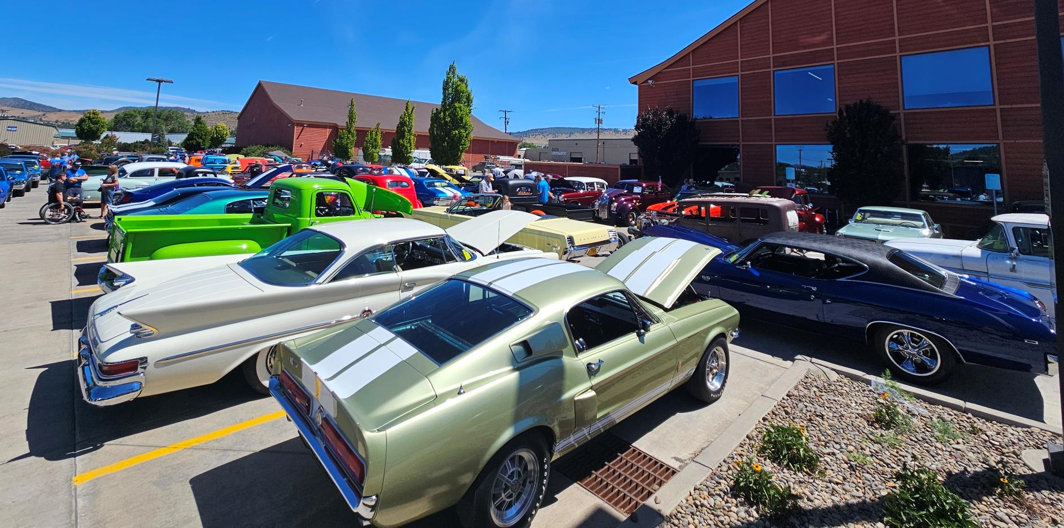

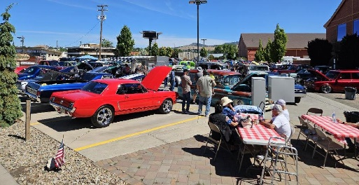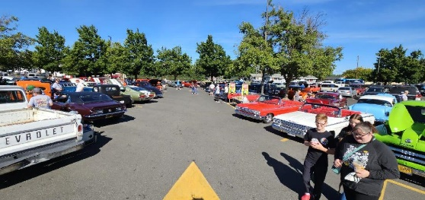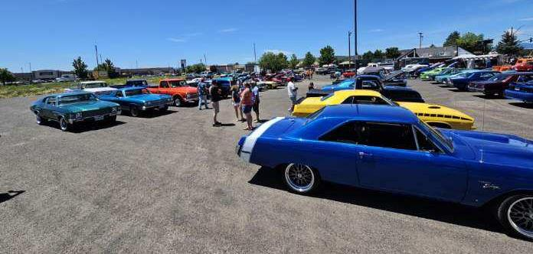

Kruise to Klamath has grown to be a very popular 4-day event that draws cars from all over. If you haven’t attended it I recommend at least going once, and with a group is so much more fun.

Rollin Oldies Thursday Night Cruise In

In front of the Grocery Outlet in Albany on Thursday nights you’ll find the Rollin Oldies hosting a Cruise In. There are some absolutely gorgeous cars and trucks that show up.

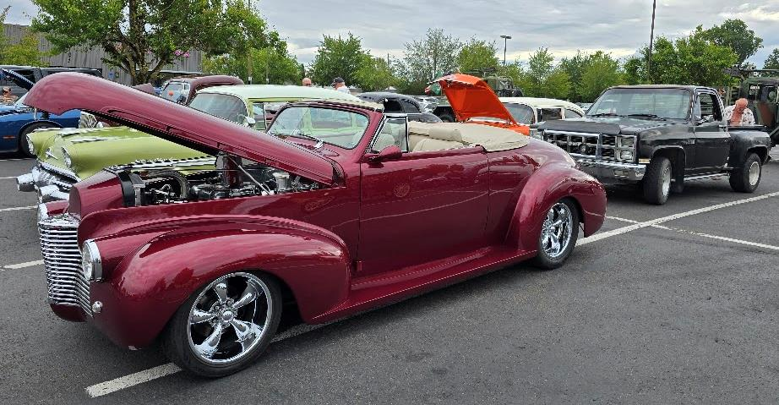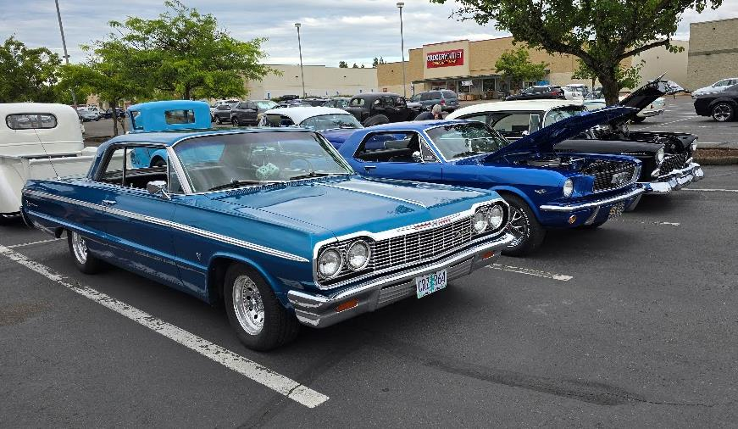

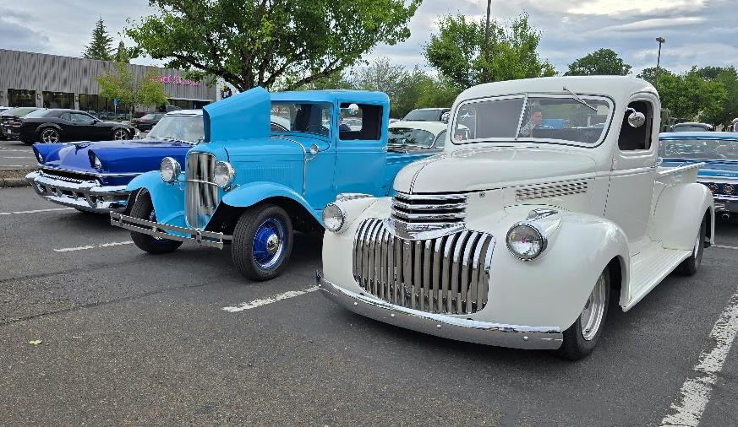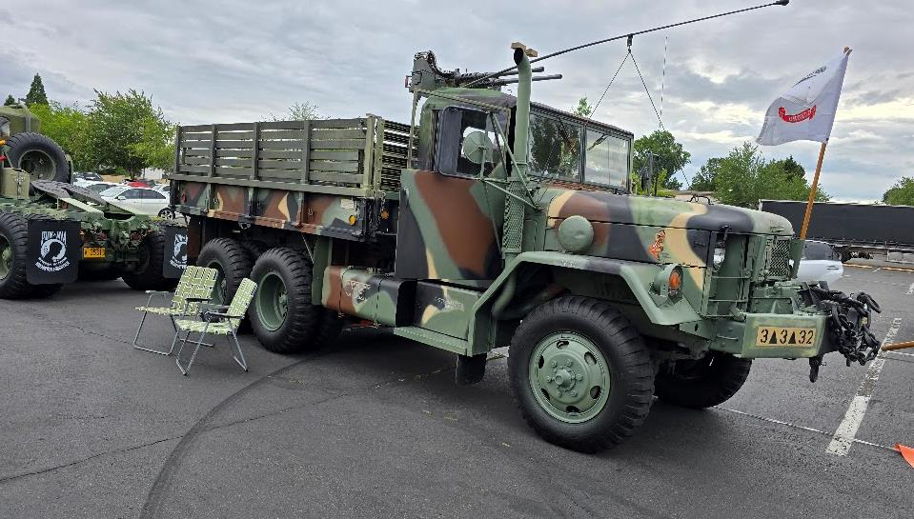

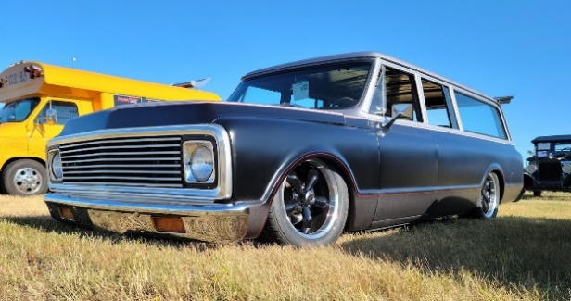

72 Suburban w/freshly rebuilt 383 stroker and 700R4 auto transmission. Vintage AC, New Airbags, runs and drive great. Contact Garry
503-507-5333. Will consider trades. $28,500

2008 Ford Mustang GT/CS Convertible
4.6L V8 5 speed w/only 56k miles
$18,000 See Ron Smith for more info RePlusRon@me.com or 503-931-7879

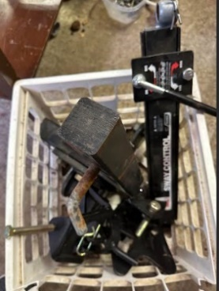
Trailer Hitch - $100 Contact Lora Baxter-King @ 503-930-5055 for more details.

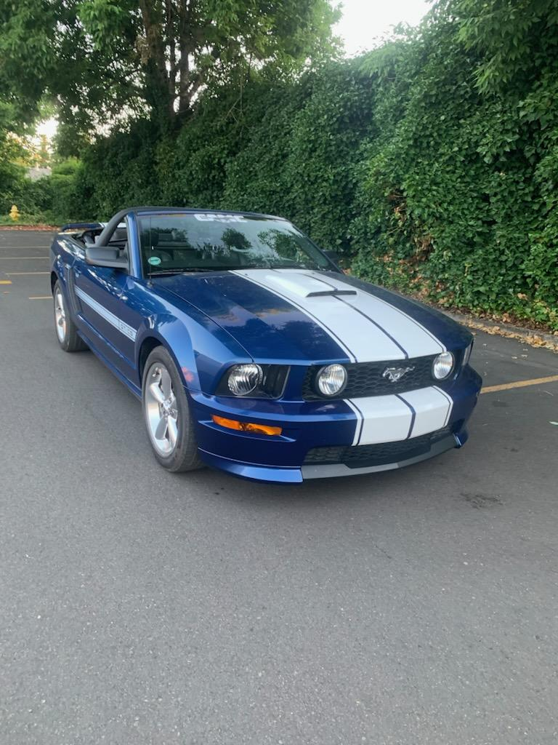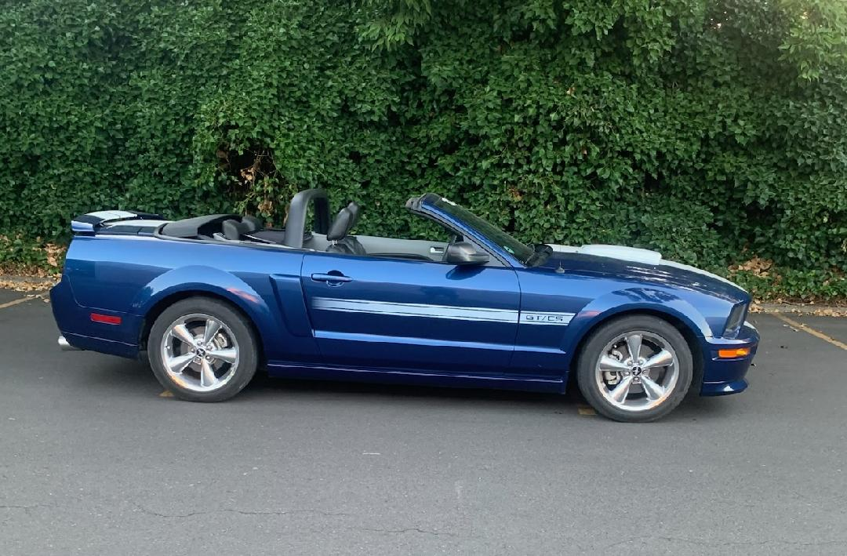

UPCOMING EVENTS

July
6: Northwest Rod and Classic, Independence OR Website9-13: Graffiti Weekend in Roseburg, OR Website
10: Cruise In & BBQ 4-7 PM @ Rosedale Friends Church on Hylo Rd. in Salem FLYER
11: Sweet Home Cut The Gut, Sweet Home, OR Website
12: 5th Annual HART Horsepower Car Show @ West Hills Stable & Vineyard. Salem, OR 8am-2pm $20 registration. Flyer
12-13: Datsun Swap Meet, Antique Powerland, Brooks OR Website
12: Donald Daze Car Show, Donald OR Website
13: Spring Hill North Albany Car Show, Albany OR Website
18: Celebrate Summer Cruise In 4:30-8PM FREE Event @ West Hills Vineyards Salem OR
19: The Bomber's Cruise 8am-1:30pm @ Keizer Lions 4100 Cherry Ave $10 FB Page
19: 19th Annual Knights of Columbus Car Show @ St. Edwards Church Keizer FLYER
19: 39th Annual Cars at the Coast in Newport OR. 8am-3pm $25 reg. Website19: Central Lane Show & Shine 8am - 2pm Eugene OR $25 reg. Website
18-19: LaGrande Classic Car Show in downtown LaGrande Visit Website
26-27: The Great Oregon Steam Up @ Powerland in Brooks OR. Website

26: Brent Strohmeyer Memorial Car Show, Sublimity OR, • Website

Save the Date: August 2nd

Let’s get out there and support Honoring Heroes annual fundraising event and have a good time doing it on a Poker Run!

I mean what’s better than a day getting to drive your hot rods with an opportunity to win cash & prizes!

Honoring Heroes does an amazing job in our community supporting veterans and supporting them is what we do.

See you out there!

2025 Contact Information (Officers in bold)
President | Russ Strohmeyer | 503-930-8976 | stroscars@wvi.com
Vice President | Pat Coffey | 541-990-8257 | pc724@hotmail.com
Member At Large | Mel Myers | 503-881-8885
Membership | Jim Walz | 503-769-7953 | jpcswalz@wvi.com
Treasurer | Michele Coffey | 541-990-8256 | tiggermichele@gmail.com
Secretary | Matt Reed | 503-428-0156 | Mreed90@msn.com
Communications Director | Vicki Champ | 503-910-5952 | vchamp@comcast.net
Carousel Cruise Directors | Janet & Tony Darcy | 541-990-6962 | jdarcy73@protonmail.com
Cruise Master | Matt Reed | 503-428-0156 | Mreed90@msn.com
Website | Garry Pullen | 503-507-5333 | garryp222@gmail.com
Newsletter | Garry Pullen | 503-507-5333 | garryp222@gmail.com
Facebook | Janet & Tony Darcy | 541-990-6962 | jdarcy73@protonmail.com
Member Care | Lora Baxter-King | 503-930-5055 | Lovesrockandroll52@yahoo.com
Social







 | 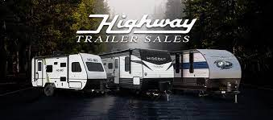

 | 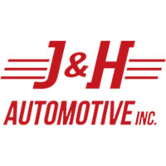
 | 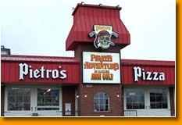
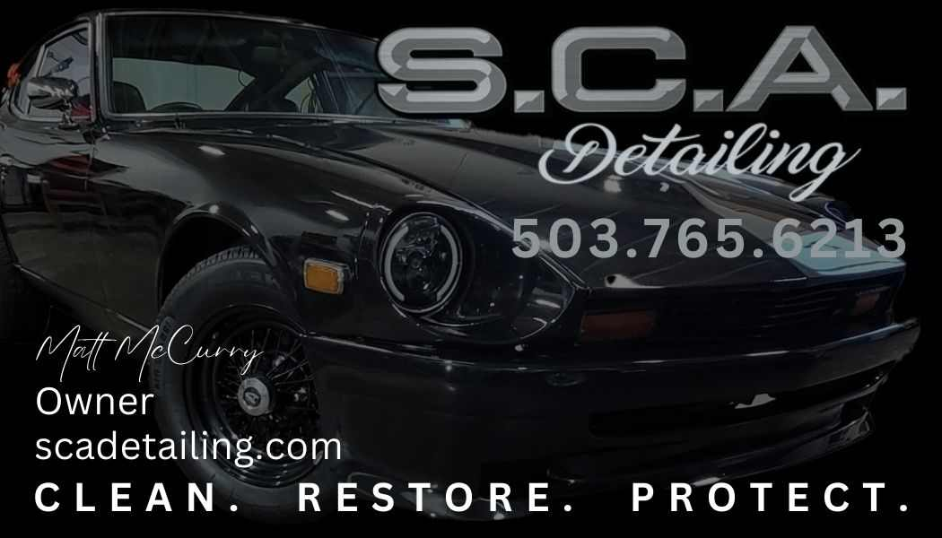 | 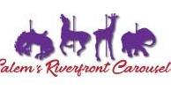

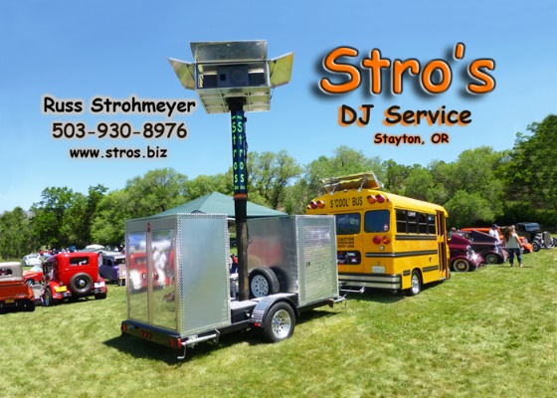 | 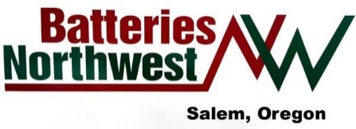 | 
 |  | 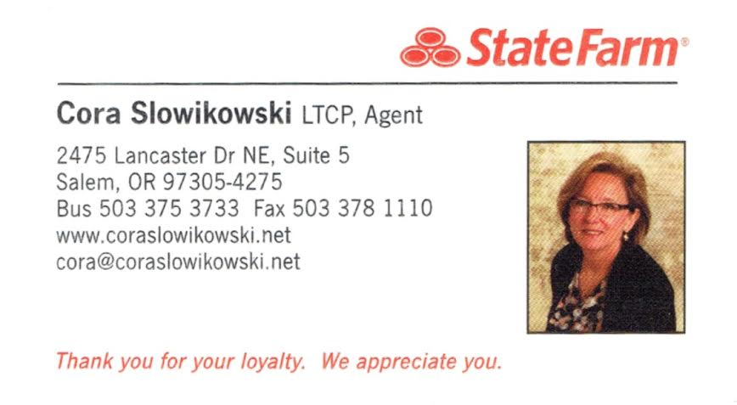
   | 
 |  | 
Lawrence’s NAPA Auto Parts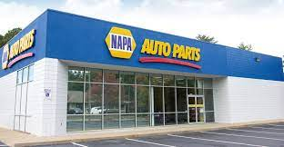
 |  | 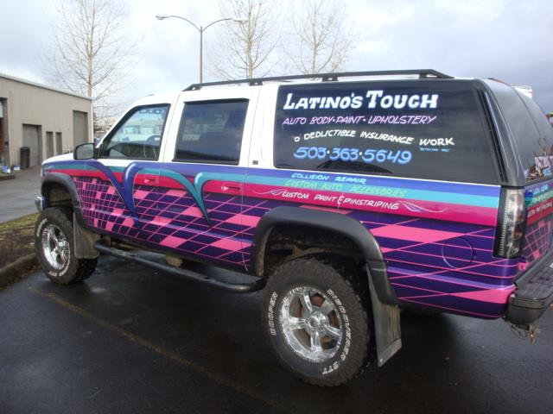
MYERS LANDSCAPING SVCS. | THE WATSON FAMILY | THE CHAMP FAMILY

Editor’s Note:

The goal is to have the newsletter out by Sunday prior to the club monthly membership meeting. Please submit any articles or photos to wvsrhq@gmail.com by the Friday prior to that Sunday distribution. The editor reserves the right to edit submissions as needed for length, fit, and content.

Thank You!
Garry Pullen

