 | CRUZ’N NEWS – JULY 2023
Next General Member Meeting July 5th
Pietro’s Pizza/ 1637 Hawthorne Av. NE, Salem
Dinner & Socializing 5 – 7pm Meeting starts at 7
Guests and Prospective Members Welcome
Next Officer Meeting July 25th
Neufeldt’s Restaurant 190 Main St. Aumsville
Dinner at 5:30pm Meeting starts at 6
Members Welcome
 | PRESIDENT’S MESSAGE
WVSR President  Russ Strohmeyer  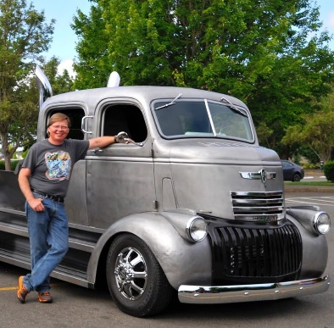  Contact Russ stroscars@wvi.com | It is less than two months before our big show at Riverfront Park, behind the Carousel. The committees have been working hard to make sure everything runs smoothly. We have so many club members that are always so gracious to step up and help on the day of the show, that’s what makes us such as good club – we’ve got the best club members!  At the July 5th meeting we’ll be passing around a sign-up sheet for anyone who hasn’t volunteered already. We are going with two-hour shifts for most of the volunteer positions, by doing that it will hopefully give more of our club members the opportunity to work that day. Even if you can’t be at the meeting or if all the volunteer slots are filled on the sign-up sheet there will be plenty of opportunities to help out that day. We need everyone there early to get set up and to stay to help tear down.  Don’t forget to bring raffle / silent auction item donations or gift cards / cash to buy items. We only have 2 meetings left before the show and we need to know as soon as possible if we’ll have enough for the show. We really hope not to have to buy items with club funds, it takes away from our charitable giving.  Enjoy your 4th of July and we’ll see you at the club meeting on Wednesday the 5th at Pietro’s!  Russ Strohmeyer  2023 WVSR President

Scheduled to bring cookies to the July meeting are:
Pat Coffey, Kathy Schuette, Joel Memmott, and Tina Stone

Ann Sowerby sends cards to members feeling less than 100% for one reason or another.

Mark Scott had a minor operation
Jeff Foster took a bad fall
Mel & Angela Myers – Mel’s brother passed away .

DID YOU KNOW?

The term “Tune-up” was coined by Henry Ford
while working on his first prototype. He noticed
that when the coils worked together properly,
they would buzz. If the coils didn’t make the
buzzing sound, he knew they needed an
adjustment that he later called a “tune-up”.

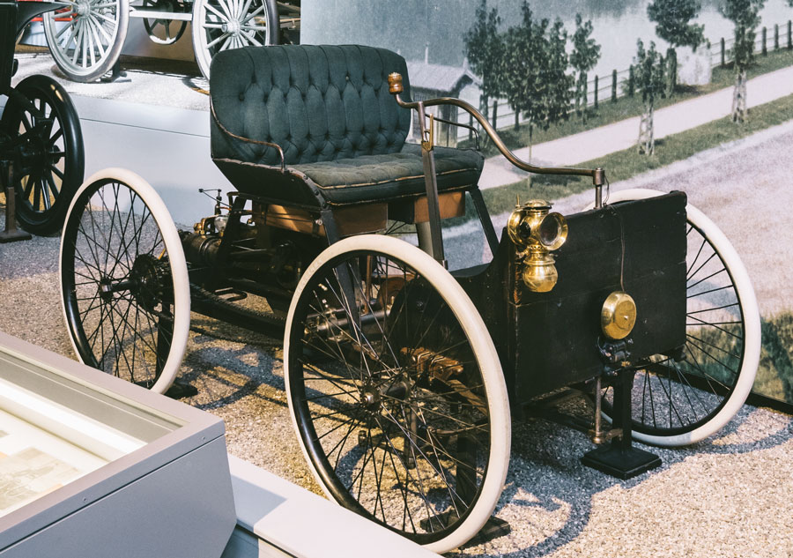

JULY BIRTHDAYS

3 | Jay Westenhouse
4 | Penny Erickson
6 | Jay Lawshe
9 | Yvonne Sanders
11 | Jeff Fawcett | Tom Gates
11 | Ken Marshall
15 | Alan Freeman
18 | Jay Miller
19 | Gloria Blair
20 | Sam Pietzold
24 | Pat Coffey
26 | Judy Horne
28 | Don Oman
30 | Aaron Reed

WVSR Speedster Program Visit
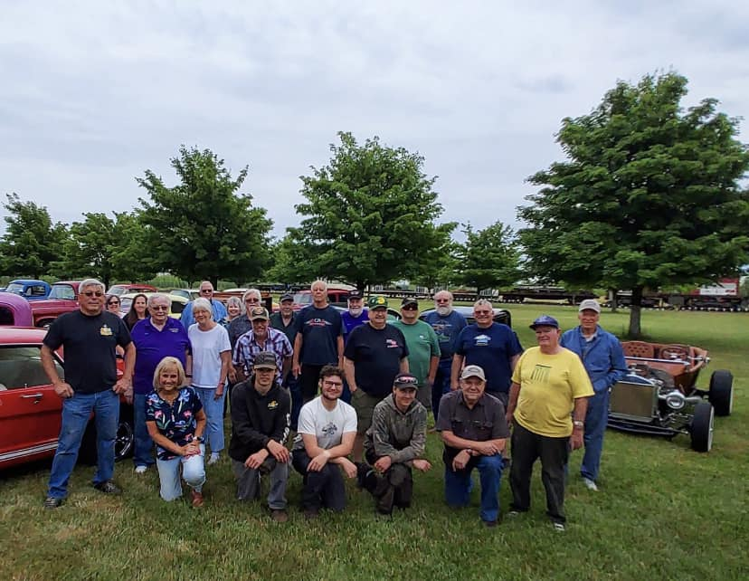

A special thank you to our club members that came out to Northwest Vintage Car and Motorcycle Museum to see the results of our 2023 Scholarship to the Speedster Program. This year our funds went to purchase new shop curtains, to create a separation in their machine shop area. They also purchased additional supplies needed to keep the program moving forward. Members enjoyed the tour, and of course cookies provided by our members. A special thanks to Glen (Rader) and Vicki for helping get the cars parked on the back lawn!
Submitted by Bob Repine

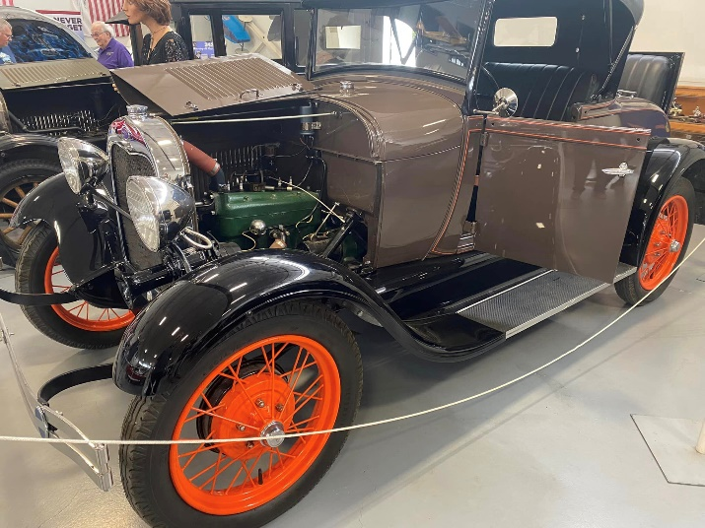
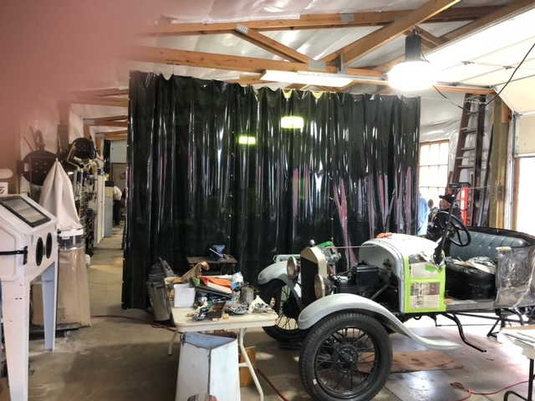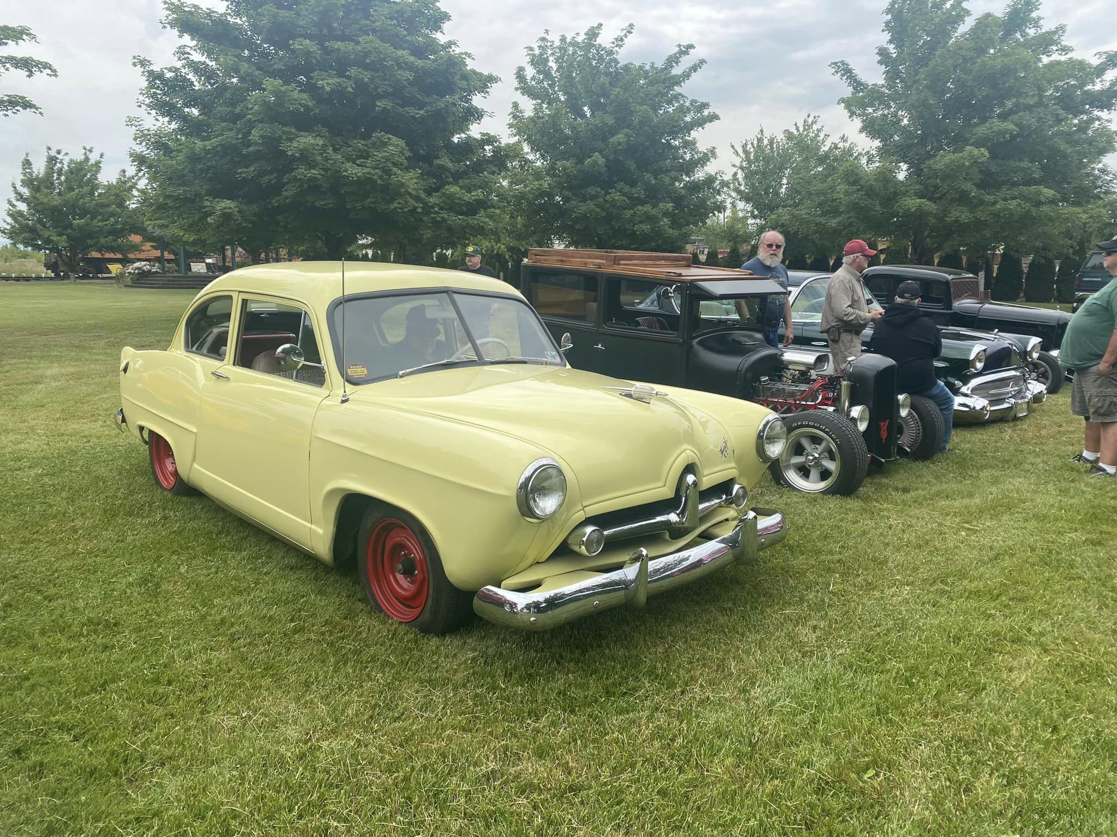

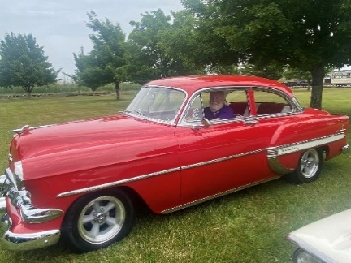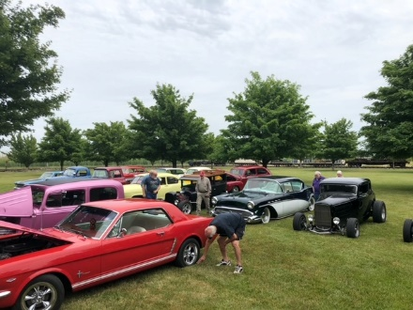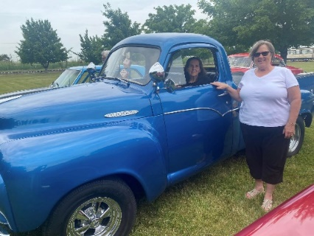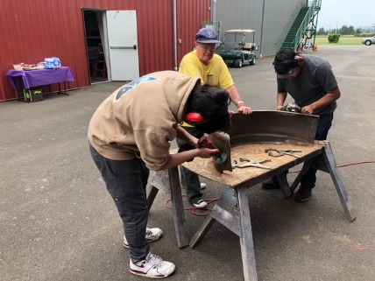
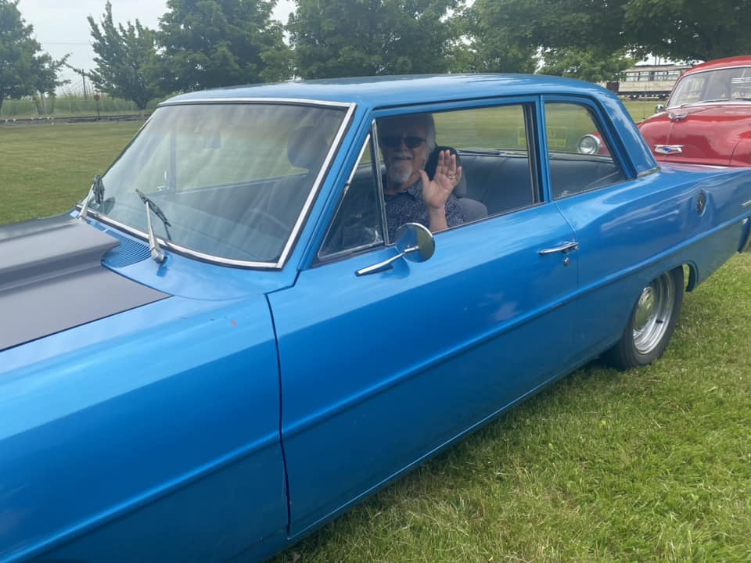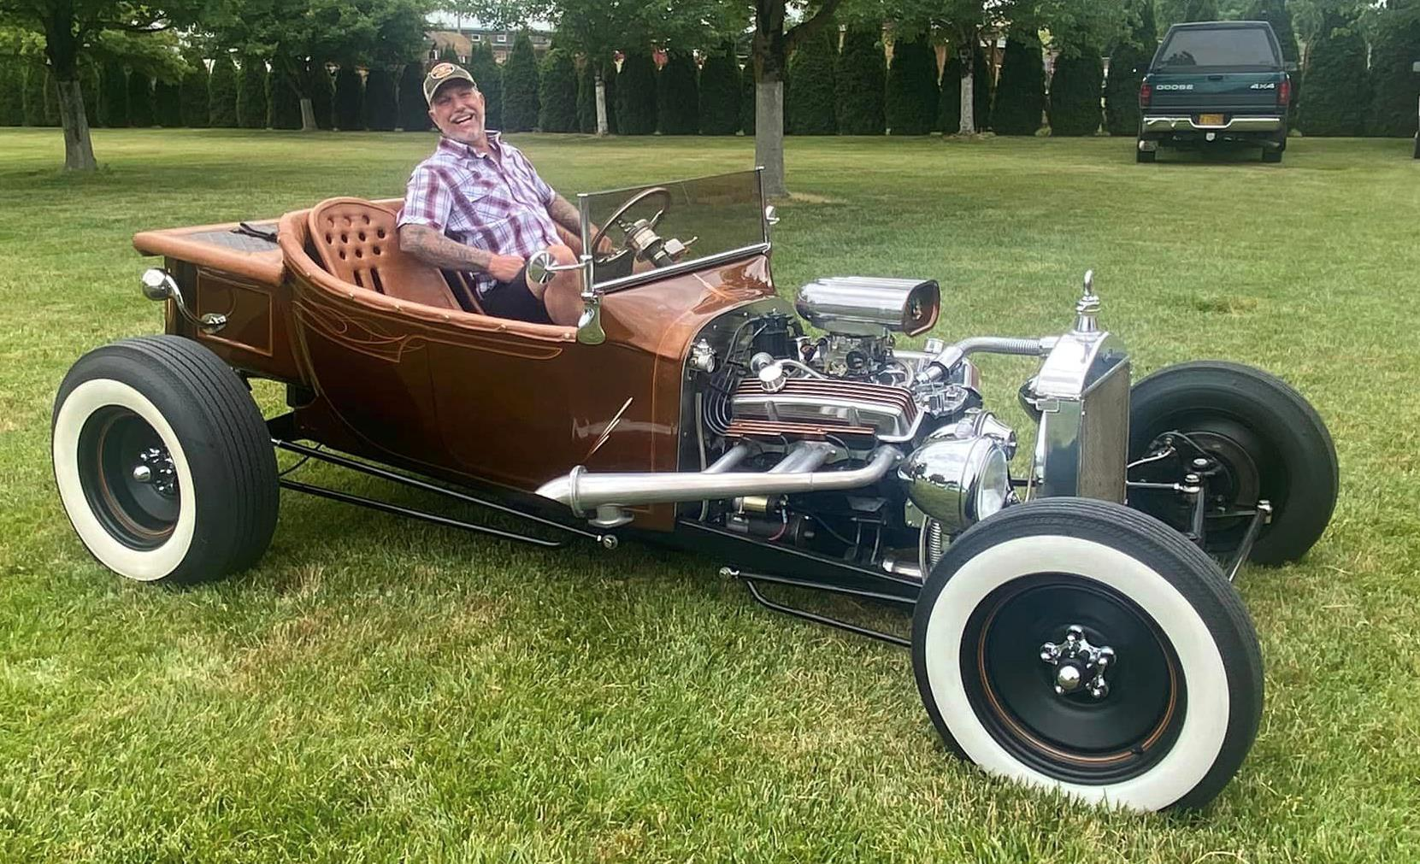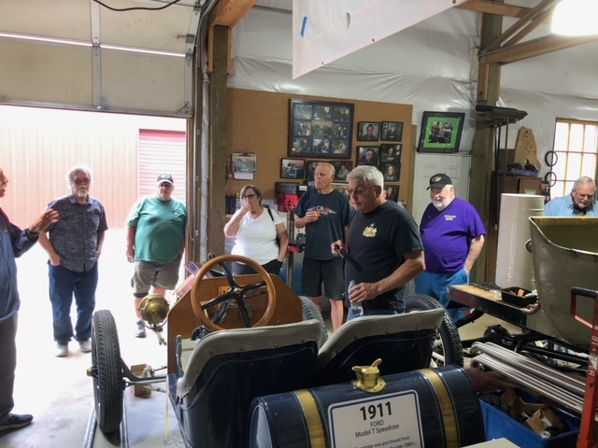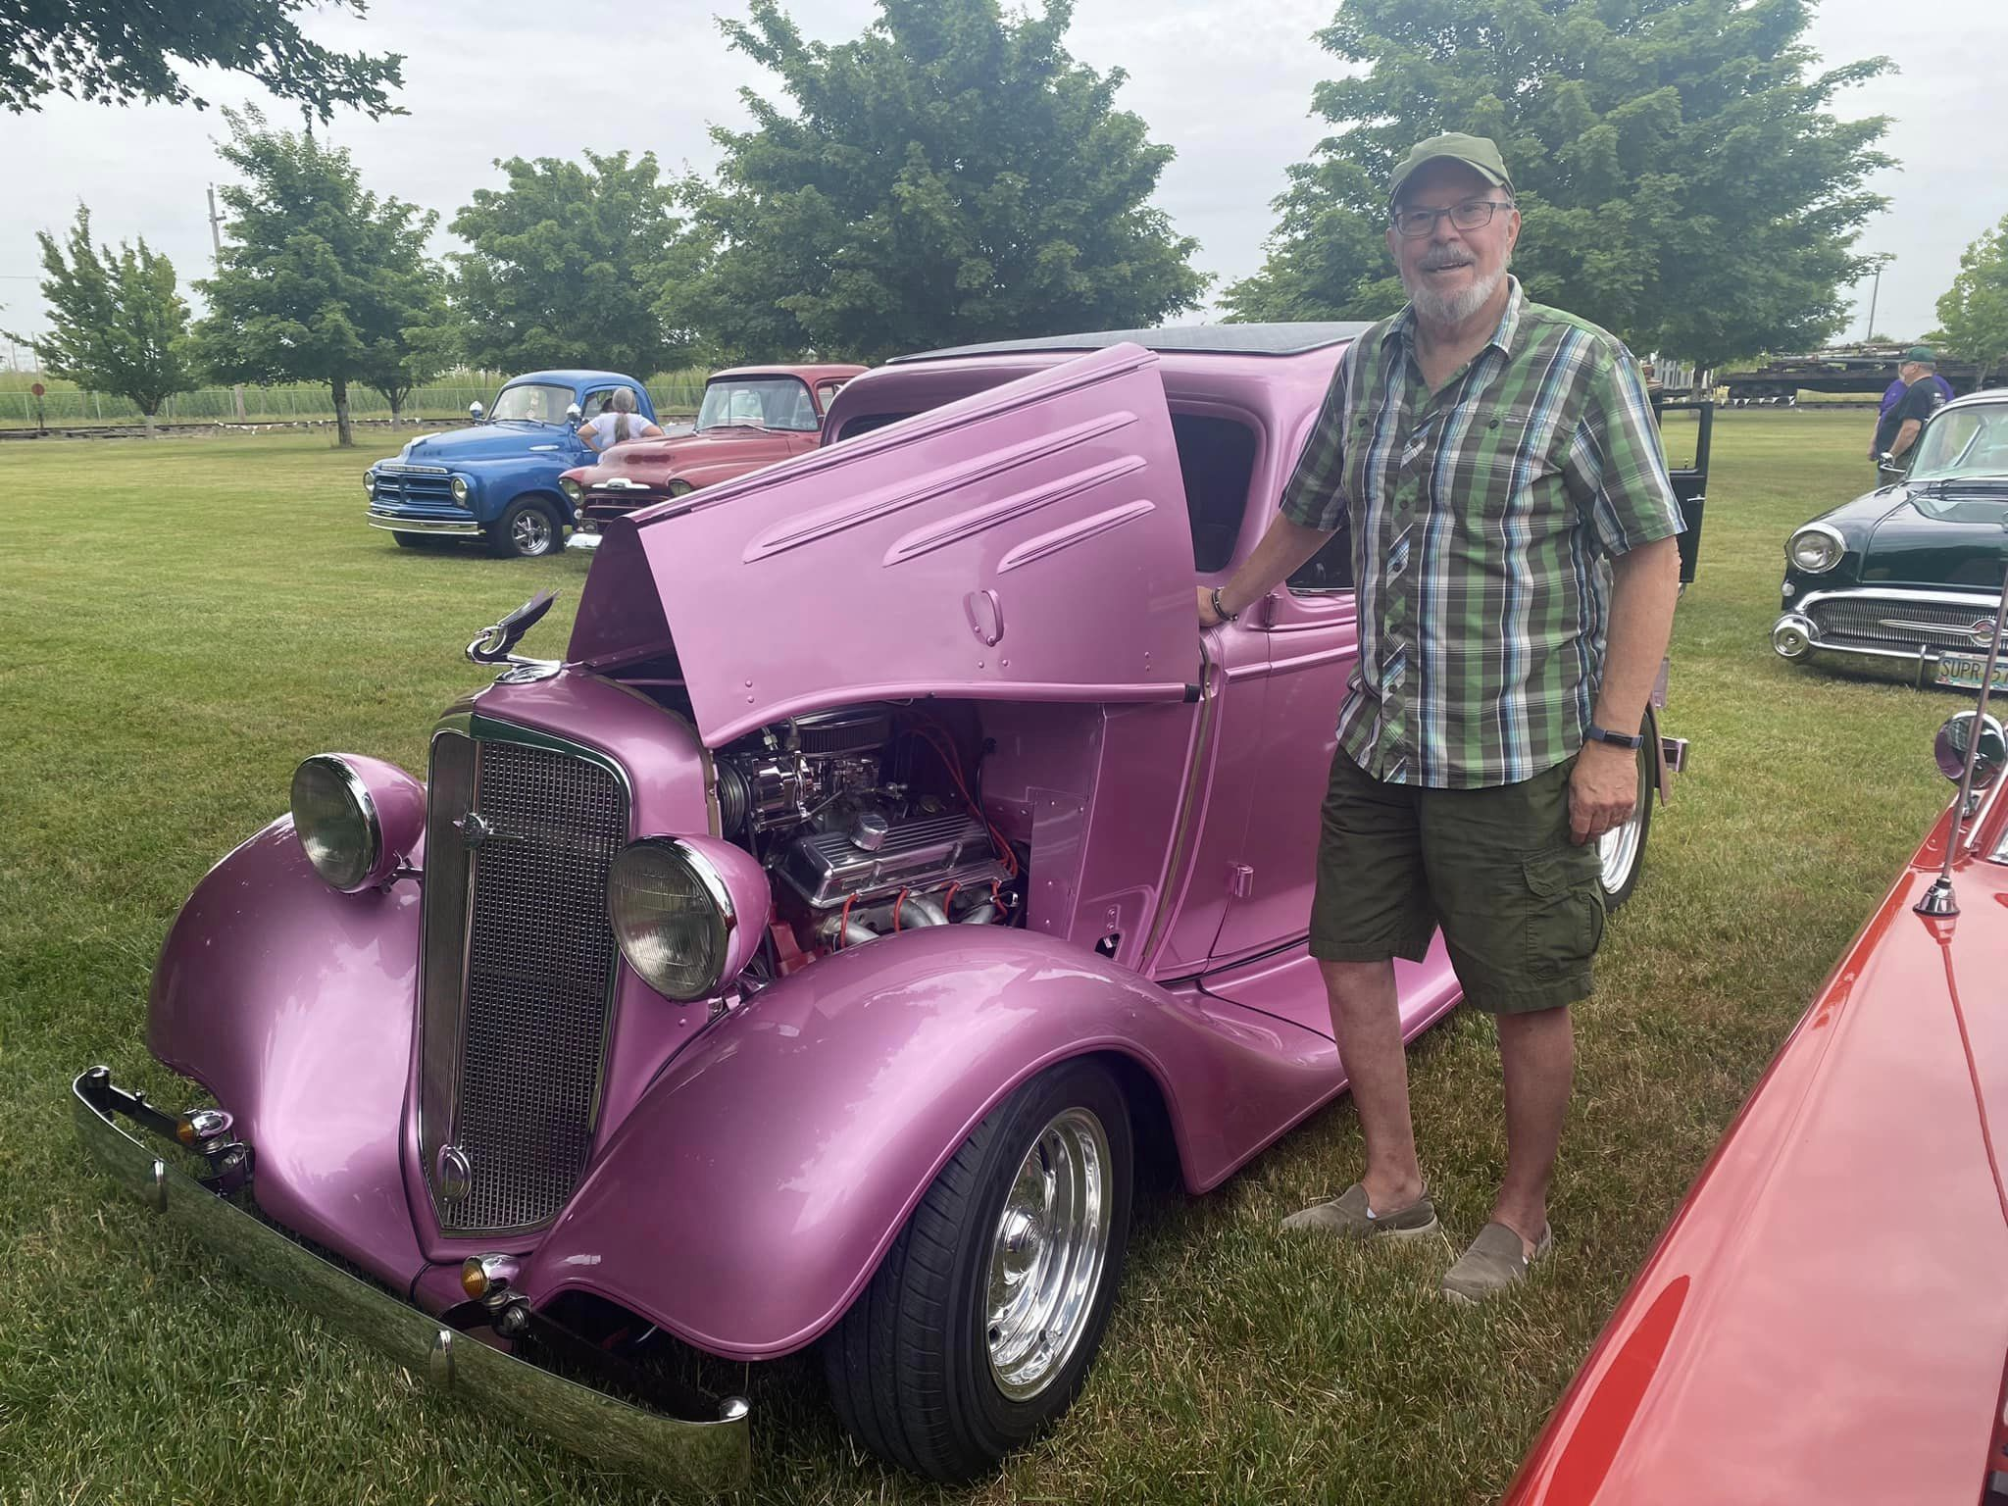

Hope Church Car Show in Albany

It was a cool but dry Saturday June 15th for this annual favorite car show. Held on Saturday this time it was lightly attended yet had an amazing array of cars, trucks, and bikes to check out. WVSR had several members bring their classics out to show too.
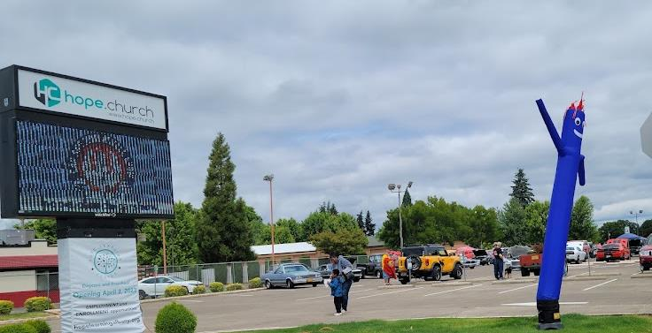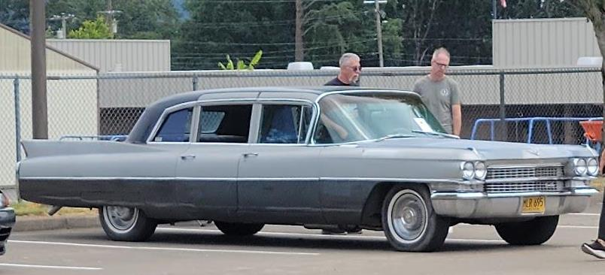

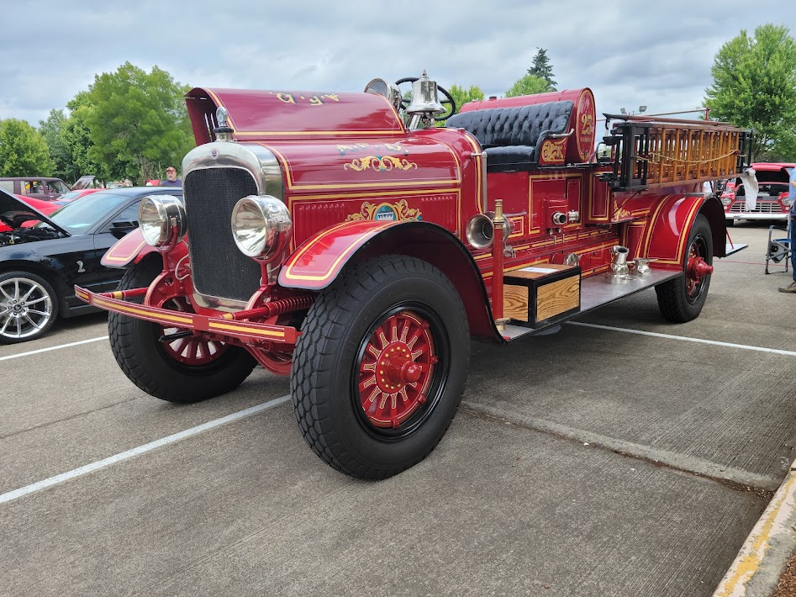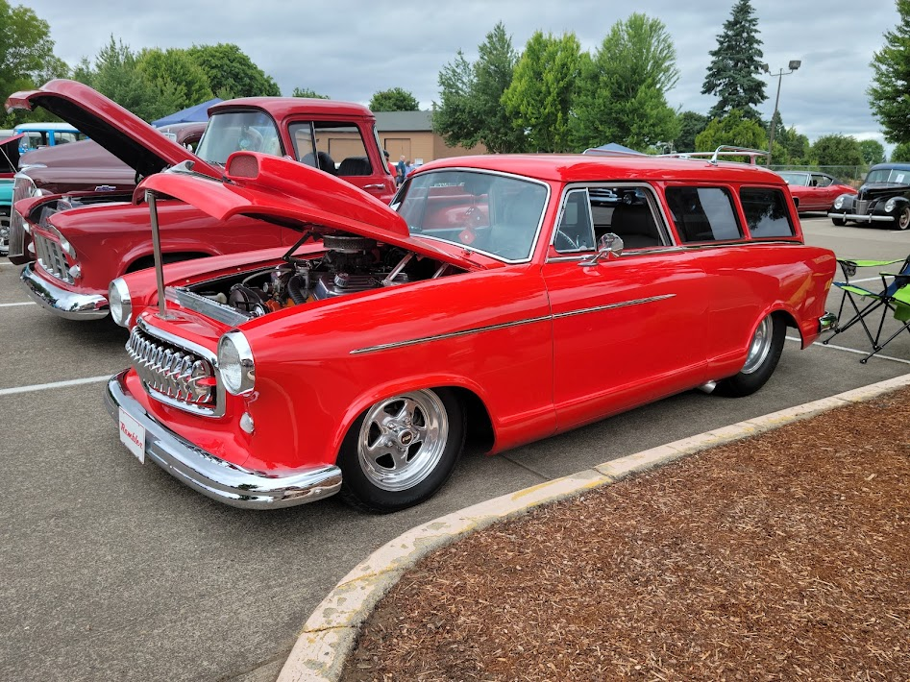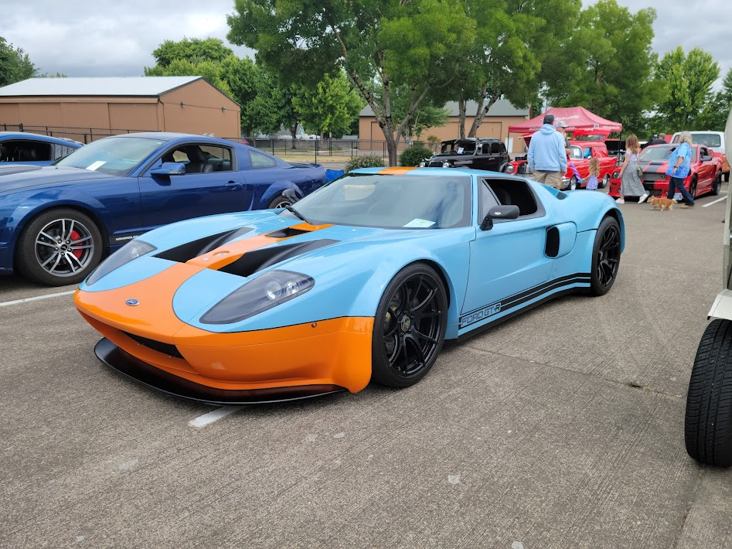

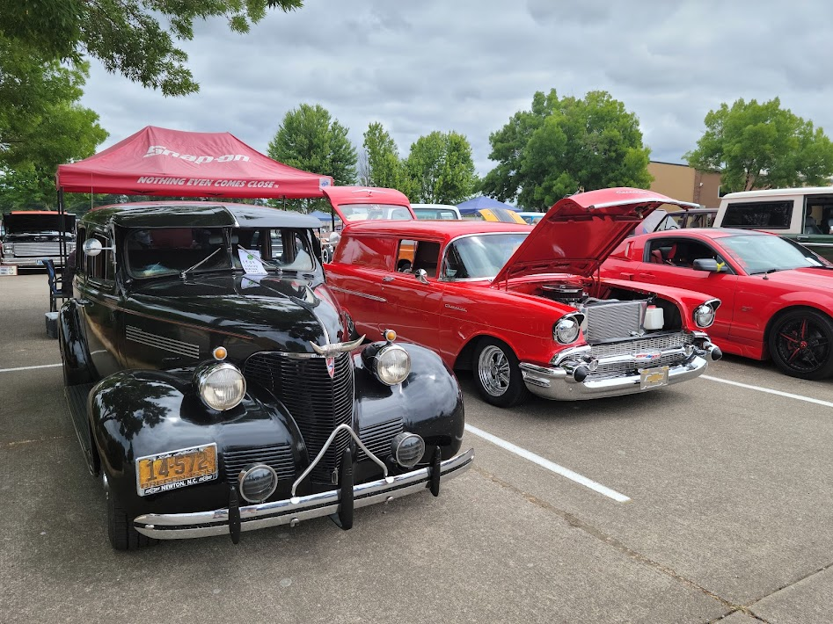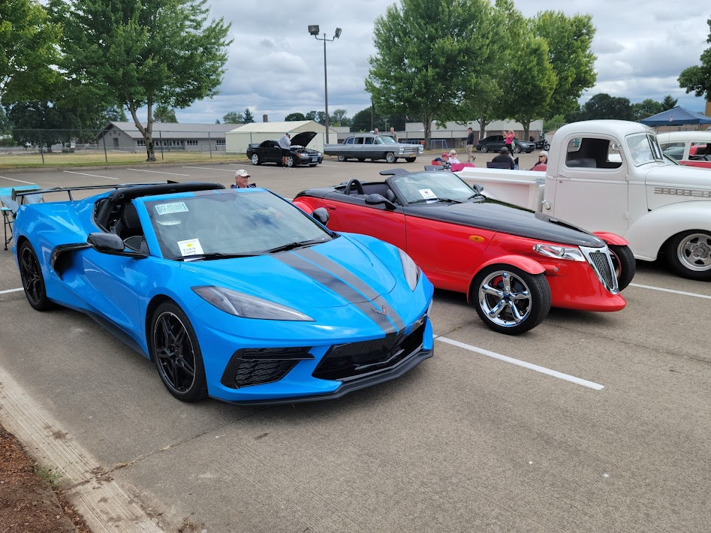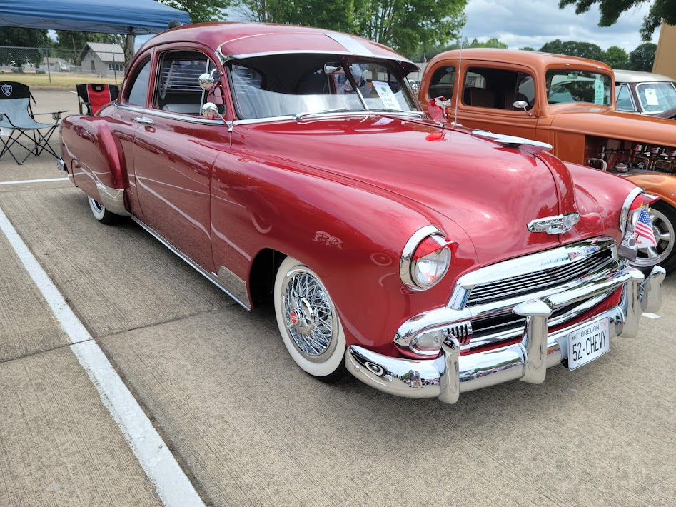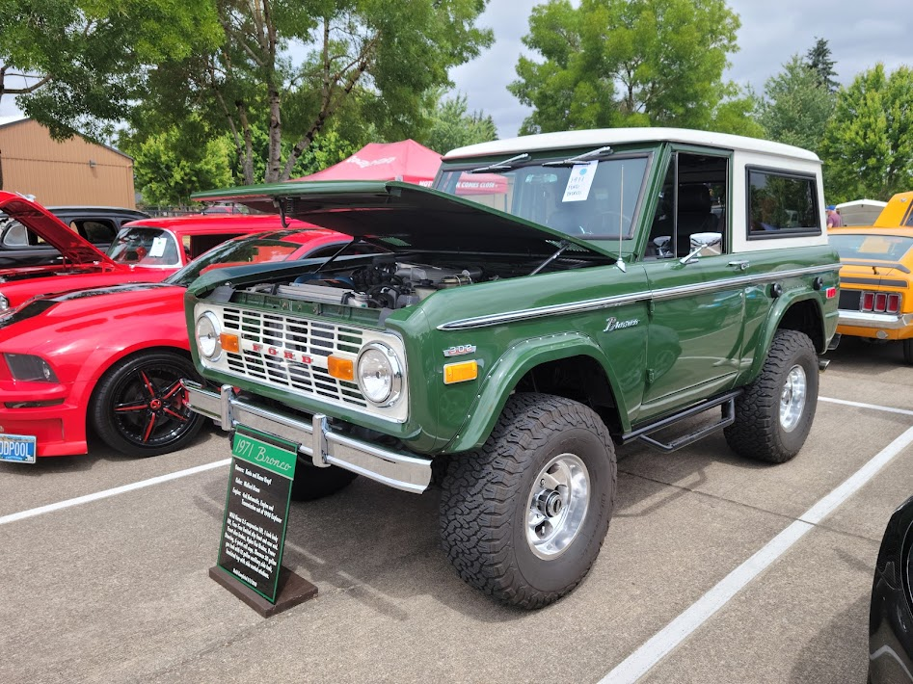

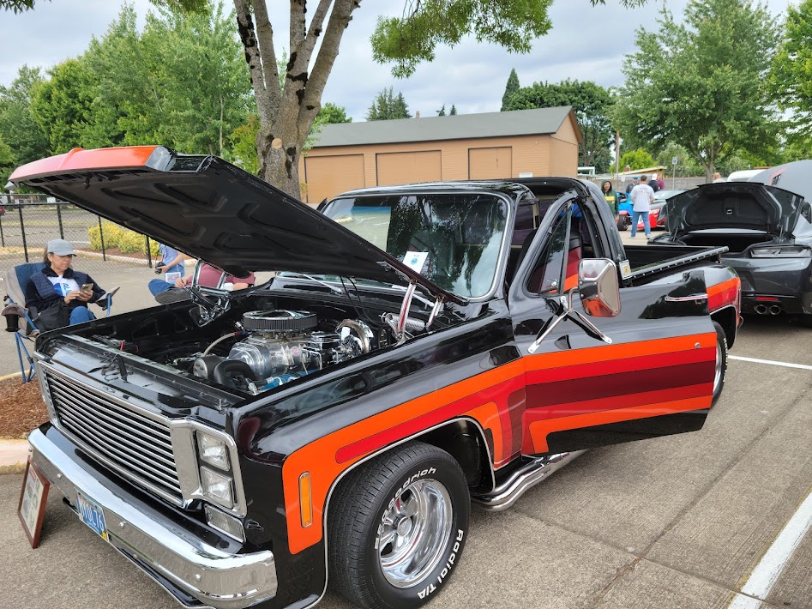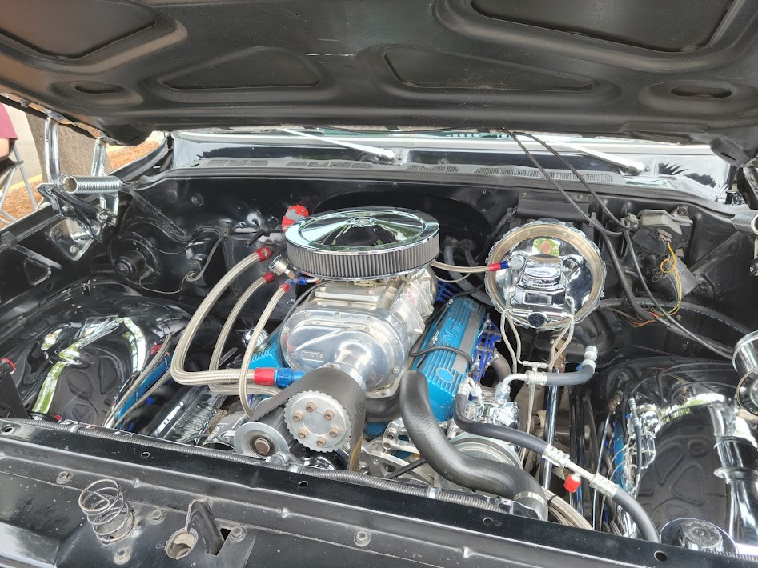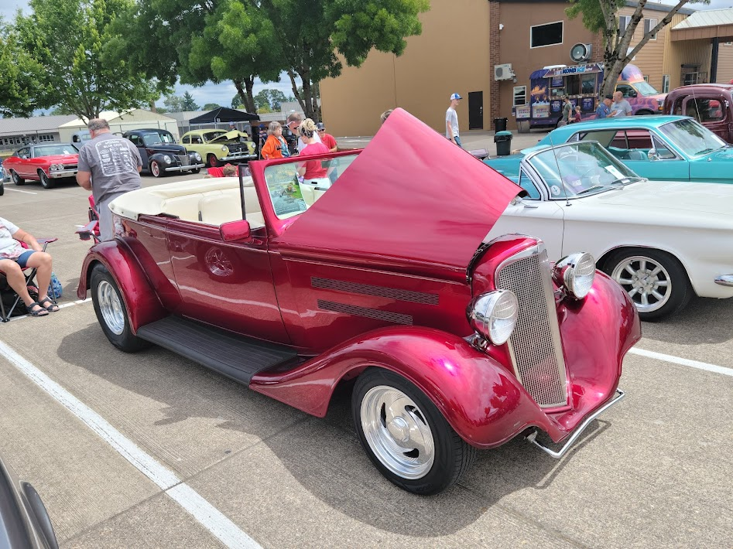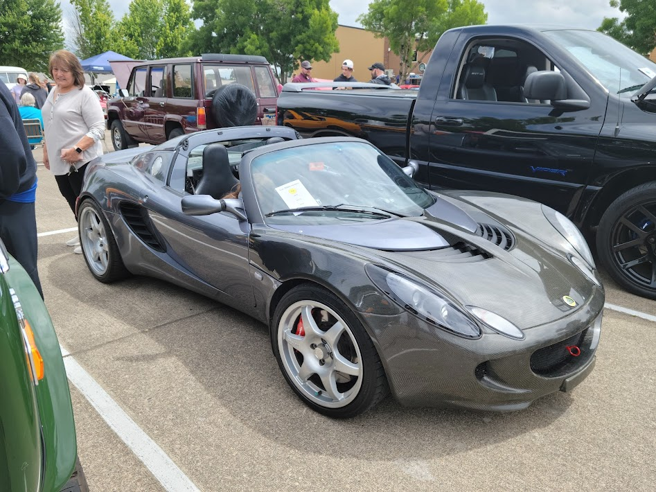

Kruise of Klamath

A few photos from the weekend where Russ DJ’d the show. Four 2-hour sponsor mini cruises in one day, the big show downtown the next, and 2 nights of cruising. If you’ve never been to this event, make it a point to go next year. WVSR usually has a decent sized group that caravans down and back and always has a great time.
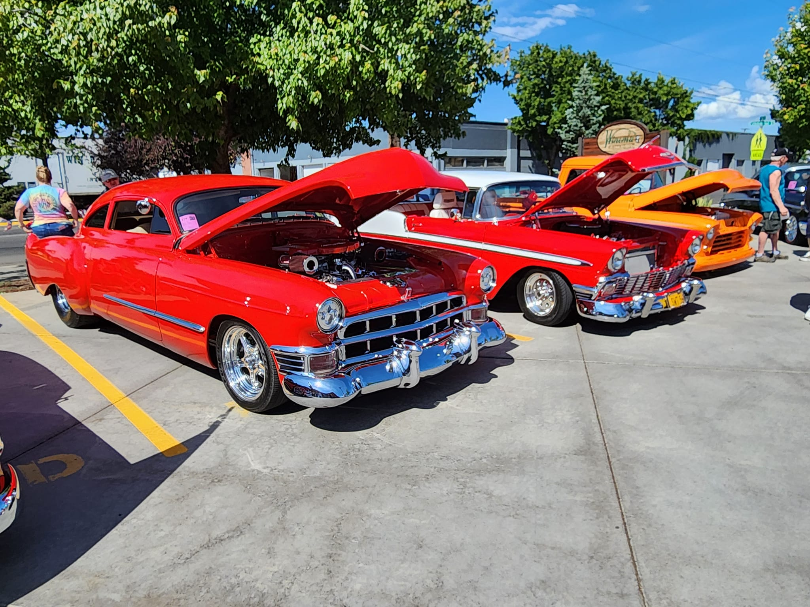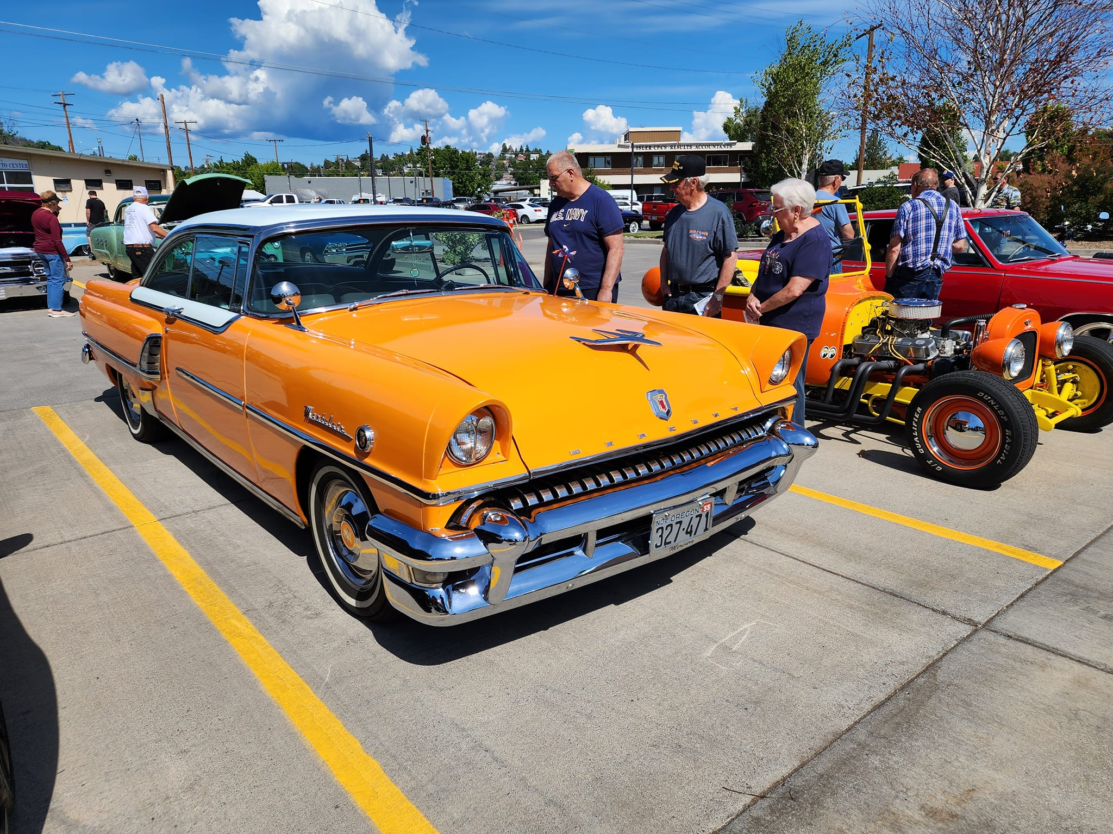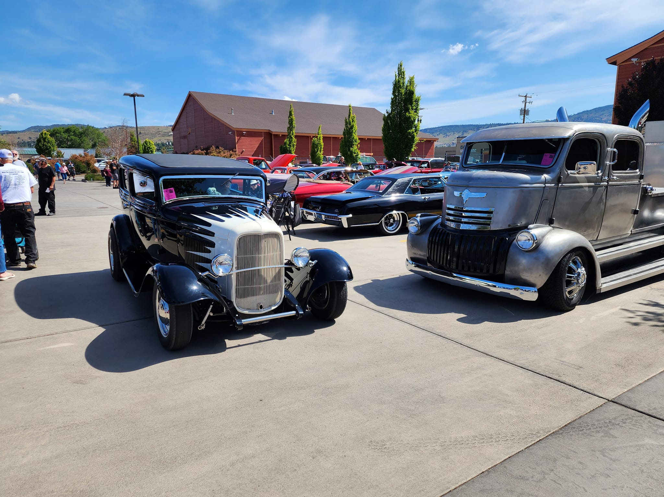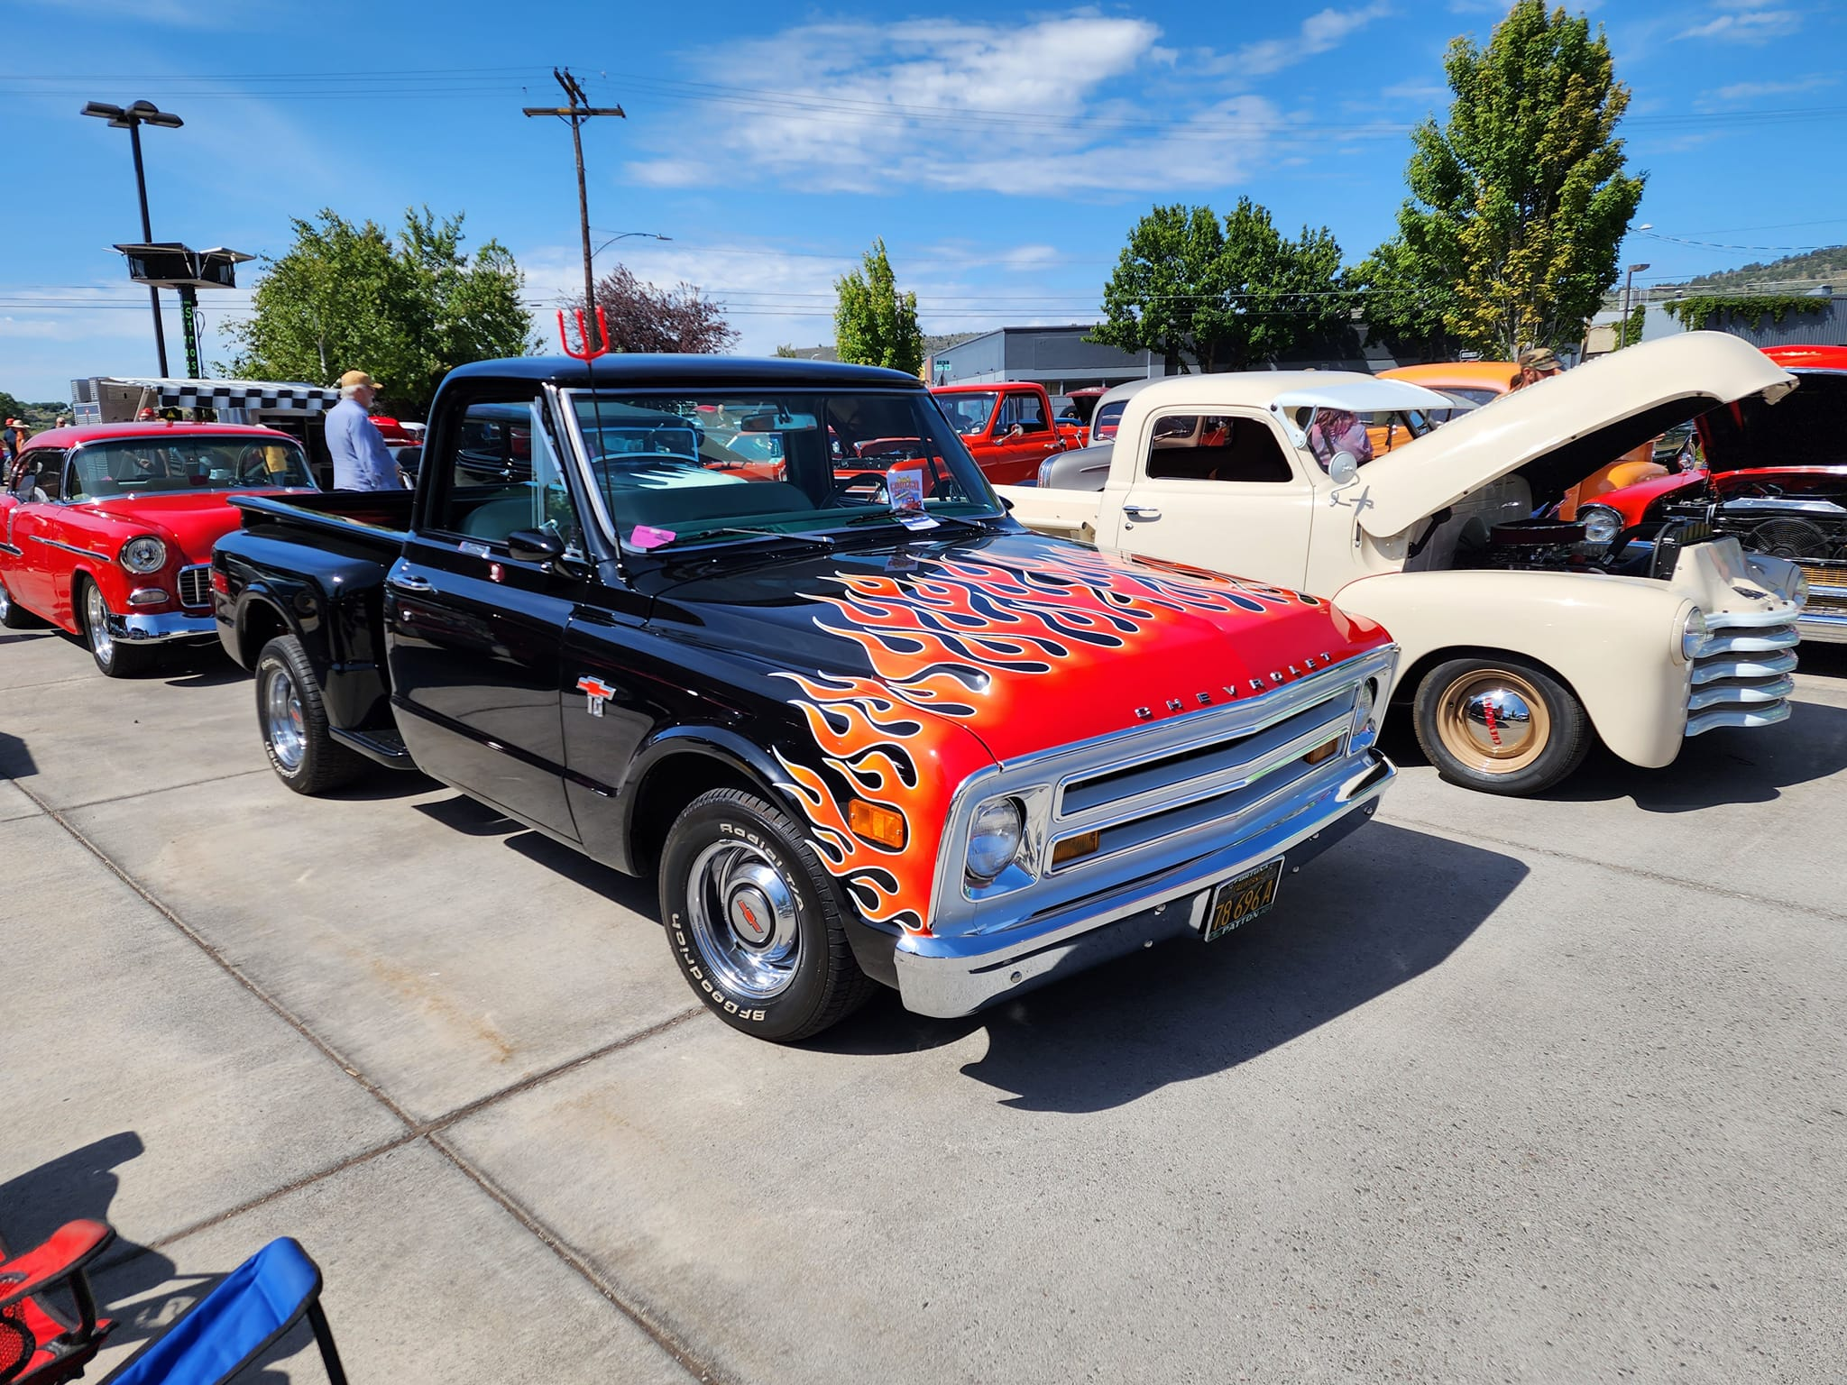

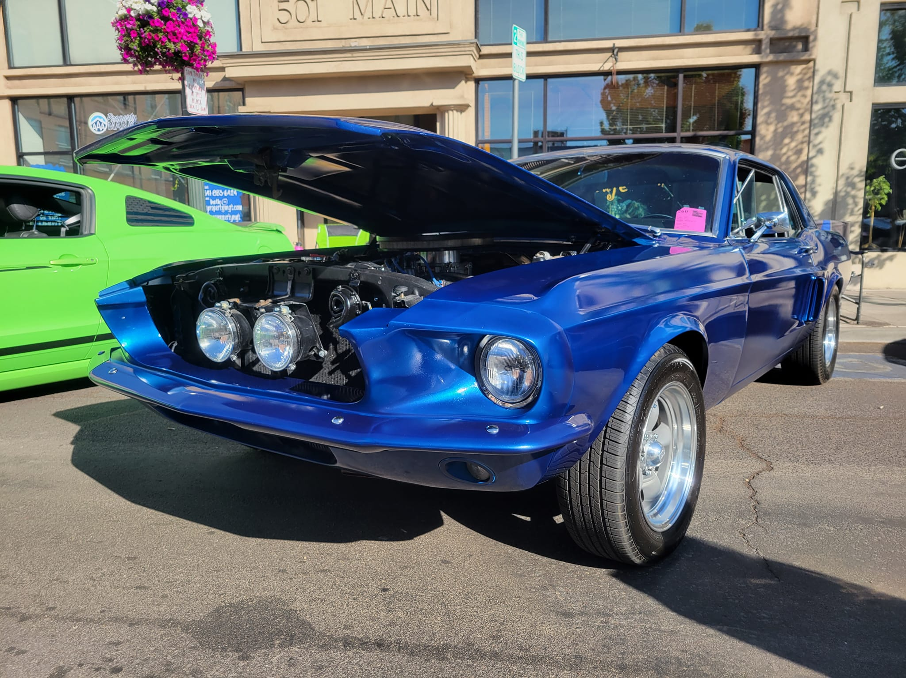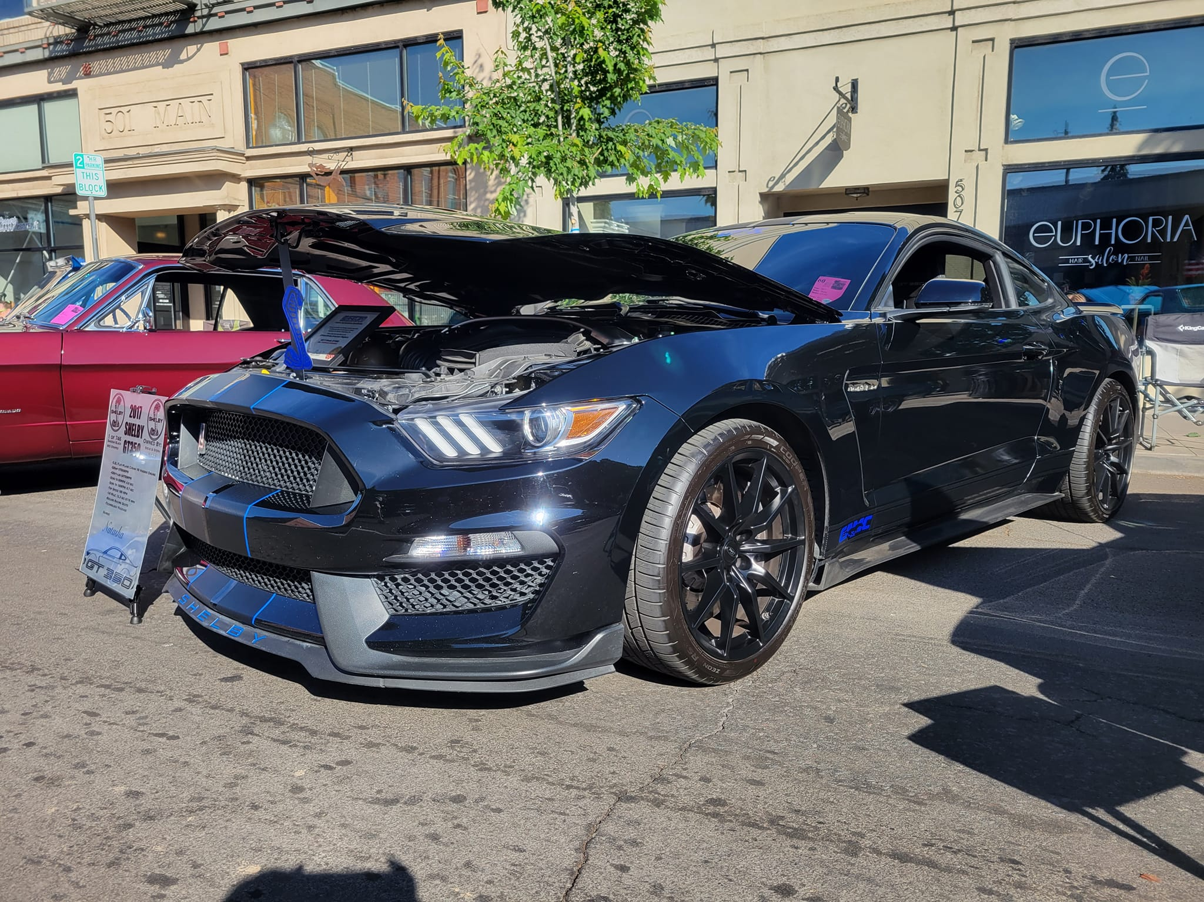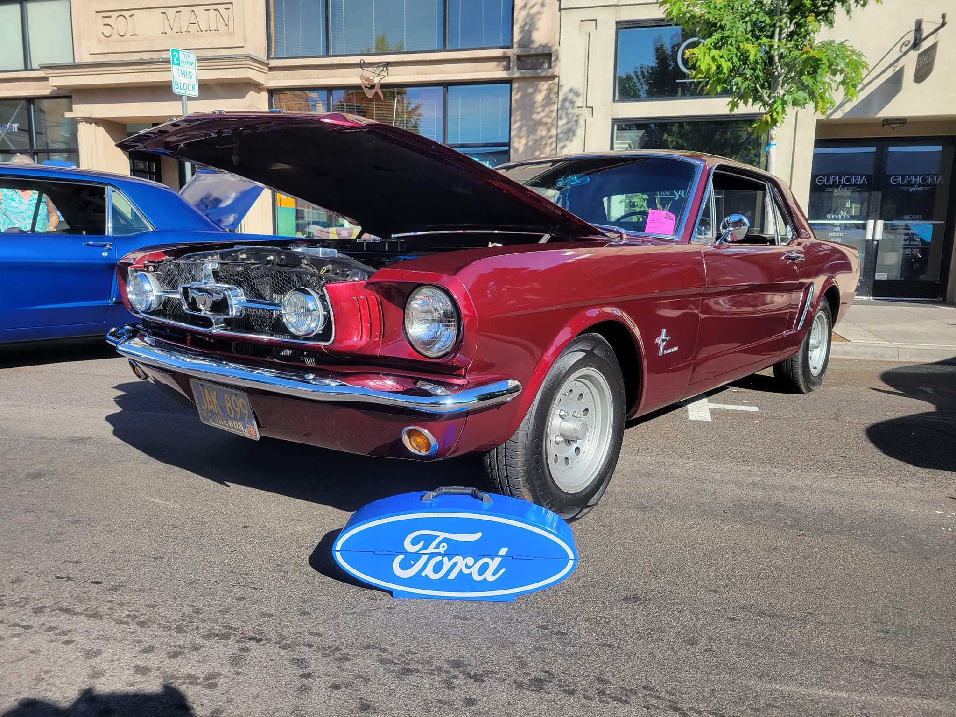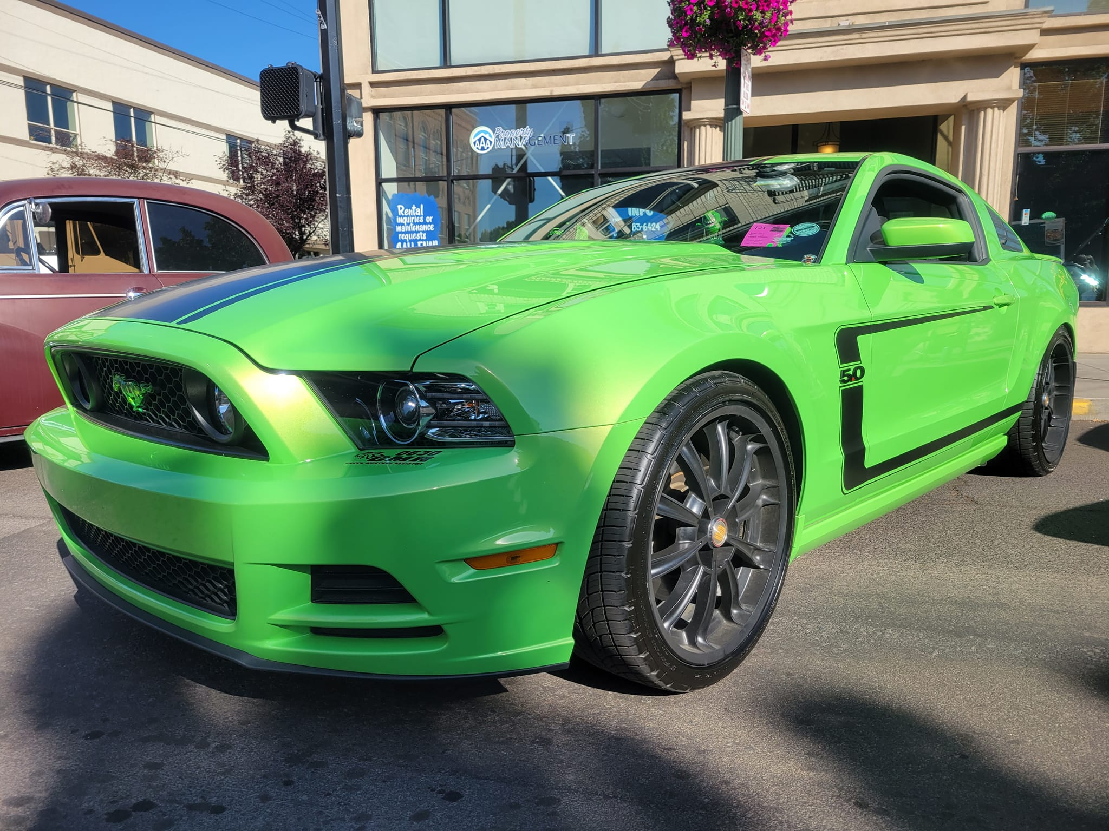

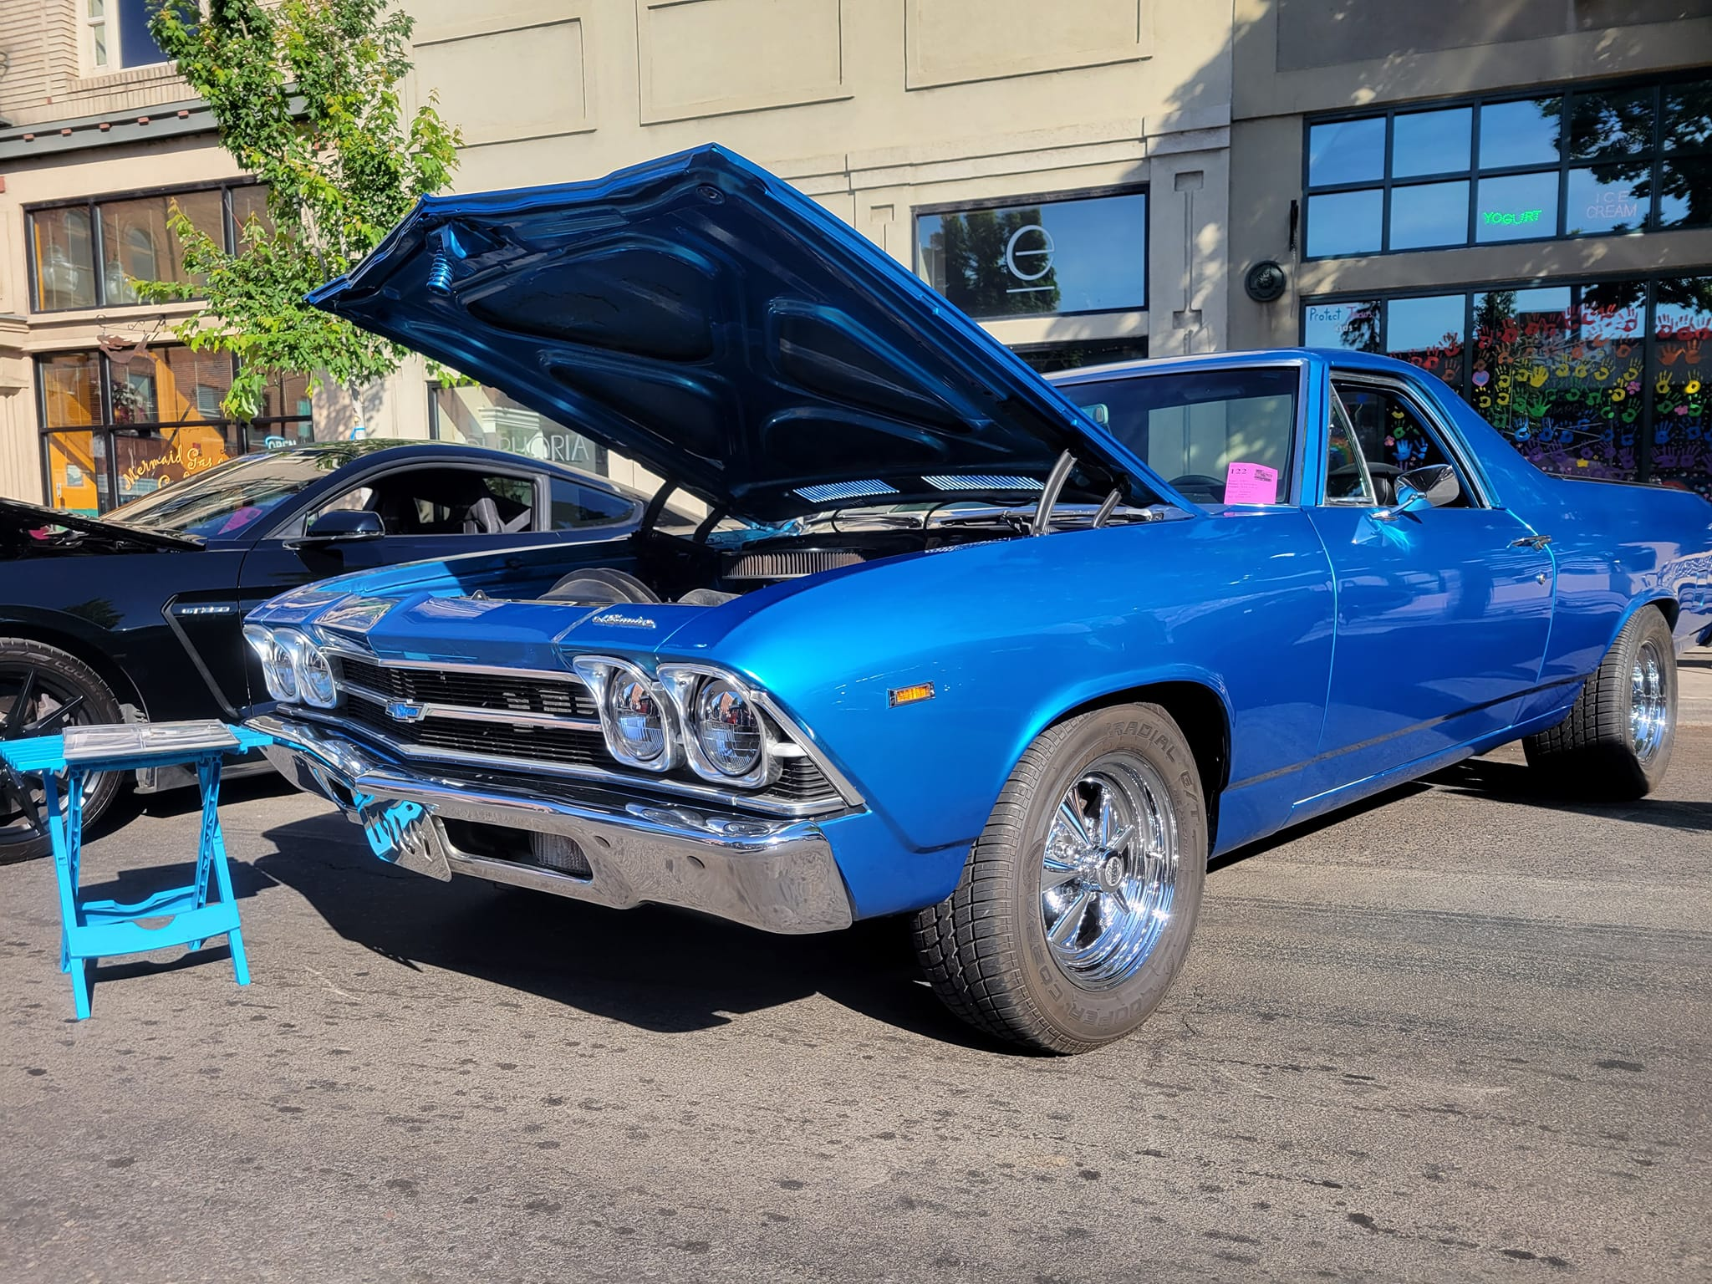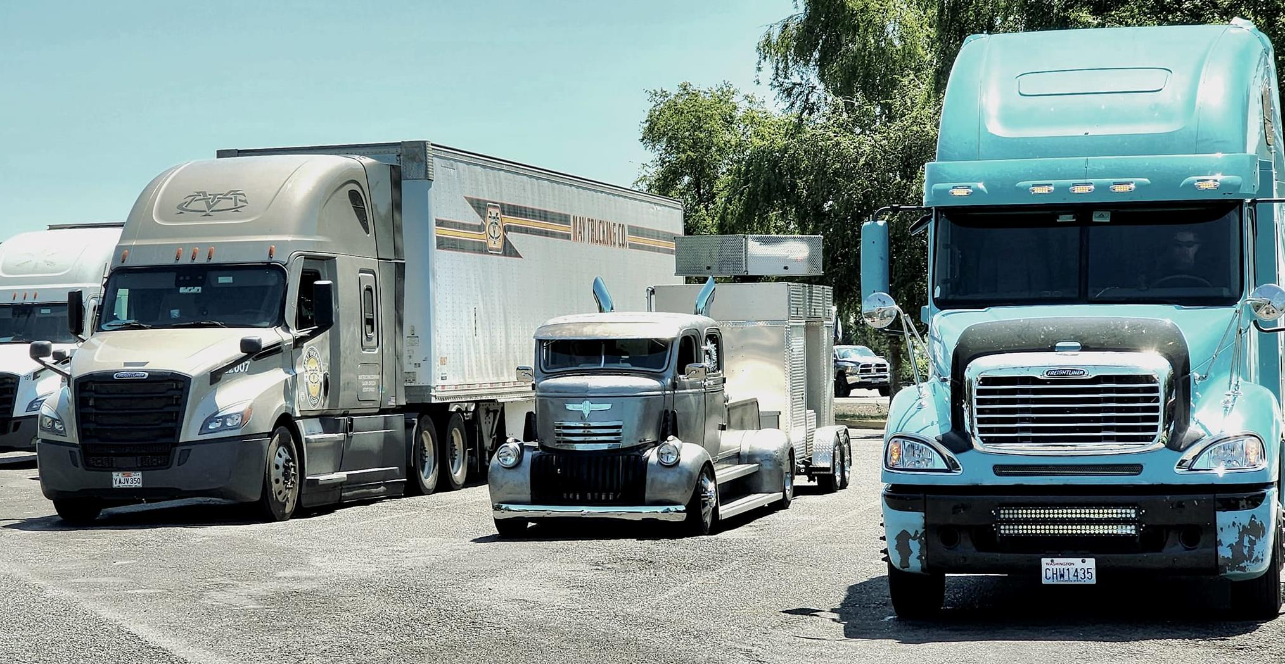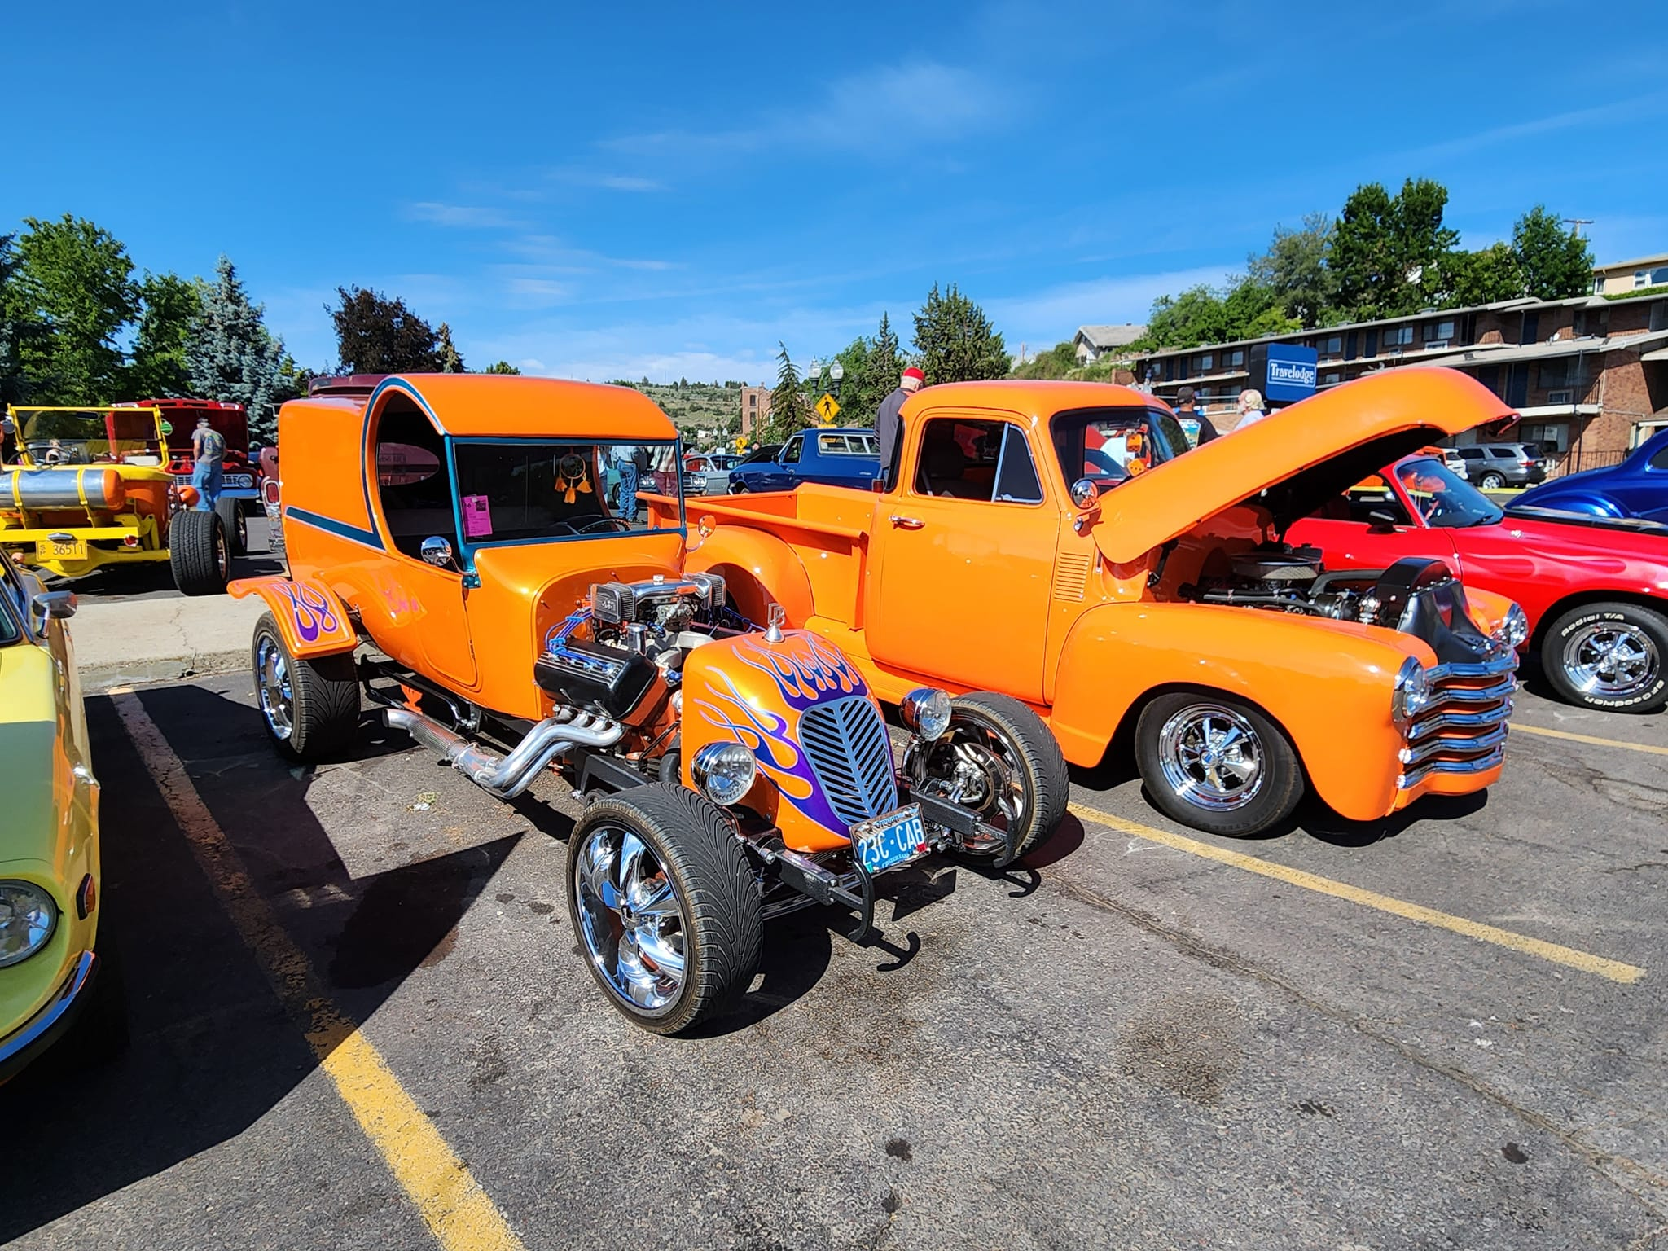

2023 Carousel Cruise –Next meeting will be held July 11 at Salem Riverfront Park beginning at 6pm. We’ll set up 3 of our new pop ups so they are ready for the day of the show and discuss this year’s layout along with any other park related items. Bring a lawn chair we’ll meet on the grass just behind the Carousel.

There are only TWO club meetings left before the show so please bring any donations for the silent auction or raffle to the club meetings. Cash is also appreciated for grabbing any items we may need to supplement donations. Please see myself or Vicki Champ.

New members – You are not required to register or pay for the event. Club cars will be parked together and given a colored window card to display.

Boone Ridge Car Show
Submitted by Bob Repine
It was a great first show for the Boone Ridge Senior Living Facilities this past month. The weather was welcoming for the 80 plus cars that participated in the event. Good food and great music highlighted the day but seeing the smiles on the residents faces that came out to share old memories about cars in their lives was the best reward for those that joined the show!
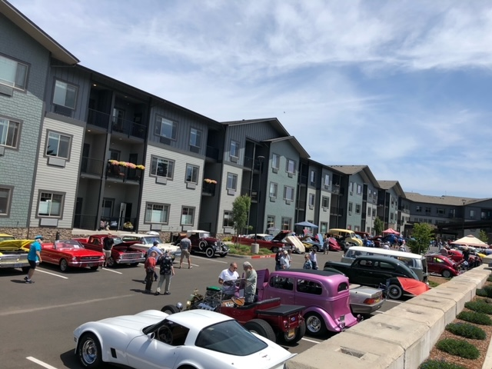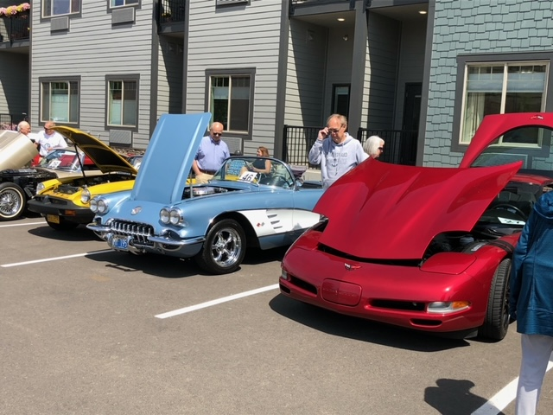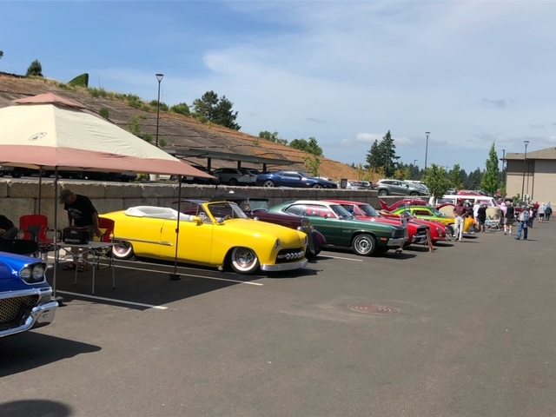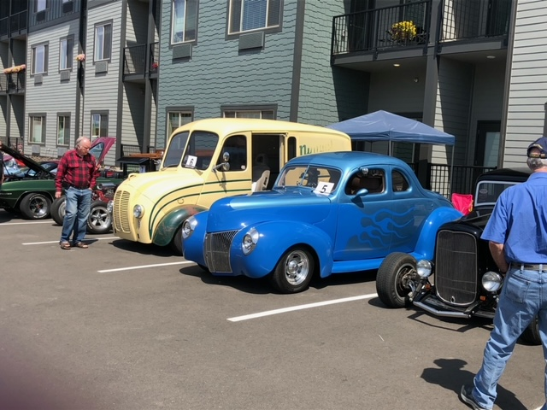

UPCOMING EVENTS:
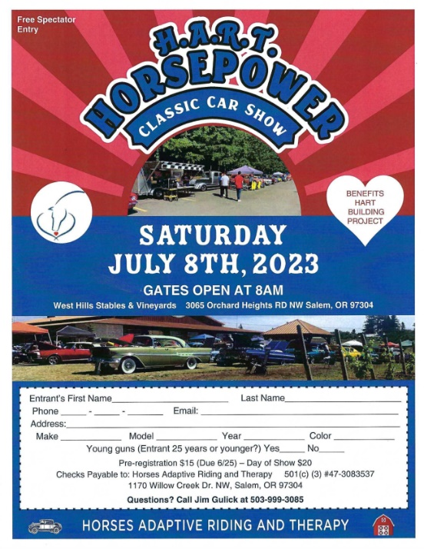 | Tim and Stephanie Brazofsky will be leading a caravan to the HART Show on Saturday, July 8, leaving Roth's in  ﻿West Salem, front parking lot  (corner of Glen Creek and Wallace Rd)  at 7:10am sharp!........  Any questions reach out to Tim  ﻿ 971.645.0194(call or text)

With car show season ramping up there are too many events to capture them all. Here is a partial list.
July
7: Filling Station Collector Car Appreciation Day noon-5pm Free
8: 9th Annual American Legion Cruise In @ PGE Estacada Timber Park 8am-3pm $20 Reg.
9: Spring Hill North Albany Car Show @ Bryant Park in Albany, OR 9am-3pm $20 Reg.
15: 14th Annual Rust-O-Rama @ Oregon State Fairgrounds FLYER
15: Central Lane Show & Shine 2023 2777 MLK Jr. Blvd. Eugene, OR 7am-4pm $25
15: Cars at the Coast @ Newport Performing Arts Center 8am-3pm $25 Reg.
15: Knights of Columbus Car Show @ St. Edward Church in Keizer, OR 10am-2pm $15 Reg.
15: Jim’s Cruise In – 25 Yr. Reunion 3pm-7pm @ People’s Church 4500 Lancaster Dr. Salem,
20-22: Flashback Cruz Car Show 21720 US20 in Bend OR 3-7pm & 8am-3pm $45 Reg.
29: Brent Strohmeyer Memorial Car Show on the grass @ Sunrise Park in Sublimity, OR 9am-3pm $15 Reg. Visit Stroscarevents.com for show updates.

Contact an Officer:

General questions sent to wvsrhq@gmail.com will be answered or distributed to an officer who can answer your question.

President – Russ Strohmeyer 503-930-8976 stroscars@wvi.com
Vice President – Tim Brazofsky 971-645-0194 tim.brazofsky@gmail.com
Member At Large – Mel Myers 503-881-8885
Membership – Jim Walz 503-769-7953 jpcswalz@wvi.com
Treasurer – Ron Sowerby 503-881-8318 rsowerby@wvi.com
Communications – Vicki Champ 503-910-5952 vchamp@comcast.net
Newsletter – Garry Pullen 503-507-5333 garryp222@gmail.com
Secretary – Michele Coffey 541-990-8256 tiggermichele@gmail.com
Website/FB- Wendi McNitt 503-949-5032 wendimcnitt@aol.com
Cruises /Social Events
Dave Cartwright 503-881-1922 davesnerri56chevy@centurylink.com
Wendi McNitt 503-949-5032 wendimcnitt@aol.com

Editors Notes:

The goal is to have the newsletter out the Sunday evening prior to the club membership meeting. Please submit any articles or photos to wvsrhq@gmail.com by the Friday prior to that Sunday distribution. Editor reserves the right to edit submissions as needed for length, fit, and content.

Thank you – Garry Pullen

-

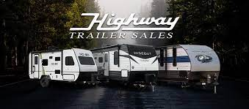
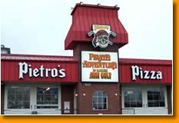

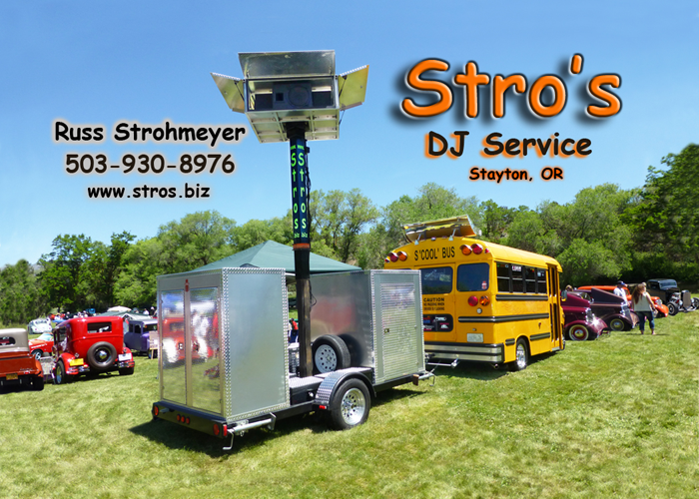

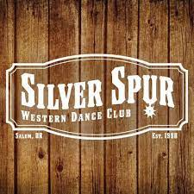

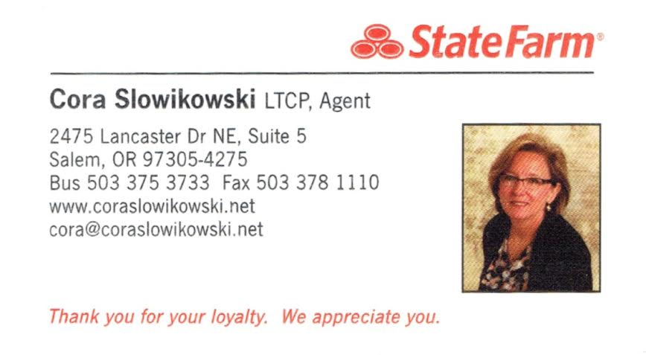
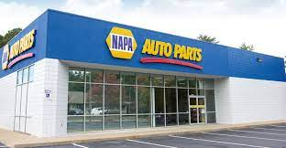
Lawrence’s Napa Auto Parts South Salem

