Dog/Handler Team Sponsorship

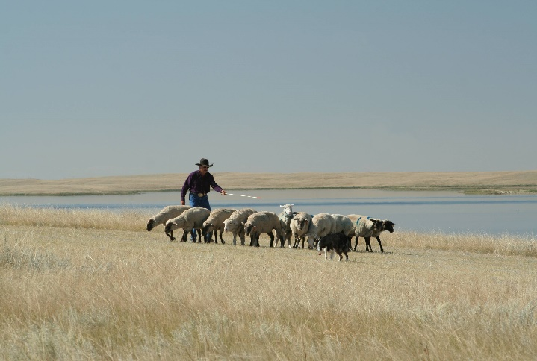

Sponsor a handler and dog during the
Western Canadian Finals/ Hilltop Sheepdog Trial- August 20-23, 2020
Follow us on the FACEBOOK PAGE – Western Canadian Finals

$125 per open team or $100 pronovice team. Teams will be noted on website as entries are obtained.

Sponsors will be noted on www.hilltoptrial.webstarts.com website and in catalogue (must be received by Aug 10th, 2020 to be included in program)

40% back to sponsors – paid to top 3 positions in both finals (Open and pronovice) – teams will be drawn for sponsorship if no team specified.

Name or company________________________________________
Address________________________________________________
Phone Number___________________________________________
email___________________________________________________
Amount
I would like to sponsor (please state number)
___ Open Dog ($125) ___ Pro novice dog ($100)
Handler/Dog wished to sponsor 1.______________________________
2._________________________________________3__________________________________________________

Make cheques payable to Wendy Schmaltz
Box 39 McCord, Saskatchewan S0H 2T0

