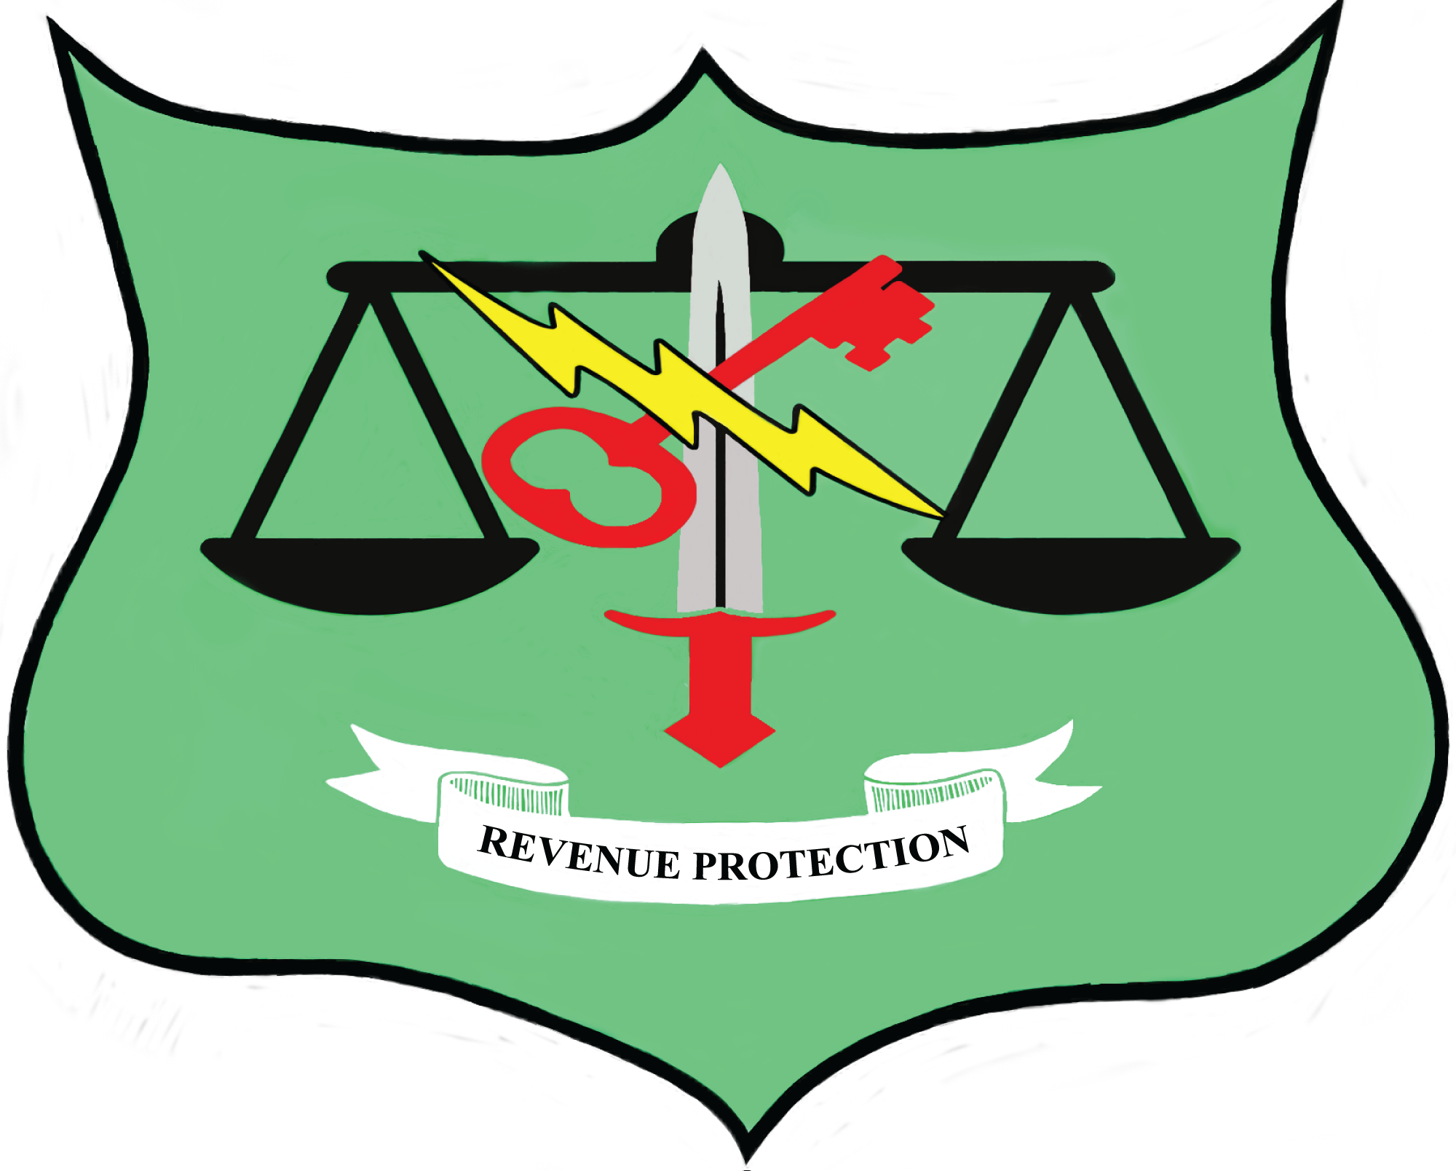

2026 NC/SC Revenue Protection Training
Seminar and Conference
April 14 – 16, 2026
Embassy Suites Kingston Plantation, Myrtle Beach, SC

Monday, April 13, 2026

4 pm – 6 pm Registration

Tuesday – April 14, 2026

7:00 am – 8:00 am Breakfast (complimentary for all hotel guests
(Coastal Grill & Bar)

8:00 am – 9:00 am Registration – Windsor Ballroom

9:00 am – 9:15 am Welcome, Opening Remarks, Introductions
& Level One Safety Message – Jason Parker, NCSCRPC President

9:15 am – 9:30 am Vendor Introductions – Ben Plexico, NCSCRPC, Director of Vendors

9:30 am – 10:30 am Keynote Speaker – The Evolution of Utility Investigations
David Lasater, Retired Duke Energy

10:30 am – 10:45 am Break/Ticket Sales/Networking/Raffle

10:45 am – Noon Active Violence in the Workplace / Active Shooter
Joshua Wallace, SLED

Noon – 1:30 pm Lunch Provided – Seaside Vista

1:30 pm – 2:30 pm Risk Mitigation in the Energy Sector
Darin Dillon, CPP, Sr. Director Energy, Lenel

2:30 pm – 3:30 pm TBA

3:30 pm – 4:00 pm Ticket Sales/Networking/Raffle

4:00 pm - 6:30 pm Vendor Event
Separate Vendor Prize drawings

2026 NC/SC Revenue Protection Training
Seminar and Conference
April 14 – 16, 2026
Embassy Suites Kingston Plantation, Myrtle Beach, SC

Wednesday – April 15, 2026

7:00 am – 8:30 am Breakfast (complimentary for all hotel guests)
Coastal Grill & Bar

8:30 am – 9:30 am TBA

9:30 am– 10:30 am TBA

10:30 am to 10:45 am Break/Ticket Sales/Networking/Raffle

10:45 am – Noon Water Revenue, AMI Technology
James Smith, Director of Key Accounts, Water Utilities, Xylem

Noon – 1:00 pm Lunch Provided – Seaside Vista

1:00 pm – 2:00 pm TBA

2:00 pm –3:00 pm Natural Gas Safety
Fred Heslip, Manager of Safety, Enbridge Gas, NC

3:00 pm –3:15 pm Break/Ticket Sales/Networking/Raffle

3:15 pm – 4:30 pm Fraud/Collections/Bill Avoidance
Tara Rivers, Customer Service Supervisor & Lisa Myers, Revenue Protection Administrator, City of Orangeburg, SC

4:30 pm – 4:45 pm Daily Raffle
Must be present to win.

5:30 pm – 7:00 pm Hotel reception (provided by Embassy Suites) in main lobby.

2025 NC/SC Revenue Protection Training
Seminar and Conference
April 14 – 16, 2026
Embassy Suites Kingston Plantation, Myrtle Beach, SC

Thursday, April 16, 2026

7:00 am – 8:30 am Breakfast (complimentary for all hotel guests)
Coastal Grill & Bar

8:30 am – 9:30 am The High Cost of Low Cybersecurity
Eric Braxton, Director of Security and Operational Technologies, Central
Electric Membership Corporation

9:30 am – 10:30 am Panel Discussion
Angela Hare, TBA

10:30 am – 11:30 am Hostile Customers & De Escalation (The Good, The Bad and the Oh My Goodness)
Kevin Myers, Manager of Marketing, Santee Electric Cooperative, Inc.

11:30 am – Noon Closing Remarks - Grand Prize Raffle
Must be present to win.

** Agenda & Topics are subject to change

