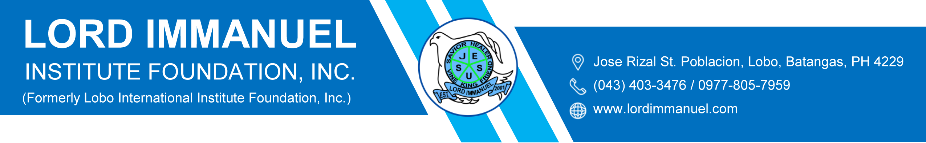

Action Plan for Flagship Team
S.Y. 2022-2023

FACULTY and CURRICULUM
DEVELOPMENT TEAM
Team Leader: Ani Pearl M. Panganiban
Members: John Daniel Abarquez
Arianne Alona B. Bañados

ACTION PLAN
SY 2022 – 2023
AREAS OF CONCERN | OBJECTIVES | STRATEGIES/ACTIVITIES | TIME FRAME | RESOURCES |  |  | FUNDING SOURCE | EXPECTED OUTCOME
 |  |  |  | FUND | HUMAN | MATERIAL/S
FACULTY and  CURRICULUM  DEVELOPMENT  TEAM | 1. Develop professionally competent teachers | 1. Attend trainings and webinars in relation to the subject taught along with Christian values. | Scheduled INSET by PEAC  Year  Round |  | Teachers  Principal  Academic Consultant | Books  Professional magazines | School  Fund | Developed, competent, dedicated, and Spirit-filled teachers
 |  | 2. Conduct in-service trainings based on needs.
 |  | 3. Read professional books, magazines, and Christian references.
- Attend post graduate studies.
(Ms. Sharmaine Dawn M. Ayano finished 9 units of Master’s degree.
Mrs. Rachel T. Ingco is currently taking 18 units of education.)
 |  | - Conduct seminars in relation to English Language Proficiency
 | 2. Fill gaps in student’s entry and exit skills in different subject areas | 1. Administer Pre – Test and Post test  2. Administer intervention program | August  To  April | Php 2,000 | Teachers | Pre-Test and Post-Test Questionnaires | School Fund | Gathered data for intervention
 | 3. Provide a variety of activities for effective teaching and learning aligned with the school’s vision, mission and philosophy for holistic student development | 1. Integration of the Bible in every subjects taught (hymns for poetry; history; Kingdom education | August  To  April |  | Teachers | www.lared.org  Survival Quest  Character Quest  www.biblegateway.com | School  Fund | Academically- competent learners equipped with physical and social skills and desired Christian values  Developed 21st century teachers
 |  | 2. Conduct of activities (curricular and co – curricular)  a. Hold academic contests and skills competition such as  • English and Filipino Contest  - Essay Writing  - Poster Making  - Postlog  • Campus Journalism  - Faculty, staff and parents  - Science  - Quiz bee  - Poster Making  - Slogan Contest  - Essay Writing | August  To  April |  | Students  Principal  Parents  Teachers  Principal  Teachers  Academic Consultant | K to 12 Curriculum Guides  Bible  Research Materials
 |  | 3. Use of Learning Materials and Teaching Guides aligned with the K to 12 Curriculum, specifically Most Essential Learning Competencies (MELCS).
 |  | 4. Utilization of the books introduced by Dr. Nancy Hameloth (English) |  |  |  | Professional Books
 |  | 5. Utilization of Purpose Driven Life (Filipino) | Every last Thursday of the Month |  | Teachers  Students | Purpose Driven Life Books (Tagalog Version)
 |  | 6. Meeting with the teachers to discuss different strategies used in the classroom teaching | Every Monday of the month |  | Principal  Teachers | Research Materials
Prepared by:
JOHN DANIEL ABARQUEZ  Member |  | ARIANNE ALONA B. BAÑADOS  Member
ANI PEARL M. PANGANIBAN
Team Leader

