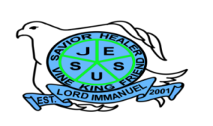
Republic of the Philippines

Department of Education
Region IV – A CALABARZON
Division of Batangas
DISTRICT OF LOBO
LORD IMMANUEL INSTITUTE FOUNDATION INC.
Jose Rizal St., Poblacion, Lobo, Batangas
www.lordimmanuel.com

ACCOMPLISHMENT REPORT
ALUMNI RELATION TEAM
S.Y. 2019-2020

The Alumni Relation Team aims on establishing and maintaining good relationship between the alumni and the school. It also helps the school in keeping track of the whereabouts of the alumni.

Some of the major accomplishments of the team were the following:

- Connection with other alumni through school’s website
- Provided monthly assistance amounting to P500 to ten alumni studying at Batangas City
- Provided financial support for college education of one (1) alumnus including tuition fees, miscellaneous fees, board and lodging and other school related expenses.

In addition to these accomplishments, we are aiming to conduct a Grand Alumni Homecoming for us to be reunited and to raise funds for the construction of the school’s covered court.

Prepared by:

SHARMAINE DAWN M. AYANO JANET H. CLARETE
Member Member

ANGIE C. RAMIREZ
Team Leader

