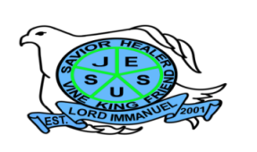
Republic of the Philippines

Department of Education
Region IV – A CALABARZON
Division of Batangas
DISTRICT OF LOBO
LORD IMMANUEL INSTITUTE FOUNDATION INC.
Jose Rizal St., Poblacion, Lobo, Batangas
www.lordimmanuel.com

ACCOMPLISHMENT REPORT
STUDENTS AND FAMILY AFFAIRS TEAM
S.Y. 2019-2020

The Students and Family Affairs Team is a group of teachers who monitors and evaluates students’ behavior and the possible causes of students’ misbehavior that affects their academic performance.
The team also conducted activities that developed students’ relationship with one another.
For the School Year 2019-2020, the team members who are dedicated doing the responsibility to hone students were Mrs. Roselle D. Sarmiento, Ms. Windel M. Diona, and Mr. Reymark D. Untalan.

Highlights of the Accomplishment

- Conducted “Pista sa Nayon” as an entrepreneurial activity
- Conducted appropriate intervention and counseling to students who have failing grades
- Conducted Parent-Teacher Fellowship at the end of each quarter
- Provided each student a copy of the handbook to both parents/guardians and students
- Conducted orientation about the School Rules and Regulation as stated in Parents-Student Handbook
- Administered survey questionnaire to identify student-at-risk
- Conducts year-round Chapel Day

Prepared by:

WINDEL M. DIONA REYMARK D. UNTALAN
Member Member

ROSELLE SARMIENTO
Team Leader

