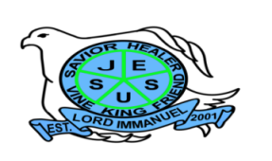
Republic of the Philippines

Department of Education
Region IV – A CALABARZON
Division of Batangas
DISTRICT OF LOBO
LORD IMMANUEL INSTITUTE FOUNDATION INC.
Jose Rizal St., Poblacion, Lobo, Batangas
www.lordimmanuel.com

ACCOMPLISHMENT REPORT
TECHNOLOGY and MEDIA TEAM
S.Y. 2019-2020

For this School Year 2019-2020, Technology and Media Team is very hands-on in doing their responsibility and achieving their objectives stated as follows:

- To develop student’s technological skills according to their grade level using multi-media
- To develop Journalists and English writers(Salt and Light)
- To disseminate information to stake holders
- To organize and secure the archives and files
- To develop a timely souvenir program and yearbook for the graduated students

The team highlights the following achievements:
- School Paper Organization
Together with the Faculty and Curriculum Team, the Technology and Media Team organized members of the Salt and Light-the official school publication of Lord Immanuel.
- Safe-keeping of files and archives
The team was able to cover events and keep it in the school archives. Some of these events were the oath-taking ceremony of the newly-elected Parent-Teacher Fellowship, traditional picture-taking with national flag, intramurals, and oath-taking ceremony of the newly-elected Servant Leaders for Christ Officers.
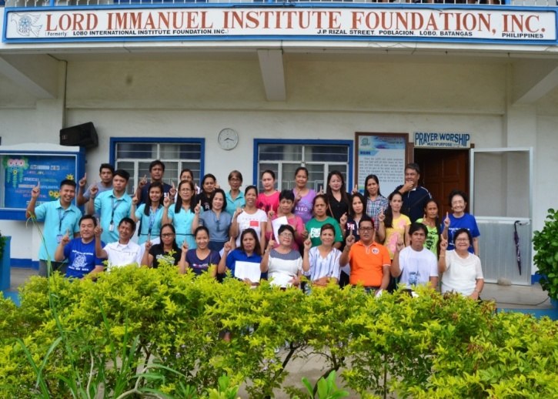
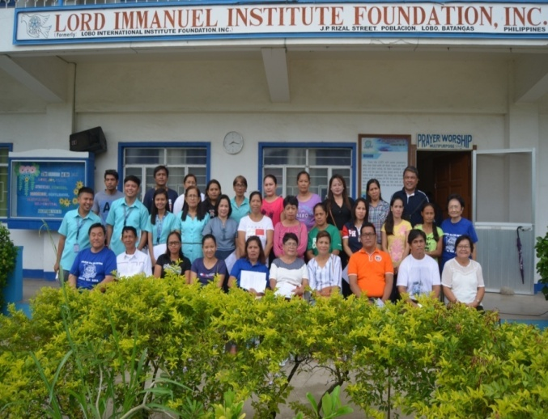

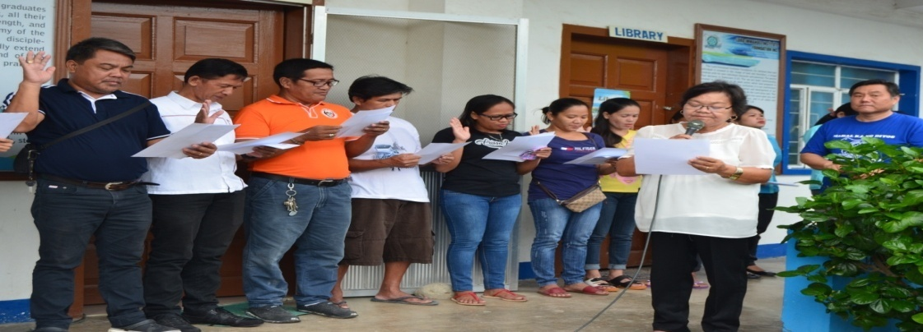
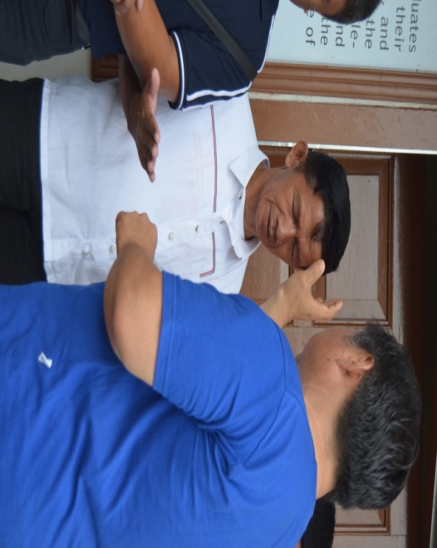

Oath Taking of PTF Officers

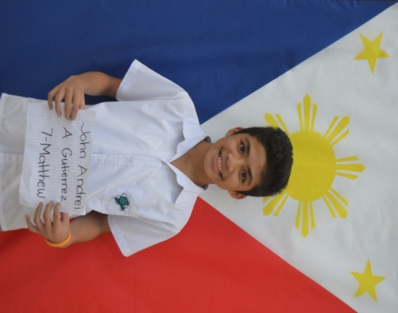
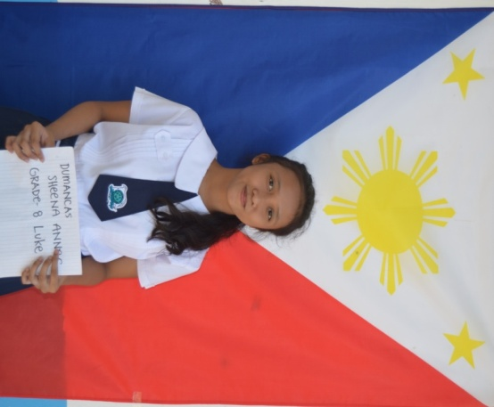
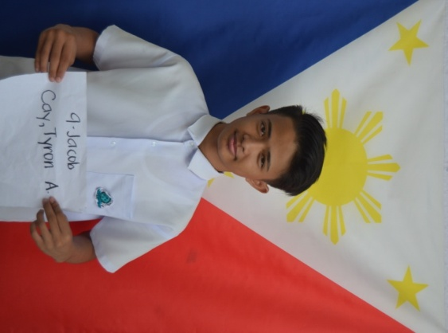

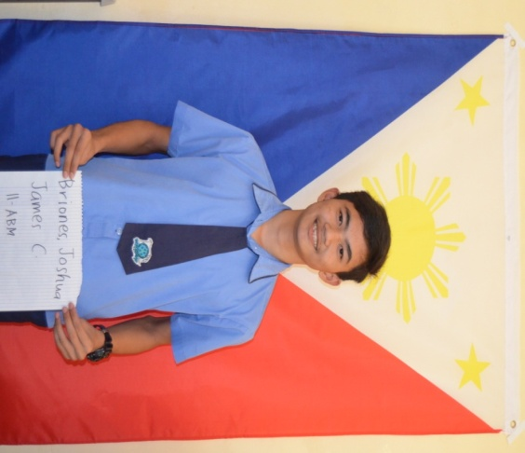
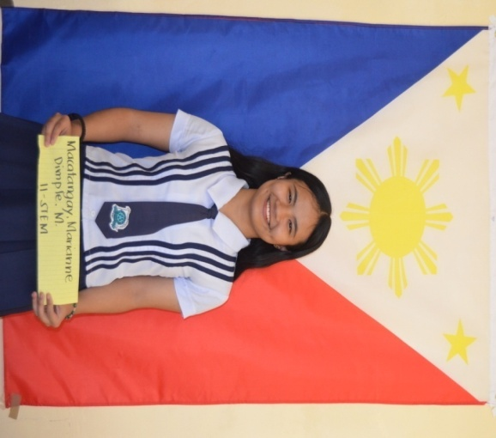
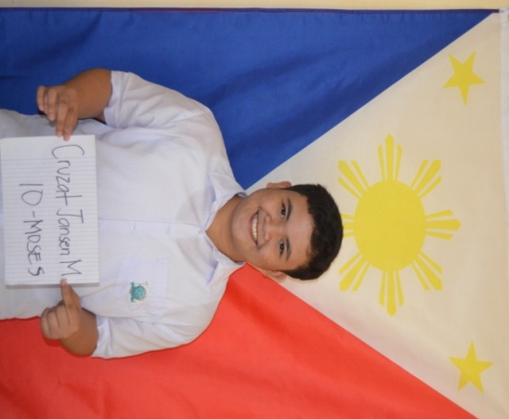

STUDENTS PICTURE TAKING WITH PHILIPPINE NATIONAL FLAG

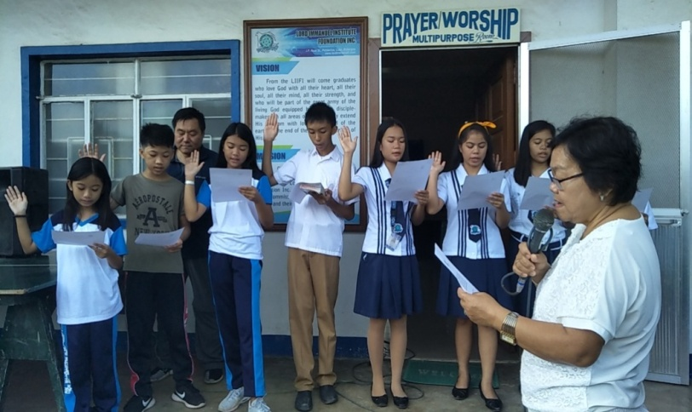
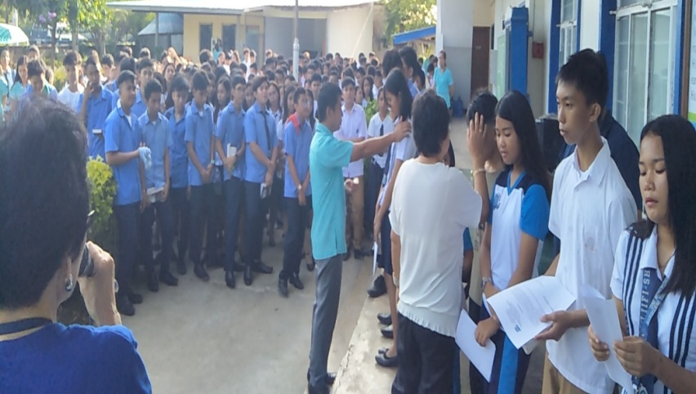

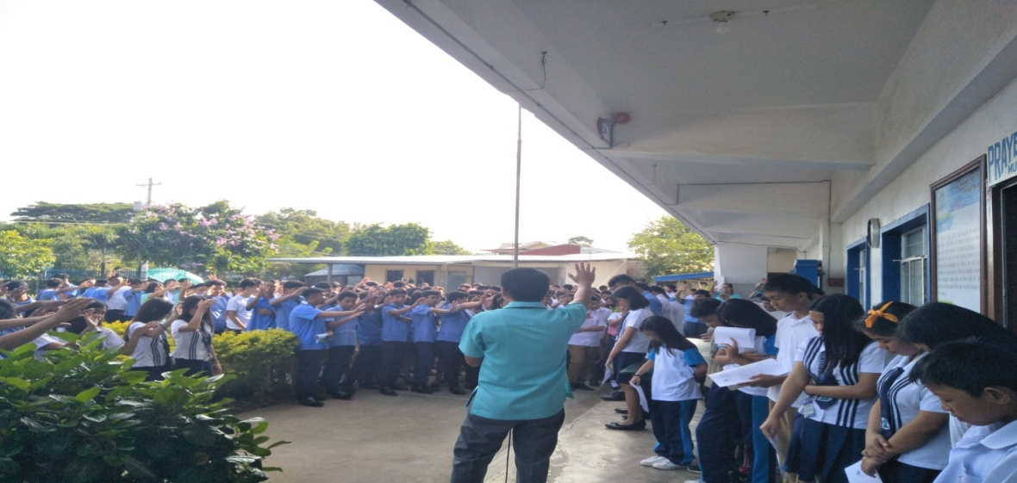

OATH TAKING FOR NEW SLC OFFICERS 2019-2020

Prepared by:

GAYMARIE I. CAEG PATHIMA MACARAIG
Member Member

JENNY ROSE U. CAGUICLA
Team Leader

