Republic of the Philippines

Department of Education
Region IV – A CALABARZON
Division of Batangas
DISTRICT OF LOBO
LORD IMMANUEL INSTITUTE FOUNDATION INC.
Jose Rizal St., Poblacion, Lobo, Batangas
www.lordimmanuel.com

ACCOMPLISHMENT REPORT
PRAISE AND WORSHIP TEAM
S.Y. 2019-2020

Praise God for another fruitful month of ministry! It has been amazing to see how God has been working in both the music and technical worship ministries in school. We have chosen a few key highlights which give some insight into what we have been doing this year.

As a team, our goal this year has been the development of the worship leaders in Lord Immanuel. Every month we have met together to study and pray, and encourage one another. We are blessed to have an amazingly talented team of worship leaders in Lord Immanuel and all of them have developed throughout the year. We have been impressed as we listen to their heart for the students of Lord Immanuel and by their vulnerability as they shared their joys and frustrations with one another.

Much of our gatherings centered on the book Exploring God. Throughout the year we covered key topics such as the Trinity, the Cross, Scripture and other practical areas of the Bible as they relate to spiritual growth and relationship with Christ. We believe that theology (what we know about God) should propel our doxology (our worship of God). We all found great value in drilling into the essentials of our faith in Christ.

Above all, Lord is gracious to us for we experienced a spectacular event like the FESTIVAL OF TALENTS that showcased the God – given talents of the students and glorify God. It was held last December 6, 2019. The event was a partnership between the Lord Immanuel and the Parent Teacher Fellowship under the leadership of Mr. Amador Sulit, the PTF President and Executive Producer, Mrs. Marites Artillaga. We are truly honored to be part of this event.

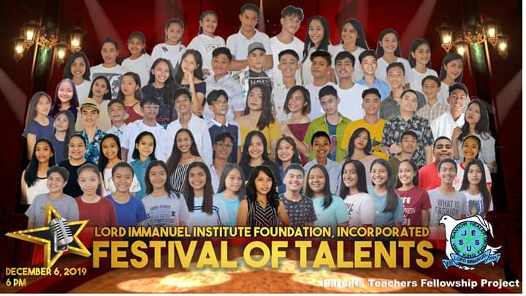

Prepared by:

ANGELIKA JOICE A. PANALIGAN JAN RIO M. ADOPTANTE
Member Member

SHARMAINE DAWN AYANO
Team Leader

