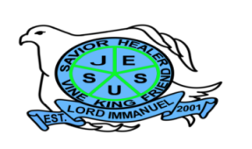
Republic of the Philippines

Department of Education
Region IV – A CALABARZON
Division of Batangas
DISTRICT OF LOBO
LORD IMMANUEL INSTITUTE FOUNDATION INC.
Jose Rizal St., Poblacion, Lobo, Batangas
www.lordimmanuel.com

ACCOMPLISHMENT REPORT
DISCIPLE – MAKING TEAM
S.Y. 2019-2020

Ultimately, the objective of the Disciple-Making Team is to spread and share the word of God to its internal and external stakeholders. The team was led by Pastor Joriel S. Asi, together with Ms. Katrine Mae Cay and Ms. Rose Anne Abdon.

For the SY 2019-2020, the Disciple-Making Team was able to conduct activities in partnership with other churches for kingdom building here in Lobo. Some of the highlights of the team’s activities were the following:

- Conducted Bahay-Bahay Sagip Buhay Program to 9 barangays
It was an Evangelism Project of the Lord Immanuel which aims to reach the communities in Lobo to share the Word of God.
- Conducted training for the Lord Immanuel students and alumni for mission mobilization.
- Established partnership with Baptist Bible College of Asia.

- Presented the gospel during General PTF Meeting and Homeroom PTF Meeting.
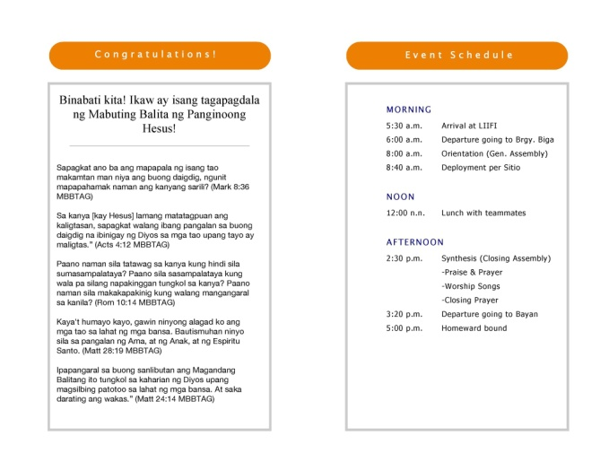
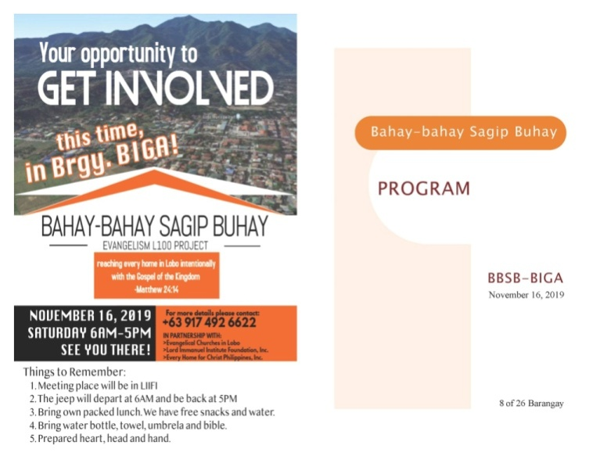

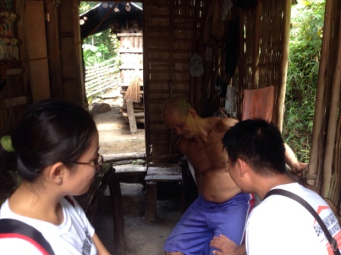
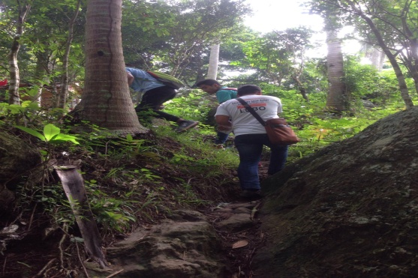

The Bahay-Bahay Sagip Buhay,an Evangelism Project of Lord Immanuel that aims to reach the communities in Lobo of the Word of God. Last November 16, 2019, they conducted evangelism in Brgy. Biga.
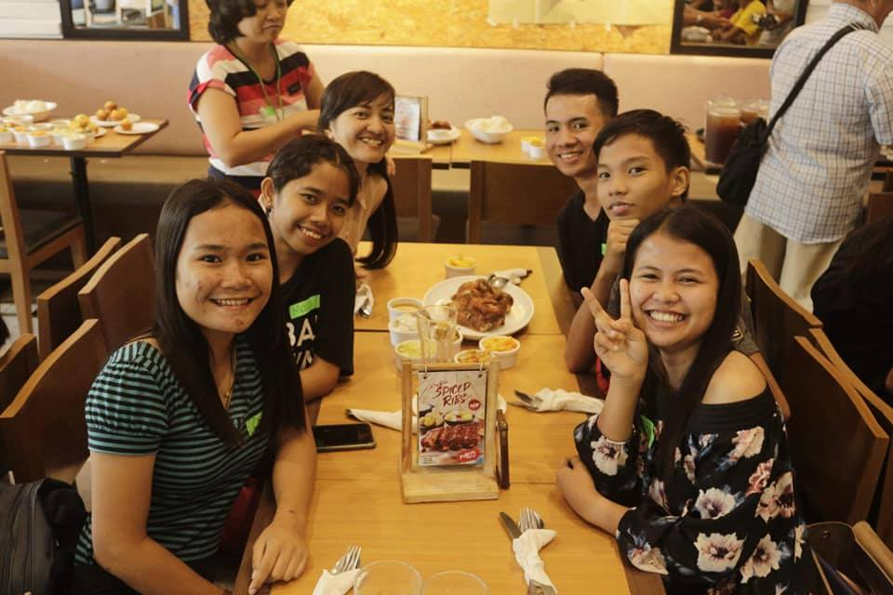

The Lord Immanuel Alumni and students attend training for mission mobilization.
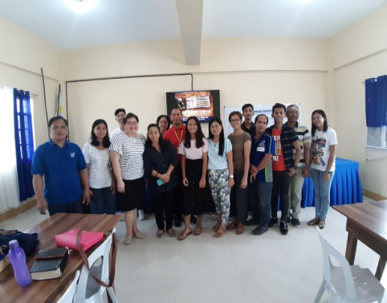
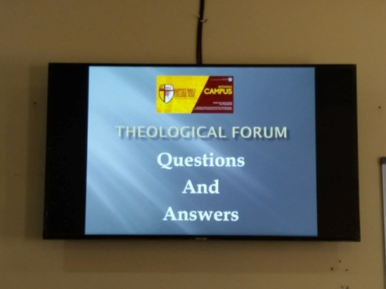
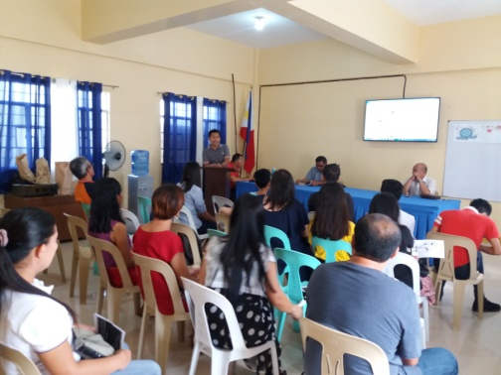

The Lord Immanuel with the partnership of Baptist Bible College of Asia was having Bible College classes during Friday and Saturday.

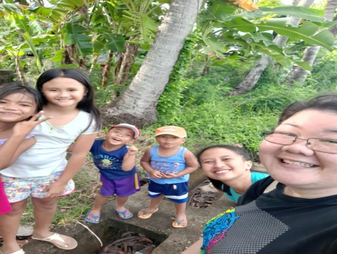
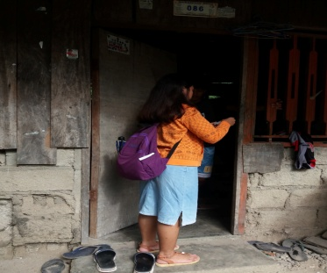

Part of their curriculum the students of BBCA shared their experiences and stories to the local.

Prepared by:

ROSE ANN ABDON KATRINE MAE CAY
Member Member

JORIEL S. ASI
Team Leader

