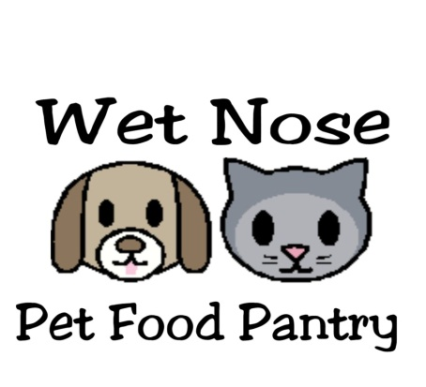WISH LIST

* Dry and wet cat and dog food
* kitty litter and litter scoopers
* paper towels/napkins * unscented baby wipes
* carpet stain remover *general household cleaner
* large sturdy zip lock bags
* gift cards for PetSmart, Pet Supplies Plus, Amazon
Walmart, Meijer, Target
* monetary donations can be mailed to the Lemont address or sent via PayPal (friends and family) to wetnosepetfoodpantry@gmail.com
Zelle: 630-967-4502 venmo : photocat79

Donations can be dropped off or mailed to 4950 Rose Ave Downers Grove, IL 60515

OUR MISSION IS TO HAVE THE 4-LEGGED FAMILY MEMBERS OF THOSE IN NEED HAVE FULL BELLIES AT EVERY MEAL
www.wetnosepetfoodpantry.webstarts.com we are on FB.
wetnosepetfoodpantry@gmail.com

