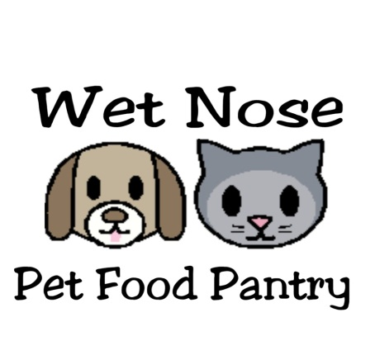WISH LIST
Food
*dry cat and dog *wet cat and dog
Animal Care Supplies
*kitty litter (clumping or non) *kitty litter scoopers *brushes/combs
*cat and dog toys *paper towels/napkins *carpet stain remover *baking soda
General items
*stamps *copy paper *envelopes *HP65 Ink
*large sturdy zip lock bags * empty ink cartridges (they get recycled for store credit)
*gift cards for Petsmart, Pet Supplies Plus, Target and Walmart
*monetary donations (our PayPal email is wetnosepetfoodpantry@gmail.com)

If you want to send food and supplies but aren’t able to drop items off, a wish list was created at Target. TGT.GIFTS/WETNOSEPETFOODPANTRY

OUR MAIN GOAL IS TO HAVE THE 4-LEGGED FAMILY MEMBERS OF THOSE IN NEED HAVE FULL BELLIES AT EVERY MEAL
www.facebook.com/wetnosepetfoodpantry
wetnosepetfoodpantry@gmail.com

