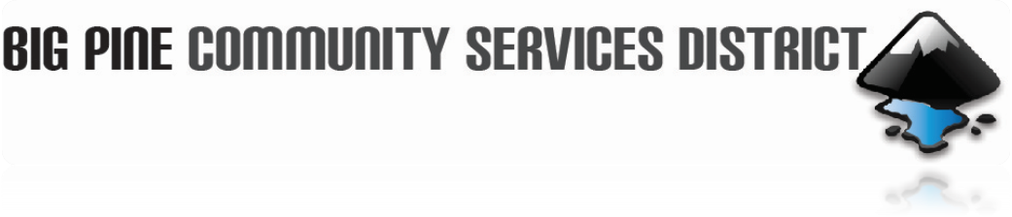

December 18, 2024

Board of Director’s Meeting

AGENDA

CALL TO ORDER:

APPROVAL OF DISCONNECTION FROM SEWER – Colleen Randolph

PRESENTAION AND QUESTIONS AND ANSWERS - Christie Martindale, Inyo County Auditor’s office

PUBLIC COMMENTS & PUBLIC HEARING – Any member of the public may present comments regarding subjects related to the operation of the Big Pine Community Service District at this time. State Law prohibits the Board from taking action on any item until it has been placed on the agenda.

MINUTES – Approval of the Minutes for the November 20, 2024 meeting.

BILLS & WARRANTS – Approval of Bills and Warrants from Nov. 20, 2024 through Dec. 13, 2024.

CORRESPONDENCE: -

OLD BUSINESS:
- Staff Report - Denise Tetrick
  - Community feedback from meter reading Error.
  - Water Boards Invoice - Motion to approve $28,205.00.

- Report from Dave Tanksley.
- Motion to approve Fat, oils, and grease, control program.
- Lead and Copper Rule.
- Water and sewer system.
- Alternate insurance

- Update on P1, R2 Aeration.
- Update on P2, R1 Sludge Bed Project.

NEW BUSINESS:
  - Part-time administrative secretary.

FUTURE AGENDA ITEMS
- Staff Report.
- Report from Dave Tanksley.
- Groundwater Monitoring Plan (OVGA) update.
- Updates on P 1, R1 Grant Implementation with IRWMP update.
- Update on P1, R2 Grant.
- P1, R2 Sludge Bed Project.
- Lead and Copper Rule
- Fat, oils, and grease control program.

OTHER – Closed meeting, if needed.

NEXT MEETING - The next regular meeting is scheduled for Wednesday, January 15. 2025, unless otherwise posted.
ADJOURNMENT –
180 N. Main Street
P.0. Box 639
Big Pine, CA 93513
Phone: 760.938.2660
Fax: 760.938-2253
Email: contactus@bigpinecsd.com

