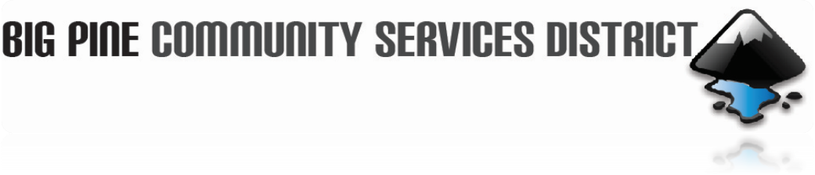

October 16, 2024

Board of Director’s Meeting

AGENDA
CALL TO ORDER:

PUBLIC COMMENTS & PUBLIC HEARING – Any member of the public may present comments regarding subjects related to the operation of the Big Pine Community Service District at this time. State Law prohibits the Board from taking action on any item until it has been placed on the agenda.

MINUTES – Approval of the Minutes for the September 18, 2024 meeting.

BILLS & WARRANTS – Approval of Bills and Warrants from Sept. 23, 2024 through Oct. 9, 2024.

CORRESPONDENCE: -

OLD BUSINESS:

- Staff Report - Denise Tetrick
  - Added a code to Sewer unit for billing purposes on grants 3 and maybe a transfer from ACO.
  - Letter sign for the grant agreement extension request.
  - December 18th Christie Martindale will attend the board meeting for budgets.
  - Certificate of Election and Oath of Office.

- Report from Dave Tanksley.
- Fat, oils, and grease, control program.
- Lead and Copper Rule.
- Water and sewer system.

- Groundwater Monitoring Plan (OVGA) up-date.
- Update on P 1, R1 Grant Implementation with IRWMP update.
- Update on P1, R2 Grant.
- Sludge Bed Project.

NEW BUSINESS:
  - Vote for new member for Big Pine CSD board.
  - Part-time administrative secretary.

FUTURE AGENDA ITEMS
- Staff Report.
- Report from Dave Tanksley.
- Groundwater Monitoring Plan (OVGA) update.
- Updates on P 1, R1 Grant Implementation with IRWMP update.
- Update on P1, R2 Grant.
- Sludge Bed Project.

OTHER – Closed meeting, if needed.

NEXT MEETING - The next regular meeting is scheduled for Wednesday, November 20. 2024, unless otherwise posted.

ADJOURNMENT –

180 N. Main Street
P.0. Box 639
Big Pine, CA 93513
Phone: 760.938.2660
Fax: 760.938-2253
Email: contactus@bigpinecsd.com

