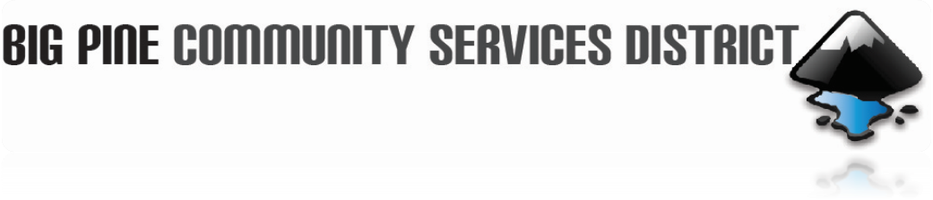

September 18, 2024

Board of Director’s Meeting

AGENDA
CALL TO ORDER:

PUBLIC COMMENTS & PUBLIC HEARING – Any member of the public may present comments regarding subjects related to the operation of the Big Pine Community Service District at this time. State Law prohibits the Board from taking action on any item until it has been placed on the agenda.

MINUTES – Approval of the Minutes for the August 21, 2024 meeting.

BILLS & WARRANTS – Approval of Bills and Warrants from Aug. 21, 2024 through Sept. 11, 2024.

CORRESPONDENCE: - Approval letter for 2024 Bacteriological Sample Siting Plan

OLD BUSINESS:

- Staff Report - Denise Tetrick
  - Signature Authorization form.
  - Denise’s reimbursement for office supplies.
  - Workplace Violence Prevention.
  - BryAnna’s Reimbursement.
  - New meter for water on 395.
  - Disconnect Notices.

- Report from Dave Tanksley.
- Fat, oils, and grease, control program.
- Backflow Device test.
- Lead and Copper Rule.
- Inventory for SDRMA insurance.

- Groundwater Monitoring Plan (OVGA) up-date.
- Update on P 1, R1 Grant Implementation with IRWMP update.
- Update on P1, R2 Grant.
- Sludge Bed Proposal.

NEW BUSINESS:

FUTURE AGENDA ITEMS
- Staff Report.
- Report from Dave Tanksley.
- Groundwater Monitoring Plan (OVGA) update.
- Updates on P 1, R1 Grant Implementation with IRWMP update.
- Update on P1, R2 Grant.
OTHER – Closed meeting, if needed.

NEXT MEETING - The next regular meeting is scheduled for Wednesday, October 16. 2024, unless otherwise posted.

ADJOURNMENT –

180 N. Main Street
P.0. Box 639
Big Pine, CA 93513
Phone: 760.938.2660
Fax: 760.938-2253
Email: contactus@bigpinecsd.com

