Mental Health in New York

This fact sheet provides an overview of mental health and substance use disorders in New York, including mental illness during the COVID-19 pandemic, trends in drug overdose death rates and suicide death rates, and coverage and access issues. For comparison, national level data are also included.

Mental Illness Prevalence
Mental illnesses can be acute or chronic and are diagnosable conditions that affect an individual’s emotional, psychological, and social well-being, and often their behavior. These conditions include depression, anxiety, schizophrenia, and mood or personality disorders, among others.
In light of the COVID-19 pandemic, mental health conditions have been exacerbated. Many adults in the U.S. reported symptoms of anxiety and/or depression, with approximately four in ten adults reporting these symptoms in early 2021, before declining to approximately three in ten adults as the pandemic continued.
- As shown in the figure below, from February 1 to 13, 2023, 31.4% of adults in New York reported symptoms of anxiety and/or depressive disorder, compared to 32.3% of adults in the U.S.

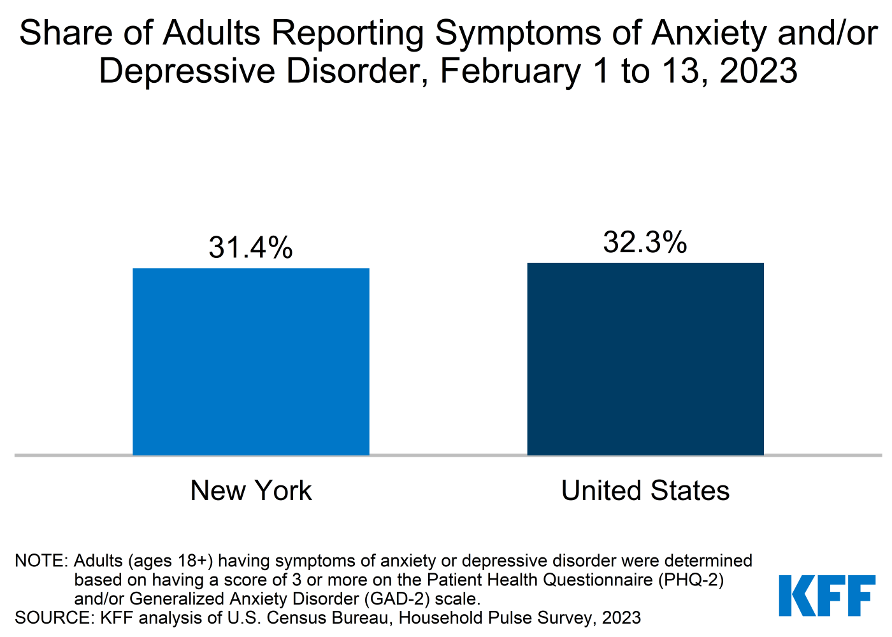

- In 2021, 20.1% of adolescents (ages 12-17) and 8.3% of adults in the U.S. reported having a major depressive episode in the past year.

Substance Use and Deaths
Substance use disorder is using illicit drugs or meeting criteria for alcohol dependence or abuse, defined based on a person reporting a “pattern of substance use leading to clinically significant impairment or distress.” The pandemic has coincided with an increase in substance use and increased death rates due to substances. In 2021, there were over 106,600 deaths due to drug overdose in the U.S.– the highest on record. This marks a 51% increase in drug overdose deaths from prior to the pandemic (there were over 70,630 deaths in 2019). The uptick in substance use and deaths disproportionately affects many people of color. While white people continue to account for the largest share of deaths due to drug overdose per year, people of color are accounting for a growing share of these deaths over time.
- As shown in the figure below, drug overdose death rates have increased in New York from 9.7 per 100,000 in 2011 to 28.7 per 100,000 in 2021. Over the same period, drug overdose death rates increased from 13.2 to 32.4 per 100,000 in the U.S.

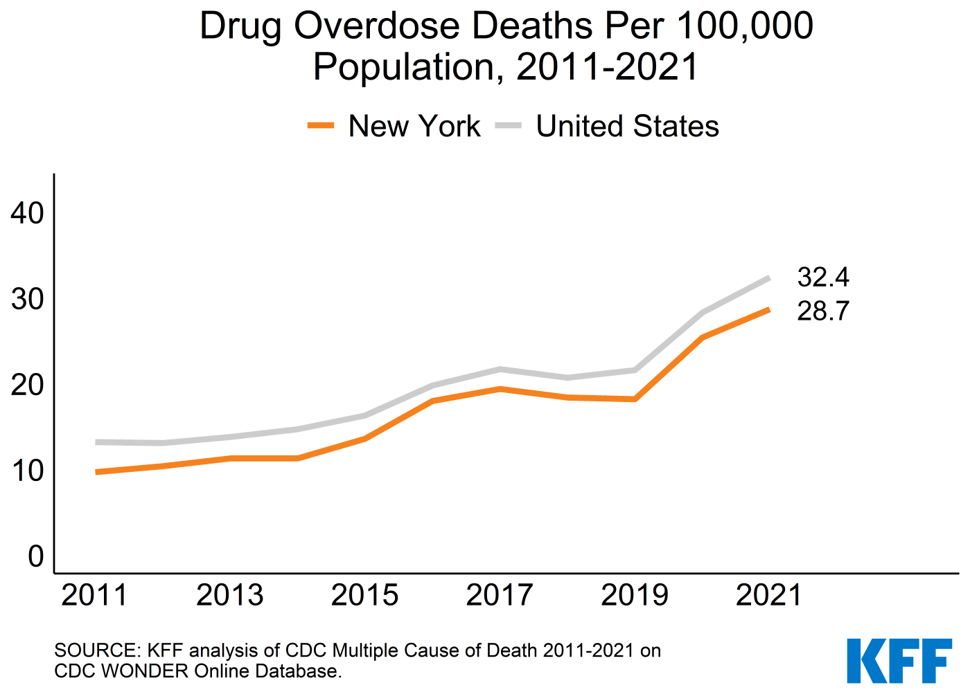

Opioid overdoses are the primary driver of increases in drug overdose deaths. In 2000, opioid overdoses represented 48% of drug overdose deaths in the U.S.; by 2021, they represented 75% of these deaths. The national opioid epidemic began with an increase in deaths from opioid prescriptions through the early 2000s, followed ten years later by a steep increase in deaths from heroin overdose, and shortly thereafter an even sharper increase in deaths from synthetic opioid overdose. The U.S. saw improvement in opioid-related death rates from 2017 to 2018, before they sharply accelerated during the pandemic and with increases in illicit fentanyl.
- In 2021, there were 4,946 opioid overdose deaths in New York, which accounted for 85% of all drug overdose deaths in the state. Across the U.S., opioid overdose deaths accounted for 75% of all drug overdose deaths in the country in 2021.
- As shown in the figure below, from 2011 to 2021, the age-adjusted death rate due to opioid overdose increased from 6.8 per 100,000 to 24.5 per 100,000 in New York. Over the same period, the age-adjusted death rate increased from 7.3 per 100,000 to 24.7 per 100,000 in the U.S.

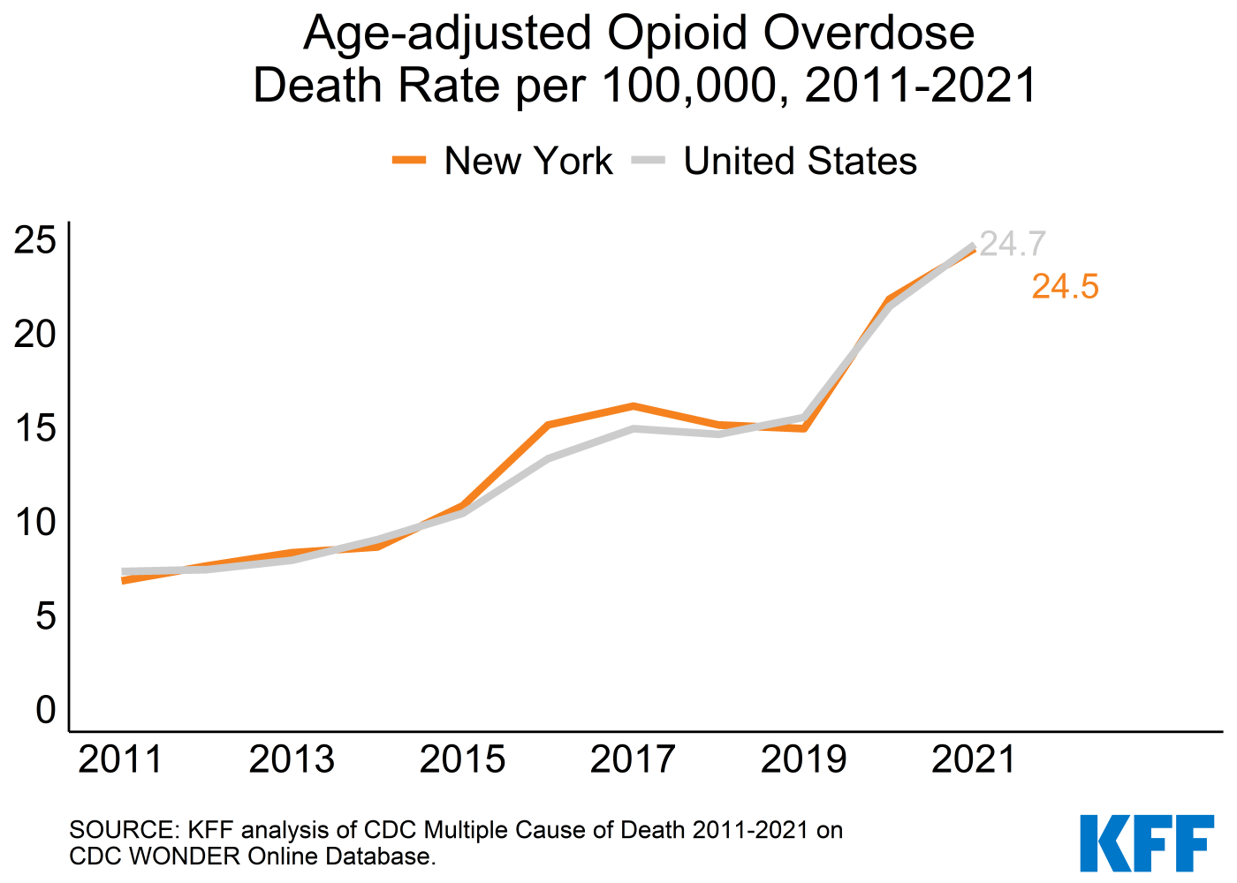

Suicide
Nationally, over half a million lives have been lost to suicide since 2010, making it a serious public health concern. The number of suicide deaths in the U.S. peaked in 2018 (48,344 deaths) and slightly decreased in 2019 and 2020 before increasing again in 2021 (48,183 deaths). Suicide deaths have increased fastest among people of color, younger individuals, and people who live in rural areas. Suicidal ideation has also been a concern throughout the pandemic. In 2021, 4.8% of adults and 12.7% of adolescents (ages 12-17) in the U.S. reported serious thoughts of suicide in the past year. Nationally, suicide deaths by firearm accounted for 55% of all suicide deaths in 2021.
While suicide is often linked to underlying mental health conditions, that is not always the case, as a combination of factors generally contribute to an individual having thoughts of suicide or attempting suicide. Risk factors can include isolation, relationship struggles, financial or housing insecurity, or problems with physical health.
- As shown in the figure below, New York’s age-adjusted suicide rate was lower than the national level in 2021.

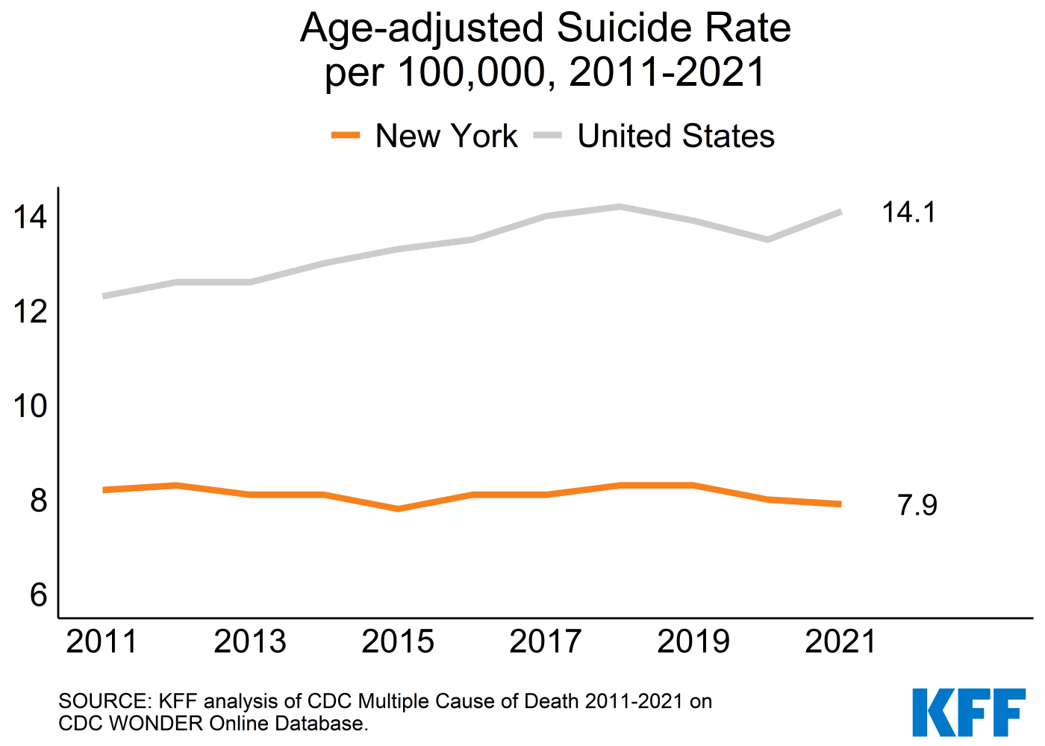

- As shown in the figure below, in 2021, New York’s suicide death rate by firearm (2 per 100,000) was lower than the suicide death rate by other means (5.9 per 100,000). In the U.S., the suicide death rate by firearm (7.5 per 100,000) was higher than the suicide death rate by other means (6.5 per 100,000).

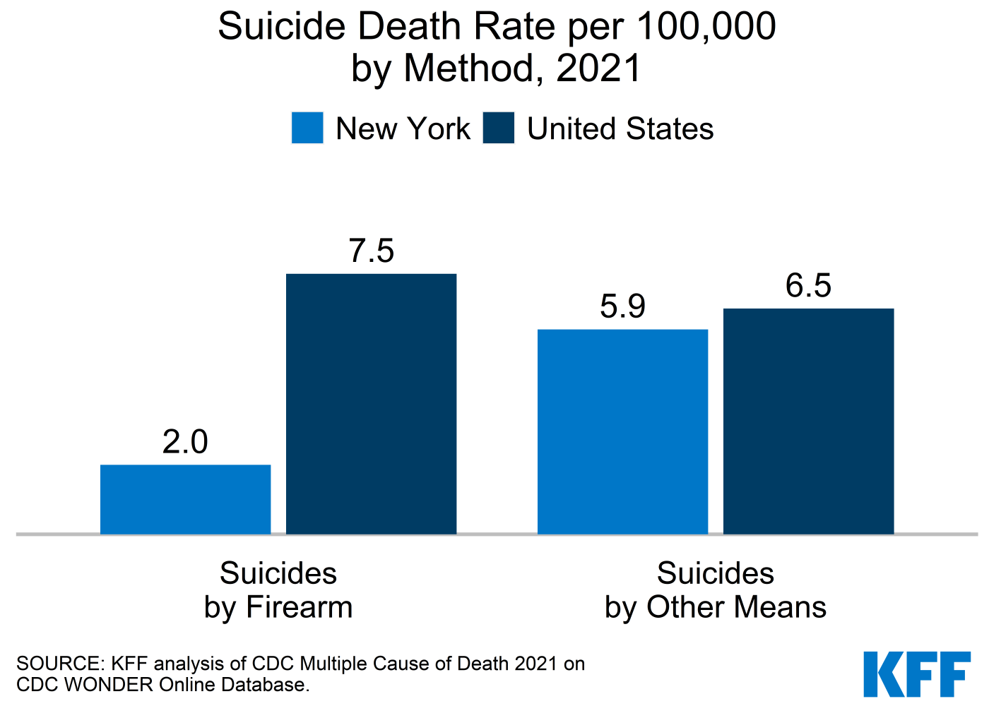

- In 2020, suicide was the second leading cause of death among adolescents (ages 12-17) across the U.S.
- In the U.S., the share of high school students who seriously considered attempting suicide was 22% in 2021.

Mental Health Workforce
Mental health professionals include psychiatrists, psychologists, psychiatric nurses, addiction counselors, and mental health or family and marriage counselors. Many people in need of mental health care or substance use treatment are unable to access it in a timely manner due to provider shortages, particularly in rural areas. There is concern that these provider shortages may be more pronounced due to increased demand during the pandemic. However, the recent shift toward telemedicine for mental health services may alleviate some issues with accessing providers.
- Health Professional Shortage Area (HPSA) designations are used to identify areas that are experiencing a shortage of health professionals. Mental health HPSA designations are primarily based on the number of psychiatrists relative to the population.
  - As shown in the table below, the percent of need for mental health professionals met in New York is 18.8%, compared to the national percent of need met (27.7%).

Mental Health Care Health Professional Shortage Areas (HPSAs), September 2022
 | Percent of  Need Met | Practitioners Needed to  Remove HPSA Designation
United States | 27.7% | 7,871
New York | 18.8% | 411
SOURCE: Bureau of Health Workforce, Health Resources and Services Administration, Designated Health Professional Shortage Areas Statistics: Designated HPSA Quarterly Summary, as of September 30, 2022.
NOTE: Percent of need met is defined as the ratio of available psychiatrists to the number needed to eliminate the HPSA designation. Calculations are based on the number of psychiatrists and do not generally include other mental health care professionals.

Unmet Need and Barriers to Care
Unmet need refers to a person having a perceived or recommended need for mental health treatment or counseling but is not receiving care. Among adults who need mental health or substance use care, some groups are more likely to face barriers to accessing care, including uninsured people, underinsured people, and communities of color.
- As shown in the figure below, in May 2022, among adults in New York who reported experiencing symptoms of anxiety and/or depressive disorder, 28.7% reported needing counseling or therapy but not receiving it in the past four weeks, compared to the U.S. average of 28.2%.

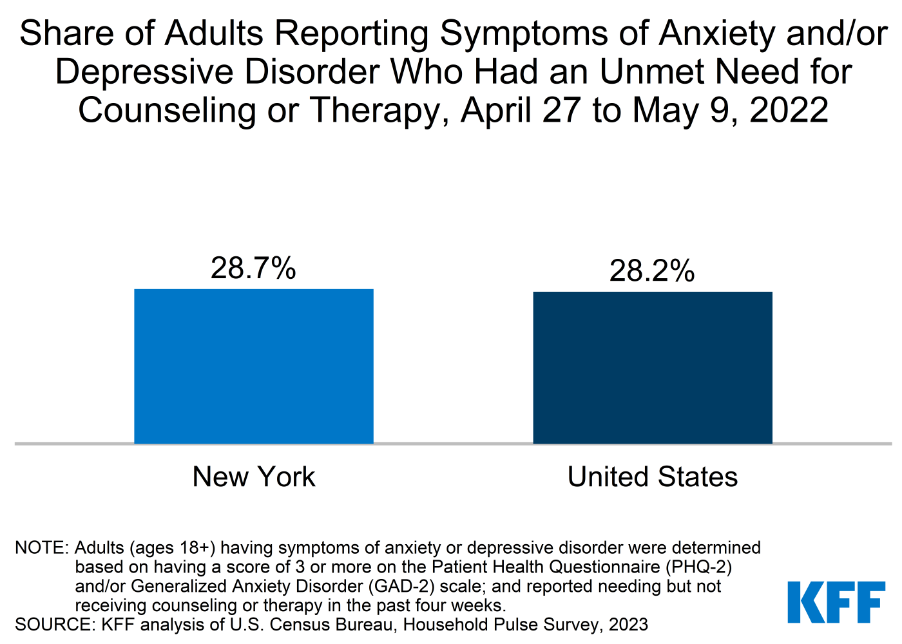

- In 2021, 9.9% of children ages 3-17 in New York received mental health care in the past year; compared to 11.2% of children in the U.S. Nationally, many children with mental health needs do not receive mental health care.

Private Insurance
The 2010 Affordable Care Act (ACA) requires coverage of mental health and substance use services as an “essential health benefit” under most health insurance plans offered in the individual and small group markets. This requirement does not apply to large group markets, but most large group plans do cover these benefits. The ACA built on the federal Mental Health Parity and Addiction Equity Act of 2008, which requires many group insurance plans that cover mental health and substance use services to do so as generously as medical and surgical services.
- In order to address the increase in mental health concerns during the pandemic, many large employers (200 or more employees) offering health insurance made changes to their mental health resources and benefits. Nationally, in 2022, 81% of large employers offered employee assistance programs (EAPs), 44% offered mental health self-care apps, and 61% added additional digital content to their wellness programs in the past two years. In 2021, 41% of large employers in the U.S. expanded the way in which enrollees could access mental health and substance use services, such as through telehealth, and 16% added or expanded their EAPs.
- Leading up to the pandemic, many adults with any mental illness were enrolled in private insurance. As shown in the figure below, in New York, 61.8% of adults with any mental illness in the past year had private insurance, compared to 59.6% of adults in the United States.

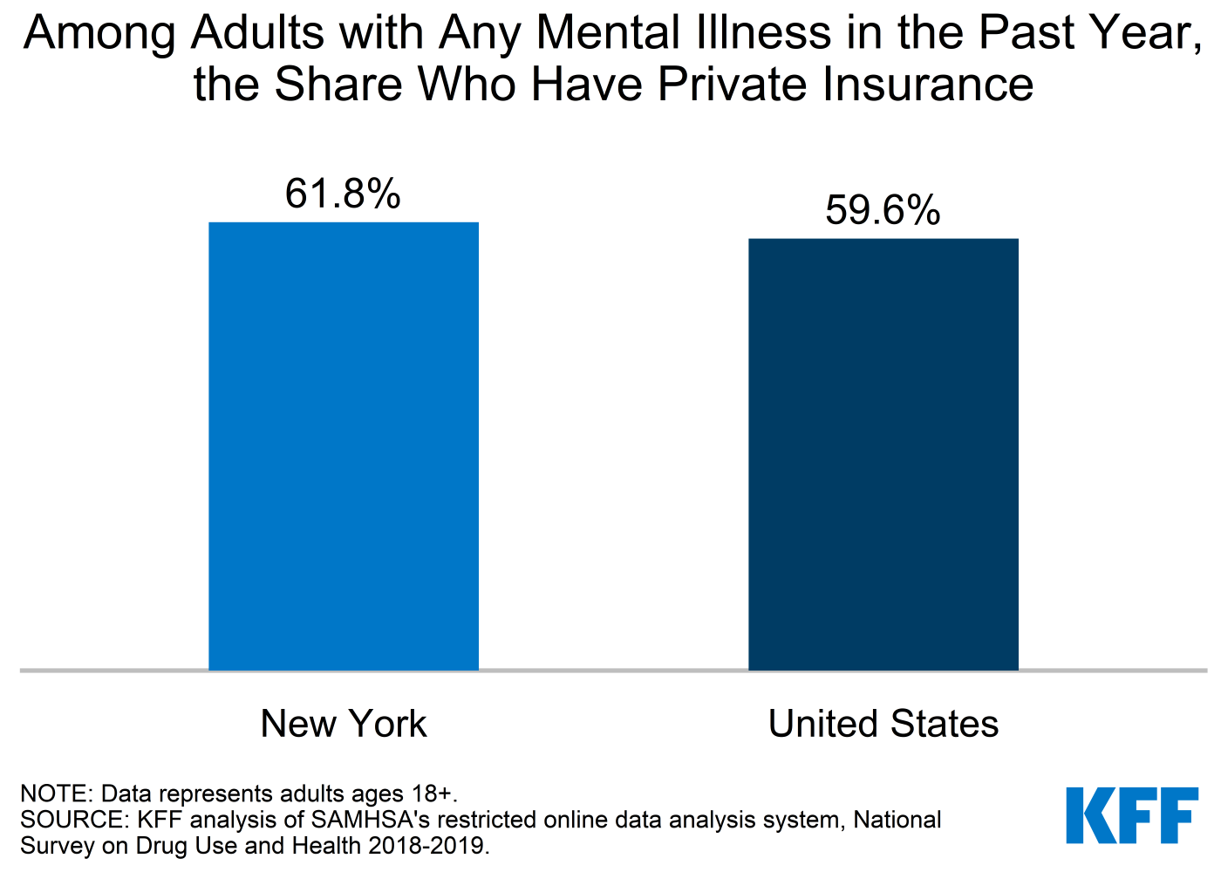

- As shown in the figure below, in 2021, the average out-of-pocket spending for all services for adults with mental illness enrolled in large employer health plans was higher than average out-of-pocket spending for adult enrollees without mental illness in New York ($1,404 vs. $652, respectively) as it was in the U.S. overall ($1,282 vs. $645, respectively). This does not include payments for services that enrollees do not claim under their employer coverage. Adults with mental illness enrolled in large employer health plans have higher average total health care spending compared to enrollees without mental illness in New York ($10,311 vs. $4,825, respectively) and in the U.S. overall ($8,823 vs. $4,198, respectively).

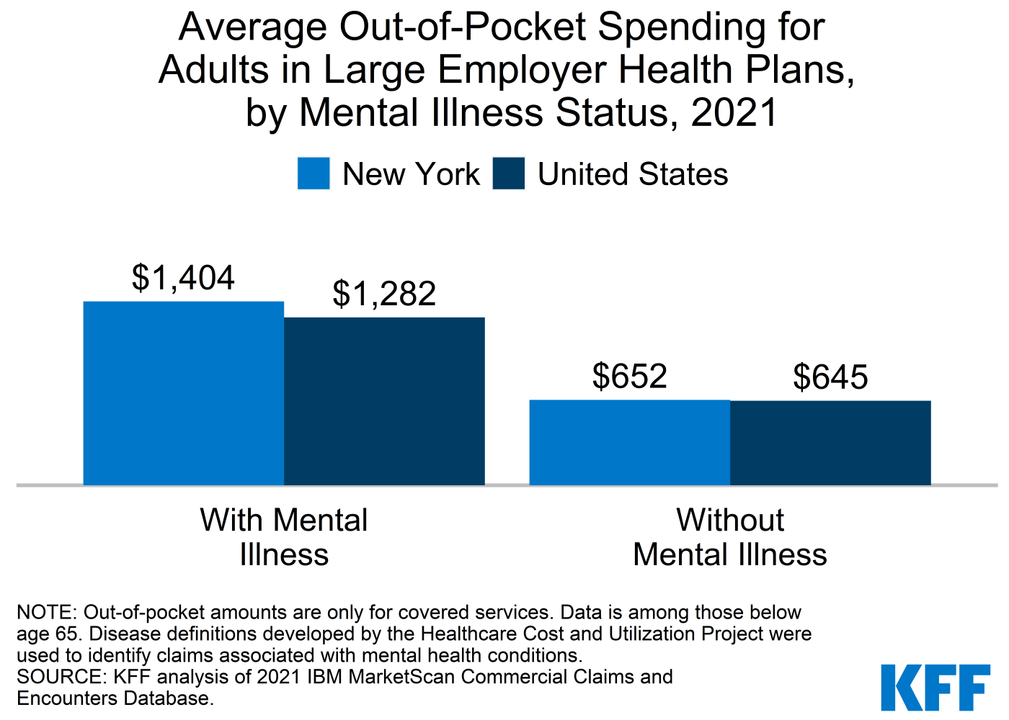
- Despite federal and state parity laws, even for people with insurance coverage, a lack of in-network options for mental health and substance use care may affect access to needed services. Nationally, in 2017, among people with large employer coverage, 20% of in-network admissions for mental health and/or substance use led to out-of-network charges.

Medicaid
Medicaid plays a key role in coverage and financing of mental health care and substance use treatment for low-income Americans. Medicaid enrollees face limited out-of-pocket expenses for care and typically have access to a broad range of mental health and substance use services.
- While most adults with mental illness have private insurance, rates of mental illness and substance use disorders are most prevalent among nonelderly adults with Medicaid.
- Many individuals, including Medicaid enrollees, delayed needed health care when the pandemic began. Data has found that among Medicaid enrollees, utilization rates for some health care services have now rebounded to pre-pandemic levels; however, utilization rates for mental health services have lagged.
- Prior to the pandemic, as shown in the figure below, 28.9% of adults with any mental illness in New York reported having Medicaid coverage in the past year.

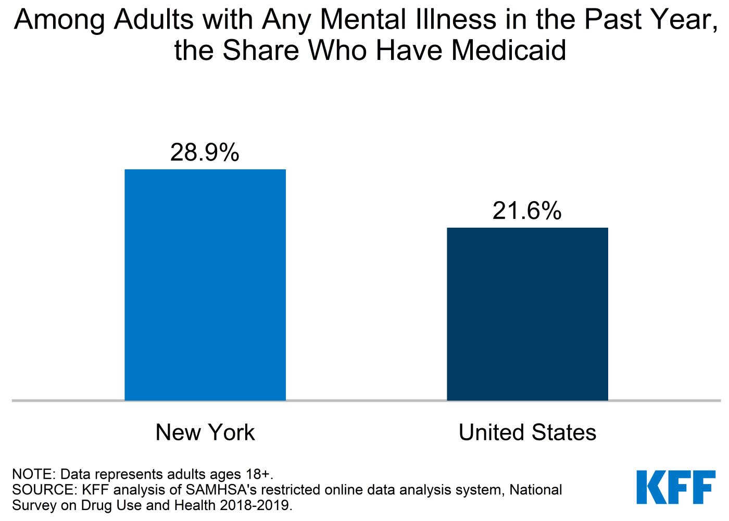

- States have flexibility in what behavioral health services are covered in Medicaid for adults. States have been expanding coverage of behavioral health services across the care continuum over time, but coverage varies across states. For a detailed look at coverage of behavioral health services across states see KFF’s Behavioral Health Services Database.

Notes
Tests measuring statistical significance were at the p<0.05 level.
For more information on Mental Health and Substance Use at the state-level, along with sources and/or methods, visit the KFF Mental Health & Substance Use Disorder State Data.
For information pertaining to COVID-19 and Mental Health, visit our analysis: The Implications of COVID-19 for Mental Health and Substance Use.
State fact sheets designed and created in RStudio by Patrick Drake and Nirmita Panchal.
This work was supported in part by Well Being Trust. KFF maintains full editorial control over all of its policy analysis, polling, and journalism activities.

