Naomi Makemie Presbyterian Church
October 8, 2023 Large Print
Onancock, VA
Our Mission Statement
​“Do what is fair and just to your neighbor, be compassionate and loyal in your love, and don’t take yourself too seriously—take God seriously.” Micah 6:8
Compassionate, Fair and Loyal​
nmpreschurch.org

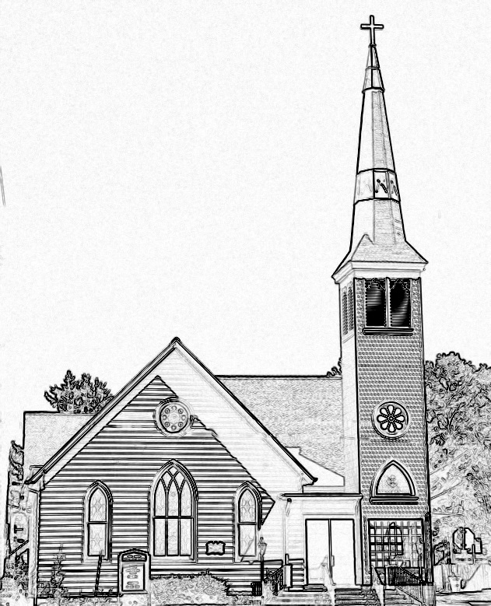

Welcome to worship! We are glad you joined us today. If you are seeking a church home, we invite you to join in the fellowship and ministry of this congregation. We look forward to seeing you again. Please fill out one of the visitor cards and drop it in the offering plate.
Prayer Concerns Carolyn Lin, Eli Chen, Meg Adams, Alicia McCarter, Suzanne Rogers, Alverna St John, John Adams, Terri Lynn Redmond, Barbara Walters, Retta Isdell, Butch Tuttle, Lois Walker

Thank you to Mark Moring for being our reader today.
Thank you to Linda Arvidson for hosting coffee hour today.

Naomi Makemie 89 Market St Onancock, VA 23417
Mailing Address- P.O. Box 397 Onancock, VA 23417
NMPresChurch.org church naomimpchurch@gmail.com

Reverend Monica Gould c-757-709-2846 mongould@gmail.com

Staff Volunteers
Organist/Pianist-Mark Nuckols Videographer – Mike Gould
Choir Director-Debbie Ryon Lead Usher – Suzanne Rogers
Office Administrator-Jennifer Stapleton Office Administrator – Jennifer Stapleton
Nursery Workers-Kamryn Mears/Emma Cathey

Elders
Class of 2023 Class of 2024 Class of 2025
Megan Ames Ron May Bill Baird
Rick Turner Linda Arvidson Patty Davis
Marsh Ryon Meg Adams Jennifer Stapleton

Naomi Makemie Presbyterian Church Onancock, VA
Mark Nuckols Reverend Monica Gould Debbie Ryon Organist/Pianist pastor Choir Director
October 8, 2023
*Asterisk is to stand in body or spirit. Bold print is congregational response.
Prelude

Welcome/Announcements

Choral Opening Come and Find a Quiet Center

Call to Worship
Come and worship, all you who love and serve our God.
who surrounds us with unfailing love, and answers us when we call;
who cares for the humble and lowly and never abandons those in need.
This is our God, worthy of our worship and praise!

Opening Prayer
Everlasting God, you have been our dwelling place in all generations. Since the creation of the world, you have nurtured us with your love. As we approach you in worship today, sear the words of your commandments in our hearts and aid us to teach them to our children from this generation to the next. In Jesus name. Amen.

*Hymn Glorious Things of Thee are Spoken #446

Young Disciples

Prayer of Confession
If we were to name all the gods we have before you, Rock of Redemption, we would be here a very long time. We elevate famous people into saviors, though they are as broken as we are. We misuse your name so much during the day, we have trouble speaking to you in prayer at night. We are so busy, we do not notice how creation witnesses to your goodness and grace. Forgive us, God our Hope. Help us to let go of what we value most, so we may open our emptiness, our hearts, our lives to the healing and loving presence of Jesus Christ, our Lord and Savior. Amen.

Words of Assurance

*Gloria Patri #579 Glory be to the Father and to the Son and to the Holy Ghost. As it was in the beginning, is now and ever shall be; world without end, amen. Amen.

*Affirmation of Faith: Apostle’s Creed
I believe in God the Father Almighty, Maker of heaven and earth. And in Jesus Christ his only son our Lord; who was conceived by the Holy Ghost, born of the virgin Mary, suffered under Pontius Pilate, was crucified, dead and buried; he descended into hell; the third day he rose again from the dead; he ascended into heaven, and sitteth on the right hand of God the Father Almighty; from thence he shall come to judge the quick and the dead. I believe in the Holy Ghost, the holy catholic church; the communion of saints; the forgiveness of sins; the resurrection of the body; and the life everlasting. Amen.

Reading Deuteronomy 5:1-21, 6:4-9; Mark 12:28-31 Mark Moring

Anthem How Can I Keep from Singing

Sermon Two Sides of the Same Coin Rev. Monica Gould

*Hymn Lord, Speak to Me #426

Prayers of the People & The Lord’s Prayer
Our Father who art in heaven, hallowed be thy name. Thy kingdom come, thy will be done, on earth as it is in heaven. Give us this day our daily bread; and forgive us our debts as we forgive our debtors; and lead us not into temptation, but deliver us from evil. For Thine is the kingdom and the power and the glory, forever. Amen

Offering

*Doxology:
Praise God, from whom all blessings flow; praise Him, all creatures here below; praise Him above, ye heavenly host; Praise Father, Son, and Holy Ghost. Amen.

*Hymn Love Divine, All Loves Excelling #376

Benediction
Choral Benediction God be with Us ‘til We Meet Again

Postlude
This Week: October 8th – 14th
Sunday: Visit Godspeed Tall Ship @ 3:00 pm @ Wharf of Onancock
Thursday: Made With Love knitting/craft group 5:30-7:00 pm, Choir practice 5:00-6:30 pm

Upcoming Events:
October 15th & 22nd – Adult and Kids Sunday School @ 9:45 am
October 16th – Session @ 5:30 pm
October 18th – Movie and Potluck @ 5:30 pm
October 19th – Prayer Group @ 9:00 am
October 22nd – Laura Chuquin-Naylor’s Commissioning Service @ 3:00 pm @ Powelton Presbyterian Church
October 27th – Men’s Group @ 9:00 am
October 29th – CCYF Meeting @ 3:00 pm

- If you would like to go as a group to visit the Godspeed Tall Ship, please meet at the Wharf of Onancock at 3:00 pm today.
- Movie/Potluck night is now at 5:30 pm on October 18th. The movie we will be watching is a Mel Gibson movie Signs. Thank you to Mark Moring for hosting the movie themes.
- The CCYF will join the Brockmeier pumpkin event on October 28th and will have a meeting on October 29th at 3:00 pm.
- We will collect Halloween candy all month. Trick-or-treating will be October 31st from 5:50-8:00 pm in Onancock. Please leave your candy donations in the Makemie Room.
- Laura Chuquin-Naylor’s commission pastor service is October 22nd at 3:00 pm at Powelton Church. NMPC choir will sing. All are invited.

