Naomi Makemie Presbyterian Church
October 1, 2023 Large Print
Onancock, VA
Our Mission Statement
​“Do what is fair and just to your neighbor, be compassionate and loyal in your love, and don’t take yourself too seriously—take God seriously.” Micah 6:8
Compassionate, Fair and Loyal​
nmpreschurch.org

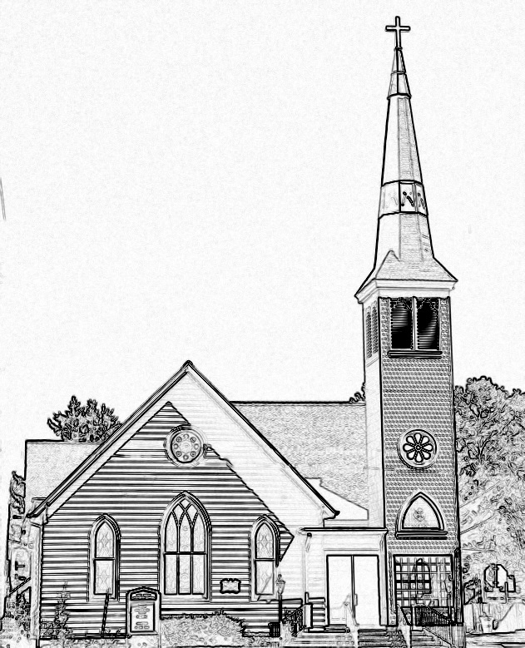

Welcome to worship! We are glad you joined us today. If you are seeking a church home, we invite you to join in the fellowship and ministry of this congregation. We look forward to seeing you again. Please fill out one of the visitor cards and drop it in the offering plate.
Prayer Concerns Carolyn Lin, Eli Chen, Meg Adams, Alicia McCarter, Suzanne Rogers, Joan May, Alverna St John, John Adams, Terri Lynn Redmond, Tine Klingen, Barbara Walters, Retta Isdell, Butch Tuttle, Janet Daniels.

Thank you to Mark Moring for being our reader today.
Thank you to Joan Motley for hosting coffee hour today.

Naomi Makemie 89 Market St Onancock, VA 23417
Mailing Address- P.O. Box 397 Onancock, VA 23417
NMPresChurch.org church naomimpchurch@gmail.com

Reverend Monica Gould c-757-709-2846 mongould@gmail.com

Staff Volunteers
Organist/Pianist-Mark Nuckols Videographer – Mike Gould
Choir Director-Debbie Ryon Lead Usher – Suzanne Rogers
Office Administrator-Jennifer Stapleton Office Administrator – Jennifer Stapleton
Nursery Workers-Kamryn Mears/Emma Cathey

Elders
Class of 2023 Class of 2024 Class of 2025
Megan Ames Ron May Bill Baird
Rick Turner Linda Arvidson Patty Davis
Marsh Ryon Meg Adams Jennifer Stapleton

Naomi Makemie Presbyterian Church Onancock, VA
Mark Nuckols Reverend Monica Gould Debbie Ryon Organist/Pianist pastor Choir Director
October 1, 2023
*Asterisk is to stand in body or spirit. Bold print is congregational response.
Prelude

Welcome/Announcements

Choral Opening Come and Find a Quiet Center

Call to Worship
Around the world people gather to break bread and pour wine.
We gather with them in heart and mind.
Around the world the broken body is made whole.
As part of that body we join in its unity.
Around the world the Banquet of God is prepared for the table.
We, who share in the banquet, come eagerly to be fed.

Opening Prayer
O God, We gather together in Your presence with expectation, hungry for an encounter with You, eager to hear Your Word. Open our eyes and ears to the presence of Your Holy Spirit. May we taste and see that the Lord is good. We pray this in the name of Jesus Christ, our teacher and our Lord. Amen.

*Opening Hymn Morning has Broken #469

Young Disciples

Prayer of Confession
Eternal God, in whom we live and have our being, whose face is hidden from us by our sins, and whose mercy we forget in the blindness of our hearts: Cleanse us form all our offenses, and deliver us from proud thoughts and vain desires. Renew us in your love and sustain through your sacraments, in Jesus name. Amen.

Words of Assurance
*Gloria Patri #579 Glory be to the Father and to the Son and to the Holy Ghost. As it was in the beginning, is now and ever shall be; world without end, amen. Amen.

*Affirmation of Faith: Apostle’s Creed
I believe in God the Father Almighty, Maker of heaven and earth. And in Jesus Christ his only son our Lord; who was conceived by the Holy Ghost, born of the virgin Mary, suffered under Pontius Pilate, was crucified, dead and buried; he descended into hell; the third day he rose again from the dead; he ascended into heaven, and sitteth on the right hand of God the Father Almighty; from thence he shall come to judge the quick and the dead. I believe in the Holy Ghost, the holy catholic church; the communion of saints; the forgiveness of sins; the resurrection of the body; and the life everlasting. Amen.

Reading Exodus 12:1-7, 14; Psalm 116:5-14; Matthew 26:26-30; Mark Moring

Anthem Table of Grace

Sermon A Festival to the Lord Rev. Monica Gould

*Hymn In Christ There is No East or West #439

Offering/Offertory

*Doxology Praise God, from whom all blessings flow; praise Him, all creatures here below; praise Him above, ye heavenly host; Praise Father, Son, and Holy Ghost. Amen.

*Hymn Let Us Break Bread Together #513

Lord’s Supper
Invitation/Prayers of Thanksgiving & The Lord’s Prayer

The Lord be with you. And also with you.
Lift up your hearts. We lift them to the Lord.
Let us give thanks to the Lord our God. It is right to give our thanks and praise…

Our Father who art in heaven, hallowed be thy name. thy kingdom come, thy will be done, on earth as it is in heaven. Give us this day our daily bread; and forgive us our debts as we forgive our debtors; and lead us not into temptation, but deliver us from evil. For Thine is the kingdom and the power and the glory, forever. Amen

Words of Institution

Communion

Prayer after communion

*Hymn The church’s one foundation. #442

*Benediction

*Choral Benediction God Be with You Till We Meet Again

Postlude

This Week: October 1st – 7th
Thursday: Made With Love knitting/craft group 5:30-7:00 pm, Choir practice 5:00-6:30 pm

Upcoming Events:
October 15th & 22nd – Adult and Kids Sunday School @ 9:45 am
October 15th – CCYF Meeting @ 3:00 pm
October 16th – Session @ 5:30 pm
October 18th – Movie and Potluck @ 5:00 pm
October 19th – Prayer Group @ 9:00 am
October 22nd – Laura Chuquin-Naylor’s Commissioning Service @ 3:00 pm @ Powelton Presbyterian Church
October 27th – Men’s Group @ 9:00 am

Non-Church Events:
Madrigals meet every Monday @ 6:00 pm
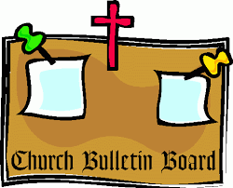
Book Club meets the third Thursday @ 1:00 pm

