Naomi Makemie Presbyterian Church
September 24, 2023 Large Print
Onancock, VA
Our Mission Statement
​“Do what is fair and just to your neighbor, be compassionate and loyal in your love, and don’t take yourself too seriously—take God seriously.” Micah 6:8
Compassionate, Fair and Loyal​
nmpreschurch.org

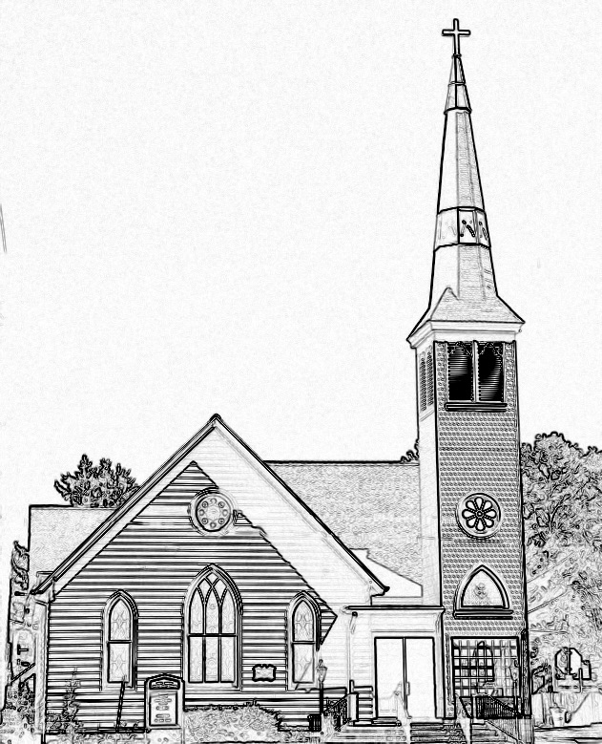

Welcome to worship! We are glad you joined us today. If you are seeking a church home, we invite you to join in the fellowship and ministry of this congregation. We look forward to seeing you again. Please fill out one of the visitor cards and drop it in the offering plate.
Prayer Concerns Carolyn Lin, Eli Chen, Meg Adams, Alicia McCarter, Suzanne Rogers, Joan May, Alverna St John, John Adams, Terri Lynn Redmond, Tine Klingen, Barbara Walters, Retta Isdell, Butch Tuttle, Janet Daniels.

Thank you to Judd Everhart for being our reader today.
Thank you to The Morings for hosting coffee hour today.

Naomi Makemie 89 Market St Onancock, VA 23417
Mailing Address- P.O. Box 397 Onancock, VA 23417
NMPresChurch.org church naomimpchurch@gmail.com

Reverend Monica Gould c-757-709-2846 mongould@gmail.com

Staff Volunteers
Organist/Pianist-Mark Nuckols Videographer – Mike Gould
Choir Director-Debbie Ryon Lead Usher – Suzanne Rogers
Office Administrator-Jennifer Stapleton Office Administrator – Jennifer Stapleton
Nursery Workers-Kamryn Mears/Emma Cathey

Elders
Class of 2023 Class of 2024 Class of 2025
Megan Ames Ron May Bill Baird
Rick Turner Linda Arvidson Patty Davis
Marsh Ryon Meg Adams Jennifer Stapleton

Naomi Makemie Presbyterian Church Onancock, VA
Mark Nuckols Reverend Monica Gould Debbie Ryon Organist/Pianist pastor Choir Director
September 24, 2023
*Asterisk is to stand in body or spirit. Bold print is congregational response.
Prelude

Welcome/Announcements

Choral Opening All are Welcome

Call to Worship
We gather here in anticipation,
seeking an encounter with our Holy God,
who comes among us when we least expect it,
who invites us to wrestle with our questions and doubts,
who richly blesses us,
and calls us each by name.

Opening Prayer
God, You have called us into a whole-hearted relationship with You. Give us courage to wrestle honestly with the things we don’t understand; to grapple daily with what it means to faithfully follow You. We are Your people, chosen and named by You. Grant us Your continued blessing and mark us with Your love. In the name of Jesus Christ, Amen.

*Hymn O Worship the King, All Glorious Above #476 v.1,2,4,5

Young Disciples

Prayer of Confession
Merciful God, the story of Jacob shows your willingness to enter into the messiness of our human struggles—into fractured relationships, family differences, un-reconciled situations with people we care about. Yet we confess that too often we hold on. Help us to wrestle with the conflicting values, desires and pressures that confront us daily so that we can unclench our hands and open ourselves to the touch of God. Renew us and call us by name through Jesus Christ our Lord. Amen.

Words of Assurance

*Gloria Patri #579 Glory be to the Father and to the Son and to the Holy Ghost. As it was in the beginning, is now and ever shall be; world without end, amen. Amen.

*Affirmation of Faith: A Prayer of Faith affirmation Julian of Norwich 1342-1416
In you, Father Almighty, we have our preservation and our bliss. In you, Christ, we have our restoring and our saving. You are our mother, brother, and Savior. In you, our Lord the Holy Spirit, is marvelous and plenteous grace. You are our clothing; for in love you wrap us and embrace us. You are our maker, our lover, our keeper. Teach us to believe that by your grace all shall be well, and all shall be well, and all manner of things shall be well. Amen.

Reading Genesis 32:9-13, 22-30; Mark 14:32-36 Judd Everhart

Anthem Make Us Instruments of your Peace

Sermon Touch Us God! Rev. Monica Gould

*Hymn I Will Come to You-You are Mine (insert)

Prayers of the People & The Lord’s Prayer
Our Father who art in heaven, hallowed be thy name. Thy kingdom come, thy will be done, on earth as it is in heaven. Give us this day our daily bread; and forgive us our debts as we forgive our debtors; and lead us not into temptation, but deliver us from evil. For Thine is the kingdom and the power and the glory, forever. Amen

Offering

*Doxology:
Praise God, from whom all blessings flow; praise Him, all creatures here below; praise Him above, ye heavenly host; Praise Father, Son, and Holy Ghost. Amen.

*Hymn Help Us Accept Each Other #358

Benediction

Choral Benediction Give Praise to the Lord

Postlude

This Week: September 24th – 30th
Wednesday – Potluck and movie with discussion 5:00-8:00 pm
Thursday: Made With Love knitting/craft group 5:30-7:00 pm, Choir practice 5:00-6:30 pm

Upcoming Events:
September 24th – Adult and Kids Sunday school @ 9:45 am
September 24th - Mission for youth during 11 am worship
September 27th – High school senior college discussion & info 4:30
September 29th – Men’s Group 9:00 am
September 30th – Church Workday @ 10:00 am

Non-Church Events:
Madrigals meet every Monday @ 6:00 pm
Book Club meets the third Thursday @ 1:00 pm

