Naomi Makemie Presbyterian Church
August 13, 2023 Large Print
Onancock, VA
Our Mission Statement
​“Do what is fair and just to your neighbor, be compassionate and loyal in your love, and don’t take yourself too seriously—take God seriously.” Micah 6:8
Compassionate, Fair and Loyal​
nmpreschurch.org

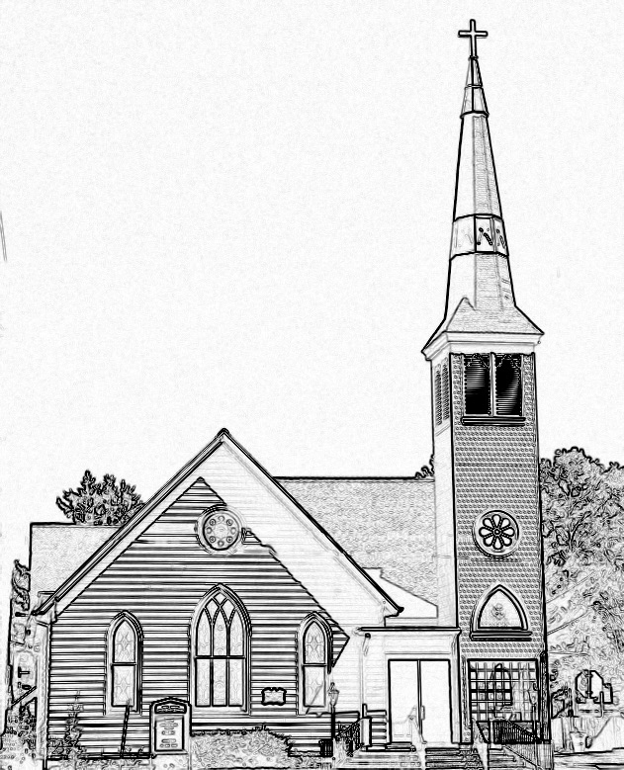

Welcome to worship! We are glad you joined us today. If you are seeking a church home, we invite you to join in the fellowship and ministry of this congregation. We look forward to seeing you again. Please fill out one of the visitor cards and drop it in the offering plate.
Prayer Concerns Carolyn Lin, Eli Chen, Meg Adams, Anne Gilchrist, Mickey Palmer, Anne Barnes, Suzanne Rogers, Joan May, Alverna St. John, John Adams, Terri Lynn Redmond

Reverend Monica Gould c-757-709-2846 mongould@gmail.com
Naomi Makemie 89 Market St Onancock/ Mailing Address- P.O. Box 397 Onancock, VA 23417 757-787-1331 Office Hours Wednesday 9:30-12
Staff, Elders & Volunteers Organist/Pianist-Mark Nuckols, Choir Director-Debbie Ryon, Office Administrator-Jennifer Stapleton, Nursery Worker-Kamryn Mears/Emma Cathey, Videographer-Mike Gould, Lead Usher-Suzanne Rogers, Clerk-Jennifer Stapleton Treasurer-George Heinrichs Elders:2025 Bill Baird, Patty Davis, Jennifer Stapleton, 2024 Ron May, Linda Arvidson, Meg Adams, Class 2023 Megan Ames, Rick Turner, Marsh Ryon; NMPresChurch.org church naomimpchurch@gmail.com
This Week:
Tuesdays 5:30 pm Made with Love craft group

Our August Mission will be focused on Light House Ministries. Light House Ministries is a transitional shelter that helps people get needed community resources. They even help people get into rehabilitation centers. Light House Ministries is always in need of certain everyday items, and this month we would like to collect the below items for them. Please bring these items to church and put in the Makemie Room. Thank you for your continued support of our mission ministries. Toilet paper, paper towels, laundry detergent, bleach, cleaning products, disinfectant wipes, envelopes, copy paper, stamps, pillows, new or gently used comforters and bath towels.

Thank you to Rick Turner for hosting coffee hour.
Thank you to Steve Doan for being our reader today.

Naomi Makemie Presbyterian Church Onancock, VA
Mark Nuckols Reverend Monica Gould Debbie Ryon Organist/Pianist pastor Choir Director
August 13, 2023
*Asterisk is to stand in body or spirit. Bold print is congregational response.
Prelude

Welcome/Announcements

Congregational Opening Be still, for the presence of the Lord, the Holy One is here. Come bow before him now, with reverence and fear. In him no sin is found; we stand on holy ground.
Be still, for the presence of the Lord, the Holy One is here. Be still, for the power of the Lord is moving in this place. He comes to cleanse and heal, to minister his grace. No work too hard for him; in faith receive from him. Be still, for the power of the Lord is moving in this place.
Call to Worship
We gather together to worship God,
who comes to us when we least expect it,
who calls us out of the safety of our ordered lives
and invites us to join Him in the adventure of faith.

Opening Prayer
Gracious God, we gather once again to offer You praise and thanksgiving for Your unfailing love and faithfulness, shown most clearly through Your Son, Jesus Christ.
Grant us grace to worship You in spirit and in truth. Through the power of Your Holy Spirit, open our eyes to recognize You here among us. Give us courage to step out in faith to meet You, and confidence to follow where You lead. In the name of Jesus Christ, our Lord. Amen.

*Hymn Holy, Holy (Jimmy Owens) #140

Young Disciples

Prayer of Confession
God, we confess that we do not always understand Your ways. We are easily discouraged when life takes unexpected turns and our carefully laid plans and dreams come to nothing. We confess that we are quick to give up when things get difficult, and quick to question Your presence and Your power. Forgive us. Give us courage to step out in faith and obedience, trusting in Your leading even when we cannot yet see the outcome. In Jesus’ name. Amen.
Words of Assurance

*Gloria Patri #579 Glory be to the Father and to the Son and to the Holy Ghost. As it was in the beginning, is now and ever shall be; world without end, amen. Amen.

*Affirmation of Faith: Apostle’s Creed
I believe in God the Father Almighty, Maker of heaven and earth. And in Jesus Christ his only son our Lord; who was conceived by the Holy Ghost, born of the virgin Mary, suffered under Pontius Pilate, was crucified, dead and buried; he descended into hell; the third day he rose again from the dead; he ascended into heaven, and sitteth on the right hand of God the Father Almighty; from thence he shall come to judge the quick and the dead. I believe in the Holy Ghost, the holy catholic church; the communion of saints; the forgiveness of sins; the resurrection of the body; and the life everlasting. Amen.

Reading Psalm 85:8-13; Matthew 14:22-33 Steve Doan

Anthem Amazing Grace sung by Linda Wilson

Sermon Jesus Walks on Water Rev. Monica Gould

*Hymn O Jesus, I Have Promised #389

Prayers of the People & The Lord’s Prayer
Our Father who art in heaven, hallowed be thy name. Thy kingdom come, thy will be done, on earth as it is in heaven. Give us this day our daily bread; and forgive us our debts as we forgive our debtors; and lead us not into temptation, but deliver us from evil. For Thine is the kingdom and the power and the glory, forever. Amen

Offering

*Doxology:
Praise God, from whom all blessings flow; praise Him, all creatures here below; praise Him above, ye heavenly host; Praise Father, Son, and Holy Ghost. Amen.

*Hymn We Walk by Faith and Not by Sight #399

Benediction
Congregational Benediction An Old Irish Blessing
May the road rise up to meet you, may the wind be always at your back, may the sun shine warm upon your face, and rain fall soft upon your fields and rain fall soft upon your fields. And until we meet again, until we meet again, and until we meet, we meet again, may God hold you in the palm of his hand.
Postlude

