Naomi Makemie Presbyterian Church
July 23, 2023 Large Print
Onancock, VA
Our Mission Statement
​“Do what is fair and just to your neighbor, be compassionate and loyal in your love, and don’t take yourself too seriously—take God seriously.” Micah 6:8
Compassionate, Fair and Loyal​
nmpreschurch.org

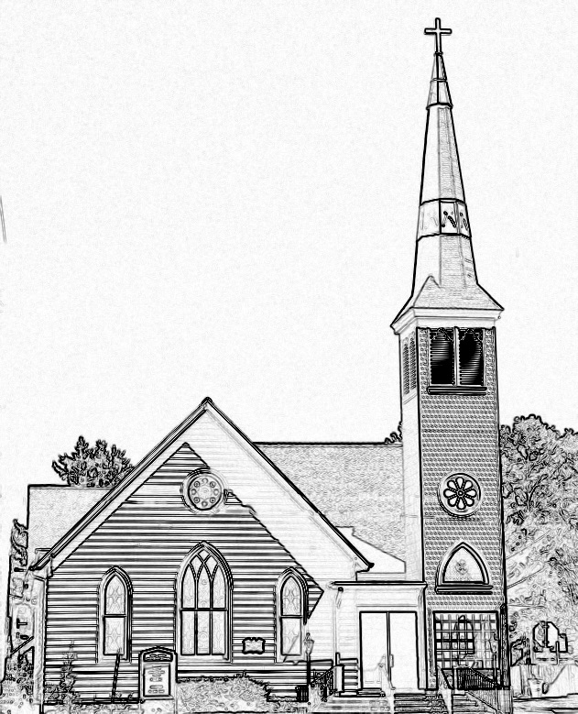

Welcome to worship! We are glad you joined us today. If you are seeking a church home, we invite you to join in the fellowship and ministry of this congregation. We look forward to seeing you again. Please fill out one of the visitor cards and drop it in the offering plate.
Prayer Concerns Carolyn Lin, Eli Chen, Meg Adams, Anne Gilchrist, Mickey Palmer, Anne Barnes, Suzanne Rogers, Joan May, Alverna St. John, John Adams, Terri Lynn Redmond

Reverend Monica Gould c-757-709-2846 mongould@gmail.com
Naomi Makemie 89 Market St Onancock/ Mailing Address- P.O. Box 397 Onancock, VA 23417 757-787-1331 Office Hours Wednesday 9:30-12
Staff, Elders & Volunteers Organist/Pianist-Mark Nuckols, Choir Director-Debbie Ryon, Office Administrator-Jennifer Stapleton, Nursery Worker-Kamryn Mears/Emma Cathey, Videographer-Mike Gould, Lead Usher-Suzanne Rogers, Clerk-Jennifer Stapleton Treasurer-George Heinrichs Elders:2025 Bill Baird, Patty Davis, Jennifer Stapleton, 2024 Ron May, Linda Arvidson, Meg Adams, Class 2023 Megan Ames, Rick Turner, Marsh Ryon; NMPresChurch.org church naomimpchurch@gmail.com
This Week:
Monday-Friday: Vacation Bible School
Tuesdays 5:30 pm Made with Love craft group

Thank you to Judd Everhart for being our reader today. Thank you to Linda Arvidson for hosting coffee hour today.
The Women’s Bible study next meetings will be held on July 27th at 5:30 pm.

Naomi Makemie Presbyterian Church Onancock, VA
Mark Nuckols Reverend Monica Gould Debbie Ryon Organist/Pianist pastor Choir Director
July 23, 2023
*Asterisk is to stand in body or spirit. Bold print is congregational response.
Prelude

Welcome/Announcements

Congregational Opening Be still, for the presence of the Lord, the Holy One is here. Come bow before him now, with reverence and fear. In him no sin is found; we stand on holy ground.
Be still, for the presence of the Lord, the Holy One is here. Be still, for the power of the Lord is moving in this place. He comes to cleanse and heal, to minister his grace. No work too hard for him; in faith receive from him. Be still, for the power of the Lord is moving in this place.

Call to Worship
We come in reverent awe before the Lord our God!
We come singing songs to the Lord our God.
We come in worship for the Lord God is worthy of our praise!
We come, to share together the news of our Glorious Lord’s saving deeds.

Opening Prayer
Eternal God, open our eyes to see your hand at work in the splendor of creation and in the beauty of human life. Touched by your hand, our world is holy. Help us to cherish the gifts that surround us, to share our blessings with our sisters and brothers, and to experience the joy of life in your presence; through Jesus Christ our Lord, who lives and reigns with you in the unity of the Holy Spirit, one God, forever and ever. Amen.

*Hymn Rejoice the Lord is King #155

Young Disciples

Prayer of Confession
O Lord, forgive us when we fail to respond to your call with faith. Through your Spirit we stand in the assurance of your acceptance. Forgive us when we are clouded sense of purpose. Forgive us when we are frightened of the future or pull back from the demand of your calling. Forgive us when we fail to sense your presence in our past, to acknowledge your grace in the present moment, and to trust you for our future. Through your Spirit we offer ourselves in discipleship in Jesus’ name. Amen.

Words of Assurance

*Gloria Patri #579 Glory be to the Father and to the Son and to the Holy Ghost. As it was in the beginning, is now and ever shall be; world without end, amen. Amen.

*Affirmation of Faith: Apostle’s Creed
I believe in God the Father Almighty, Maker of heaven and earth. And in Jesus Christ his only son our Lord; who was conceived by the Holy Ghost, born of the virgin Mary, suffered under Pontius Pilate, was crucified, dead and buried; he descended into hell; the third day he rose again from the dead; he ascended into heaven, and sitteth on the right hand of God the Father Almighty; from thence he shall come to judge the quick and the dead. I believe in the Holy Ghost, the holy catholic church; the communion of saints; the forgiveness of sins; the resurrection of the body; and the life everlasting. Amen.

Reading Psalm 96; Acts 16:11-15 Judd Everhart

Anthem There is a Redeemer (by Melody Green) Diane Taylor and Patty Davis

Sermon Beginnings Rev. Monica Gould

*Hymn Help Us Accept Each Other #358

Prayers of the People & The Lord’s Prayer
Our Father who art in heaven, hallowed be thy name. Thy kingdom come, thy will be done, on earth as it is in heaven. Give us this day our daily bread; and forgive us our debts as we forgive our debtors; and lead us not into temptation, but deliver us from evil. For Thine is the kingdom and the power and the glory, forever. Amen

Offering

*Doxology:
Praise God, from whom all blessings flow; praise Him, all creatures here below; praise Him above, ye heavenly host; Praise Father, Son, and Holy Ghost. Amen.

*Hymn God, Bless Your Church with Strength! #418

Benediction
Congregational Benediction An Old Irish Blessing
May the road rise up to meet you, may the wind be always at your back, may the sun shine warm upon your face, and rain fall soft upon your fields and rain fall soft upon your fields. And until we meet again, until we meet again, and until we meet, we meet again, may God hold you in the palm of his hand.

Postlude

