Naomi Makemie Presbyterian Church
July 9, 2023 Large Print
Onancock, VA
Our Mission Statement
​“Do what is fair and just to your neighbor, be compassionate and loyal in your love, and don’t take yourself too seriously—take God seriously.” Micah 6:8
Compassionate, Fair and Loyal​
nmpreschurch.org

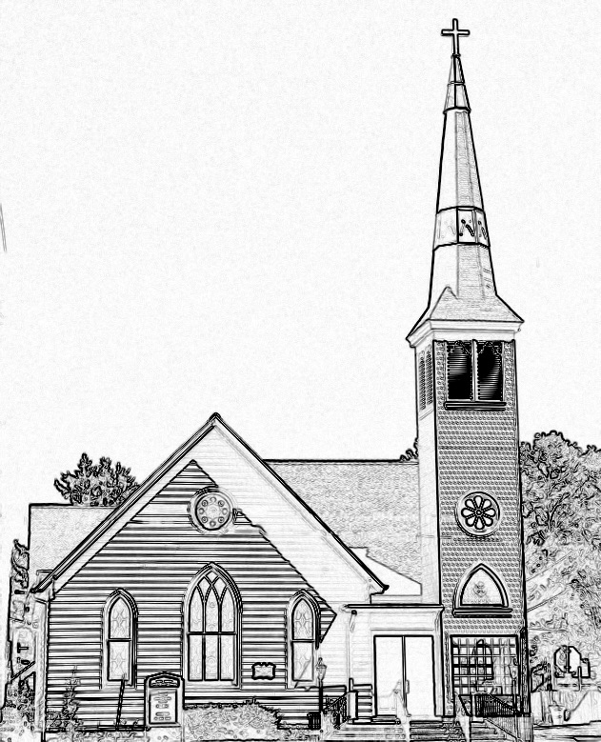

Welcome to worship! We are glad you joined us today. If you are seeking a church home, we invite you to join in the fellowship and ministry of this congregation. We look forward to seeing you again. Please fill out one of the visitor cards and drop it in the offering plate.
Prayer Concerns Carolyn Lin, Eli Chen, Meg Adams, Anne Gilchrist, Mickey Palmer, Anne Barnes, Suzanne Rogers, Joan May, Alverna St. John

Reverend Monica Gould c-757-709-2846 mongould@gmail.com
Naomi Makemie 89 Market St Onancock/ Mailing Address- P.O. Box 397 Onancock, VA 23417 757-787-1331 Office Hours Wednesday 9:30-12
Staff, Elders & Volunteers Organist/Pianist-Mark Nuckols, Choir Director-Debbie Ryon, Office Administrator-Jennifer Stapleton, Nursery Worker-Kamryn Mears/Emma Cathey, Videographer-Mike Gould, Lead Usher-Suzanne Rogers, Clerk-Jennifer Stapleton Treasurer-George Heinrichs Elders:2025 Bill Baird, Patty Davis, Jennifer Stapleton, 2024 Ron May, Linda Arvidson, Meg Adams, Class 2023 Megan Ames, Rick Turner, Marsh Ryon; NMPresChurch.org church naomimpchurch@gmail.com
This Week:
Tuesdays 5:30 pm Made with Love craft group
Thursday: Choir at 5:00 pm

Thank you to Steve Doan for being our reader today. Thank you to Rick Turner for hosting coffee hour today.
Please let Monica or Jennifer Stapleton know if you can provide snacks for VBS or if you would like to volunteer that week. VBS is July 24th-28th.
The Women’s Bible study next meetings will be held on July 20th and 27th at 5:30 pm.
Leadership training for new VBS leaders will be on July 20th and 21st at 9:30 am -12:00 pm

Naomi Makemie Presbyterian Church Onancock, VA
Mark Nuckols Reverend Monica Gould Debbie Ryon Organist/Pianist pastor Choir Director
July 9, 2023
*Asterisk is to stand in body or spirit. Bold print is congregational response.
Prelude

Welcome/Announcements

Congregational Opening Be still, for the presence of the Lord, the Holy One is here. Come bow before him now, with reverence and fear. In him no sin is found; we stand on holy ground.
Be still, for the presence of the Lord, the Holy One is here. Be still, for the power of the Lord is moving in this place. He comes to cleanse and heal, to minister his grace. No work too hard for him; in faith receive from him. Be still, for the power of the Lord is moving in this place.

Call to Worship
Our souls proclaim your greatness, O God.
And our spirits rejoice in you.
We will praise you as long as we live.
We will sing praises to you our whole lives long.

Opening Prayer
Lord, the eyes of all look to You in hope; and You give them what they need. You open Your hand and satisfy the hunger and thirst of every living thing. May the time we spend together in Your presence nourish our hearts and minds; may it strengthen our relationship with You, and renew our commitment to live in this world as Your faithful disciples. For You alone are God, the Source and Sustainer of life. In Jesus’ name, Amen.

*Hymn As the Deer insert

Young Disciples

Prayer of Confession
O God you have given us your Word to guide us. Yet we struggle with this guidance, and too often fail in our attempts to build community. Father, forgive us. Take away whatever holds us back. Show us the way to confidence and generosity so that we may be known as your people. Through Christ make us Repairers of the broken places. By your Spirit empower us as Restorers of streets to safety and peace. In Christ, with Christ’s help we can change and bring you glory. Amen
Words of Assurance
*Gloria Patri #579 Glory be to the Father and to the Son and to the Holy Ghost. As it was in the beginning, is now and ever shall be; world without end, amen. Amen.

*Affirmation of Faith: Apostle’s Creed
I believe in God the Father Almighty, Maker of heaven and earth. And in Jesus Christ his only son our Lord; who was conceived by the Holy Ghost, born of the virgin Mary, suffered under Pontius Pilate, was crucified, dead and buried; he descended into hell; the third day he rose again from the dead; he ascended into heaven, and sitteth on the right hand of God the Father Almighty; from thence he shall come to judge the quick and the dead. I believe in the Holy Ghost, the holy catholic church; the communion of saints; the forgiveness of sins; the resurrection of the body; and the life everlasting. Amen.

Reading Isaiah 58:6-14; Acts 9:36-43 Steve Doan

Special Music Though I May Speak (Hopson/Weaver)

Sermon Devoted to Good Works Rev. Monica Gould

*Hymn Live into Hope #332

Prayers of the People & The Lord’s Prayer
Our Father who art in heaven, hallowed be thy name. Thy kingdom come, thy will be done, on earth as it is in heaven. Give us this day our daily bread; and forgive us our debts as we forgive our debtors; and lead us not into temptation, but deliver us from evil. For Thine is the kingdom and the power and the glory, forever. Amen

Offering

*Doxology:
Praise God, from whom all blessings flow; praise Him, all creatures here below; praise Him above, ye heavenly host; Praise Father, Son, and Holy Ghost. Amen.

*Hymn Guide Me, O Thou Great Jehovah #281

Benediction
*Choral Benediction May the road rise up to meet you, may the wind be always at your back, may the sun shine warm upon your face, and rain fall soft upon your fields and rain fall soft upon your fields. And until we meet again, until we meet again, and until we meet, we meet again, may God hold you in the palm of his hand.

Postlude

