Naomi Makemie Presbyterian Church
July 2, 2023 Large Print
Onancock, VA
Our Mission Statement
​“Do what is fair and just to your neighbor, be compassionate and loyal in your love, and don’t take yourself too seriously—take God seriously.” Micah 6:8
Compassionate, Fair and Loyal​
nmpreschurch.org

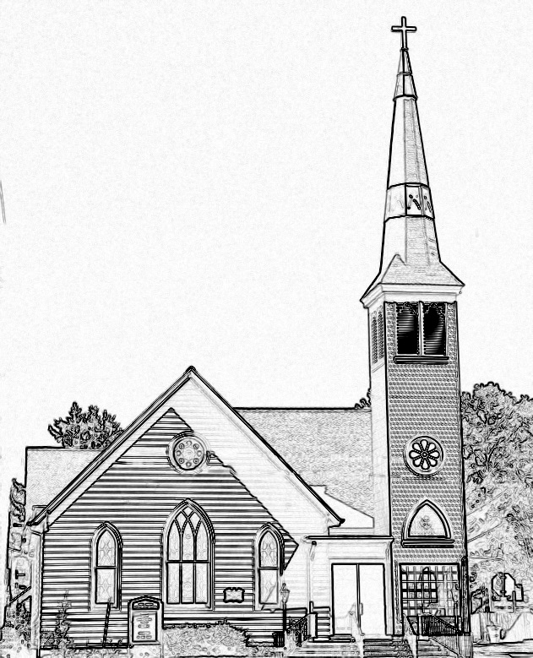

Welcome to worship! We are glad you joined us today. If you are seeking a church home, we invite you to join in the fellowship and ministry of this congregation. We look forward to seeing you again. Please fill out one of the visitor cards and drop it in the offering plate.
Prayer Concerns Carolyn Lin, Eli Chen, Meg Adams, Anne Gilchrist, Mickey Palmer, Anne Barnes, Suzanne Rogers, Joan May, Alverna St. John

Reverend Monica Gould c-757-709-2846 mongould@gmail.com
Naomi Makemie 89 Market St Onancock/ Mailing Address- P.O. Box 397 Onancock, VA 23417 757-787-1331 Office Hours Wednesday 9:30-12
Staff, Elders & Volunteers Organist/Pianist-Mark Nuckols, Choir Director-Debbie Ryon, Office Administrator-Jennifer Stapleton, Nursery Worker-Kamryn Mears/Emma Cathey, Videographer-Mike Gould, Lead Usher-Suzanne Rogers, Clerk-Jennifer Stapleton Treasurer-George Heinrichs Elders:2025 Bill Baird, Patty Davis, Jennifer Stapleton, 2024 Ron May, Linda Arvidson, Meg Adams, Class 2023 Megan Ames, Rick Turner, Marsh Ryon; NMPresChurch.org church naomimpchurch@gmail.com
This Week:
Tuesdays 5:30 pm Made with Love craft group
Thursday: Women’s Evening Disciple’s Study- July 6th at 5:30 pm.

Welcome to the musical ensemble today: Bruce Gittinger, Steve Elliot, Conrad Meil, Diane Taylor, and Debbie Ryon. Thank you for your beautiful music.
Thank you to Donna Doan for being our reader today. Thank you to The Morings for hosting coffee hour today.
Thank you to our Communion Servers and Preparers: Megan Ames, Linda Arvidson, Anne Barnes, and Rick Turner

Please let Monica or Jennifer Stapleton know if you can provide snacks for VBS or if you would like to volunteer that week. VBS is July 24th-28th.

Naomi Makemie Presbyterian Church Onancock, VA
Mark Nuckols Reverend Monica Gould Debbie Ryon Organist/Pianist pastor Choir Director
July 2, 2023
*Asterisk is to stand in body or spirit. Bold print is congregational response.
Prelude

Welcome/Announcements

Congregational Opening Be still, for the presence of the Lord, the Holy One is here. Come bow before him now, with reverence and fear. In him no sin is found; we stand on holy ground.
Be still, for the presence of the Lord, the Holy One is here. Be still, for the power of the Lord is moving in this place. He comes to cleanse and heal, to minister his grace. No work too hard for him; in faith receive from him. Be still, for the power of the Lord is moving in this place.
Call to Worship
Welcome one another in Jesus’ name, for Christ is truly among us.
The steadfast love of the Lord never ceases, the mercy of God never ends.
Our freedom comes through Christ Jesus, we will worship his holy name!

Opening Prayer
God of the nations, you have revealed your will with all people and promised us your
saving help. Give us courage as you gave the apostles, that we may faithfully serve
you and care for others. Guide us through worship that your name is lifted up and
your glory shines to the world, in Jesus name. Amen.

*Opening Hymn My Country Tis of Thee #561 Brass

Young Disciples

Prayer of Confession
God of mercy, you sent Jesus to seek and save the lost. We confess that we have been
misled by pride and self-assurance. We turn from our friends rather than trust the
goodness in their hearts. We find ways to ignore hope or accept fate. Renew our strength to trust and to come to you to be healed. Restore our friendships that offer us guidance and help. Keep us from discouragement and bring us into your overwhelming love, through Christ our Lord. Amen.

Words of Assurance
*Gloria Patri #579 Glory be to the Father and to the Son and to the Holy Ghost. As it was in the beginning, is now and ever shall be; world without end, amen. Amen.

*Affirmation of Faith: Apostle’s Creed
I believe in God the Father Almighty, Maker of heaven and earth. And in Jesus Christ his only son our Lord; who was conceived by the Holy Ghost, born of the virgin Mary, suffered under Pontius Pilate, was crucified, dead and buried; he descended into hell; the third day he rose again from the dead; he ascended into heaven, and sitteth on the right hand of God the Father Almighty; from thence he shall come to judge the quick and the dead. I believe in the Holy Ghost, the holy catholic church; the communion of saints; the forgiveness of sins; the resurrection of the body; and the life everlasting. Amen.

Reading Psalm 133; Luke 5:17-25 Donna Doan

Sermon “What Friends Do” Rev. Monica Gould

*Hymn O Beautiful For Spacious Skies v. 1,2,4 #564

Offering/Offertory Battle Hymn of the Republic arr. Chauvin

*Doxology Praise God, from whom all blessings flow; praise Him, all creatures here below; praise Him above, ye heavenly host; Praise Father, Son, and Holy Ghost. Amen.

*Hymn Let Us Break Bread Together #513

Lord’s Supper
Invitation/Prayers of Thanksgiving & The Lord’s Prayer

The Lord be with you. And also with you.
Lift up your hearts. We lift them to the Lord.
Let us give thanks to the Lord our God. It is right to give our thanks and praise…

Our Father who art in heaven, hallowed be thy name. thy kingdom come, thy will be done, on earth as it is in heaven. Give us this day our daily bread; and forgive us our debts as we forgive our debtors; and lead us not into temptation, but deliver us from evil. For Thine is the kingdom and the power and the glory, forever. Amen

Words of Institution/Communion/Prayer after communion

*Hymn Eternal Father Strong to Save #562

*Benediction

*Choral Benediction May the road rise up to meet you, may the wind be always at your back, may the sun shine warm upon your face, and rain fall soft upon your fields and rain fall soft upon your fields. And until we meet again, until we meet again, and until we meet, we meet again, may God hold you in the palm of his hand.

Postlude God Bless America. Berlin arr Brandon

