Naomi Makemie Presbyterian Church
June 25, 2023 Large Print
Onancock, VA
Our Mission Statement
​“Do what is fair and just to your neighbor, be compassionate and loyal in your love, and don’t take yourself too seriously—take God seriously.” Micah 6:8
Compassionate, Fair and Loyal​
nmpreschurch.org

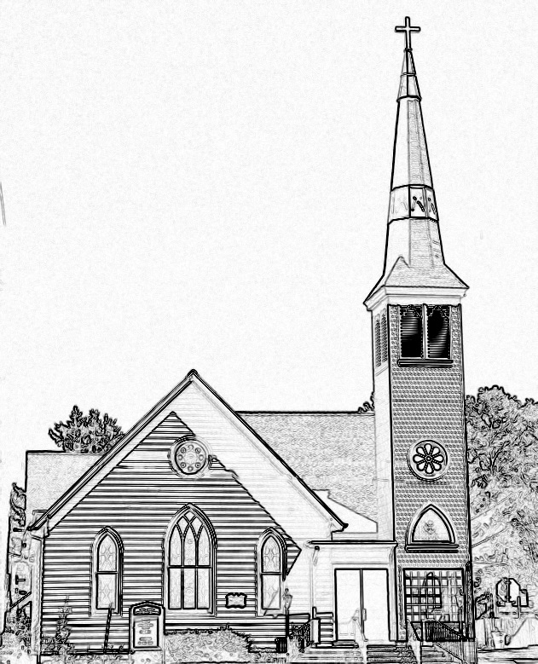

Welcome to worship! We are glad you joined us today. If you are seeking a church home, we invite you to join in the fellowship and ministry of this congregation. We look forward to seeing you again. Please fill out one of the visitor cards and drop it in the offering plate.
Prayer Concerns Carolyn Lin, Eli Chen, Meg Adams, Anne Gilchrist, Mickey Palmer, Anne Barnes, Suzanne Rogers, Joan May

Reverend Monica Gould c-757-709-2846 mongould@gmail.com
Naomi Makemie 89 Market St Onancock/ Mailing Address- P.O. Box 397 Onancock, VA 23417 757-787-1331 Office Hours Wednesday 9:30-12
Staff, Elders & Volunteers Organist/Pianist-Mark Nuckols, Choir Director-Debbie Ryon, Office Administrator-Jennifer Stapleton, Nursery Worker-Kamryn Mears/Emma Cathey, Videographer-Mike Gould, Lead Usher-Suzanne Rogers, Clerk-Jennifer Stapleton Treasurer-George Heinrichs Elders:2025 Bill Baird, Patty Davis, Jennifer Stapleton, 2024 Ron May, Linda Arvidson, Meg Adams, Class 2023 Megan Ames, Rick Turner, Marsh Ryon; NMPresChurch.org church naomimpchurch@gmail.com
This Week:
Tuesdays 5:30 pm Made with Love craft group
Thursday: Women’s Evening Disciple’s Study- June 29th at 5:30 pm.
Friday: Men’s Group meets on June 30th at 9:00 am. Lesson is 2nd Chronicles 7:14

Please join us for our first women’s evening disciple’s study on Thursday, June 29th at 5:30 pm. We’ll study the book “The Universe in 57 words-Seven Days Inside the Lord’s Prayer” by Carolyn Arends. The other meeting dates are July 6th, July 20th, and July 27th. Nina Moring and Monica will facilitate this study.

Naomi Makemie Presbyterian Church Onancock, VA
Mark Nuckols Reverend Monica Gould Debbie Ryon Organist/Pianist pastor Choir Director
June 25, 2023
*Asterisk is to stand in body or spirit. Bold print is congregational response.
Prelude

Welcome/Announcements

Congregational Opening Be still, for the presence of the Lord, the Holy One is here. Come bow before him now, with reverence and fear. In him no sin is found; we stand on holy ground.
Be still, for the presence of the Lord, the Holy One is here. Be still, for the power of the Lord is moving in this place. He comes to cleanse and heal, to minister his grace. No work too hard for him; in faith receive from him. Be still, for the power of the Lord is moving in this place.

Call to Worship
When we pass through the waters, God carries us through the water.
When we suffer and feel hopeless, God holds us in the palm of his hand.
When we are joyful and celebratory, God dances with us.
Whether we feel triumphant or defeated, God is our stronghold, always!

Opening Prayer

God of many names. Our Abba, we give ourselves into the hand of your continuing creativity; Our past, with its joys and triumphs, its failures and regrets, Our present, with its struggles and accomplishments, its hopes and setbacks, Our future, with its fears and freedom. We enter worship today trusting the Spirit that breathes life, trusting the love that will not let us go, trusting the promise of the Word made flesh. Amen.

*Hymn God of the Sparrow #272

Young Disciples

Prayer of Confession
God who Delivers and Redeems, we have failed to live into the promise of new life. We have been afraid to enter troubled waters to help the poor and downtrodden. We have sought ease and comfort in exchange for ignoring the hungry and sick in our world. Forgive us when we have seen our faith in such narrowness, thinking of only our own salvation. Forgive us when we have not lived for others, when we have not been willing to risk ourselves for the sake of others. Call us into new life, a life that is lived in the promise of Your love for the whole world. In Jesus’ name. Amen.

Words of Assurance
*Gloria Patri #579 Glory be to the Father and to the Son and to the Holy Ghost. As it was in the beginning, is now and ever shall be; world without end, amen. Amen.

*Affirmation of Faith: A Modern Version (read responsively)
Do you believe in God?
I believe in God, the Father Almighty, Creator of heaven and earth.
Do you believe in Christ?
I believe in Jesus Christ, God's only Son, our Lord, who was conceived by the Holy Spirit, born of the Virgin Mary, suffered under Pontius Pilate, was crucified, died, and was buried; he descended to the dead. On the third day he rose again; he ascended into heaven, he is seated at the right hand of God the Father, and he will come again to judge the living and the dead.
Do you believe in the Holy Spirit?
I believe in the Holy Spirit, the holy catholic church, the communion of saints, the forgiveness of sins, the resurrection of the body, and the life everlasting. AMEN

Reading Isaiah 43:1-13; Acts 9:1-19
Special Music How Great Thou Art Patty Davis, Becky Everhart
Sermon My Servant Whom I’ve Chosen Rev. Monica Gould

*Hymn Do Not Be Afraid (insert)

Prayers of the People & The Lord’s Prayer
Our Father who art in heaven, hallowed be thy name. Thy kingdom come, thy will be done, on earth as it is in heaven. Give us this day our daily bread; and forgive us our debts as we forgive our debtors; and lead us not into temptation, but deliver us from evil. For Thine is the kingdom and the power and the glory, forever. Amen

Offering

*Doxology:
Praise God, from whom all blessings flow; praise Him, all creatures here below; praise Him above, ye heavenly host; Praise Father, Son, and Holy Ghost. Amen.

*Hymn Christ is Made the Sure Foundation v. 1.2.4 #417

Benediction
Congregational Benediction An Old Irish Blessing
May the road rise up to meet you, may the wind be always at your back, may the sun shine warm upon your face, and rain fall soft upon your fields and rain fall soft upon your fields. And until we meet again, until we meet again, and until we meet, we meet again, may God hold you in the palm of his hand.

Postlude

Additional Announcements:
Sign up for leadership for VBS and snack donations will be begin next week.
Baby Welcome Shower for Skylar, Gabe and Baby Raelynn May today at 3pm. Please let Monica know if you plan to attend. We want to shower Raelynn May with a warm welcome.

