Naomi Makemie Presbyterian Church
June 18, 2023 Large Print
Onancock, VA
Our Mission Statement
​“Do what is fair and just to your neighbor, be compassionate and loyal in your love, and don’t take yourself too seriously—take God seriously.” Micah 6:8
Compassionate, Fair and Loyal​
nmpreschurch.org

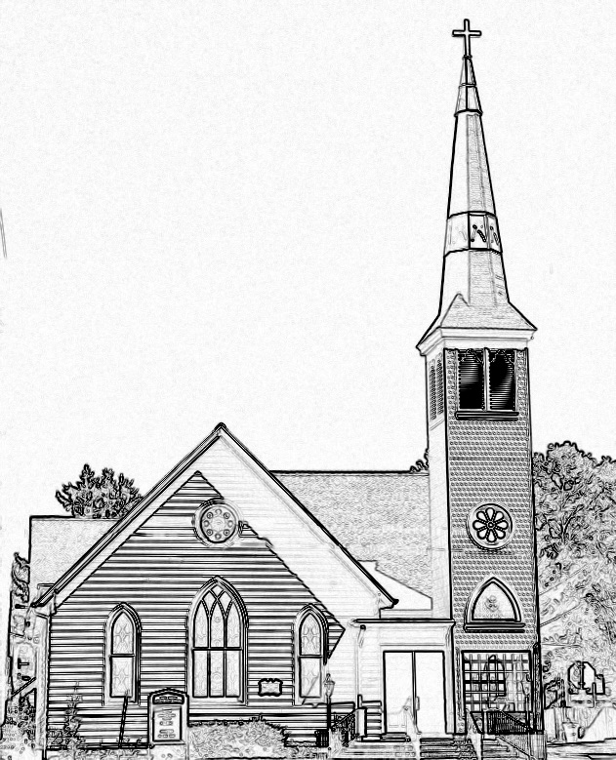

Welcome to worship! We are glad you joined us today. If you are seeking a church home, we invite you to join in the fellowship and ministry of this congregation. We look forward to seeing you again. Please fill out one of the visitor cards and drop it in the offering plate.
Prayer Concerns Carolyn Lin, Eli Chen, Meg Adams, Anne Gilchrist, Mickey Palmer, Anne Barnes, Suzanne Rogers, Joan May

Reverend Monica Gould c-757-709-2846 mongould@gmail.com
Naomi Makemie 89 Market St Onancock/ Mailing Address- P.O. Box 397 Onancock, VA 23417 757-787-1331 Office Hours Wednesday 9:30-12
Staff, Elders & volunteers Organist/Pianist-Mark Nuckols, Choir Director-Debbie Ryon, Office Administrator-Jennifer Stapleton, Nursery Worker-Mickey Palmer, Videographer-Mike Gould, Lead Usher-Suzanne Rogers, Clerk-Jennifer Stapleton Treasurer-George Heinrichs Elders:2025 Bill Baird, Patty Davis, Jennifer Stapleton, 2024 Ron May, Linda Arvidson, Meg Adams Class 2023 Megan Ames, Rick Turner, Marsh Ryon; NMPresChurch.org church naomimpchurch@gmail.com

This Week:
Tuesdays 5:30 pm Made with Love craft group

Welcome to Reverend Donna Doan today as she leads us in worship.
Please join us for our first women’s evening disciple’s study on Thursday, June 29th at 5:30 pm. We’ll study the book “The Universe in 57 words-Seven Days Inside the Lord’s Prayer” by Carolyn Arends. The other meeting dates are July 6th, July 20th, and July 27th. Nina Moring and Monica will facilitate this study.

Naomi Makemie Presbyterian Church Onancock, VA
Mark Nuckols Reverend Monica Gould Debbie Ryon Organist/Pianist pastor Choir Director
June 18, 2023
*Asterisk is to stand in body or spirit. Bold print is congregational response.
Prelude

Welcome/Announcements

Congregational Opening Be still, for the presence of the Lord, the Holy One is here. Come bow before him now, with reverence and fear. In him no sin is found; we stand on holy ground.
Be still, for the presence of the Lord, the Holy One is here. Be still, for the power of the Lord is moving in this place. He comes to cleanse and heal, to minister his grace. No work too hard for him; in faith receive from him. Be still, for the power of the Lord is moving in this place.

Call to Worship
Come, let us bless the Lord!
For the Lord is like a faithful father to his children,
Compassionate and merciful, filled with endless love.
God showers us with love and mercy and blesses us with hope!
The proof of God’s love is Jesus Christ, our Lord, Savior, and Friend.
Let’s worship God together!

Opening Prayer
On this Father’s Day we come before you, our Heavenly Father, with grateful hearts. We pray that you fill this place with your presence, that we will give you glory and honor in all things, and that we open ourselves to receive your word for us today. In the name of Jesus Christ, Amen.'

*Hymn Great is Thy Faithfulness #276

FATHER’S DAY PRAYER

Prayer of Confession
Lord, you know our inmost being. You know all that we are, all that we think, and all that we believe. When our thoughts, beliefs, and actions turn away from you, we long to find our way back to you, reconciling ourselves to your righteousness. We pray that the recognition of our sins will turn us toward you, and we will grow closer to you and your hopes for us. Cleanse us of our sin. We pray this in the name of your Son Jesus. Amen.

Words of Assurance
*Gloria Patri #579 Glory be to the Father and to the Son and to the Holy Ghost. As it was in the beginning, is now and ever shall be; world without end, amen. Amen.

*Affirmation of Faith: A Modern Version (read responsively)
Do you believe in God?
I believe in God, the Father Almighty, Creator of heaven and earth.
Do you believe in Christ?
I believe in Jesus Christ, God's only Son, our Lord, who was conceived by the Holy Spirit, born of the Virgin Mary, suffered under Pontius Pilate, was crucified, died, and was buried; he descended to the dead. On the third day he rose again; he ascended into heaven, he is seated at the right hand of God the Father, and he will come again to judge the living and the dead.
Do you believe in the Holy Spirit?
I believe in the Holy Spirit, the holy catholic church, the communion of saints, the forgiveness of sins, the resurrection of the body, and the life everlasting. AMEN

Reading John 1:1-4, 14, 18; Colossians 1:19-20; Philippians 2:4-11
Anthem Sing of the Lord's Goodness
Sermon The Word Made Flesh Rev. Donna Doan

*Hymn Love Divine, All Loves Excelling #376

Prayers of the People & The Lord’s Prayer
Our Father who art in heaven, hallowed be thy name. Thy kingdom come, thy will be done, on earth as it is in heaven. Give us this day our daily bread; and forgive us our debts as we forgive our debtors; and lead us not into temptation, but deliver us from evil. For Thine is the kingdom and the power and the glory, forever. Amen
Offering
*Doxology:
Praise God, from whom all blessings flow; praise Him, all creatures here below; praise Him above, ye heavenly host; Praise Father, Son, and Holy Ghost. Amen.
*Hymn Called As Partners In Christ’s Service #343
Benediction
Congregational Benediction An Old Irish Blessing
May the road rise up to meet you, may the wind be always at your back, may the sun shine warm upon your face, and rain fall soft upon your fields and rain fall soft upon your fields. And until we meet again, until we meet again, and until we meet, we meet again, may God hold you in the palm of his hand.
Postlude

