Naomi Makemie Presbyterian Church
June 11, 2023 Large Print
Onancock, VA
Our Mission Statement
​“Do what is fair and just to your neighbor, be compassionate and loyal in your love, and don’t take yourself too seriously—take God seriously.” Micah 6:8
Compassionate, Fair and Loyal​
nmpreschurch.org

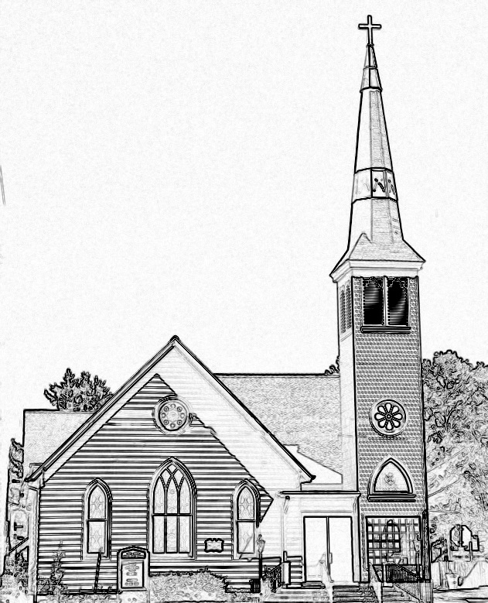

Welcome to worship! We are glad you joined us today. If you are seeking a church home, we invite you to join in the fellowship and ministry of this congregation. We look forward to seeing you again. Please fill out one of the visitor cards and drop it in the offering plate.
Prayer Concerns Carolyn Lin, Eli Chen, Meg Adams, Anne Gilchrist, Mickey Palmer, Anne Barnes, Suzanne Rogers

Reverend Monica Gould c-757-709-2846 mongould@gmail.com
Naomi Makemie 89 Market St Onancock/ Mailing Address- P.O. Box 397 Onancock, VA 23417 757-787-1331 Office Hours Wednesday 9:30-12
Staff, Elders & volunteers Organist/Pianist-Mark Nuckols, Choir Director-Debbie Ryon, Office Administrator-Jennifer Stapleton, Nursery Worker-Mickey Palmer, Videographer-Mike Gould, Lead Usher-Suzanne Rogers, Clerk-Jennifer Stapleton Treasurer-George Heinrichs Elders:2025 Bill Baird, Patty Davis, Jennifer Stapleton, 2024 Ron May, Linda Arvidson, Meg Adams Class 2023 Megan Ames, Rick Turner, Marsh Ryon; NMPresChurch.org church naomimpchurch@gmail.com

This Week:
Sunday school June 11th
Tuesdays 5:30 pm Made with Love craft group
Thursdays Choir meets at 5:00 pm

Welcome to Reverend Steve Doan today as he leads us in worship.

Naomi Makemie Presbyterian Church Onancock, VA
Mark Nuckols Reverend Monica Gould Debbie Ryon Organist/Pianist pastor Choir Director
June 11, 2023
*Asterisk is to stand in body or spirit. Bold print is congregational response.
Prelude

Welcome/Announcements

Congregational Opening Be still, for the presence of the Lord, the Holy One is here. Come bow before him now, with reverence and fear. In him no sin is found; we stand on holy ground.
Be still, for the presence of the Lord, the Holy One is here. Be still, for the power of the Lord is moving in this place. He comes to cleanse and heal, to minister his grace. No work too hard for him; in faith receive from him. Be still, for the power of the Lord is moving in this place.

Call to Worship
When Christ calls us, he asks us to be joyful.
When Christ calls us, he turns our eyes away from lesser things.
When Christ calls us, he leads us into a life a service.
When Christ calls us, he welcomes us into the Beloved Community.
When Christ calls us, he empowers us with gifts of the Spirit to freely give ourselves.
And when Christ calls us, we begin to learn what it truly means to love and be loved.

Opening Prayer
Merciful and loving Creator God, remake us afresh into living reminders of the power of your love and help us share the power that lies in humility and new beginnings. As your people of the New Creation, we can truly feel the excitement and energy that come from turning away from all that has gone before and weighed us down. Cover the Earth with your transforming Love, through Christ our Lord. Amen.

*Hymn Joyful, Joyful, We Adore Thee #464

Prayer of Confession
Eternal and Divine Presence, for the times when we lost our sense of wonder and mystery, forgive us and restore them to our hearts. For the moments and even days when we wandered away from the joy you were offering, open our eyes to see our path clearly. For all the times when we were content to live lives of quiet desperation and darkness, turn us once more to the light of your love and the healing power of serving others and receiving the ministry we so desperately crave and need. For it is Christ who has shown us the path of wholeness and kindly led the way. Amen.

Words of Assurance

*Gloria Patri #579 Glory be to the Father and to the Son and to the Holy Ghost. As it was in the beginning, is now and ever shall be; world without end, amen. Amen.

*Affirmation of Faith: Apostle’s Creed
I believe in God the Father Almighty, Maker of heaven and earth. And in Jesus Christ his only son our Lord; who was conceived by the Holy Ghost, born of the virgin Mary, suffered under Pontius Pilate, was crucified, dead and buried; he descended into hell; the third day he rose again from the dead; he ascended into heaven, and sitteth on the right hand of God the Father Almighty; from thence he shall come to judge the quick and the dead. I believe in the Holy Ghost, the holy catholic church; the communion of saints; the forgiveness of sins; the resurrection of the body; and the life everlasting. Amen.

Reading Philippians 4: 4-14
Anthem We Will Rise Again
Sermon Revolutionary Joy Rev. Steve Doan

*Hymn O, For a Thousand Tongues to Sing #466

Prayers of the People & The Lord’s Prayer
Our Father who art in heaven, hallowed be thy name. Thy kingdom come, thy will be done, on earth as it is in heaven. Give us this day our daily bread; and forgive us our debts as we forgive our debtors; and lead us not into temptation, but deliver us from evil. For Thine is the kingdom and the power and the glory, forever. Amen

Offering

*Doxology:
Praise God, from whom all blessings flow; praise Him, all creatures here below; praise Him above, ye heavenly host; Praise Father, Son, and Holy Ghost. Amen.

*Hymn Come, Thou Fount of Every Blessing #356

Benediction
Congregational Benediction An Old Irish Blessing
May the road rise up to meet you, may the wind be always at your back, may the sun shine warm upon your face, and rain fall soft upon your fields and rain fall soft upon your fields. And until we meet again, until we meet again, and until we meet, we meet again, may God hold you in the palm of his hand.

Postlude

