Naomi Makemie Presbyterian Church
June 4, 2023 Large Print
Onancock, VA
Our Mission Statement
​“Do what is fair and just to your neighbor, be compassionate and loyal in your love, and don’t take yourself too seriously—take God seriously.” Micah 6:8
Compassionate, Fair and Loyal​
nmpreschurch.org

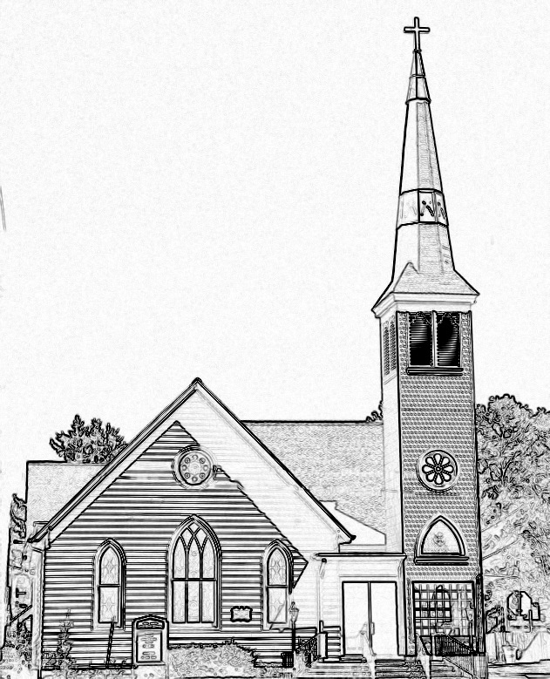

Welcome to worship! We are glad you joined us today. If you are seeking a church home, we invite you to join in the fellowship and ministry of this congregation. We look forward to seeing you again. Please fill out one of the visitor cards and drop it in the offering plate.
Prayer Concerns Carolyn Lin, Eli Chen, Meg Adams, Anne Gilchrist, Mickey Palmer, Anne Barnes, Suzanne Rogers

Reverend Monica Gould c-757-709-2846 mongould@gmail.com
Naomi Makemie 89 Market St Onancock/ Mailing Address- P.O. Box 397 Onancock, VA 23417 757-787-1331 Office Hours Wednesday 9:30-12
Staff, Elders & volunteers Organist/Pianist-Mark Nuckols, Choir Director-Debbie Ryon, Office Administrator-Jennifer Stapleton, Nursery Worker-Mickey Palmer, Videographer-Mike Gould, Lead Usher-Suzanne Rogers, Clerk-Jennifer Stapleton Treasurer-George Heinrichs Elders:2025 Bill Baird, Patty Davis, Jennifer Stapleton, 2024 Ron May, Linda Arvidson, Meg Adams Class 2023 Megan Ames, Rick Turner, Marsh Ryon; NMPresChurch.org church naomimpchurch@gmail.com

This Week:
Sunday school June 11th
Tuesdays 5:30 pm Made with Love craft group
Thursdays Choir meets at 5:00 pm

Our annual church picnic is today following worship in the Makemie Room.

Naomi Makemie Presbyterian Church Onancock, VA
Mark Nuckols Reverend Monica Gould Debbie Ryon Organist/Pianist pastor Choir Director
June 4, 2023
*Asterisk is to stand in body or spirit. Bold print is congregational response.
Prelude

Welcome/Announcements

Call to Worship
A word of encouragement came from prophet to people;
Live a life that is full – build, plant, eat, love, multiply--
Pray for your communities.
Keep God in the center of all that is.
We enter into worship today with hope in our hearts.
For something happens here that reminds us that we can live as God desires
God has made a promise of faithfulness to us
and we can trust the promise.

Opening Prayer
Holy God, before time you named us. Through time you redeem us. You call us, precious in your sight. May we love as you love. Gracious God, may the fruits of our lives be food for the hungry, bread, clothing, shelter, fire, water, and your Word bring new life. Be with us now as we bring you all honor and praise in Jesus’ name. Amen.

*Hymn Immortal, Invisible #263
Recognition of transitions

Prayer of Confession
We are so easily confused by what the world tells us, Protecting God, that we forget the stories of faith we heard as children. We are so fearful of tomorrow, we are not aware of your Spirit with us today. We are so busy wondering, 'what if?' or 'suppose?' we cannot hear the promises you whisper to us. So once again, Gracious God, have mercy on us. You know our hearts so well—touch them with your grace.
You see our deepest fears—heal them with your peace.
You hear our secret longings—speak to them of your hope.
This we pray in the name of Jesus Christ, our Lord and Savior. Amen.

Words of Assurance
*Gloria Patri #579 Glory be to the Father and to the Son and to the Holy Ghost. As it was in the beginning, is now and ever shall be; world without end, amen. Amen.

*Affirmation of Faith: This We Believe (Mark 1:14-20, Matthew 4:18-22) Bruce Prewer
I believe in an innovative God, who does not wait for us to find ourselves but comes seeking the lost and calling us into a new way.
I believe in Jesus of Nazareth as God’s crucial initiative, that when he calls us to follow, Christ also gives us the power to become, both in creed and deed, the children of the living God.
I believe in the Spirit by whom Jesus still comes to us, calling us to follow him into an obedience which is true liberty and to a humble service which is the fruit of holy friendship.
I believe in the church as the fellowship of Christ’s people, called to respect and support one another through joys and tribulations as we travel the road towards the “promised land” of God’s future. Because Christ has called me in this I truly believe. Amen.

Reading Psalm 8; Jeremiah 29:11; 2 Thessalonians 2:13-17

Anthem Many Gifts, One Spirit
Sermon I Know the Plans Rev. Monica Gould

*Hymn Though I May Speak #335
Prayers of the People & The Lord’s Prayer
Our Father who art in heaven, hallowed be thy name. Thy kingdom come, thy will be done, on earth as it is in heaven. Give us this day our daily bread; and forgive us our debts as we forgive our debtors; and lead us not into temptation, but deliver us from evil. For Thine is the kingdom and the power and the glory, forever. Amen

Offering

*Doxology:
Praise God, from whom all blessings flow; praise Him, all creatures here below; praise Him above, ye heavenly host; Praise Father, Son, and Holy Ghost. Amen.

*Hymn I’m Gonna Live So God Can Use Me #369
Benediction
Choral Benediction The Lord bless you and keep you; the Lord lift his countenance upon you,
and give you peace; the Lord make his face to shine upon you, and be gracious unto you. Amen, amen.
Postlude

