Naomi Makemie Presbyterian Church
May 28, 2023 Large Print
Onancock, VA
Our Mission Statement
​“Do what is fair and just to your neighbor, be compassionate and loyal in your love, and don’t take yourself too seriously—take God seriously.” Micah 6:8
Compassionate, Fair and Loyal​
nmpreschurch.org

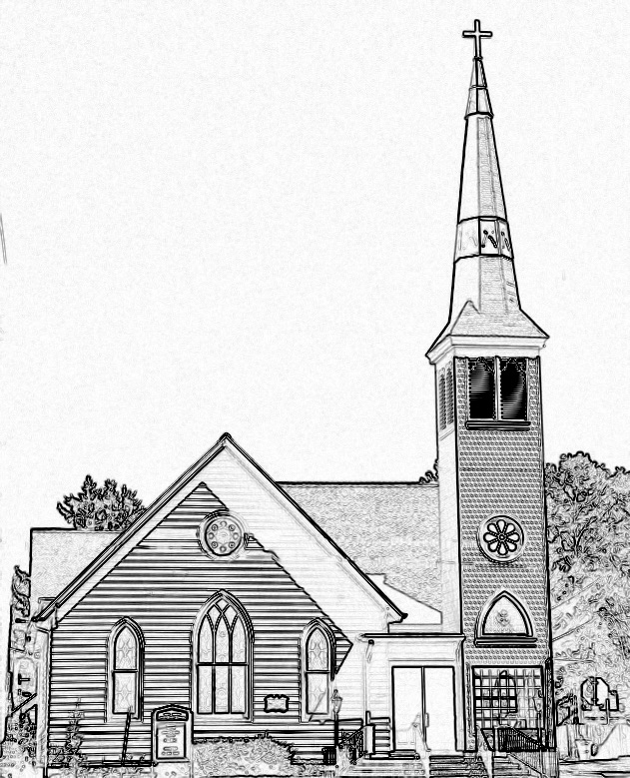

Welcome to worship! We are glad you joined us today. If you are seeking a church home, we invite you to join in the fellowship and ministry of this congregation. We look forward to seeing you again. Please fill out one of the visitor cards and drop it in the offering plate.
Prayer Concerns Carolyn Lin, Eli Chen, Meg Adams, Anne Gilchrist, Mickey Palmer, Anne Barnes, Suzanne Rogers

Thank you to The Chapman Family for hosting coffee hour.
Thank you to Steve Doan for being our reader today.
Thank you to the guitars and special musicians.
Emma Cathey is our nursery worker today.
Reverend Monica Gould c-757-709-2846 mongould@gmail.com
Naomi Makemie 89 Market St Onancock/ Mailing Address- P.O. Box 397 Onancock, VA 23417 757-787-1331 Office Hours Wednesday 9:30-12
Staff, Elders & volunteersOrganist/Pianist-Mark Nuckols, Choir Director-Debbie Ryon, Office Administrator-Jennifer Stapleton, Nursery Worker-Mickey Palmer, Videographer-Mike Gould, Lead Usher-Suzanne Rogers, Clerk-Jennifer Stapleton Treasurer-George Heinrichs Elders:2025 Bill Baird, Patty Davis, Jennifer Stapleton, 2024 Ron May, Linda Arvidson, Meg Adams Class 2023 Megan Ames, Rick Turner, Marsh Ryon; NMPresChurch.org church naomimpchurch@gmail.com

This Week:
Sunday school May 14th & May 28th
Tuesdays 5:30 pm Made with Love craft group
Thursdays Choir meets at 5:00 pm

Looking ahead:
Our annual church picnic is June 4th following worship. It will be another indoor picnic.

Naomi Makemie Presbyterian Church Onancock, VA
Mark Nuckols Reverend Monica Gould Debbie Ryon Organist/Pianist pastor Choir Director
May 28, 2023
*Asterisk is to stand in body or spirit. Bold print is congregational response.
Prelude

Welcome/Announcements

Choral Opening God is here! As we your people meet to offcer praise and prayer, may we find in fuller measure, what it is in Christ we share. Here, as in the world around us, all our varied skills and arts wait the coming of the Spirit into open minds and hearts.

Call to Worship
Remember the promise of the Lord:
God will pour out the Spirit upon all flesh.
Life is a celebration!
An affirmation of God’s love.
Life is a beautiful tapestry, woven together in love! The Spirit is among us!
Surely, that’s cause for joy. Surely, we should celebrate!

Opening Prayer
Surely, God, this is good news, that you came to us with your Spirit. We are grateful today for your church, for your love, and for the chance to celebrate. We thank you and praise you, for the power of your Holy Spirit to weave us together as one. Grant that we may raise our voices in song and joy through Jesus Christ our Lord. Amen.

*Hymn Every time I feel the Spirit #315

We are God’s Handiwork Part 1 Christopher, Addison

Prayer of Confession
Almighty God, you poured your Spirit upon gathered disciples creating bold tongues, open ears, and a new community of faith. We confess that we hold back the force of your Spirit among us. We do not listen for your word of grace, speak the good news of your love, or live as a people made one in Christ. We ignore your grace that weaves us together through the power of your Spirit. Remind us over and over again that we are your children, never alone, and always carried in your love. Through Christ our Lord and Savior forever. Amen.

Words of Assurance

*Gloria Patri #579 Glory be to the Father and to the Son and to the Holy Ghost. As it was in the beginning, is now and ever shall be; world without end, amen. Amen.

*Affirmation of Faith: (on the back) Addison, Christopher

Reading Acts 2:1-21; Ephesians 2:10; Colossians 2:2-3 Steve Doan

Anthem On Eagle’s Wings

Sermon We are God’s Handiwork Rev. Monica Gould

*Hymn Lone Wild Bird #319

We are God’s Handiwork Part II Youth

Confirmation Addison, Christopher, Sponsors

*Hymn Spirit #320

Prayers of the People & The Lord’s Prayer
Our Father who art in heaven, hallowed be thy name. Thy kingdom come, thy will be done, on earth as it is in heaven. Give us this day our daily bread; and forgive us our debts as we forgive our debtors; and lead us not into temptation, but deliver us from evil. For Thine is the kingdom and the power and the glory, forever. Amen

Offering Spirit of God Dave Sommerville, Diane Taylor

*Doxology:
Praise God, from whom all blessings flow; praise Him, all creatures here below; praise Him above, ye heavenly host; Praise Father, Son, and Holy Ghost. Amen.

*Hymn Here I Am, Lord #525

Benediction

Choral Benediction The Lord bless you and keep you; the Lord lift his countenance upon you,
and give you peace; the Lord make his face to shine upon you, and be gracious unto you. Amen, amen.

Postlude

Please Join in the affirmation of Faith led by our youth.

Christopher- I believe that our God is loving, kind, and forgiving. I am not perfect, nor are my family, friends or acquaintances. In this busy world, it's easy to get caught up in competition and wanting to be the best and most perfect at everything we do. But God does not expect perfection. God is watching over us, he guides us and gives us grace, and I am very thankful for that. Amen.
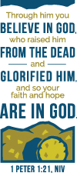
Ever since I was young, my family has said the same blessing before we eat dinner. It reads, "God we thank you for our food, for rest and home and all things good, for wind and rain and sun above but most of all for those we love." I am grateful for all God has given to me, to my family, and my community. I believe that God shares "all things good" with us and I look forward to continuing my faith journey in the months and years ahead.

Addison-I believe that Jesus is the Son of God and that he died on the cross and suffered for my sins because he loves me. God will love me for who I am and he doesn’t expect me to be perfect. In my life, I have always tried to be a good person, thinking that if I am good enough God will be pleased with me so that I will go to heaven when I die. But, as I look at my life, I realize that I am still a sinner and that I always will be even if I try to be the best that I can possibly be. I know that I am covered by God’s love and grace. Amen.

