Naomi Makemie Presbyterian Church
May 21, 2023 Large Print
Onancock, VA
Our Mission Statement
​“Do what is fair and just to your neighbor, be compassionate and loyal in your love, and don’t take yourself too seriously—take God seriously.” Micah 6:8
Compassionate, Fair and Loyal​
nmpreschurch.org

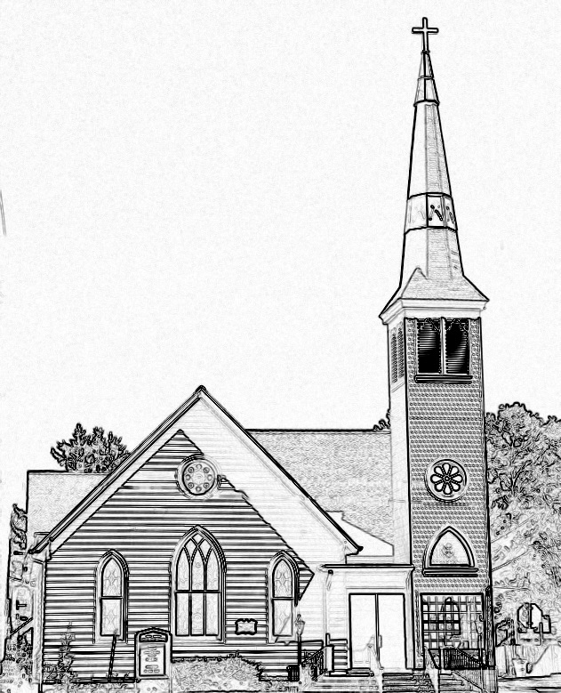

Welcome to worship! We are glad you joined us today. If you are seeking a church home, we invite you to join in the fellowship and ministry of this congregation. We look forward to seeing you again. Please fill out one of the visitor cards and drop it in the offering plate.
Prayer Concerns Carolyn Lin, Eli Chen, Meg Adams, Anne Gilchrist, Mickey Palmer, Anne Barnes, Suzanne Rogers

Thank you to The Ames Family for hosting coffee hour.
Thank you to Donna Doan for being our reader today.
Thank you to Becky Everhart for being our organist today.

This Week:
Reverend Monica Gould c-757-709-2846 mongould@gmail.com
Naomi Makemie 89 Market St Onancock/ Mailing Address- P.O. Box 397 Onancock, VA 23417 757-787-1331 Office Hours Wednesday 9:30-12
Staff, Elders & volunteersOrganist/Pianist-Mark Nuckols, Choir Director-Debbie Ryon, Office Administrator-Jennifer Stapleton, Nursery Worker-Mickey Palmer, Videographer-Mike Gould, Lead Usher-Suzanne Rogers, Clerk-Jennifer Stapleton Treasurer-George Heinrichs Elders:2025 Bill Baird, Patty Davis, Jennifer Stapleton, 2024 Ron May, Linda Arvidson, Meg Adams Class 2023 Megan Ames, Rick Turner, Marsh Ryon; NMPresChurch.org church naomimpchurch@gmail.com
Sunday school May 14th & May 28th
Tuesdays 5:30 pm Made with Love craft group
Thursdays Choir meets at 5:00 pm

Looking ahead:
Confirmation after church May 21st.
May 21st – Coffee Hour - Chapman Family

Naomi Makemie Presbyterian Church Onancock, VA
Mark Nuckols Reverend Monica Gould Debbie Ryon Organist/Pianist pastor Choir Director
May 21, 2023
*Asterisk is to stand in body or spirit. Bold print is congregational response.
Prelude

Welcome/Announcements

Choral Opening God is here! As we your people meet to offer praise and prayer, may we find in fuller measure, what it is in Christ we share. Here, as in the world around us, all our varied skills and arts wait the coming of the Spirit into open minds and hearts.

Call to Worship
It is a wonderful thing when members of the family live together in love and peace.
They shall be like trees planted beside flowing rivers.
May the church be one, just as Christ and God are one,
that Christ may be glorified in us.
They shall yield good fruit in its season,
and their leaf shall never wither.

Opening Prayer
Almighty God, your blessed Son, our Savior Jesus Christ, ascended far above all heavens that he might fulfill all things. Give us faith to trust as he promised that he abides with us on earth until the end of time. In the name of Father, Son, and Holy Spirit, Amen.

*Hymn Holy, Holy, Holy Lord God Almighty #138

Young disciples

Prayer of Confession
Forgive us, O God, when we treat people as though they are just a nuisance; when we are annoyed with others’ behavior; when people unexpectedly assert themselves; when we find it difficult to include those who think or act differently from the norm; when we are cruel in our judgements or exclusion. Teach us to recognize the gifts of grace among all those who call upon you and confess the faith of Jesus Christ our Lord. May we be united in your name now and forever. Amen.

Words of Assurance

*Gloria Patri #579 Glory be to the Father and to the Son and to the Holy Ghost. As it was in the beginning, is now and ever shall be; world without end, amen. Amen.

*Affirmation of Faith: Apostle’s Creed
I believe in God the Father Almighty, Maker of heaven and earth. And in Jesus Christ his only son our Lord; who was conceived by the Holy Ghost, born of the virgin Mary, suffered under Pontius Pilate, was crucified, dead and buried; he descended into hell; the third day he rose again from the dead; he ascended into heaven, and sitteth on the right hand of God the Father Almighty; from thence he shall come to judge the quick and the dead. I believe in the Holy Ghost, the holy catholic church; the communion of saints; the forgiveness of sins; the resurrection of the body; and the life everlasting. Amen.

Reading Psalm 47, John 17:1-11 Donna Doan

Anthem Gather By the River to Pray

Sermon Be As One Rev. Monica Gould

*Hymn Crown Him with Many Crowns #151

Prayers of the People & The Lord’s Prayer
Our Father who art in heaven, hallowed be thy name. Thy kingdom come, thy will be done, on earth as it is in heaven. Give us this day our daily bread; and forgive us our debts as we forgive our debtors; and lead us not into temptation, but deliver us from evil. For Thine is the kingdom and the power and the glory, forever. Amen

Offering

*Doxology:
Praise God, from whom all blessings flow; praise Him, all creatures here below; praise Him above, ye heavenly host; Praise Father, Son, and Holy Ghost. Amen.

*Hymn Rejoice Ye Pure in Heart #145

Benediction
Choral Benediction The Lord bless you and keep you; the Lord lift his countenance upon you,
and give you peace; the Lord make his face to shine upon you, and be gracious unto you. Amen, amen.
Postlude

Additonal Announcements
Patty Davis has put together a church directory. Please see her to check if your information is correct. Also if you wish to have your name included is we have not yet received your information.
If you have a child making a transition this year, please let Monica know. We will be celebrating graduates on June 4th. That means moving from pre-k to kindergarten, kindergarten to 1st grade, 5th grade to middle, middle to high school, and 12th grade completion. It’s always an exciting time.
-Our two mission opportunities for May are the ESPM school supply fundraiser and a chance to write letters to our military in active duty here at home and abroad.

-Our Confirmation youth will be celebrated on Pentecost May 28.

-Our graduates will be celebrated on Sunday June 4th during worship and the CCYF at 4 pm.

-Our annual church picnic is June 4th following worship. It will be another indoor picnic.

