Naomi Makemie Presbyterian Church
May 14, 2023 Large Print
Onancock, VA
Our Mission Statement
​“Do what is fair and just to your neighbor, be compassionate and loyal in your love, and don’t take yourself too seriously—take God seriously.” Micah 6:8
Compassionate, Fair and Loyal​
nmpreschurch.org

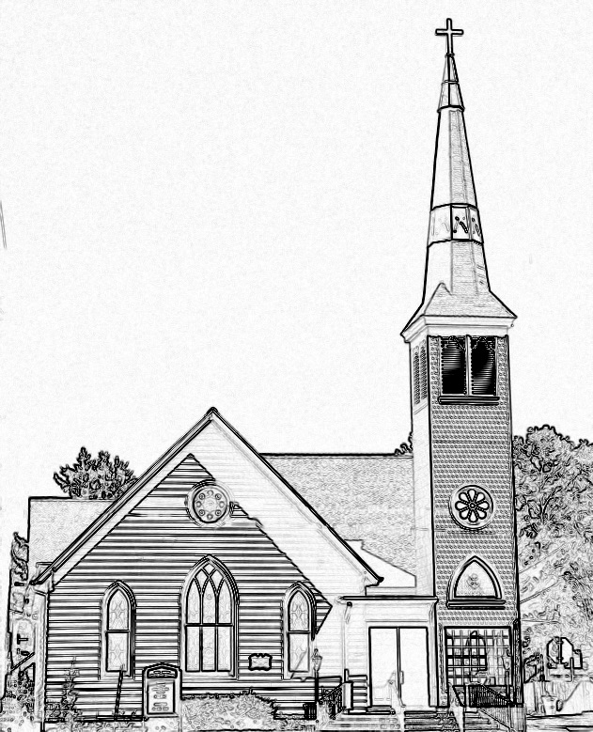

Welcome to worship! We are glad you joined us today. If you are seeking a church home, we invite you to join in the fellowship and ministry of this congregation. We look forward to seeing you again. Please fill out one of the visitor cards and drop it in the offering plate.
Prayer Concerns Carolyn Lin, Eli Chen, Meg Adams, Anne Gilchrist, Mickey Palmer, Anne Barnes, Suzanne Rogers

Thank you to Nina and Joan for hosting coffee hour.

This Week:
Reverend Monica Gould c-757-709-2846 mongould@gmail.com
Naomi Makemie 89 Market St Onancock/ Mailing Address- P.O. Box 397 Onancock, VA 23417 757-787-1331 Office Hours Wednesday 9:30-12
Staff, Elders & volunteersOrganist/Pianist-Mark Nuckols, Choir Director-Debbie Ryon, Office Administrator-Jennifer Stapleton, Nursery Worker-Mickey Palmer, Videographer-Mike Gould, Lead Usher-Suzanne Rogers, Clerk-Jennifer Stapleton Treasurer-George Heinrichs Elders:2025 Bill Baird, Patty Davis, Jennifer Stapleton, 2024 Ron May, Linda Arvidson, Meg Adams Class 2023 Megan Ames, Rick Turner, Marsh Ryon; NMPresChurch.org church naomimpchurch@gmail.com
Sunday school May 14th & May 28th
Monday – Session Meeting @ 5:30 pm
Tuesdays 5:30 pm Made with Love craft group
Thursdays Choir meets at 5:00 pm
CCYF at Camp Occohannock May 19th-21st.
Looking ahead:
Confirmation after church May 21st.
May 21st – Coffee Hour - Ames Family; Reader - Donna Doan

Naomi Makemie Presbyterian Church Onancock, VA
Mark Nuckols Reverend Monica Gould Debbie Ryon Organist/Pianist pastor Choir Director
May 14, 2023
*Asterisk is to stand in body or spirit. Bold print is congregational response.
Prelude
Welcome/Announcements

Choral Opening God is here! As we your people meet to offer praise and prayer, may we find in fuller measure, what it is in Christ we share. Here, as in the world around us, all our varied skills and arts wait the coming of the Spirit into open minds and hearts.

Call to Worship
We gather to worship our loving, nurturing God,
who, like a mother, knows us better than we know ourselves,
God loves us unconditionally,
God teaches us the way we should go. We will follow our Lord.

Opening Prayer
Gracious God you are both mother and father to us all. You are our maker, and we are your children. We are the creatures of your kindness and the bearers of your image. Today we enter your sanctuary with praise. We delight in your law. This is the day the Lord has made, we will rejoice and be glad! Amen.

*Hymn Come Thou Almighty King #139

Young disciples

Litany for Mother’s Day

Prayer of Confession
Holy God, we are quick to criticize, quick to judge, quick to blame. We fail to offer others the same grace we receive from you. Help us to be molded by our families and our faith communities. Help us to offer love and grace unconditionally as Christ has done for us. Forgive us for our quick tempers and knee jerk reactions. Guide us with the loving patience God offers us as an example. Scoop us up and wrap us in your arms so we will remember we are forgiven now and forevermore. Through Christ our Lord. Amen.

Words of Assurance

*Gloria Patri:
Glory be to the Father and to the Son and to the Holy Ghost. As it was in the beginning, is now and ever shall be; world without end, amen. Amen.

*Affirmation of Faith Apostle’s Creed
I believe in God the Father Almighty, Maker of heaven and earth. And in Jesus Christ his only son our Lord; who was conceived by the Holy Ghost, born of the virgin Mary, suffered under Pontius Pilate, was crucified, dead and buried; he descended into hell; the third day he rose again from the dead; he ascended into heaven, and sitteth on the right hand of God the Father Almighty; from thence he shall come to judge the quick and the dead. I believe in the Holy Ghost, the holy catholic church; the communion of saints; the forgiveness of sins; the resurrection of the body; and the life everlasting. Amen.

Reading Psalm 66:8-20; John 14:15-21

Anthem Make My Life an Alleluia

Sermon You Will See Me. Rev. Monica Gould

*Hymn Jesus Fill Us with Your Love v.2.3.5 #367

Prayers of the People & The Lord’s Prayer
Our Father who art in heaven, hallowed be thy name. Thy kingdom come, thy will be done, on earth as it is in heaven. Give us this day our daily bread; and forgive us our debts as we forgive our debtors; and lead us not into temptation, but deliver us from evil. For Thine is the kingdom and the power and the glory, forever. Amen

Offering

*Doxology:
Praise God, from whom all blessings flow; praise Him, all creatures here below; praise Him above, ye heavenly host; Praise Father, Son, and Holy Ghost. Amen.

*Hymn Be Thou My Vision #339

Benediction

Choral Benediction The Lord bless you and keep you; the Lord lift his countenance upon you,
and give you peace; the Lord make his face to shine upon you, and be gracious unto you. Amen, amen.

Postlude

Additonal Announcements
Patty Davis has put together a church directory. Please see her to check if your information is correct. Also if you wish to have your name included is we have not yet received your information.
If you have a child making a transition this year, please let Monica know. We will be celebrating graduates on June 4th. That means moving from pre-k to kindergarten, kindergarten to 1st grade, 5th grade to middle, middle to high school, and 12th grade completion. It’s always an exciting time.
-Welcome to worship Rev. Jeff Bell our Commission on Ministry Liaison from PEVA and his wife Sue.

-Thank you to everyone who helped with the yard sale.

-Session meeting Monday at 5:30 pm our guest will be Rev. Jeff Bell.

-Join us Wednesday May 17 for a potluck supper and the movie Jesus Revolution.

-Choir will be at 4:30 on Thursday.

-Our two mission opportunities for May are the ESPM school supply fundraiser and a chance to write letters to our military in active duty here at home and abroad.

-Our CCYF weekend is this Friday to Sunday. This is the last few days to register. We need to let the camp and the horse farm know for how many youth to prepare.

-Our Confirmation youth will be celebrated on Pentecost May 28.

-Our graduates will be celebrated on Sunday June 4th during worship and the CCYF at 4 pm.

-Our annual church picnic is June 4th following worship. It will be another indoor picnic.

-Please pick up a printed newsletter to keep or share with a neighbor.

