Naomi Makemie Presbyterian Church
May 7, 2023 Large Print
Onancock, VA
Our Mission Statement
​“Do what is fair and just to your neighbor, be compassionate and loyal in your love, and don’t take yourself too seriously—take God seriously.” Micah 6:8
Compassionate, Fair and Loyal​
nmpreschurch.org

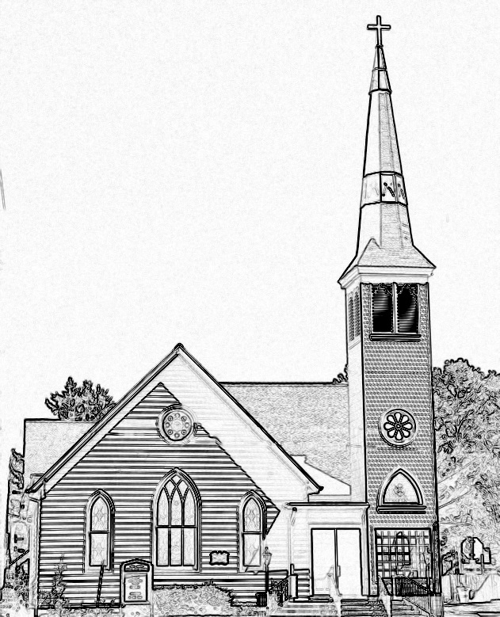

Welcome to worship! We are glad you joined us today. If you are seeking a church home, we invite you to join in the fellowship and ministry of this congregation. We look forward to seeing you again. Please fill out one of the visitor cards and drop it in the offering plate.
Prayer Concerns Carolyn Lin, Eli Chen, Meg Adams, Anne Gilchrist, Mickey Palmer, Anne Barnes, Suzanne Rogers

Thank you to Linda Arvidson for hosting coffee hour. Thank you to Judd Everhart for being our reader this morning.

This Week:
Reverend Monica Gould c-757-709-2846 mongould@gmail.com
Naomi Makemie 89 Market St Onancock/ Mailing Address- P.O. Box 397 Onancock, VA 23417 757-787-1331 Office Hours Wednesday 9:30-12
Staff, Elders & volunteersOrganist/Pianist-Mark Nuckols, Choir Director-Debbie Ryon, Office Administrator-Jennifer Stapleton, Nursery Worker-Mickey Palmer, Videographer-Mike Gould, Lead Usher-Suzanne Rogers, Clerk-Jennifer Stapleton Treasurer-George Heinrichs Elders:2025 Bill Baird, Patty Davis, Jennifer Stapleton, 2024 Ron May, Linda Arvidson, Meg Adams Class 2023 Megan Ames, Rick Turner, Marsh Ryon; NMPresChurch.org church naomimpchurch@gmail.com
Sunday school May 14th & May 28th
Tuesdays 5:30 pm Made with Love craft group
Thursdays Choir meets at 5:00 pm
Looking ahead:
Session Meeting – May 15th
Confirmation after church May 21st.
May 13th Yard sale – save your items to donate to the sale.
CCYF at Camp Occohannock May 19th-21st.

The Yard Sale is always a BIG event at NMPC. Drop your items (not large ones) at the church this week in the Makemie Room (Fellowship hall). Let Linda Arvidson know if you can help with the yard sale.

Naomi Makemie Presbyterian Church Onancock, VA
Mark Nuckols Reverend Monica Gould Debbie Ryon Organist/Pianist pastor Choir Director
May 7, 2023
*Asterisk is to stand in body or spirit. Bold print is congregational response.
Prelude
Welcome/Announcements

Choral Opening Sing, make a joyful song to God. All creation joins in praise to the Lord in heaven above. He inhabits the praise of his people, so let His praises ring. Let the people join their voices and sing!

Call to Worship (From Psalm 100)
Make a joyful noise to the LORD, all the earth!
Serve the LORD with gladness!
Come into his presence with singing!
Enter his gates with thanksgiving, and his courts with praise!
Give thanks to him; bless his name! For the LORD is good;
His steadfast love endures forever, and his faithfulness to all generations.

Opening Prayer
Lord, we thank you for the gift of another day, another Sunday, to come before you and lift our voices in praise. We pray that this service will bring glory and honor to you. Open our hearts and minds to receive your word for us today. In the name of Jesus our Redeemer, Amen.
*Opening Hymn O For a Thousand Tongues to Sing #466

Prayer of Confession
Merciful God, Creator of all that is good, we know your love for all the world, and yet too often, we are hesitant to speak of our faith with others; may we find greater confidence in our proclamation of our love for you. Too often we are half-hearted in our service to others; remind us to humbly offer help to those in need. We admit that too often we live as if dependent wholly on our own resources rather than seeking you will and your guidance. Forgive the poverty of our efforts and the frailty of our faith and open wide our hearts finding the boldness and courage to be faithful disciples of our risen and living Lord Jesus Christ. Amen.

Words of Assurance

*Gloria Patri #579 Glory be to the Father and to the Son and to the Holy Ghost. As it was in the beginning, is now and ever shall be; world without end, amen. Amen.

*Affirmation of Faith: Apostle’s Creed
I believe in God the Father Almighty, Maker of heaven and earth. And in Jesus Christ his only son our Lord; who was conceived by the Holy Ghost, born of the virgin Mary, suffered under Pontius Pilate, was crucified, dead and buried; he descended into hell; the third day he rose again from the dead; he ascended into heaven, and sitteth on the right hand of God the Father Almighty; from thence he shall come to judge the quick and the dead. I believe in the Holy Ghost, the holy catholic church; the communion of saints; the forgiveness of sins; the resurrection of the body; and the life everlasting. Amen.

Reading John 1:1-5, 14; Philippians 2:1-11 Judd Everhart

Anthem Guide My Wayfaring Feet

Sermon “The Word Made Flesh” Rev. Donna Doan

*Hymn Jesus Loves Me insert

Prayers of the People & The Lord’s Prayer
Our Father who art in heaven, hallowed be thy name. Thy kingdom come, thy will be done, on earth as it is in heaven. Give us this day our daily bread; and forgive us our debts as we forgive our debtors; and lead us not into temptation, but deliver us from evil. For Thine is the kingdom and the power and the glory, forever. Amen

Offering/Offertory

*Doxology Praise God, from whom all blessings flow; praise Him, all creatures here below; praise Him above, ye heavenly host; Praise Father, Son, and Holy Ghost. Amen.

*Hymn Called As Partners In Christ’s Service #343
*Benediction

*Choral Benediction You shall go out with joy And be led forth with peace The mountains and the hills Will break forth before you There'll be shouts of joy And all the trees of the field Will clap, will clap their hands. And all the trees of the field will clap their hands The trees of the field will clap their hands The trees of the field will clap their hands, While you go out with joy!
Postlude

Additonal Announcements
Patty Davis has put together a church directory. Please see her to check if your information is correct. Also if you wish to have your name included is we have not yet received your information.
If you have a child making a transition this year, please let Monica know. We will be celebrating graduates on June 4th. That means moving from pre-k to kindergarten, kindergarten to 1st grade, 5th grade to middle, middle to high school, and 12th grade completion. It’s always an exciting time.
Congratulations to Skylar Stapleton and Gabe Nock for the arrival of their baby girl Raelynn. She was born on May 2nd weighing 7 lbs 15 oz. Mom and baby are doing great!

