Naomi Makemie Presbyterian Church
April 30, 2023 Large Print
Onancock, VA
Our Mission Statement
​“Do what is fair and just to your neighbor, be compassionate and loyal in your love, and don’t take yourself too seriously—take God seriously.” Micah 6:8
Compassionate, Fair and Loyal​
nmpreschurch.org

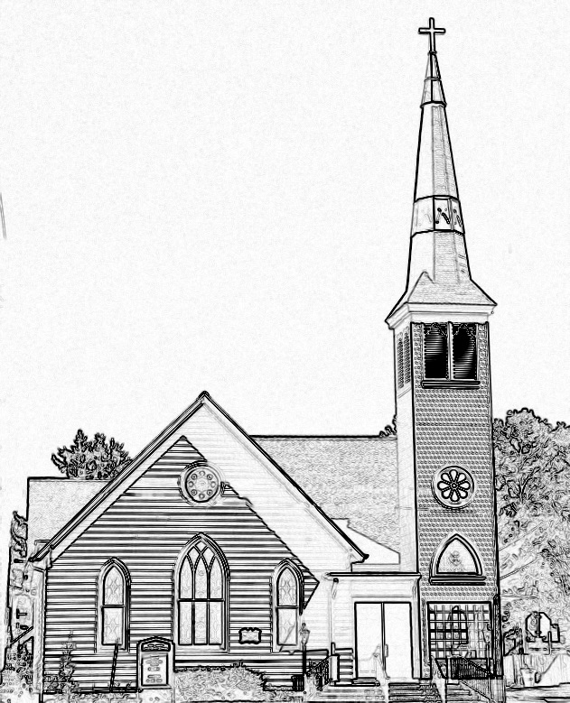

Welcome to worship! We are glad you joined us today. If you are seeking a church home, we invite you to join in the fellowship and ministry of this congregation. We look forward to seeing you again. Please fill out one of the visitor cards and drop it in the offering plate.
Prayer Concerns Carolyn Lin, Eli Chen, Meg Adams, Anne Gilchrist, Mickey Palmer, Anne Barnes, John Holdren

Thank you to George, Wilma, and Joan Motely/Heinrichs for hosting coffee hour. Thank you to Joan Motely for being our reader this morning.

This Week:
Reverend Monica Gould c-757-709-2846 mongould@gmail.com
Naomi Makemie 89 Market St Onancock/ Mailing Address- P.O. Box 397 Onancock, VA 23417 757-787-1331 Office Hours Wednesday 9:30-12
Staff, Elders & volunteersOrganist/Pianist-Mark Nuckols, Choir Director-Debbie Ryon, Office Administrator-Jennifer Stapleton, Nursery Worker-Mickey Palmer, Videographer-Mike Gould, Lead Usher-Suzanne Rogers, Clerk-Jennifer Stapleton Treasurer-George Heinrichs Elders:2025 Bill Baird, Patty Davis, Jennifer Stapleton, 2024 Ron May, Linda Arvidson, Meg Adams Class 2023 Megan Ames, Rick Turner, Marsh Ryon; NMPresChurch.org church naomimpchurch@gmail.com
Sunday school May 4th & May 28th
Tuesdays 5:30 pm Made with Love knitting/craft group
Thursdays Choir meets at 5:00 pm

Looking ahead:
Coffee Hour Host for May 7th – The Chapman Family
Confirmation after church April 16th & 30th & May 21st.
May 13th Yard sale – save your items to donate to the sale.
CCYF at Camp Occohannock May 19th-21st.

The Yard Sale is always a BIG event at NMPC. If you enjoy the work of sorting, pricing, and helping the days before and on the day please talk to Linda Arvidson this morning. She needs a team of at least three to four folks to help her.

Naomi Makemie Presbyterian Church Onancock, VA
Mark Nuckols Reverend Monica Gould Debbie Ryon Organist/Pianist pastor Choir Director
April 30, 2023
*Asterisk is to stand in body or spirit. Bold print is congregational response.
Prelude
Welcome/Announcements

Choral Opening Sing, make a joyful song to God. All creation joins in praise to the Lord in heaven above. He inhabits the praise of his people, so let His praises ring. Let the people join their voices and sing!
Call to Worship
Hear the call of our Shepherd, and allow His voice to lead us.
May the light of Christ shine into our lives.
Praise the Lamb of God who came into the world that we may have life.
May the mercy of our Shepherd gather us in as we worship today.

Opening Prayer
Almighty God you sent Jesus to be the Shepherd who gathers the flock and provides them with shelter. We come with praise and thanksgiving today. We rejoice in the abundance of his love; in Christ Jesus we pray. Amen.

*Opening Hymn Come Christians Join to Sing #150

Prayer of Confession
Shepherd of our lives, Guide us to the still waters. Lead us on the right paths. Walk beside us when we go through our darkest valleys. Help us to know Your Comforting Presence is always with us. Forgive us, God, for not following Your ways. Forgive us for not remembering that we are Your sheep, and You are our Shepherd. Forgive us when we have not listened for Your voice and instead have acted in the ways of the world. Guide us back to Your path, to loving You and loving our neighbors. In the name of Christ our Shepherd we pray. Amen.
Words of Assurance
*Gloria Patri #579 Glory be to the Father and to the Son and to the Holy Ghost. As it was in the beginning, is now and ever shall be; world without end, amen. Amen.

*Affirmation of Faith: Apostle’s Creed
I believe in God the Father Almighty, Maker of heaven and earth. And in Jesus Christ his only son our Lord; who was conceived by the Holy Ghost, born of the virgin Mary, suffered under Pontius Pilate, was crucified, dead and buried; he descended into hell; the third day he rose again from the dead; he ascended into heaven, and sitteth on the right hand of God the Father Almighty; from thence he shall come to judge the quick and the dead. I believe in the Holy Ghost, the holy catholic church; the communion of saints; the forgiveness of sins; the resurrection of the body; and the life everlasting. Amen.

Reading Psalm 23; John 10:1-10 Joan Motely

Anthem May Your Roots Go Deep

Sermon Gates! Rev. Monica Gould

*Hymn There’s a Wideness in God’s Mercy #298

Prayers of the People & The Lord’s Prayer
Our Father who art in heaven, hallowed be thy name. Thy kingdom come, thy will be done, on earth as it is in heaven. Give us this day our daily bread; and forgive us our debts as we forgive our debtors; and lead us not into temptation, but deliver us from evil. For Thine is the kingdom and the power and the glory, forever. Amen

Offering/Offertory Penland family
*Doxology Praise God, from whom all blessings flow; praise Him, all creatures here below; praise Him above, ye heavenly host; Praise Father, Son, and Holy Ghost. Amen.
*Hymn Savior, like a Shepherd Lead Us #387
*Benediction
*Choral Benediction You shall go out with joy And be led forth with peace The mountains and the hills Will break forth before you There'll be shouts of joy And all the trees of the field Will clap, will clap their hands. And all the trees of the field will clap their hands The trees of the field will clap their hands The trees of the field will clap their hands, While you go out with joy!
Postlude

Additonal Announcements
Patty Davis has put together a church directory. Please see her to check if your information is correct. Also if you wish to have your name included is we have not yet received your information.
If you have a child making a transition this year, please let Monica know. We will be celebrating graduates on June 4th. That means moving from pre-k to kindergarten, kindergarten to 1st grade, 5th grade to middle, middle to high school, and 12th grade completion. It’s always an exciting time.

