Naomi Makemie Presbyterian Church
April 23, 2023 Large Print
Onancock, VA
Our Mission Statement
​“Do what is fair and just to your neighbor, be compassionate and loyal in your love, and don’t take yourself too seriously—take God seriously.” Micah 6:8
Compassionate, Fair and Loyal​
nmpreschurch.org

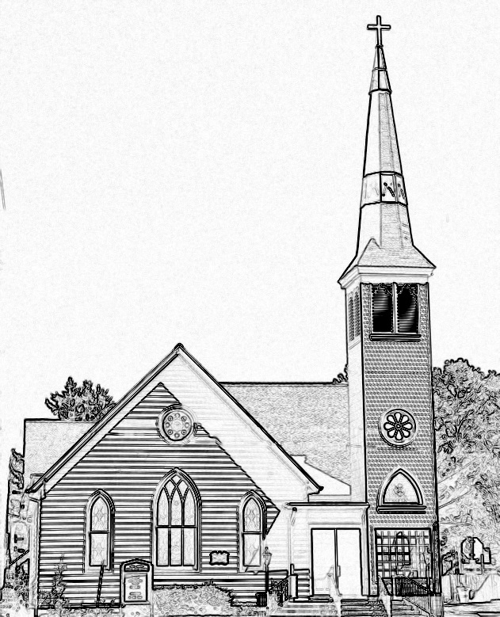

Welcome to worship! We are glad you joined us today. If you are seeking a church home, we invite you to join in the fellowship and ministry of this congregation. We look forward to seeing you again. Please fill out one of the visitor cards and drop it in the offering plate.
Prayer Concerns Carolyn Lin, Eli Chen, Meg Adams, Anne Gilchrist, Mickey Palmer, Anne Barnes, John Holdren

Thank you to the Batemans for hosting coffee hour.
Reverend Monica Gould c-757-709-2846 mongould@gmail.com
Naomi Makemie 89 Market St Onancock/ Mailing Address- P.O. Box 397 Onancock, VA 23417 757-787-1331 Office Hours Wednesday 9:30-12
Staff, Elders & volunteersOrganist/Pianist-Mark Nuckols, Choir Director-Debbie Ryon, Office Administrator-Jennifer Stapleton, Nursery Worker-Mickey Palmer, Videographer-Mike Gould, Lead Usher-Suzanne Rogers, Clerk-Jennifer Stapleton Treasurer-George Heinrichs Elders:2025 Bill Baird, Patty Davis, Jennifer Stapleton, 2024 Ron May, Linda Arvidson, Meg Adams Class 2023 Megan Ames, Rick Turner, Marsh Ryon; NMPresChurch.org church naomimpchurch@gmail.com

This Week:
Sunday school May 4th & May 28th
Tuesdays 5:30 pm Made with Love knitting/craft group
Thursdays Choir meets at 5:00 pm
Senior Exercises with Rhudy is taking pause until May.
Looking ahead:
Coffee Hour Host for April 30th – George, Wilma, & Joan Motely/Heinrichs
Reader for April 30th – Joan Motely
Confirmation after church April 16th & 30th & May 21st.
May 13th Yard sale – save your items to donate to the sale.
CCYF at Camp Occohannock May 19th-21st.

Naomi Makemie Presbyterian Church Onancock, VA
Mark Nuckols Reverend Monica Gould Debbie Ryon Organist/Pianist pastor Choir Director
April 23, 2023
*Asterisk is to stand in body or spirit. Bold print is congregational response.
Prelude

Welcome

Announcements

Choral Opening Sing, make a joyful song to God. All creation joins in praise to the Lord in heaven above. He inhabits the praise of his people, so let His praises ring. Let the people join their voices and sing!
Call to Worship
The heavens declare the glory of God.
The firmament proclaims his handiwork.
The plants and the trees show the Lord’s presence.
Let us join with all creation as we worship our Lord today

Opening Prayer
God of awe and wonder, of all beauty and joy, of all things made, we join our voices in giving thanks. Unite us by your Spirit that we may be signs of your abundant grace as we seek to fulfill your command to care for all of your creation. May our worship and praise of all you have made restore our resolve to care for this world and one another. In Jesus’ name. Amen.

*Opening Hymn Morning Has Broken #469

Message about the sunflower & Young disciples Joan May

Prayer of Confession
Heavenly Father, you created us in your image and the world for our pleasure. Forgive us for neglecting the responsibility of care you bestowed on us. We have polluted the air and destroyed the earth. We have neglected your extraordinary creatures and caused their extinction. Forgive our shortsightedness. Restore us with your vision that you have for our world. Through Jesus Christ, make us agents of healing and blessing. Amen.

Words of Assurance
*Gloria Patri #579 Glory be to the Father and to the Son and to the Holy Ghost. As it was in the beginning, is now and ever shall be; world without end, amen. Amen.
*Affirmation of Faith: The love of God section 9.16, 9.17 from the confession of 1967
God has created the world of space and time to be the sphere of God’s dealings with humankind. In its beauty and vastness, sublimity and awfulness, order and disorder, the world reflects to the eye of faith, the majesty and mystery of its Creator. God has endowed humans with capacities to make the world serve their needs and to enjoy its good things. Life is a gift to be received with gratitude and a task to be pursued with courage. People are free to seek life within the purpose of God: to develop and protect the resources of nature for the common welfare, to work for justice and peace in society, and in other ways to use their creative powers for the fulfillment of human life. Now to him who by the power at work within us is able to do far more abundantly than all we ask or think, to him be glory in the church and in Christ Jesus to all generations. Amen.

Reading Psalm 19; 2 Corinthians 5:16-21

Anthem For the Beauty of the Earth

Sermon Telling the Glory of God
Genesis (Sunday school) Mrs. Kate, Carter Ames, Amelia Stapleton,

*Hymn This is My Father’s World #293

Prayers of the People & The Lord’s Prayer
Our Father who art in heaven, hallowed be thy name. Thy kingdom come, Thy will be done, on earth as it is in heaven. Give us this day our daily bread; and forgive us our debts as we forgive our debtors; and lead us not into temptation, but deliver us from evil. For Thine is the kingdom and the power and the glory, forever. Amen

Offering/Offertory
*Doxology Praise God, from whom all blessings flow; praise Him, all creatures here below; praise Him above, ye heavenly host; Praise Father, Son, and Holy Ghost. Amen.
*Hymn All Things Bright and Beautiful #267
*Benediction
*Choral Benediction You shall go out with joy And be led forth with peace The mountains and the hills Will break forth before you There'll be shouts of joy And all the trees of the field Will clap, will clap their hands. And all the trees of the field will clap their hands The trees of the field will clap their hands The trees of the field will clap their hands, While you go out with joy!
Postlude

