Naomi Makemie Presbyterian Church
April 16, 2023 Large Print
Onancock, VA
Our Mission Statement
​“Do what is fair and just to your neighbor, be compassionate and loyal in your love, and don’t take yourself too seriously—take God seriously.” Micah 6:8
Compassionate, Fair and Loyal​
nmpreschurch.org

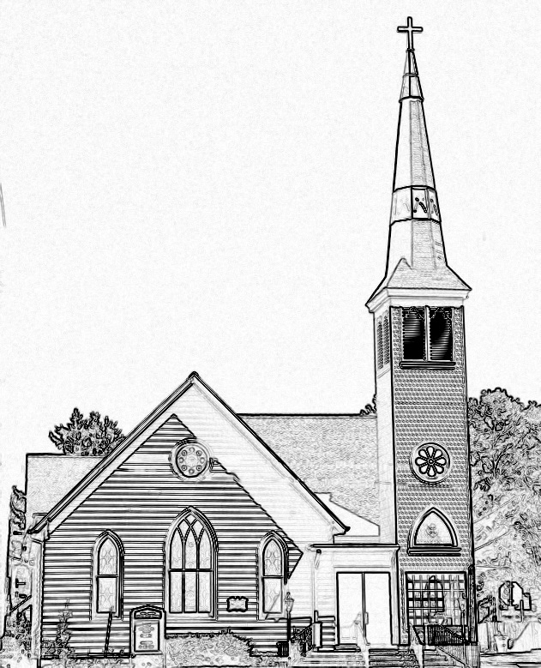

Welcome to worship! We are glad you joined us today. If you are seeking a church home, we invite you to join in the fellowship and ministry of this congregation. We look forward to seeing you again. Please fill out one of the visitor cards and drop it in the offering plate.
Prayer Concerns Carolyn Lin, Eli Chen, Meg Adams, Anne Gilchrist, Mickey Palmer, Anne Barnes

Thank you to Suzanne Rogers for hosting coffee hour.
Reverend Monica Gould c-757-709-2846 mongould@gmail.com
Naomi Makemie 89 Market St Onancock/ Mailing Address- P.O. Box 397 Onancock, VA 23417 757-787-1331 Office Hours Wednesday 9:30-12
Staff, Elders & volunteersOrganist/Pianist-Mark Nuckols, Choir Director-Debbie Ryon, Office Administrator-Jennifer Stapleton, Nursery Worker-Mickey Palmer, Videographer-Mike Gould, Lead Usher-Suzanne Rogers, Clerk-Jennifer Stapleton Treasurer-George Heinrichs Elders:2025 Bill Baird, Patty Davis, Jennifer Stapleton, 2024 Ron May, Linda Arvidson, Meg Adams Class 2023 Megan Ames, Rick Turner, Marsh Ryon; NMPresChurch.org church naomimpchurch@gmail.com

This Week:
Sunday school April 2nd and 23rd
CCYF will meet today April 16th at 4:00 pm.
Session meets tomorrow April 17th at 5:30 pm
Tuesdays 5:30 pm Made with Love knitting/craft group
Thursdays Choir meets at 5:00 pm
Senior Exercises with Rhudy is taking pause until May.
Work Day at church April 22nd at 10:00am
Looking ahead:
Meeting to plan VBS Thursday April 20th 4:00pm.
Confirmation after church April 16th & 30th & May 21st.
The next guitar service will be April 23rd for Earth Day celebration.
May 13th Yard sale – save your items to donate to the sale.
CCYF at Camp Occohannock May 19th-21st.

Naomi Makemie Presbyterian Church Onancock, VA
Mark Nuckols Reverend Monica Gould Debbie Ryon Organist/Pianist pastor Choir Director
April 16, 2023
*Asterisk is to stand in body or spirit. Bold print is congregational response.
Prelude

Welcome

Announcements

Choral Opening Sing, make a joyful song to God. All creation joins in praise to the Lord in heaven above. He inhabits the praise of his people, so let His praises ring. Let the people join their voices and sing!

Call to Worship
Blessed are those who have not seen and yet believe.
By God’s great mercy we have been born anew to a living hope
We are Easter people!
Let us worship God!

Opening Prayer
Risen Christ, whose absence leaves us paralyzed, but whose presence is overwhelming: Breathe on us with your abundant life, that where we cannot see we may have courage to believe that we may be raised with you. Amen.

*Opening Hymn Thine is the Glory #122

Prayer of Confession
God of empty tombs and empty people: when we hesitate to speak of your hope, forgive us, and give us voice. When we find it difficult to love another, forgive us, and give us new compassion. When we want to stand with the high and mighty, forgive us, and put us next to the poor and oppressed. When we stay locked behind our fears and doubts, forgive us, and send us out to share your grace. When we cannot believe your Word of new life, forgive us, and fill us with your joy. In Christ Jesus our Lord. Amen.

Words of Assurance

*Gloria Patri #579 Glory be to the Father and to the Son and to the Holy Ghost. As it was in the beginning, is now and ever shall be; world without end, amen. Amen.
*Affirmation of Faith: Apostle’s Creed
I believe in God the Father Almighty, Maker of heaven and earth. And in Jesus Christ his only son our Lord; who was conceived by the Holy Ghost, born of the virgin Mary, suffered under Pontius Pilate, was crucified, dead and buried; he descended into hell; the third day he rose again from the dead; he ascended into heaven, and sitteth on the right hand of God the Father Almighty; from thence he shall come to judge the quick and the dead. I believe in the Holy Ghost, the holy catholic church; the communion of saints; the forgiveness of sins; the resurrection of the body; and the life everlasting. Amen.

Reading Psalm 16, John 20:19-31

Anthem Dona Nobis Pacem Hal Hopson

Sermon Unless…I Will Not Believe Rev. Monica Gould

*Hymn Without Seeing You Insert

Prayers of the People & The Lord’s Prayer
Our Father who art in heaven, hallowed be thy name. Thy kingdom come, thy will be done, on earth as it is in heaven. Give us this day our daily bread; and forgive us our debts as we forgive our debtors; and lead us not into temptation, but deliver us from evil. For Thine is the kingdom and the power and the glory, forever. Amen

Offering/Offertory
*Doxology Praise God, from whom all blessings flow; praise Him, all creatures here below; praise Him above, ye heavenly host; Praise Father, Son, and Holy Ghost. Amen.

*Hymn Christ is Alive #108

*Benediction

*Choral Benediction You shall go out with joy And be led forth with peace The mountains and the hills Will break forth before you There'll be shouts of joy And all the trees of the field Will clap, will clap their hands. And all the trees of the field will clap their hands The trees of the field will clap their hands The trees of the field will clap their hands, While you go out with joy!
Postlude

