Naomi Makemie Presbyterian Church
April 9, 2023 Large Print
Onancock, VA
Our Mission Statement
​“Do what is fair and just to your neighbor, be compassionate and loyal in your love, and don’t take yourself too seriously—take God seriously.” Micah 6:8
Compassionate, Fair and Loyal​
nmpreschurch.org

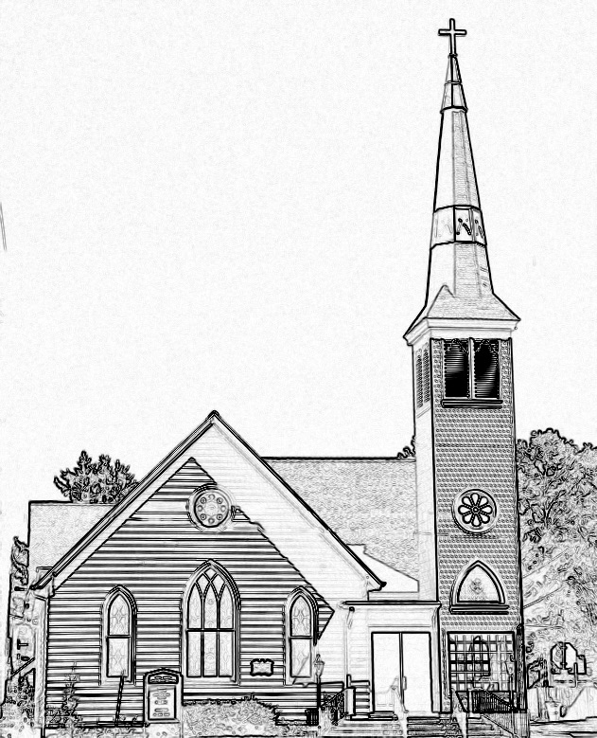

Welcome to worship! We are glad you joined us today. If you are seeking a church home, we invite you to join in the fellowship and ministry of this congregation. We look forward to seeing you again. Please fill out one of the visitor cards and drop it in the offering plate.
Prayer Concerns Carolyn Lin, Eli Chen, Meg Adams, Anne Gilchrist, Mickey Palmer, Anne Barnes

A Lenten Journey of Amazing Grace - Devotional Reading Recap This week we have been on the final leg of our Lenten journey, a journey where at its end Jesus gave His all. Jesus gave His life to bring abundant, everlasting life to all those who believe the Good News. News that carries us through our darkest days, that promises us forgiveness and challenges us to love one another with the same great love with which Jesus loved us. This Good News is ours to trust in, and ours to share now and forever. CHRIST IS RISEN! GRACE ABOUNDS! When we've been there ten thousand years, Bright shining as the sun, We've no less days to sing God's praise Than when we'd first begun.
Thank you to the Rick Turner for hosting coffee hour.
Reverend Monica Gould c-757-709-2846 mongould@gmail.com
Naomi Makemie 89 Market St Onancock/ Mailing Address- P.O. Box 397 Onancock, VA 23417 757-787-1331 Office Hours Wednesday 9:30-12
Staff, Elders & volunteersOrganist/Pianist-Mark Nuckols, Choir Director-Debbie Ryon, Office Administrator-Jennifer Stapleton, Nursery Worker-Mickey Palmer, Videographer-Mike Gould, Lead Usher-Suzanne Rogers, Clerk-Jennifer Stapleton Treasurer-George Heinrichs Elders:2025 Bill Baird, Patty Davis, Jennifer Stapleton, 2024 Ron May, Linda Arvidson, Meg Adams Class 2023 Megan Ames, Rick Turner, Marsh Ryon; NMPresChurch.org church naomimpchurch@gmail.com
Thank you to our reader Steve Doan.

This Week:
Sunday school April 2nd and 23rd
Tuesdays 5:30 pm Made with Love knitting/craft group Thursdays Choir meets at 5:00 pm
Senior Exercises with Rhudy is taking pause until May. Looking Ahead: VBS meeting April 20th 4:00. Guitar service April 23rd. May 13th yard sale.

Naomi Makemie Presbyterian Church Onancock, VA
Mark Nuckols Reverend Monica Gould Debbie Ryon Organist/Pianist pastor Choir Director
April 9, 2023 Easter Sunday
*Asterisk is to stand in body or spirit. Bold print is congregational response.
Prelude

Welcome

Announcements

Choral Opening Hallelujah
Call to Worship
The Lord is risen! Alleluia!
Alleluia! The Lord is risen indeed!
The Lord is risen! This is our message.
Let us go and tell the good news to all.

Opening Prayer
God of the resurrection, you conquered death and opened the gates of everlasting life. In the power of the Holy Spirit, raise us with Christ that we, too, may proclaim healing and peace to the nations. Amen.

*Opening Hymn Jesus Christ is Risen Today #123

Young disciples

Prayer of Confession
Living God, we confess that we look for the living among the dead. We are foolish and slow to believe the promise of the prophets. We are frightened and full of doubt, even when you stand among us. Forgive us, God of Grace. Open our hearts to receive your word, through Jesus Christ our Lord. Amen.

Words of Assurance
*Gloria Patri #579 Glory be to the Father and to the Son and to the Holy Ghost. As it was in the beginning, is now and ever shall be; world without end, amen. Amen.

*Affirmation of Faith: Apostle’s Creed
I believe in God the Father Almighty, Maker of heaven and earth. And in Jesus Christ his only son our Lord; who was conceived by the Holy Ghost, born of the virgin Mary, suffered under Pontius Pilate, was crucified, dead and buried; he descended into hell; the third day he rose again from the dead; he ascended into heaven, and sitteth on the right hand of God the Father Almighty; from thence he shall come to judge the quick and the dead. I believe in the Holy Ghost, the holy catholic church; the communion of saints; the forgiveness of sins; the resurrection of the body; and the life everlasting. Amen.

Reading Psalm 118: 1-2, 14-24; Matthew 28:1-10 Steve Doan

Anthem Christ the Lord

Sermon He is Not Here Rev. Monica Doan

*Hymn Up From the Grave He Arose insert

Prayers of the People & The Lord’s Prayer
Our Father who art in heaven, hallowed be thy name. Thy kingdom come, thy will be done, on earth as it is in heaven. Give us this day our daily bread; and forgive us our debts as we forgive our debtors; and lead us not into temptation, but deliver us from evil. For Thine is the kingdom and the power and the glory, forever. Amen

Offering/Offertory
*Doxology Praise God, from whom all blessings flow; praise Him, all creatures here below; praise Him above, ye heavenly host; Praise Father, Son, and Holy Ghost. Amen.
*Hymn The Day of Resurrection #118

*Benediction

*Choral Benediction You shall go out with joy And be led forth with peace The mountains and the hills Will break forth before you There'll be shouts of joy And all the trees of the field Will clap, will clap their hands. And all the trees of the field will clap their hands The trees of the field will clap their hands The trees of the field will clap their hands, While you go out with joy!
Postlude

